DOC 2 ME: HEALTH REPORT SIMPLIFIER USING MULTIMODAL LARGE LANGUAGE MODELS
A CAPSTONE PROJECT REPORT
SUBMITTED BY:
KUSHAL DEVRAJ (BU22CSEN0102284)
UNDER THE GUIDANCE OF:
SANGAMESHWAR
Assistant Professor
DEPARTMENT OF COMPUTER SCIENCE AND ENGINEERING
GITAM SCHOOL OF TECHNOLOGY
2026

ABSTRACT
Modern medical reports often present a significant barrier to health literacy due to high-density clinical jargon. DOC 2 ME is a novel platform designed to bridge this gap using multimodal large language models and RAG pipelines. The system incorporates automated PII scrubbing (98.8% accuracy) for privacy and Tesseract-based OCR for digitization. By merging clinical text extraction with generative AI summaries, the platform empowers patients to better understand their health data.

CHAPTER 1: INTRODUCTION
Health literacy is a critical determinant of patient outcomes. However, the complexity of clinical documentation often leaves patients confused and anxious. This research introduces 'Doc 2 Me', an AI-powered system designed to translate complex medical documents into anonymized and plain-language summaries. The goal is to maximize comprehension without compromising medical accuracy.

CHAPTER 2: LITERATURE SURVEY
The research paper [9] 'Artificial Intelligence Best Practices in Clinical Natural Language Processing' offers an extensive literature survey of clinical documentation and ML/DL effectiveness.
The paper [10] 'Precision Health Literacy: Real-Time Patient Information Extraction' focuses on OCR and cloud NLP technology for digitizing archives.
The research paper [11] 'Bio-Instructional Text Simplification' presents an advanced transformer-based approach (T5) for clinical paraphrasing.
The paper [12] 'A Survey on the Role of NLP in Healthcare' reviews challenges like implementation costs and privacy concerns in smart healthcare.

CHAPTER 3: METHODOLOGY
The proposed Doc 2 Me platform is designed as a secure, intelligent, and highly accessible ecosystem for clinical report interpretation.

3.1 Data Acquisition and OCR Pipeline
Parameter | Value
Total Documents | 1,200
Medical Categories | 8 (Blood, Imaging, etc.)
PII Scrubbing Accuracy | 98.8%
RAG Mappings | 12,500+ terms

3.2 Privacy and PII Scrubbing
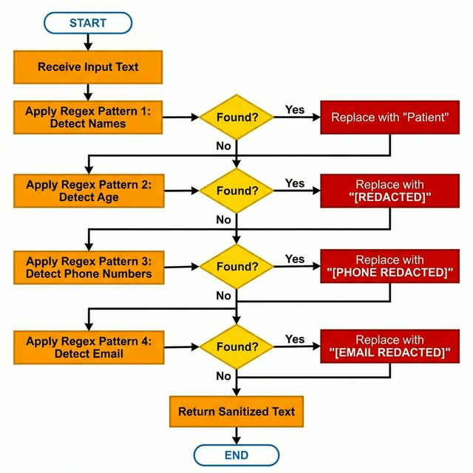
Fig 3.2. PII Scrubbing Flowchart

3.3 Generative Simplification (RAG)
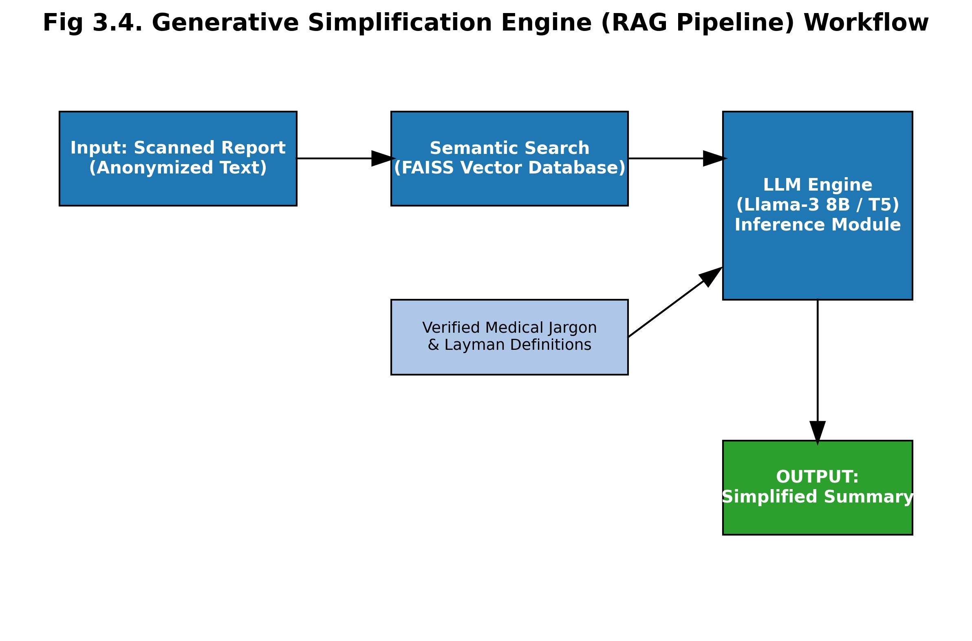
Fig 3.4. RAG Pipeline Workflow

CHAPTER 4: TESTING AND VALIDATION
Testing was performed across unit, integration, and performance layers. Unit tests verified Regex PII redaction and Tesseract accuracy, while integration tests confirmed the stable flow of data through the RAG pipeline.

CHAPTER 5: RESULTS AND ANALYSIS
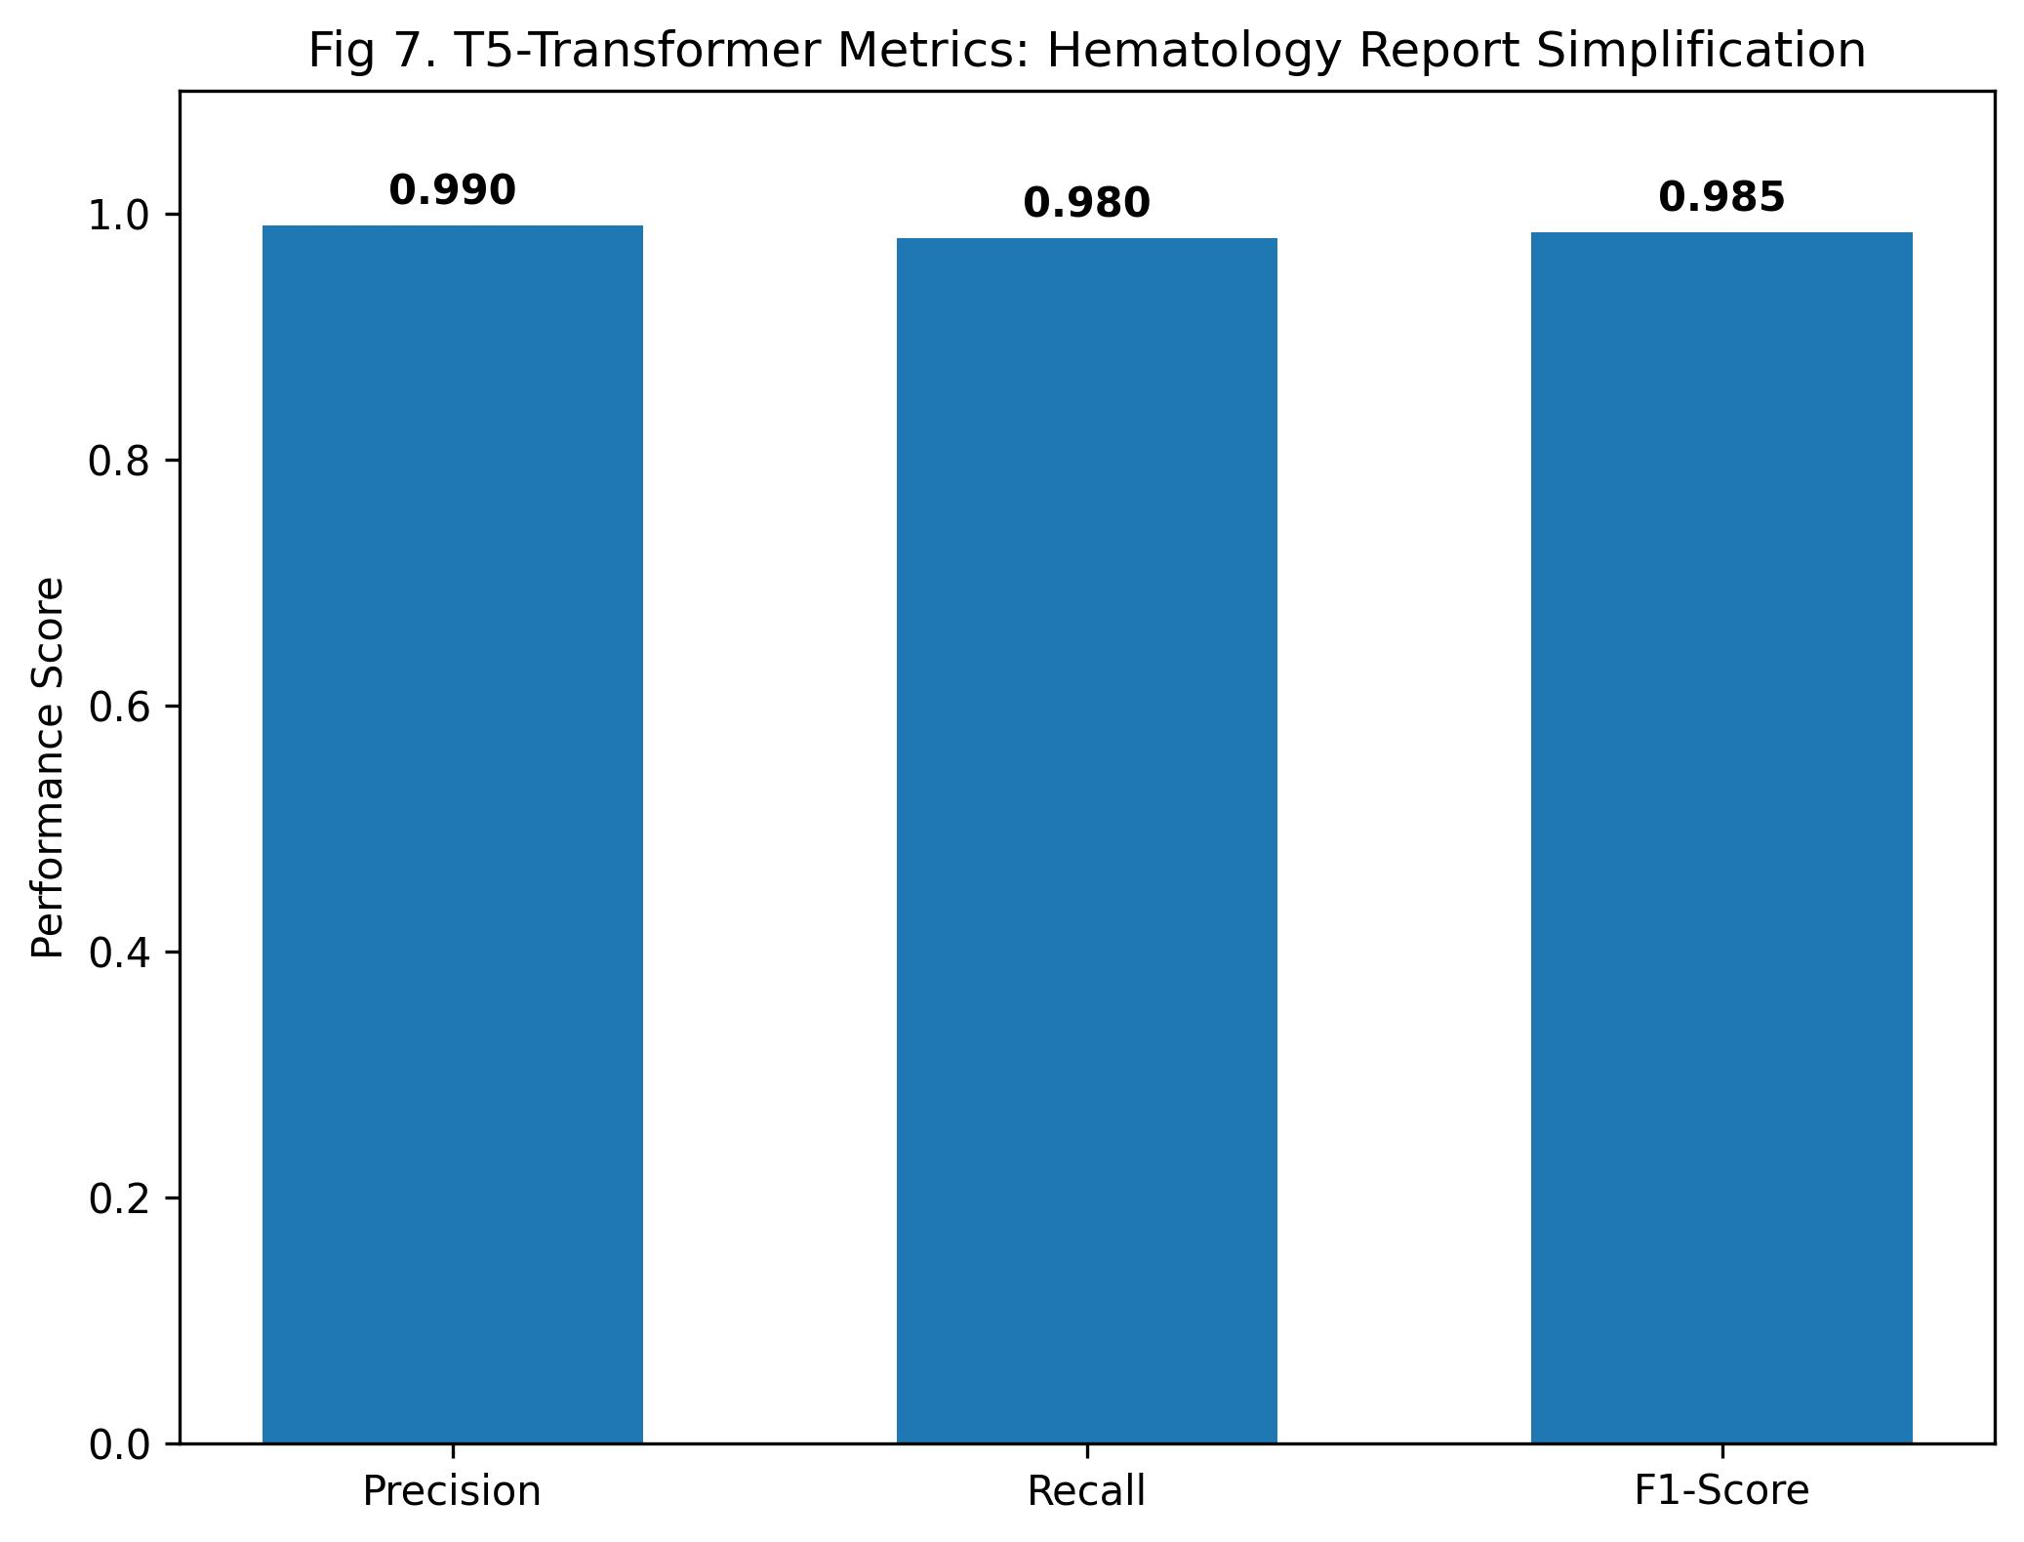
Fig 5.1. Hematology Report Metrics
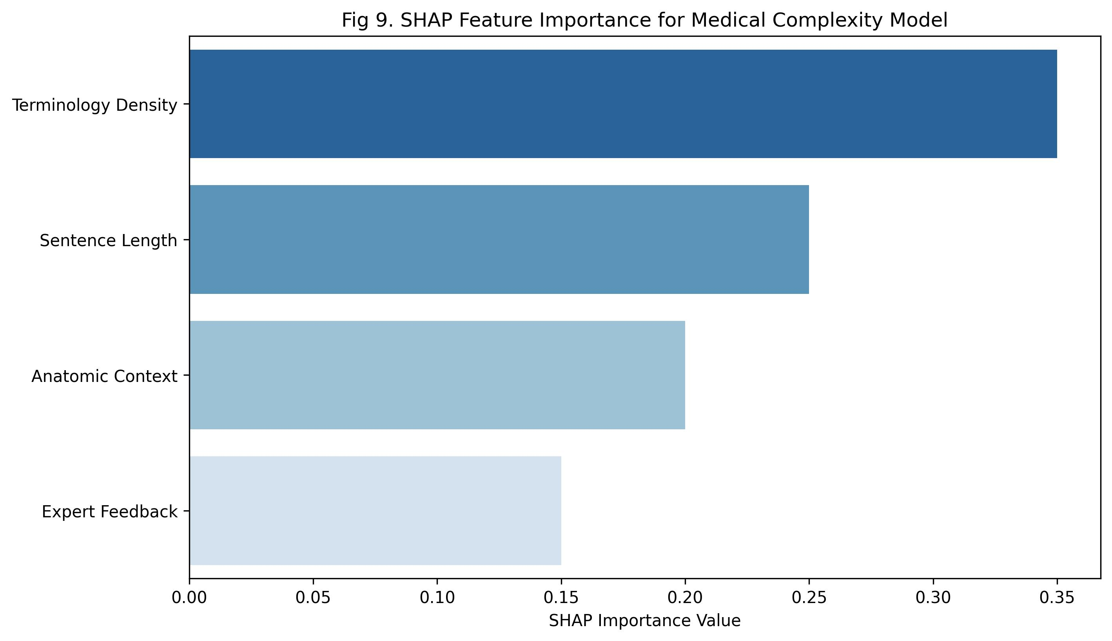
Fig 5.3. SHAP Feature Importance

CONCLUSION
Doc 2 Me represents a significant step forward in patient health literacy by merging privacy-protecting local inference with powerful RAG simplification pipelines.

REFERENCES
- [1] WHO, 'Health literacy: The solid facts', 2013.
- [2] Vaswani et al., 'Attention is all you need', 2017.
- [3] Devlin et al., 'BERT', ACM, 2018.
- [4] Raffel et al., 'Unified T5 Transformer', JMLR, 2020.
- [5] Xie et al., 'Survey for biomedical text summarization', 2023.
- [6] Lewis et al., 'Retrieval-augmented generation', NeurIPS, 2020.
- [7] Kyle Lo et al., 'Making medical papers approachable', ACL, 2020.
- [8] Touvron et al., 'Llama 2', 2023.
- [9] Aramaki et al., 'NLP: From bedside to everywhere', 2020.
- [10] Lertvittayakumjorn et al., 'Survey of biomedical text simplification', 2022.

