Software Architecture Document
Project: Web-Based ML Model Evaluator
Version | 1.0
Authors | Kushal Jayavarapu, [names of the other team members to confirm]
Date | 11-11-2026
Status | Draft for review

Revision History
Version | Date | Author | Change Summary
1.0 | 11-11-2026 | Team SE-Jackfruit | First SAD in the course template; describes the system as built and tested.

Approvals
Role | Name | Signature/Date
Course Coordinator | [to be filled]
Project Guide / Reviewer | [to be filled]

1. Introduction

1.1 Purpose
This document describes the architecture and design of the Web-Based ML Model Evaluator: how the system is divided into parts, why it is built this way, how the parts talk to each other and how it is protected.

1.2 Scope
Covers the whole application: accounts and roles, upload and validation of models and datasets, evaluation, charts, comparison, reports and administration. Deployment to a production environment is covered only as far as security needs it (section 3.9).

1.3 Audience
Developers, testers, security reviewers, course staff and anyone who extends the system later.

1.4 Definitions
ADR: architecture decision record. API: application programming interface. CSRF: cross-site request forgery. RBAC: role-based access control. SQLite: file-based SQL database. STRIDE: Spoofing, Tampering, Repudiation, Information disclosure, Denial of service, Elevation of privilege. TLS: Transport Layer Security. Other terms are in the SRS, section 1.4.

2. Document Overview

2.1 How to use this document
Section 3 is the big picture (components, patterns, security). Section 4 is the detail (sequence diagrams, API, errors, user interface, open issues). Requirement IDs (MLE-F, MLE-NF, MLE-SR) refer to the SRS.

2.2 Related Documents
- Software Requirements Specification (SRS) v1.0
- Software Test Plan (STP) v1.0, with the Test Cases document and the System Validation Report
- Use Case Flow document (UC-01 to UC-13); Requirements Traceability Matrix (SRS section 8)
- Setup and usage guide (docs/USAGE.md) and README

3. Architecture

3.1 Goals & Constraints
Goals: keep each Analyst's data private (MLE-NF-002); give a specific reason for every rejection (MLE-NF-003); return an evaluation within 10 seconds for the stated limits (MLE-NF-001); let a new metric, chart or task type be added in one place (MLE-NF-005); stay simple enough for a student team to build, test and run on one laptop.
Constraints: Python and Flask; SQLite and local files (no database server); models are scikit-learn style objects stored as .pkl or .joblib; 100 MB model and 50,000 row limits; one project semester.

3.2 Stakeholders & Concerns
Stakeholder | Concerns
Analyst | Privacy of own data, clear errors, fast results, results that can be reopened and compared
Admin | Control of accounts and roles; a trace of every change; never being locked out
Course staff / evaluators | Requirements met and traceable; tests; quality of design documents
Developers | Modularity, easy testing, easy extension
Security reviewer | Access control, isolation, CSRF, password storage, handling of uploaded files

3.3 Component (UML) Diagram
The browser talks to a Flask application, which calls a layer of service modules. Services read and write a SQLite database and the file storage folders. The yellow modules (compatibility, metrics, visualization) are the pieces that change when the evaluation pipeline is extended.
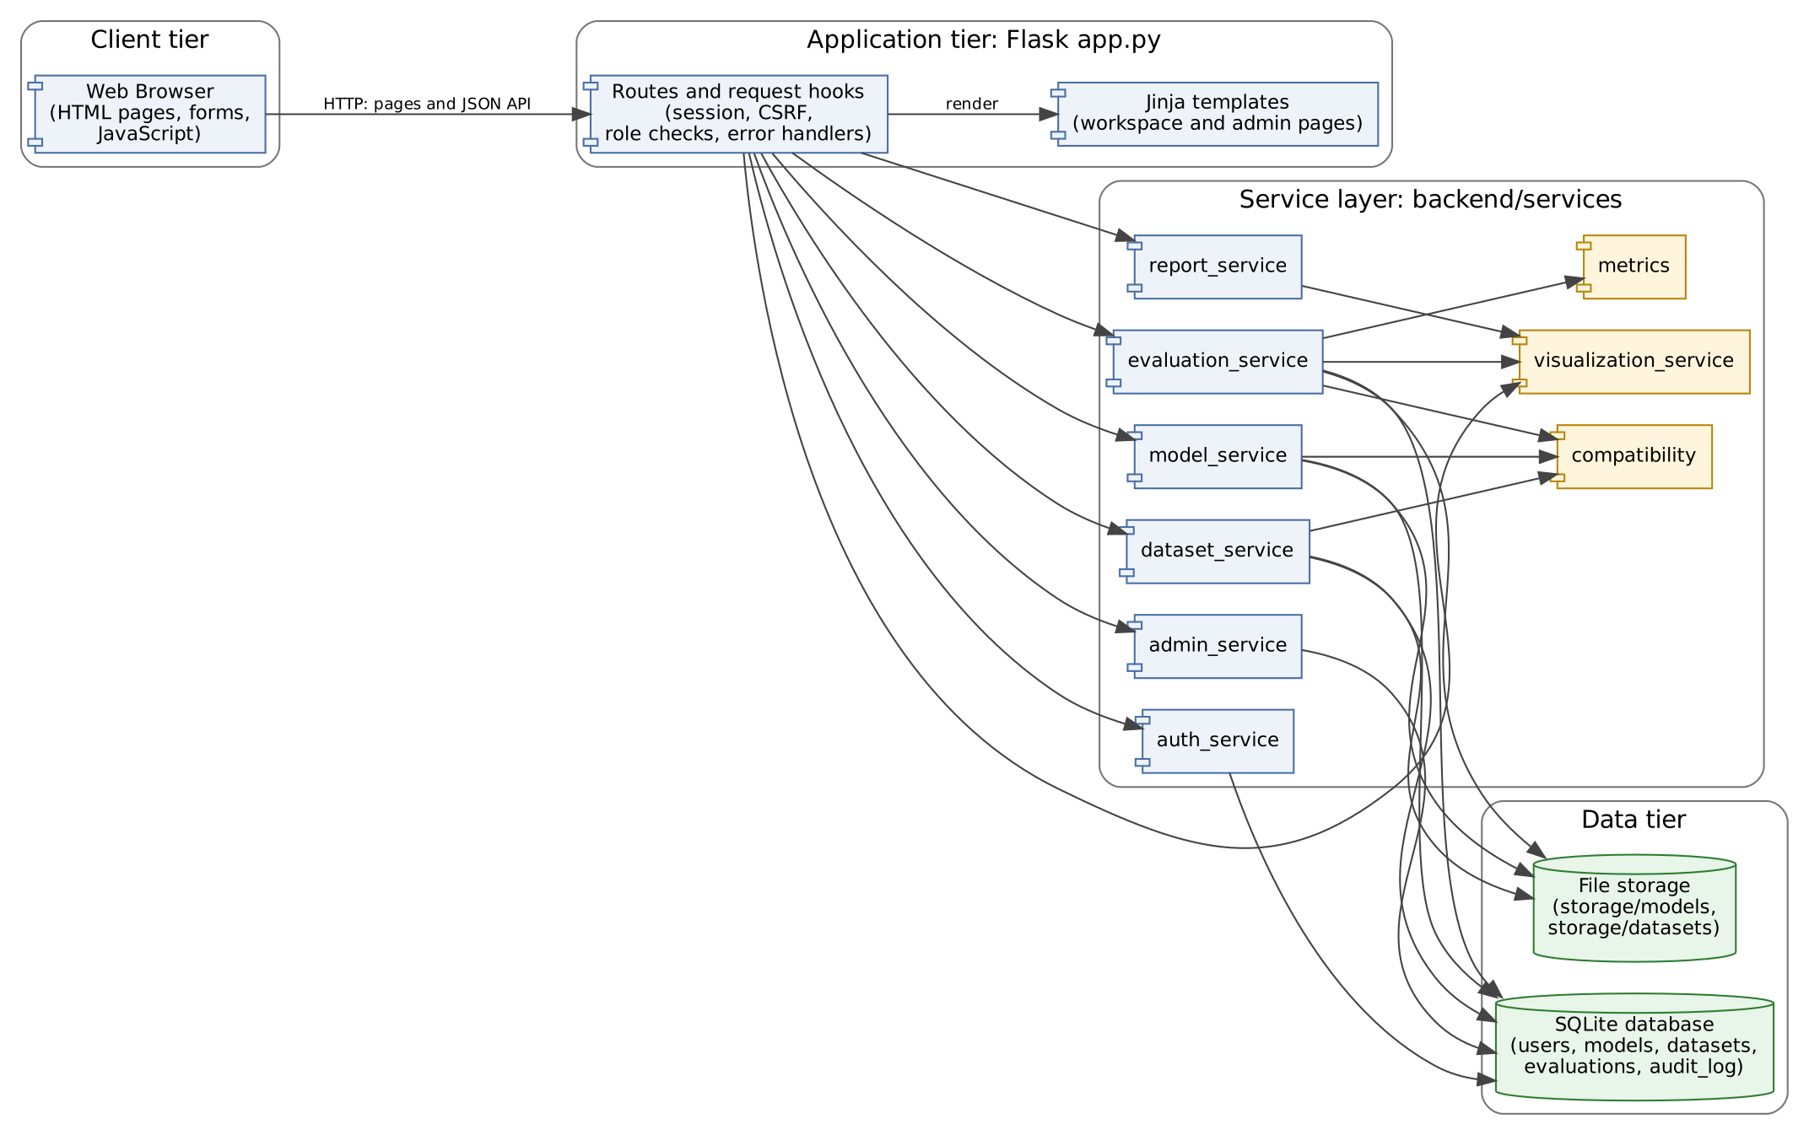
Figure 1. UML component diagram

3.4 Component Descriptions
Component | Responsibility | Main requirements
Web Browser | Shows pages, sends forms and JSON requests, loads chart images. | MLE-NF-004
Routes and request hooks (app.py) | Maps URLs to services; before every request loads the user from the database, checks the session and the CSRF token; enforces login and Admin-only access; turns errors into safe messages. | MLE-F-002, MLE-SR-002 to 004, MLE-NF-003
Templates (Jinja) | Pages for dashboard, models, datasets, evaluate, evaluation, history, compare and the Admin pages. | MLE-NF-004
auth_service | Registration rules, password hashing, authentication, user lookup. | MLE-F-001 to 003, MLE-SR-001
admin_service | Account list, suspend and reactivate, role change, Admin creation, audit log; guards for own account and last Admin. | MLE-F-040 to 043
model_service | Model upload (type and size), validation (loadable, required inputs), compatibility with datasets, delete. | MLE-F-011, MLE-F-012
dataset_service | Dataset upload (type, rows, target column), validation (schema summary, missing target values), compatibility with models, delete. | MLE-F-010, MLE-F-012
compatibility | Compares the features a model expects with the dataset columns. | MLE-F-012
evaluation_service | Runs the evaluation: checks, prediction, metrics, chart data, saving; lists, reopens and compares saved evaluations. | MLE-F-020 to 023, 030 to 033
metrics | Classification and regression metric calculation. | MLE-F-021, MLE-F-022, MLE-NF-005
visualization_service | Builds chart data at evaluation time and draws the PNG charts on request. | MLE-F-031, MLE-NF-005
report_service | Builds the PDF report from saved evaluations. | MLE-F-034
db and file storage | SQLite tables users, models, datasets, evaluations, audit_log; uploaded files under storage/models and storage/datasets with generated names. | MLE-F-032, MLE-SR-008

3.5 Chosen Architecture Pattern and Rationale
A layered monolith: pages and routes on top, services in the middle, storage at the bottom. Routes contain no business rules; services contain no web code, so they can be tested directly (the 219 automated tests do both). Microservices and a single-page front end were rejected because they add deployment and security work that a one-server, small-user system does not need. The decisions are recorded below.
ADR | Decision | Alternatives considered | Reason
ADR-1 | Layered monolith (Flask routes, service modules) | Microservices | One team, one server; far less to deploy and secure.
ADR-2 | Server-rendered Jinja pages with a small JSON API | Single-page app (React) | Fewer moving parts; works with plain forms; the API is still usable from scripts and tests.
ADR-3 | SQLite plus files on disk | PostgreSQL / MySQL | No server to install; enough for the load in MLE-NF-001; one file to back up. Limits parallel writes.
ADR-4 | Server-side session cookie (signed), user re-read from the database on every request | Token (JWT) stored in the browser | Suspension and role changes take effect on the next request (MLE-F-040, 041).
ADR-5 | Store chart data with the evaluation and draw PNGs on demand | Store PNG files; recompute on view | Reopened results are exactly the stored values; no model needed again; small records.
ADR-6 | Check compatibility twice: at validation and again before evaluating | Once at upload | A model or dataset may change or be deleted in between; the final check is cheap.
ADR-7 | Other users' records return 404, not 403 | 403 Forbidden | Does not reveal that a record exists.
ADR-8 | PDF reports built from saved data with reportlab | Re-run the evaluation; HTML print | Report matches what the Analyst saw; no model needed.

3.6 Technology Stack & Data Stores
Area | Technology
Language / framework | Python 3.10+ (tested on 3.13), Flask, Jinja templates, plain JavaScript
Machine learning | scikit-learn models loaded with joblib; pandas for datasets; numpy
Charts and reports | matplotlib (PNG charts), reportlab (PDF)
Data stores | SQLite file (storage/evaluator.db): users, models, datasets, evaluations, audit_log. Uploaded files in storage/models and storage/datasets.
Passwords and sessions | werkzeug password hashing; Flask signed session cookie (HttpOnly, SameSite=Lax, 8 hours); CSRF token
Testing | pytest (219 tests), pytest-cov with branch coverage; JUnit XML evidence

Data model: users(id, name, email unique, password_hash, role analyst|admin, status active|suspended, created_at, last_login_at); models and datasets (id, owner_id, file names, size or row count, validation status and message, required inputs or schema summary, target variable for datasets); evaluations (id, owner_id, model and dataset ids and file names, task type, row count, metrics, notes, chart data, duration, time); audit_log (actor, target, action, old and new value, time). Evaluations keep copies of the file names, so history and reports still work after a model or dataset is deleted.

3.7 Risks & Mitigations
Risk | Mitigation
A model file (pickle) can run code when loaded | Only registered, signed-in Analysts can upload; Admins can suspend a misused account. Not solved: see 4.6. A production system should load models in a sandbox.
Large model or dataset slows the server | Limits of 100 MB and 50,000 rows; request size limit; timing tested (MLE-NF-001).
SQLite does not suit many parallel users | Short-lived connections; acceptable for the target group; move to a server database if needed (ADR-3).
Loss of the only Admin | Last active Admin cannot be suspended or demoted; first Admin can be recreated from the command line.
Plain HTTP exposes passwords on a network | Deploy behind HTTPS (MLE-SR-009); not tested in the project.
Secret key leaks, so sessions can be forged | Key comes from the environment or a random key file in storage, kept out of the repository.

3.8 Traceability to Requirements
Requirement(s) | Component(s)
MLE-F-001 to 003 (accounts) | auth_service, admin_service, app.py hooks
MLE-F-010 to 012 (uploads, compatibility) | dataset_service, model_service, compatibility
MLE-F-020 to 023 (evaluation) | evaluation_service, metrics, visualization_service
MLE-F-030 to 034 (results) | evaluation_service, visualization_service, report_service, templates
MLE-F-040 to 043 (administration) | admin_service, db (audit_log)
MLE-NF-001 / 002 / 003 / 004 / 005 | evaluation_service / owner scoping in every service / errors and app.py handlers / templates / metrics and visualization_service
MLE-SR-001 to 009 | auth_service, app.py hooks, services, deployment (TLS)

3.9 Security Architecture
Controls: login required on every route except login, registration and static files; role check for Admin routes; CSRF token on every data-changing request; password hashes; per-owner queries (every lookup includes owner_id); safe redirect after login; generated file names; size and type checks; HttpOnly, SameSite cookies; safe error messages.
Threat modelling (STRIDE):
Threat | Example in this system | Control | Req.
Spoofing | Guessing or stealing a login; forging a session cookie | Password hashing; same message for wrong email or password; signed HttpOnly cookie; suspension ends sessions | SR-001, SR-007
Tampering | Forged request from another site changes data; Analyst edits a role | CSRF token; Admin-only routes; role read from the database each request | SR-003, SR-004
Repudiation | An Admin denies suspending an account | Audit log with actor, target, old and new value, time | F-042
Information disclosure | Reading another Analyst's files or results by guessing an ID; leaking details in errors; traffic read on the network | Owner-scoped queries, 404 for others' records; generic message for unexpected errors; HTTPS at deployment | SR-005, SR-009, NF-002
Denial of service | Huge uploads or very large datasets | Request size limit, 100 MB and 50,000 row limits. No rate limiting yet. | SR-008
Elevation of privilege | Registering as Admin; Analyst calling Admin API; malicious pickle model running code | Registration creates Analysts only; Admin check on every Admin route; pickle risk is open (4.6) | F-003, SR-003

4. Design

4.1 Design Overview
Every operation follows the same path: the route checks the session and the CSRF token, calls one service function with the signed-in user's ID, and the service reads or writes the database, always filtered by owner. Services raise three kinds of error (validation, not found, forbidden) with messages written for the user; the route turns them into the right status code. Nothing is stored unless the whole operation succeeded.

4.2 UML Sequence Diagrams
Three flows are shown: evaluating a model (the core feature), logging in (security) and changing a role (administration).
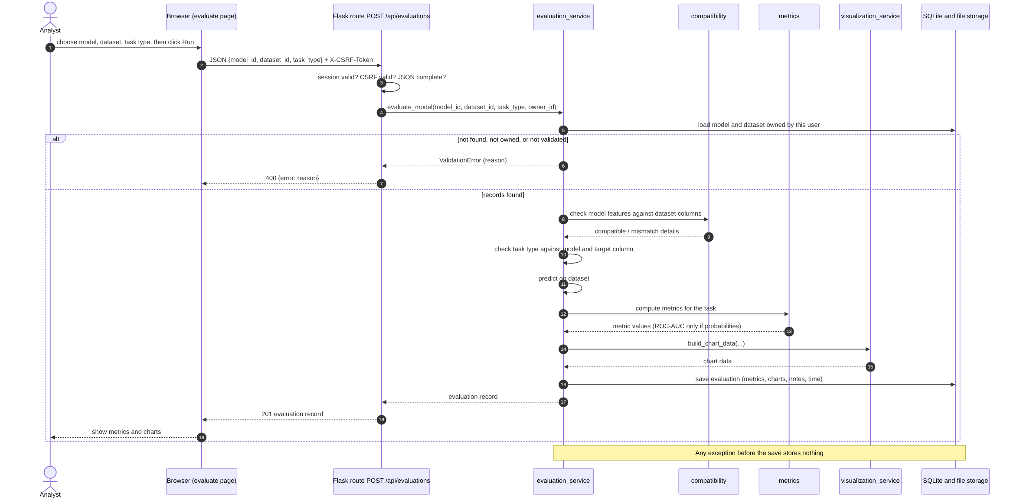
Figure 2. Sequence diagram: evaluate a model (UC-05, UC-06)

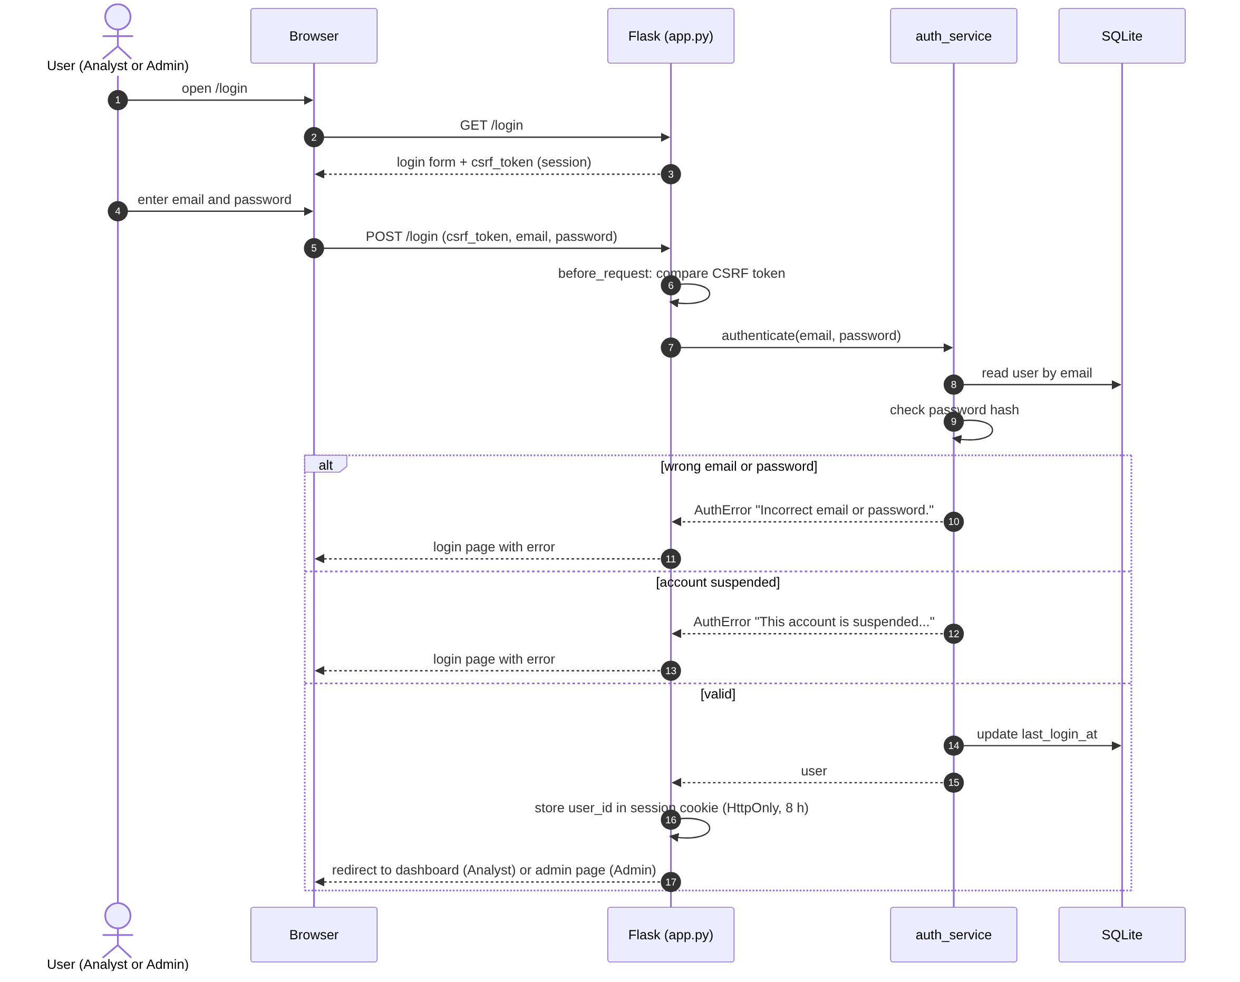
Figure 3. Sequence diagram: log in (UC-02)

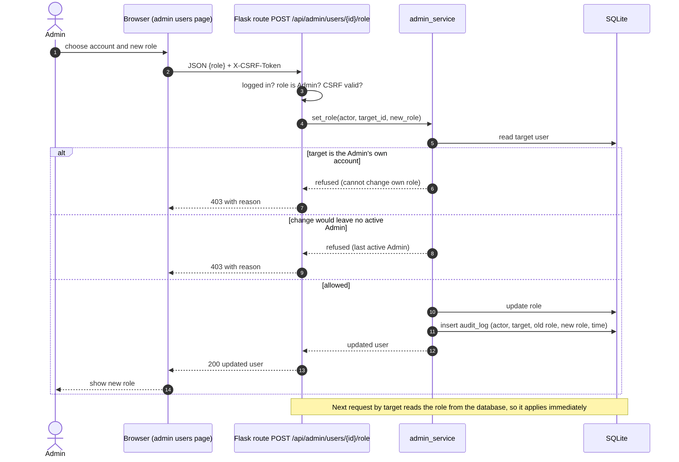
Figure 4. Sequence diagram: Admin changes a role (UC-13)

4.3 API Design
All API calls need a signed-in user (401 JSON otherwise). Calls that change data also need the X-CSRF-Token header. Errors always have the form {"error": "message"}. Records of other accounts return 404. Interfaces are defined below for four components.

Component 1: Evaluation (evaluation_service)
Endpoint | Method | Request | Response | Errors
/api/evaluations | POST | JSON {model_id, dataset_id, task_type} | 201 evaluation record: id, model and dataset names, task_type, row_count, metrics, notes, charts (list), duration_seconds, evaluated_at | 400 not JSON, missing field, model or dataset not found or not validated, incompatible features, task type mismatch, prediction failure
/api/evaluations | GET | none | 200 list of the user's evaluations, newest first | 401
/api/evaluations/{id} | GET | none | 200 evaluation record | 404 not available
/api/evaluations/{id}/charts/{kind}.png | GET | kind: confusion_matrix, roc_curve, residuals, predicted_vs_actual | 200 PNG image | 404 unknown evaluation or chart not available
/api/compare?ids=a,b | GET | two or more evaluation IDs | 200 {task_type, metric_keys, evaluations} | 400 fewer than two, different task types; 404 an ID is not available
/api/reports?ids=a,b | GET | one or more evaluation IDs | 200 PDF download | 400 none selected; 404 an evaluation no longer exists

Component 2: Models and datasets (model_service, dataset_service)
Endpoint | Method | Request | Response | Errors
/api/models/upload | POST | multipart: model_file (.pkl or .joblib, up to 100 MB) | 201 model record (validation_status not_validated) | 400 no file, wrong type, empty, over 100 MB; 413 request too large
/api/models/{id}/validate | POST | none | 200 model record: validation status and message, required inputs, compatibility with the user's datasets | 404 no such model
/api/models | GET | none | 200 list of the user's models | 401
/api/models/{id} | DELETE | none | 200 {deleted: id} | 404
/api/datasets/upload | POST | multipart: dataset_file (.csv, up to 50,000 rows), target_variable | 201 dataset record | 400 no file, wrong type, no target, target not a column, unreadable, too many rows
/api/datasets/{id}/validate | POST | none | 200 dataset record: validation status, schema summary, compatibility with the user's models | 404 no such dataset
/api/datasets, /api/datasets/{id} | GET, DELETE | none | 200 list, or {deleted: id} | 404

Component 3: Accounts and sessions (auth_service)
Endpoint | Method | Request | Response | Errors
/register | POST (form) | name, email, password, confirm_password, csrf_token | Redirect to dashboard; session started; Analyst role | 400 page with message: blank, invalid email, short password, mismatch, duplicate
/login | POST (form) | email, password, csrf_token, optional next | Redirect to next (same site only) or the role's home page | 400 incorrect email or password; suspended account message
/logout | POST | csrf_token | Redirect to login; session cleared | 400 expired session
/api/me | GET | none | 200 current user (no password hash) | 401

Component 4: Administration (admin_service)
Endpoint | Method | Request | Response | Errors
/api/admin/users | GET | none | 200 all accounts with role and status | 403 not an Admin
/api/admin/users | POST | JSON {name, email, password, role} | 201 new account | 400 invalid fields or duplicate; 403
/api/admin/users/{id}/status | POST | JSON {status: active|suspended} | 200 updated account | 400 invalid or already that status; 403 own account or last active Admin
/api/admin/users/{id}/role | POST | JSON {role: analyst|admin} | 200 updated account | 400 invalid or already that role; 403 own role or last active Admin
/api/admin/audit | GET | none | 200 audit entries, newest first (up to 500) | 403

4.4 Error Handling, Logging & Monitoring
- Validation errors carry a message written for the user (for example the 100 MB limit, the missing feature names, or the task and model that do not match). The API returns it as {"error": ...}; pages show it next to the action.
- Status codes: 400 bad input, 401 not signed in, 403 signed in but not allowed, 404 not found or not yours, 413 request too large.
- Unexpected errors return one safe message ("Something went wrong...") with status 500; the full details are written to the server log. Messages never include stack traces, file paths or other users' data.
- An evaluation that fails stores nothing (MLE-F-023). A rejected upload leaves no stored file or record.
- Logging: Flask's server log for unexpected errors; the audit log (database) for account changes. Monitoring beyond this (uptime, failure rate) is not built; the evaluation duration is stored with each evaluation.

4.5 UX Design
- One navigation bar; the page order follows the work: Models, Datasets, Evaluate, History, Compare.
- Upload forms state the accepted file types and the limits before the file is chosen; the dataset target is chosen from a list of the file's columns.
- After upload, the validation result and the compatibility with the user's other files are shown on the same page, so a mismatch is seen before the evaluation is started.
- Results page: metrics first, then charts; a note appears when ROC-AUC could not be calculated.
- Plain labels and messages, readable font sizes. Not done: screen-reader testing, high-contrast mode, language selection.

4.6 Open Issues & Next Steps
- Pickle safety: models are loaded with joblib, which can run arbitrary code. A real deployment should sandbox model loading or accept only a safe format such as ONNX.
- TLS must be added at deployment; the project was only run on plain HTTP.
- No password reset, email verification, rate limiting or account lockout after repeated failed logins.
- Usability checked with one tester; accessibility not tested.
- Possible additions: more metrics (for example log loss), more task types, a larger database, background jobs for long evaluations.

5. Appendices

5.1 Glossary
ADR, API, CSRF, RBAC, ROC-AUC, SQLite, STRIDE, TLS (see 1.4 and SRS section 1.4).

5.2 References
IEEE 42010 (architecture description); OWASP Top 10 and the OWASP CSRF guidance; Flask, scikit-learn, pandas, matplotlib and reportlab documentation; the course SAD template.

5.3 Tools
Graphviz (use-case and component diagrams), Mermaid (sequence diagrams), pytest and coverage.py, Git and GitHub.

