Software Requirements Specification
Project: Web-Based ML Model Evaluator
Version | 1.0
Authors | Kushal Jayavarapu, [names of the other team members to confirm]
Date | 11-11-2026
Status | Draft for review

Revision history
Version | Date | Author | Change summary | Approval
1.0 | 11-11-2026 | Team SE-Jackfruit | First SRS in the course template. Replaces the earlier requirements document (FR-01 to FR-08, NFR-01 to NFR-05); old IDs are kept in the Comments and in the RTM. | [pending]

Approvals
Role | Name | Signature / Email | Date
Course Coordinator | [to be filled]

Table of Contents
1. Introduction
2. Overall description
3. External interface requirements
4. System features (detailed)
5. Non-functional requirements (detailed), including 5.1 Security
6. Quality attributes and acceptance tests
7. System models and diagrams (UML use-case diagrams)
8. Requirements Traceability Matrix (RTM)

1. Introduction

1.1 Purpose
This document is the Software Requirements Specification (SRS) for the Web-Based ML Model Evaluator. It states what the system must do, how well it must do it and how each requirement is checked. It is written for the team, the course staff who assess the project and anyone who later extends the system.

1.2 Scope
The system is a web application in which an Analyst uploads a trained machine-learning model and a test dataset, chooses the task type (classification or regression), and gets metrics and charts. Every evaluation is saved, so it can be reopened, compared with others and exported as a PDF report. An Admin manages accounts and roles, and every such change is written to an audit log.
Out of scope: training models, editing datasets, model types other than those scikit-learn can load from a .pkl or .joblib file, multi-server deployment, password reset by email, and any integration with outside services.

1.3 Audience
Developers, testers, the course instructor and assessment evaluators.

1.4 Definitions
Term | Meaning
Analyst | A registered user who uploads files, runs evaluations and reads results.
Admin | A user who manages accounts and roles. Cannot be created by registration.
Evaluation | One run of one model on one dataset for one task type, with its metrics and chart data, saved under the Analyst's account.
Target column | The dataset column holding the correct answers the model is compared against.
Task type | Classification (predict a category) or regression (predict a number).
ROC-AUC | Area under the ROC curve; needs the model to give class probabilities or scores.
CSRF | Cross-site request forgery: a forged request sent from another website using a user's session.
API | Application programming interface. Here: the JSON endpoints under /api used by the pages.
RTM | Requirements Traceability Matrix (section 8).
TLS | Transport Layer Security, the encryption used by HTTPS.
UI | User interface.
SRS | Software Requirements Specification (this document).

2. Overall description

2.1 Product perspective
The product is a self-contained web application. A Flask server renders the pages and offers a JSON API; a SQLite file holds accounts, uploads, evaluations and the audit log; uploaded model and dataset files are kept on the server's disk. Users reach it with an ordinary web browser. It does not depend on any outside service. The architecture is described in the Software Architecture Document (SAD).

2.2 Major product functions
- Register, log in and log out; role-based access for Analysts and Admins
- Upload a dataset (with its target column) and one or more models; validate each file and check each model against the dataset
- Choose the task type and check it against the model and dataset
- Run the model and calculate the metrics for the task
- Show confusion matrix, ROC curve, residual and predicted-versus-actual plots
- Save evaluations, list them and reopen them with the same values
- Compare two or more evaluations of the same task type
- Export a PDF report for one or several evaluations
- Admin: list accounts, suspend and reactivate, change roles, view the audit log

2.3 User roles and characteristics
- Analyst: knows machine learning and has trained model files; wants to upload, evaluate and compare quickly, and wants clear reasons when something is rejected.
- Admin: looks after the accounts of the team or class; does not need access to Analysts' data; must be held accountable for every account change.

2.4 Operating environment
Server: Python 3.10 or newer (developed and tested on 3.13) on Windows, macOS or Linux, about 600 MB of disk for the Python packages, no database server. Client: a current Chrome, Edge, Firefox or Safari. Libraries: Flask, pandas, scikit-learn, joblib, matplotlib, reportlab.

2.5 Constraints, assumptions and known limits
- Evaluation limits: datasets up to 50,000 rows, model files up to 100 MB.
- Only .csv datasets and .pkl or .joblib models are accepted.
- SQLite and local file storage: suitable for one server and a small group of users, not for heavy parallel use.
- Model files are Python pickle files, and loading a pickle can run code. The system therefore assumes that registered Analysts are trusted. This is a known limit (see SAD section 4.6).
- The built-in Flask server speaks plain HTTP. TLS has to be provided at deployment (MLE-SR-009).
- There is no password reset or email verification.

3. External interface requirements

3.1 User interfaces
A multi-page browser interface with one navigation bar: Dashboard, Models, Datasets, Evaluate, History and Compare for Analysts; Users and Audit log for Admins. Upload forms list the accepted file types and limits. Every rejected action shows its reason in words next to the action. Pages are in English and use plain text labels. The usability target is MLE-NF-004.

3.2 Hardware interfaces
None. The system runs on a standard computer; it uses no special devices.

3.3 Software interfaces
- Browser to server: HTML pages and a JSON API over HTTP (endpoints in the SAD, section 4.3).
- SQLite (through Python's sqlite3) for all stored records.
- scikit-learn and joblib to load models and predict; pandas to read datasets; matplotlib to draw charts; reportlab to build PDF reports.

3.4 Communications
HTTP between browser and server. When deployed for real use, a reverse proxy shall provide HTTPS with TLS 1.2 or later (MLE-SR-009). Session cookies are HttpOnly and SameSite=Lax; every data-changing request carries a CSRF token (MLE-SR-004).

4. System features (detailed)
Each requirement has acceptance criteria and test cases. IDs follow MLE-F-###. Test case IDs refer to the Software Test Plan and the Test Cases document (for example 01_UT_01 is the first unit test of UC-01). The Comments column also gives the ID used in the earlier requirements document.

4.1 Account access
Description: Registration, login and the rules for who may hold which role.
Req ID | Requirement (shall...) | Type | Priority | Source / Stakeholder | Acceptance criteria / Test case ref | Comments / Dependencies
MLE-F-001 | The system shall let a visitor register as an Analyst with a name, a valid email, a password of at least 8 characters and a matching confirmation, and shall reject blank fields, invalid emails, short passwords and an email that is already registered (ignoring letter case). | Functional | High | Analyst | AC-MLE-F-001: Valid details create an Analyst account and sign the user in. Blank fields, a bad email, a short password, a mismatched confirmation and a duplicate email (any letter case) are each rejected with a message.  Test: 01_UT_01, 01_UT_02, 01_UT_03, 01_UT_04, 01_ST_01 | Registration signs the new Analyst in and opens the dashboard.  Earlier ID: FR-01 / UC-01. Module: auth_service.
MLE-F-002 | The system shall authenticate users by email and password, open the dashboard that matches their role, require a signed-in user for every page and API call except login and registration, and end the session on logout. | Functional | High | Analyst, Admin | AC-MLE-F-002: A valid login opens the Analyst or Admin dashboard. Wrong credentials give one message for both causes. Pages redirect anonymous visitors to login; the API returns 401. Logout ends the session.  Test: 02_UT_01, 02_UT_02, 02_IT_01, 02_IT_02, 02_ST_01 | Wrong password and unknown email give the same message, so the form does not reveal which emails exist.  Earlier ID: FR-01 / UC-02. Module: auth_service, app.py hooks.
MLE-F-003 | The system shall never create an Admin through public registration. An Admin account shall be created only by an existing Admin, and the first Admin only from the command line. | Functional | High | Security, Course | AC-MLE-F-003: A registration request that includes role=admin still creates an Analyst. Only an Admin can create an Admin; the first Admin is created with the command line.  Test: 13_ST_01, SEC_02 | Prevents an Analyst from raising their own access level.  Earlier ID: FR-01 / UC-01, UC-13. Module: auth_service, admin_service.

4.2 Upload and validation
Description: Checking each uploaded file, and each model against the dataset.
Req ID | Requirement (shall...) | Type | Priority | Source / Stakeholder | Acceptance criteria / Test case ref | Comments / Dependencies
MLE-F-010 | The system shall accept a CSV dataset of up to 50,000 rows, require the Analyst to name the target column when uploading, and reject non-CSV, corrupt, empty or oversized files and a missing or unknown target column, each with a reason. | Functional | High | Analyst | AC-MLE-F-010: A CSV with a valid target is accepted and gets a schema summary. 50,000 rows pass and 50,001 are rejected. Other file types, corrupt files, a missing target and a target with missing values are rejected or marked invalid with a reason.  Test: 03_UT_01, 03_UT_02, 03_UT_03, 03_UT_04, 03_IT_01, 03_IT_02 | Each file is checked on its own, at upload.  Earlier ID: FR-02 / UC-03. Module: dataset_service.
MLE-F-011 | The system shall accept trained model files (.pkl, .joblib) of up to 100 MB, and shall reject other file types, empty files, files over the limit and files that cannot be loaded as a model, each with a reason. | Functional | High | Analyst | AC-MLE-F-011: .pkl and .joblib files up to 100 MB are accepted. Other types, empty files, files over 100 MB and unloadable files are rejected or marked invalid with a reason.  Test: 04_UT_01, 04_UT_02, 04_UT_03, 04_IT_01 | An Analyst can upload several models against the same dataset.  Earlier ID: FR-02 / UC-04. Module: model_service.
MLE-F-012 | The system shall compare the input features a model expects with the columns of the dataset, show the result for each model and dataset pair, and shall not allow an evaluation of a model that is not compatible. | Functional | High | Analyst | AC-MLE-F-012: A model that has all the dataset's feature columns passes; a model with missing features fails with the names. The validation page shows the result for each existing dataset or model. A model without a valid pairing cannot be evaluated.  Test: 04_IT_02, 04_IT_03, 06_IT_02 | Needs both a validated model and a validated dataset.  Earlier ID: FR-02 / UC-04, UC-06. Module: compatibility, model_service, dataset_service.

4.3 Evaluation
Description: Choosing the task, running the model and calculating metrics.
Req ID | Requirement (shall...) | Type | Priority | Source / Stakeholder | Acceptance criteria / Test case ref | Comments / Dependencies
MLE-F-020 | The system shall let the Analyst choose classification or regression and shall refuse to evaluate when the chosen task does not match the model type or the dataset target, giving the reason. | Functional | High | Analyst | AC-MLE-F-020: Classification and regression are accepted and any other value is rejected. A task that does not match the model type or the target column is refused with a reason and nothing is stored.  Test: 05_UT_01, 05_IT_01, 05_ST_01 | A wrong metric set gives numbers that look valid but mean nothing, so the check is explicit.  Earlier ID: FR-03 / UC-05. Module: evaluation_service.
MLE-F-021 | The system shall run the model on the dataset for a classification task and calculate accuracy, precision, recall, F1-score (weighted for multiclass) and ROC-AUC. ROC-AUC shall be skipped, with a note, when the model gives no probabilities. | Functional | High | Analyst | AC-MLE-F-021: Accuracy, precision, recall, F1 and ROC-AUC equal the hand-calculated values on a fixed dataset. Without probabilities ROC-AUC is omitted with a note. Multiclass models are supported.  Test: 06_UT_01, 06_UT_03, 06_ST_01 | Values are checked against hand calculations.  Earlier ID: FR-04 / UC-06. Module: evaluation_service, metrics.
MLE-F-022 | The system shall run the model on the dataset for a regression task and calculate MAE, MSE, RMSE and R2, and shall not show classification metrics for a regression result. | Functional | High | Analyst | AC-MLE-F-022: MAE, MSE, RMSE and R2 equal the hand-calculated values on a fixed dataset. No classification metric appears.  Test: 06_UT_02, 06_ST_02, 07_UT_01 | Several models can be evaluated on one dataset.  Earlier ID: FR-04 / UC-06. Module: evaluation_service, metrics.
MLE-F-023 | The system shall stop an evaluation that fails during prediction, metric calculation or chart preparation, store no partial result and tell the Analyst why. | Functional | High | Analyst | AC-MLE-F-023: A model that crashes while predicting, or a model or dataset that is not validated, gives a specific message and no evaluation record exists afterwards.  Test: 06_IT_02, 06_ST_03 | Also covers a model or dataset that has not passed validation.  Earlier ID: FR-04 / UC-06 (alt.). Module: evaluation_service.

4.4 Results
Description: Viewing, saving, comparing and exporting evaluations.
Req ID | Requirement (shall...) | Type | Priority | Source / Stakeholder | Acceptance criteria / Test case ref | Comments / Dependencies
MLE-F-030 | The system shall show the stored metric values of a completed evaluation, and a clear message when the evaluation does not exist. | Functional | High | Analyst | AC-MLE-F-030: The evaluation page shows exactly the metrics defined for its task, with the stored values. A missing evaluation shows a message, not an error page.  Test: 07_UT_01, 07_UT_02, 07_IT_01 | Earlier ID: FR-04 / UC-07. Module: app.py, evaluation_service.
MLE-F-031 | The system shall draw a confusion matrix, and an ROC curve when probabilities exist, for classification, and a residual plot and a predicted-versus-actual plot for regression, from the stored results. It shall not draw a chart of the wrong task type. | Functional | Medium | Analyst | AC-MLE-F-031: Classification shows a confusion matrix and, if probabilities exist, an ROC curve. Regression shows residual and predicted-versus-actual plots. A chart of the wrong type or an unknown chart name returns 404. Chart data agrees with the results.  Test: 08_UT_01, 08_UT_02, 08_IT_01, 08_ST_01, 08_ST_02 | No ROC curve is shown when ROC-AUC could not be calculated.  Earlier ID: FR-05 / UC-08. Module: visualization_service.
MLE-F-032 | The system shall save every completed evaluation under the Analyst's account, list them newest first, and reopen each one with exactly the stored values. | Functional | Medium | Analyst | AC-MLE-F-032: A completed evaluation is listed in history, newest first, and reopens with identical values. A new user sees an empty history message.  Test: 06_IT_01, 07_IT_01, 10_UT_01, 10_UT_02 | History still works after the model or dataset file is deleted.  Earlier ID: FR-07 / UC-10. Module: evaluation_service, db.
MLE-F-033 | The system shall show the metrics of two or more completed evaluations of the same task type side by side, warn and refuse when the task types differ, and never pick a winner. | Functional | High | Analyst | AC-MLE-F-033: Selecting fewer than two evaluations is refused. Different task types are refused with a warning. Same-task evaluations are shown side by side with no winner marked.  Test: 09_UT_01, 09_IT_01, 09_IT_02, 09_ST_01 | Earlier ID: FR-06 / UC-09. Module: evaluation_service, visualization_service.
MLE-F-034 | The system shall generate a PDF report for one saved evaluation or for several, built from the saved results, and shall refuse with a message when an evaluation no longer exists or none is selected. | Functional | Medium | Analyst | AC-MLE-F-034: A PDF is produced for one or for several selected evaluations, from saved data. No selection or a removed evaluation gives a message and no report.  Test: 11_UT_01, 11_UT_02, 11_UT_03, 11_IT_01, 11_ST_01 | The report includes model, dataset, metrics and charts.  Earlier ID: FR-07 / UC-11. Module: report_service.

4.5 Administration
Description: Account status, roles and the audit log.
Req ID | Requirement (shall...) | Type | Priority | Source / Stakeholder | Acceptance criteria / Test case ref | Comments / Dependencies
MLE-F-040 | The system shall let an Admin see all accounts with their role and status and suspend or reactivate an account. A suspended account shall not be able to log in, and an open session shall end at once. | Functional | High | Admin | AC-MLE-F-040: The Admin sees every account with role and status. A suspended account cannot log in until reactivated, and its open session ends at once.  Test: 12_UT_01, 12_UT_02, 12_ST_01, 02_IT_03, 02_IT_04 | Earlier ID: FR-08 / UC-12. Module: admin_service, auth_service.
MLE-F-041 | The system shall let an Admin change an account's role between Analyst and Admin, and the change shall apply from the account's next request. | Functional | High | Admin | AC-MLE-F-041: An Admin can promote an Analyst and demote an Admin; the new role applies on the account's next request.  Test: 13_UT_01, 13_ST_01 | The role is read from the database on every request.  Earlier ID: FR-08 / UC-13. Module: admin_service.
MLE-F-042 | The system shall record every successful status change and role change with who made it, which account it affected, the old and new value and the time, and shall show the log to Admins. Refused changes shall not be logged as changes. | Functional | High | Admin, Course | AC-MLE-F-042: Each successful change adds one log entry with the Admin, the affected account, the old and new value and the time. Refused changes add no entry.  Test: 13_IT_03 | Earlier ID: FR-08 / UC-12, UC-13. Module: admin_service, db.
MLE-F-043 | The system shall refuse to let an Admin suspend or change the role of their own account, and shall refuse to suspend or demote the last active Admin. | Functional | High | Admin | AC-MLE-F-043: An Admin cannot suspend or change their own account. The last active Admin cannot be suspended or demoted.  Test: 12_IT_01, 12_IT_02, 13_IT_01, 13_IT_02 | Keeps at least one working Admin.  Earlier ID: FR-08 / UC-12, UC-13. Module: admin_service.

5. Non-functional requirements (detailed)
The requirements below are measurable and tied to test cases. IDs follow MLE-NF-###.
Req ID | Requirement | Category | Priority | Acceptance criteria / Measurement | Comments
MLE-NF-001 | For a dataset of up to 50,000 rows and a model file of up to 100 MB, the evaluation result shall be returned within 10 seconds for a single user. | Performance | High | Pass: at least 95% of evaluations within these limits finish in 10 s or less in a single-user test. Fail: runs regularly take longer.  Test: NF_PF_01, NF_PF_02, NF_PF_03  Note: 95% of runs within 10 s, single-user load. Measured: 50,000-row runs in the suite and a 95.8 MB model in 1.59 to 1.67 s (one model type, one laptop). | Earlier ID: NFR-01
MLE-NF-002 | Datasets, models and evaluations of one account shall not be visible or reachable by any other account, including by guessing a URL or an ID. | Security | High | Pass: another account's records cannot be reached by list, URL or ID guessing. Fail: any record of another account can be opened.  Test: SEC_08, SEC_09, SEC_10, SEC_11, SEC_12  Note: Another account's ID returns 404, not 403, so its existence is not revealed. | Earlier ID: NFR-02
MLE-NF-003 | Invalid files, incompatible inputs and errors during evaluation shall always be reported with a specific reason; the system shall not fail silently or crash the session. | Reliability | High | Pass: every failure case tested (corrupt file, schema mismatch, oversize file, bad JSON, unknown route) returns its own specific message. Fail: a generic message, no message or a crash.  Test: NF_ER_01, NF_ER_02, NF_ER_03, NF_ER_04  Note: Unexpected errors return a safe message and are written to the server log. | Earlier ID: NFR-03
MLE-NF-004 | A first-time user shall be able to go from uploading files to viewing results without outside instructions. | Usability | Medium | Pass: a first-time user completes upload-to-results unaided. Fail: the user gets stuck and cannot tell what to do.  Test: NF_US_01, NF_US_02  Note: Checked with one tester outside the team (about 2 to 3 minutes). One tester is a small sample. | Earlier ID: NFR-04
MLE-NF-005 | The evaluation pipeline shall be organised so that a new metric, a new visualization or a new task type can be added without changing unrelated parts of the system. | Maintainability | Low | Pass: a new chart extends only the chart module; a new metric only the metrics module. Fail: upload, storage or login code must change.  Test: NF_EX_01  Note: Checked by adding a chart through the chart module only. A new metric or task type was not tried. | Earlier ID: NFR-05

5.1 Security

5.1.1 Security Objectives
ID | Objective | Meaning for this system
SO-1 | Confidentiality of user data | Each Analyst's models, datasets, results and reports are available only to that Analyst.
SO-2 | Integrity and accountability of accounts | Only authenticated, authorised users can act, nobody can raise their own access level, and every change to an account's status or role can be traced to an Admin.
SO-3 | Safe handling of untrusted input | Uploaded files, form data and requests are checked and refused with a clear message when invalid, so that bad input cannot damage stored data or crash the service.

5.1.2 Security Requirements
Req ID | Requirement (shall...) | Type | Priority | Acceptance criteria / Test case ref
MLE-SR-001 | Passwords shall be stored only as salted hashes and never in plain text. | Security | High | Objective: SO-2  Test: SEC_01  Note: werkzeug password hashing.
MLE-SR-002 | Every page and API call except login, registration and static files shall require a signed-in user; anonymous page requests are sent to the login page and anonymous API calls get 401. | Security | High | Objective: SO-1, SO-2  Test: SEC_03
MLE-SR-003 | Admin pages and the Admin API shall be refused to Analysts, and an Analyst shall not be able to change any role or status, including their own. | Security | High | Objective: SO-2  Test: SEC_06, SEC_07
MLE-SR-004 | Every request that changes data shall carry a valid CSRF token and shall be rejected otherwise. | Security | High | Objective: SO-2  Test: SEC_05  Note: Header X-CSRF-Token or form field csrf_token.
MLE-SR-005 | Every model, dataset, evaluation, chart, comparison and report shall be scoped to its owner; requests for another account's records shall return 404. | Security | High | Objective: SO-1  Test: SEC_08, SEC_09, SEC_10, SEC_11, SEC_12  Note: Also covers MLE-NF-002.
MLE-SR-006 | After login the system shall redirect only to pages on its own site. | Security | Medium | Objective: SO-3  Test: SEC_04  Note: Stops an external address in the next parameter.
MLE-SR-007 | Sessions shall use HttpOnly, SameSite=Lax cookies, expire after 8 hours, and end immediately when the account is suspended. | Security | Medium | Objective: SO-2  Test: 02_IT_04  Note: Cookie flags and the 8-hour limit are set in app.py and were checked by inspection, not by an automated test.
MLE-SR-008 | Uploads shall be limited to the allowed file types and sizes, stored under generated names, and a rejected upload shall leave nothing stored. | Security | High | Objective: SO-3  Test: NF_ER_04, 04_UT_01, 04_UT_03, 03_UT_01, 03_UT_04  Note: Stored file names are generated IDs, not the uploaded names.
MLE-SR-009 | When the system is deployed beyond a single trusted computer, all network connections shall use TLS 1.2 or later. | Security | High | Objective: SO-1, SO-2  Test: none (deployment check)  Note: Deployment requirement: the built-in Flask server uses plain HTTP, so TLS must come from a reverse proxy. Not tested in the project.

6. Quality attributes and acceptance tests
- Exit criteria for acceptance: all High-priority functional requirements are implemented and verified, no critical non-functional failure is open, and the RTM shows every test case passed.
- Acceptance test suites: Account access, Upload and validation, Evaluation, Results, Administration, Performance, Security, Usability and Extensibility. The 86 test cases are listed in the Test Cases document.
- Current result: the full automated suite (219 tests) passes, all 86 test-plan cases are recorded as Pass, line coverage is 95.8% and branch coverage 88.9%.
- Known limits: TLS is a deployment matter (MLE-SR-009); usability was checked with one tester; the 100 MB timing used one model type.

7. System models and diagrams

7.1 UML Use-Case diagrams
Diagram 1 shows what an Analyst does. Diagram 2 shows what an Admin does. Use cases are numbered UC-01 to UC-13, as in the Use Case Flow document.
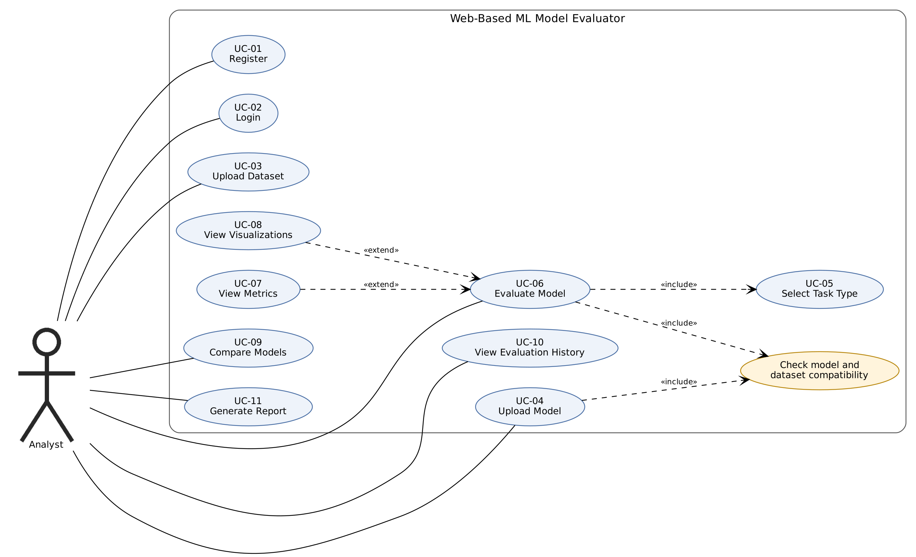
Figure 1. Use-case diagram: Analyst
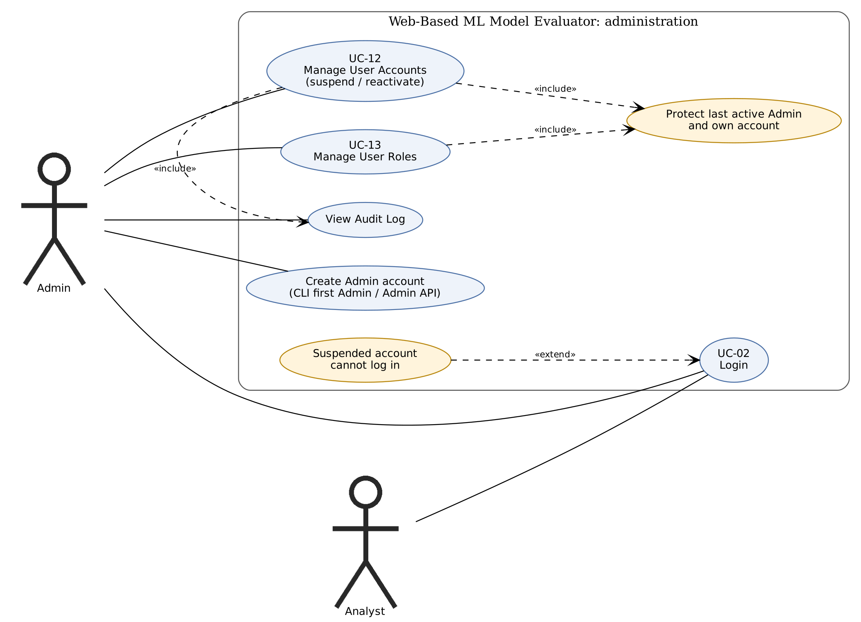
Figure 2. Use-case diagram: Admin

8. Requirements Traceability Matrix (RTM)
Status: N = not implemented, P = partly achieved, A = achieved (implemented and its test cases pass). Design references point to sections of the SAD.
Req ID | Requirement short | Section ref / Design spec | Module | Test case(s) | Status (N/P/A) | Comments
MLE-F-001 | Analyst registration | 4.1 / SAD 3.4, auth_service | auth_service | 01_UT_01, 01_UT_02, 01_UT_03, 01_UT_04, 01_ST_01 | A | Earlier ID: FR-01 / UC-01
MLE-F-002 | Login, session and logout | 4.1 / SAD 3.4, auth_service, app.py hooks | auth_service, app.py hooks | 02_UT_01, 02_UT_02, 02_IT_01, 02_IT_02, 02_ST_01 | A | Earlier ID: FR-01 / UC-02
MLE-F-003 | Admin accounts only through an Admin | 4.1 / SAD 3.4, auth_service, admin_service | auth_service, admin_service | 13_ST_01, SEC_02 | A | Earlier ID: FR-01 / UC-01, UC-13
MLE-F-010 | Dataset upload and validation | 4.2 / SAD 3.4, dataset_service | dataset_service | 03_UT_01, 03_UT_02, 03_UT_03, 03_UT_04, 03_IT_01, 03_IT_02 | A | Earlier ID: FR-02 / UC-03
MLE-F-011 | Model upload and validation | 4.2 / SAD 3.4, model_service | model_service | 04_UT_01, 04_UT_02, 04_UT_03, 04_IT_01 | A | Earlier ID: FR-02 / UC-04
MLE-F-012 | Model and dataset compatibility check | 4.2 / SAD 3.4, compatibility, model_service, dataset_service | compatibility, model_service, dataset_service | 04_IT_02, 04_IT_03, 06_IT_02 | A | Earlier ID: FR-02 / UC-04, UC-06
MLE-F-020 | Task type selection and check | 4.3 / SAD 3.4, evaluation_service | evaluation_service | 05_UT_01, 05_IT_01, 05_ST_01 | A | Earlier ID: FR-03 / UC-05
MLE-F-021 | Classification metrics | 4.3 / SAD 3.4, evaluation_service, metrics | evaluation_service, metrics | 06_UT_01, 06_UT_03, 06_ST_01 | A | Earlier ID: FR-04 / UC-06
MLE-F-022 | Regression metrics | 4.3 / SAD 3.4, evaluation_service, metrics | evaluation_service, metrics | 06_UT_02, 06_ST_02, 07_UT_01 | A | Earlier ID: FR-04 / UC-06
MLE-F-023 | Failed evaluation leaves nothing behind | 4.3 / SAD 3.4, evaluation_service | evaluation_service | 06_IT_02, 06_ST_03 | A | Earlier ID: FR-04 / UC-06 (alt.)
MLE-F-030 | View metrics | 4.4 / SAD 3.4, app.py, evaluation_service | app.py, evaluation_service | 07_UT_01, 07_UT_02, 07_IT_01 | A | Earlier ID: FR-04 / UC-07
MLE-F-031 | Visualizations | 4.4 / SAD 3.4, visualization_service | visualization_service | 08_UT_01, 08_UT_02, 08_IT_01, 08_ST_01, 08_ST_02 | A | Earlier ID: FR-05 / UC-08
MLE-F-032 | Saved evaluations and history | 4.4 / SAD 3.4, evaluation_service, db | evaluation_service, db | 06_IT_01, 07_IT_01, 10_UT_01, 10_UT_02 | A | Earlier ID: FR-07 / UC-10
MLE-F-033 | Compare evaluations | 4.4 / SAD 3.4, evaluation_service, visualization_service | evaluation_service, visualization_service | 09_UT_01, 09_IT_01, 09_IT_02, 09_ST_01 | A | Earlier ID: FR-06 / UC-09
MLE-F-034 | PDF report | 4.4 / SAD 3.4, report_service | report_service | 11_UT_01, 11_UT_02, 11_UT_03, 11_IT_01, 11_ST_01 | A | Earlier ID: FR-07 / UC-11
MLE-F-040 | Account list, suspend and reactivate | 4.5 / SAD 3.4, admin_service, auth_service | admin_service, auth_service | 12_UT_01, 12_UT_02, 12_ST_01, 02_IT_03, 02_IT_04 | A | Earlier ID: FR-08 / UC-12
MLE-F-041 | Role change | 4.5 / SAD 3.4, admin_service | admin_service | 13_UT_01, 13_ST_01 | A | Earlier ID: FR-08 / UC-13
MLE-F-042 | Audit log | 4.5 / SAD 3.4, admin_service, db | admin_service, db | 13_IT_03 | A | Earlier ID: FR-08 / UC-12, UC-13
MLE-F-043 | Protected accounts | 4.5 / SAD 3.4, admin_service | admin_service | 12_IT_01, 12_IT_02, 13_IT_01, 13_IT_02 | A | Earlier ID: FR-08 / UC-12, UC-13
MLE-NF-001 | Performance | 5 / SAD 3.9, 4.4 | evaluation_service | NF_PF_01, NF_PF_02, NF_PF_03 | A | Earlier ID: NFR-01
MLE-NF-002 | Data isolation | 5 / SAD 3.9, 4.4 | all services (owner_id scoping) | SEC_08, SEC_09, SEC_10, SEC_11, SEC_12 | A | Earlier ID: NFR-02
MLE-NF-003 | Clear error reporting | 5 / SAD 3.9, 4.4 | errors, app.py handlers | NF_ER_01, NF_ER_02, NF_ER_03, NF_ER_04 | A | Earlier ID: NFR-03
MLE-NF-004 | First-time usability | 5 / SAD 3.9, 4.4 | templates | NF_US_01, NF_US_02 | A | Earlier ID: NFR-04
MLE-NF-005 | Extensibility | 5 / SAD 3.9, 4.4 | metrics, visualization_service | NF_EX_01 | A | Earlier ID: NFR-05
MLE-SR-001 | Password hashing | 5.1 / SAD 3.9 | app.py, services | SEC_01 | A
MLE-SR-002 | Login required everywhere | 5.1 / SAD 3.9 | app.py, services | SEC_03 | A
MLE-SR-003 | Role enforcement | 5.1 / SAD 3.9 | app.py, services | SEC_06, SEC_07 | A
MLE-SR-004 | CSRF protection | 5.1 / SAD 3.9 | app.py, services | SEC_05 | A
MLE-SR-005 | Per-account data scoping | 5.1 / SAD 3.9 | app.py, services | SEC_08, SEC_09, SEC_10, SEC_11, SEC_12 | A
MLE-SR-006 | Safe login redirect | 5.1 / SAD 3.9 | app.py, services | SEC_04 | A
MLE-SR-007 | Session security | 5.1 / SAD 3.9 | app.py, services | 02_IT_04 | A | Inspection only for cookie flags
MLE-SR-008 | Upload limits and storage | 5.1 / SAD 3.9 | app.py, services | NF_ER_04, 04_UT_01, 04_UT_03, 03_UT_01, 03_UT_04 | A
MLE-SR-009 | TLS 1.2+ when deployed | 5.1 / SAD 3.9 | app.py, services | none | P | Deployment requirement, not tested

