PROJECT REPORT
Lost & Found Management System
A Django Web Application for Reporting, Tracking, and Resolving Lost and Found Items
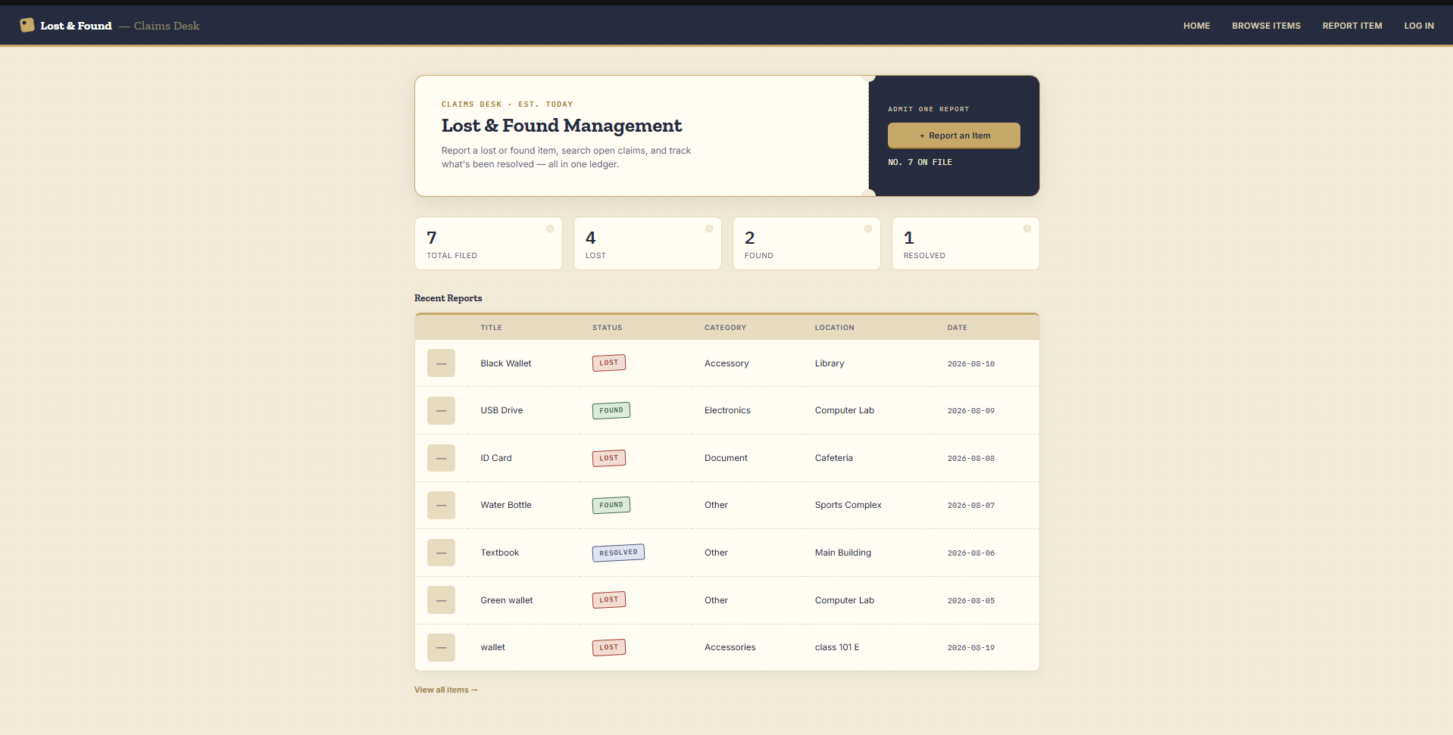

• Kushal Maharjan • Nhuza Maharjan • Arpita Katuwal
• Rohina Tandukar

1. Introduction
Misplaced belongings are a routine problem on any campus, and without a shared way to record them, lost items and the people who find them rarely connect. Reports scatter across group chats and notice boards and are quickly forgotten.
The Lost & Found Management System is a lightweight Django web application that gives a campus community one always-available place to report an item, search existing reports, and mark items resolved once they are reunited with their owners. It favours simplicity over heavy infrastructure: item records live in a plain CSV file (mirrored automatically to JSON) instead of a database, keeping the codebase small and easy to inspect.
- Core Problem Statement: Lost-and-found reports are informal and unsearchable, item status is never tracked consistently, and staff logbooks aren't accessible to the people who actually need them.
- Project Objectives: Let anyone report and search items, give admins the ability to edit, resolve, or delete records, and surface at-a-glance stats — all without requiring a full database or account system.
- Operational Scope: Covers reporting, browsing, searching, editing, and resolving items, plus a single shared admin login guarding edit and delete actions.
- Design Focus: A human-readable CSV/JSON data layer and a minimal signed-cookie admin session, keeping the whole system transparent and easy to run.

2. Literature Review
Lost-and-found coordination is a familiar “community bulletin board” problem: post an entry easily, search it easily, and remove it once it's resolved. Existing approaches range from physical logbooks, which can't be searched remotely, to repurposed spreadsheets and forms, which lack structured status tracking and duplicate protection.
This project follows the pattern used by dedicated lost-and-found platforms — structured records, a status lifecycle, and admin-gated write access — while trading a full database and user-account system for a CSV-backed store, which fits the scale of a single campus and keeps the project easy to understand and extend.
- Identified Market Gap: Logbooks and generic forms offer no searchable record, no consistent status tracking, and no protection against duplicate or stale entries.
- Design Pattern Followed: Structured item records, a lost → found → resolved lifecycle, search/filter, and access control on write operations.
- Backend Framework Selection: Django was chosen for its routing, templating, and CSRF protection out of the box, letting the project focus on application logic.
- Data Layer Selection: Python's built-in csv and json modules give a database-like read/write API with zero setup and files that can be inspected directly.

3. System Design
The system loosely follows Django's Model-View-Template pattern: instead of ORM models, a set of plain-dictionary functions read and write the CSV file directly. Views handle validation, filtering, and authentication; templates handle presentation, all sharing one base layout inside a single app called pages.
Each item is a flat record with eight fields — title, status, category, location, date, description, contact, and image — where status moves through a simple lifecycle: LOST or FOUND, then RESOLVED once claimed.
- Single-App Structure: One Django app (pages) owns all routes, views, and templates — no cross-app relationships to manage.
- Item Lifecycle: status is constrained to LOST, FOUND, or RESOLVED, giving every record a clear, trackable state.
- Access Control Design: A single shared admin identity, verified against settings.py credentials, carried in a signed, httponly cookie — no need for a full user-account system.
- Data Flow: Browser requests hit Django's URL router, views read or write the CSV/JSON files and image folder, and templates render the response.
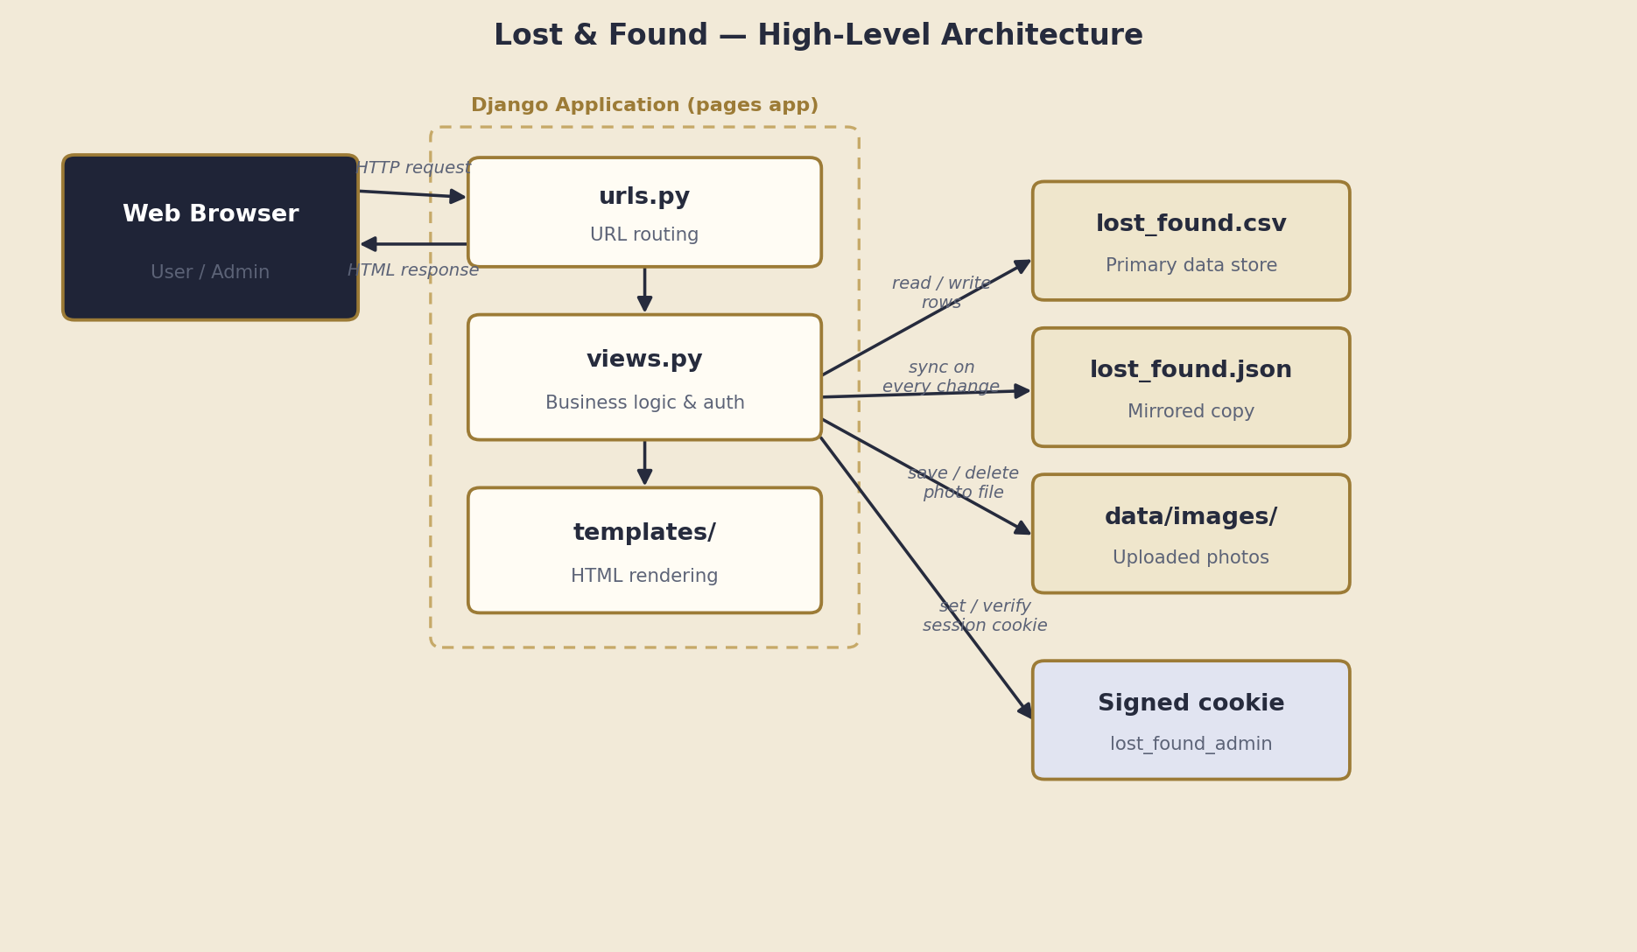

4. Implementation
Implementation centered on a small, well-organized set of CRUD views — report, browse/search, view detail, edit, and delete — plus a lightweight admin login, all sharing one consistent “claims desk” visual theme.
Error handling was kept simple but deliberate: missing files, invalid item references, and unauthorized access are all handled gracefully rather than crashing the app.
- Safe Data Access: read_items() catches a missing CSV file instead of raising an error, so a fresh install starts cleanly with an empty list.
- Guarded Admin Actions: An admin_required decorator checks the signed cookie before every edit or delete, redirecting unauthenticated requests to login.
- Invalid Item Handling: Requesting an out-of-range item ID renders an “Item not found” page instead of throwing an error.
- Safe Photo Uploads: Uploaded images are renamed with a millisecond timestamp prefix so two people uploading the same filename never overwrite each other.
- Open-Redirect Protection: The login flow's next parameter is checked before redirecting, falling back to the home page for any external URL.

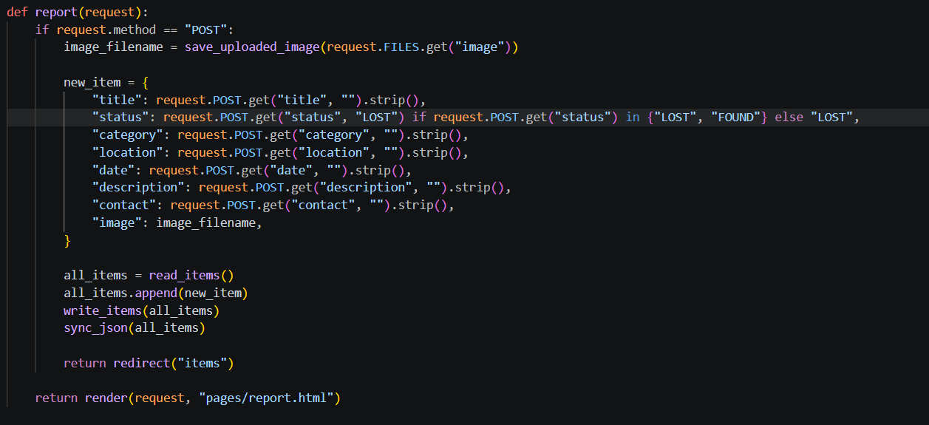

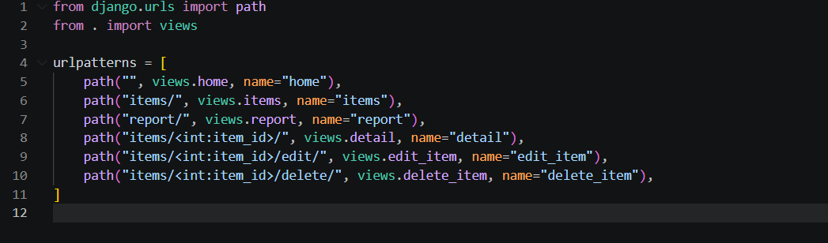

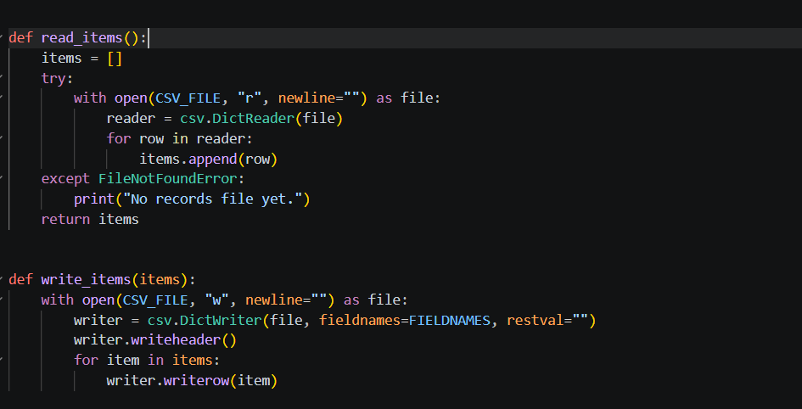

5. Testing
Since the project has no automated test suite, verification was carried out through structured manual testing of every route and user flow, alongside Django's built-in configuration check.
- CRUD Flow Verification: Reporting, searching, editing, resolving, and deleting items were each confirmed to update the CSV and its JSON mirror correctly.
- Access-Control Boundary Tests: Edit and delete routes were confirmed to redirect signed-out visitors to login rather than exposing the action.
- Edge Case Handling: Invalid item IDs, missing optional fields, and edits without a replacement photo were all confirmed to behave safely.
- Configuration Check: python manage.py check was run to confirm the project has no reported configuration errors.

6. Conclusion & Future Roadmap
The Lost & Found Management System meets its goal: a simple, always-available way for a campus community to report, search, and resolve lost items, without the overhead of a full database or user-account system. Keeping data in a readable CSV/JSON store and authentication in a small signed-cookie mechanism keeps the codebase compact and easy to reason about.
- Achieved Milestones: A working CRUD application with search/filter, photo uploads, admin-gated editing, and a live statistics dashboard.
- Known Limitations: Items are addressed by CSV row position rather than a permanent ID, and there is a single shared admin account with no per-user accountability.
- Database Migration: Move item storage to the Django ORM with a proper Item model, replacing positional indexes with stable primary keys.
- Automated Testing: Add a test suite covering the CRUD views, search/filter logic, and admin authentication flow.
- Smarter Matching: Suggest existing FOUND items when someone reports a LOST item with a similar title or category.

