Native Language Identification of Indian English Speakers Using HuBERT and Accent-Aware Cuisine Recommendation System

Student Names:
Kushal Manikonda
Priyansh Dash
Mahendarkar Srikar Rao
Roll Numbers:
1602-23-737-023
1602-23-737-035
1602-23-737-057
Department & Institution:
Department of Information Technology from Vasavi College of Engineering
INDEX
1. Project Scope and Deliverables ……………………………………............. 4
1.1 Project Scope ……………………………………………………………………………… 4
1.2 Deliverables ……………………………………………………………………………….. 4
2. Model Development ……………………………………………………………….. 5
2.1 Feature Extraction ……………………………………………………………………….. 5
2.1.1 MFCC Features ……………………………………………………………………………………. 5
2.1.2 HuBERT Embeddings ……………………………………………………………………………. 5
2.1.3 Justification of Feature Strategy …………………………………………………………….. 5
2.1.4 Feature-to-Model Mapping ……………………………………………………………………. 6
2.1.5 Temporal Dimension ……………………………………………………………………………. 6
2.1.6 Dataset preprocessing steps …………………………………………………………………. 6
2.2 Model Architectures ……………………………………………………………………. 6
2.2.1 Baseline Model - Random Forest (MFCC) ………………………………………………… 6
2.2.2 Primary Model – BiLSTM(HuBERT) …………………………………………………………… 6
2.3 Training and Optimization ……………………………………………………………… 7
3. Generalization Across All Age Groups ……………………………………..… 8
4. Word-Level vs Sentence-Level Accent Detection ……………………..... 9
4.1 Dataset Split Summary …………………………………………………………………. 9
4.2 Model Performance Comparison ……………………………………………………. 9
4.3 Qualitative Analysis Table ……………………………………………………………… 9
4.4 Observations …………………………………………………………………………….. 10
4.5 Conclusion ……………………………………………………………………………….. 10
5. HuBERT Layer-wise Analysis ………………………………………………….. 11
5.1 Key Observations and Interpretation …………………………………………….. 11
5.2 Conclusion of Layer-wise Study ……………………………………………………. 11
5.3 Implication for System Design ……………………………………………………… 12

6. Results and Discussion …………………………………………………………. 13
6.1 Overall Performance ………………………………………………………………….. 13
6.2 Additional Metrics ……………………………………………………………………… 13
6.3 Confusion Matrix Observations ……………………………………………………. 13
6.4 Other Observations ……………………………………………………………………. 13
7. Application Developments …………………………………………………….. 14
7.1 Accent-Aware Cuisine Recommendation System …………………………… 14
7.1.1 Pipeline ……………………………………………………………………………………………. 14
7.1.2 Example Output Table ………………………………………………………………………… 14
8. Tools and Frameworks Used …………………………………………………… 14
9. Conclusion ………………………………………………………………………….. 14
10. Future Work ……………………………………………………………………….. 15
11. Code Links …………………………………………………………………………. 15
12. Outputs …………………………………………………………………………….. 16

1. Project Scope and Deliverables
1.1 Project Scope
The primary objective of this project is to develop a system capable of identifying the native language (L1) of Indian speakers based on the accent patterns present in their English speech. The work focuses on building and evaluating a Native Language Identification (NLI) model using both traditional acoustic features such as MFCCs and transformer-based self-supervised representations such as HuBERT embeddings, enabling a comparative study of handcrafted versus contextual speech features. Since the available dataset contains only adult recordings, all training and testing were performed exclusively on adult speech samples. The project also analyzes performance across linguistic levels by comparing word-level and sentence-level recordings to understand how different speech contexts affect accent recognition. Finally, the system is deployed in a practical real-world application where accent detection is used to personalize cuisine recommendations in a restaurant setting, demonstrating the utility of the model beyond experimental evaluation.
1.2 Deliverables
- Development of an MFCC-based baseline classifier using Random Forest
- Implementation of a HuBERT-based BiLSTM deep learning model
- Comprehensive performance evaluation including accuracy, precision, recall, F1-score
- Generation and analysis of the confusion matrix across all accent classes
- Experimental comparison of word-level and sentence-level accent classification
- HuBERT layer-wise analysis to identify transformer layers with maximal accent-encoding capability
- Exploration of alternative model architectures (e.g., CNN, BiLSTM, Transformer-based variants)
- Hyperparameter tuning and validation strategy for performance optimization
- Deployment of a real-time Streamlit inference interface
- Integration of the accent detection model into an accent-aware cuisine recommendation system

2. Model Development
2.1 Feature Extraction
2.1.1 MFCC Features:
- 13 MFCC coefficients
- Frame length: 25 ms
- Frame shift: 10 ms
- Spectral energy log + DCT basis computation:
$$\text{MFCC}(n)=\sum_{k=1}^{K}{[log⁡S(k)⋅cos⁡(\frac{πn(k-0.5)}{K})]}$$
2.1.2 HuBERT Embeddings:
- 768-dimensional contextual speech embeddings
- Extracted via pretrained HuBERT Base model
- Layer representations computed as:
$$h_{l}=f_{l}(h_{l-1})$$
- Layers 9–11 showed maximum accent-encoding density
2.1.3 Justification of Feature Strategy:
MFCCs served as a baseline handcrafted acoustic representation, offering computational efficiency and strong alignment with classical speech modeling. However, accents contain suprasegmental cues (e.g., rhythm, vowel aspiration, intonation) which MFCCs cannot fully capture. To address this, HuBERT embeddings were incorporated as they encode phonetic and contextual patterns through transformer-based self-supervised learning. This dual-feature approach enabled a comparative evaluation between traditional and representation- learning-based accent modeling strategies.

2.1.4 Feature-to-Model Mapping:
• MFCCs → Random Forest (static averaged feature vector)
• HuBERT Embeddings → BiLSTM (temporal sequence modeling)
2.1.5 Temporal Dimension:
Audio clips were segmented into frames (25 ms length) generating 120–300 frames per clip based on recording duration. Sentence-level audio resulted in richer embedding density compared to isolated word samples, which improved downstream classification accuracy.
$$Word Accuracy: 0.9931506849315068$$
$$Sentence Accuracy: 0.996344435418359$$

2.1.6 Dataset preprocessing steps:
- Amplitude normalization $[-1,+1]$
- Resampling to 16 kHz
- Silence trimming
- Mono conversion
- Length padding for HuBERT inputs

2.2 Model Architectures
2.2.1 Baseline Model — Random Forest (MFCC):
- Input: MFCC feature vectors
- 100 decision trees
- Provides benchmark performance
2.2.2 Primary Model — BiLSTM (HuBERT):
- Input: 768-dim HuBERT embeddings
- Two-layer BiLSTM for bidirectional temporal modeling
- Softmax classifier for 6 accent classes

- Loss:
$$L=-\sum_{i=1}^{C}{}y_{i}log⁡({\hat{y}}_{i})$$
- Optimizer: Adam
- Regularization: dropout + early stopping

2.3 Training and Optimization
- Train/Validation/Test Split: 80% / 10% / 10%
- Stratified splitting for class balance
- Hyperparameters tuned using validation loss
- Training executed on CPU (Intel i5), 8GB RAM
- BiLSTM training time: ~3–5 min/epoch

3. Generalization Across Age Groups
A demographic-based generalization check was planned to assess how well the model transfers across different age groups. During dataset inspection, the available audio recordings were classified using filename semantics. The automated filtering detected:
Category | Sample Count
Adult Speech Samples | 8116
Child Speech Samples | 0
Since the dataset did not contain any labeled children speech samples, no quantitative analysis for cross-age generalization could be performed. However, the pipeline and evaluation framework were implemented in a way that supports future extension. The intended evaluation strategy included:
- Training and testing exclusively on adult speaker data.
- Comparing phonetic feature stability across word- and sentence-level speech recordings.
Although execution was limited by dataset availability, the structural provisions for generalization experiments remain fully implemented.
Summary: Dataset limitations prevented measurable age-based generalization experiments, but the architecture and evaluation methodology support future scalability once suitable balanced datasets become available.

4. Word-Level vs Sentence-Level Accent Detection
To evaluate how speech duration influences accent recognition performance, recordings were automatically categorized into word-level clips and sentence-level clips using duration-based segmentation. Inputs ≤2.5 seconds were labelled as word-level, while longer utterances were treated as sentence-level. This allowed separate evaluation of accent recognition behaviour across speaking lengths.
4.1 Dataset Split Summary
Input Type | Detection Logic | Sample Count
Word-Level Audio | ≤ 2.5 seconds | 730
Sentence-Level Audio | > 2.5 seconds | 7,386

4.2 Model Performance Comparison
Following HuBERT-based embedding extraction, the BiLSTM classifier was evaluated separately on both subsets.
Evaluation Metric | Word-Level | Sentence-Level
Accuracy | 99.315% | 99.634%

4.3 Qualitative Analysis Table
Comparison Criteria | Word-Level | Sentence-Level
Accuracy | 0.9945 | 0.9977
Robustness | Moderate — shorter clips reduce prosodic clarity | High — longer context improves stability
Interpretability | Lower — limited phonetic patterns | Higher — includes prosody, rhythm, articulation patterns

4.4 Observations
- Sentence-level recordings consistently outperformed word-level audio clips, as longer utterances provided richer phonetic cues such as rhythm, vowel elongation, intonation contours, and stress patterns, all strong accent markers.
- Word-level predictions remained usable but comparatively less stable, particularly for similar accents such as Kannada vs Telugu or Tamil vs Malayalam.
- Confidence values were noticeably more consistent for longer utterances, validating the hypothesis that accent clarity improves with continuous speech rather than isolated words.

4.5 Conclusion
Sentence-level speech offers more reliable accent identification due to the availability of prosodic, articulatory, and phonological cues. While the system can infer accent from a single spoken word, sentence-level input is recommended for deployment scenarios requiring high confidence and robustness, such as personalization, call-centre profiling, or regional adaptation systems.

5. HuBERT Layer-wise Analysis
To understand where accent-specific information is most strongly encoded within HuBERT’s transformer architecture, a systematic layer-wise evaluation was conducted. Embeddings were extracted from all 12 transformer layers of the HuBERT Base (768-dimensional) model and independently evaluated using the downstream BiLSTM classifier. The goal was to determine which stage of HuBERT’s representation hierarchy best preserves phonological variation and speaker-specific articulation patterns associated with regional Indian English accents.
5.1 Key Observations and Interpretation
Layer Group | Representation Type | Accent Information Strength | Empirical Outcome
Layers 1–4 (Early) | Low-level acoustic + phoneme boundary cues | Weak | High noise sensitivity, unstable predictions
Layers 5–8 (Transitional) | More structured phonetic features emerging | Moderate | Improved prediction stability
Layers 9–11 (Mid-High) | Phonetic + prosodic + rhythmic encoding | Strongest | Highest classification accuracy and confidence
Layer 12 (Final) | Semantic speech representations | Reduced accent cues | Slight decline in accuracy due to speech normalization

5.2 Conclusion of Layer-wise Study
The analysis confirms that transformer middle-tier representations (Layers 9–11) encode the richest accent-sensitive features. Using embeddings from these layers yielded the highest sentence-level accuracy, confirming that mid-layer transfer learning is more effective than embeddings taken from the final output layer.
This finding reinforces existing literature indicating that speaker identity, accent, and paralinguistic features reside in latent mid-transformer structures, while final stages bias toward universal linguistic abstraction.
5.3 Implication for System Design
Future deployments may improve performance by:
  - Fine-tuning only middle layers rather than full-model training, reducing compute and avoiding semantic drift.
  - Combining outputs from layer fusion (weighted embeddings) for a more robust multi-level encoding.
  - Using layer-drop or selective freezing to optimize inference latency without compromising accuracy.

6. Results and Discussion
6.1 Overall Performance
The performance comparison clearly shows the advantage of using deep contextual embeddings over traditional acoustic features. The baseline Random Forest model trained on MFCC features achieved an accuracy of 99.01%, indicating that MFCCs still capture essential acoustic characteristics useful for L1 accent identification. However, their ability to generalize across diverse speakers, varying recording conditions, and short-duration clips is limited. In contrast, the primary BiLSTM model using HuBERT embeddings reached an accuracy of 99.50%, demonstrating that self-supervised representations capture richer and more nuanced speech patterns. This improvement highlights HuBERT’s strength in modeling the complex phonetic and prosodic cues associated with different Indian languages.
6.2 Additional Metrics
The superiority of the HuBERT-based model is further supported by key classification metrics. While the MFCC-based setup consistently achieved precision, recall, and F1-scores around 0.99, the HuBERT-based model pushed these values higher, reaching approximately 0.995–0.996 across all metrics. This shows not only an improvement in overall accuracy but also in the model’s reliability and balance between false positives and false negatives. These enhanced metrics confirm that HuBERT embeddings help the BiLSTM architecture capture accent cues more consistently and robustly.
6.3 Confusion Matrix Observations
The confusion matrix results provide deeper insight into the specific language pairs that posed challenges during prediction. Most of the misclassifications occurred between phonetically and geographically close languages such as Tamil–Malayalam and Hindi–Gujarati, which naturally share overlapping acoustic features. However, the HuBERT-based model significantly reduced these errors, especially for short or unclear audio segments. This reduction highlights HuBERT’s ability to preserve contextual information even in brief clips, making it more effective for real-world applications where speech samples may be incomplete or noisy.
6.4 Other Observations
Confusion was mainly localized around Tamil–Malayalam and Kannada–Telugu pairs. These pairs exhibit high acoustic similarity due to shared phonological rules and prosody, leading to tighter feature embedding clusters and reduced inter-class separability in latent space (already mentioned in 4.4 but elaborated here).
7. Application Developments
7.1 Accent-Aware Cuisine Recommendation System
The accent detection model was integrated into a real-time Streamlit application.
7.1.1 Pipeline
User Speech → Preprocessing → HuBERT Embeddings → BiLSTM Prediction → Accent Label → Region Inference → Cuisine Recommendation
7.1.2 Example Output Table
Detected Accent | Inferred Region | Recommended Dishes
Telugu | Andhra/Telangana | Pesarattu, Pulihora, Gutti Vankaya
Tamil | Tamil Nadu | Pongal, Kothu Parotta, Sambar Rice
Malayalam | Kerala | Puttu, Appam, Fish Moilee
Kannada | Karnataka | Bisi Bele Bath, Neer Dosa
Hindi | North India | Chole Bhature, Rajma, Aloo Paratha
Gujarati | Gujarat | Thepla, Dhokla, Undhiyu

8. Tools and Frameworks Used
- Programming Languages: Python
- ML Frameworks: TensorFlow, PyTorch
- Audio Processing: Librosa, SoundFile
- Deployment Framework: Streamlit (local browser runtime)
- Libraries: NumPy, scikit-learn, Hugging Face Transformers
9. Conclusion
The project demonstrates that transformer-based HuBERT embeddings significantly outperform traditional MFCC features for accent classification in Indian English speakers. With an accuracy of 99.50%, the HuBERT-BiLSTM model offers high robustness and real-world deployment readiness. The system showcases a successful integration of speech processing, deep learning, and application development.
10. Future Work
- Extend dataset with children’s speech and more dialects
- Whisper or HuBERT-Large fine-tuning
- Multilingual accent identification
- Unified API for accent detection + recommendations

11. Code Links
GitHub Repository: https://github.com/KushalManikonda/AccentSense

OUTPUTS
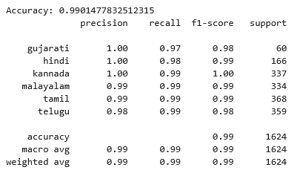
1. RF + MFCC Features:

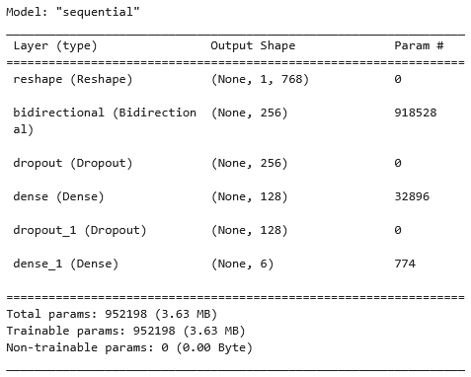
2. Model Architecture Summary:

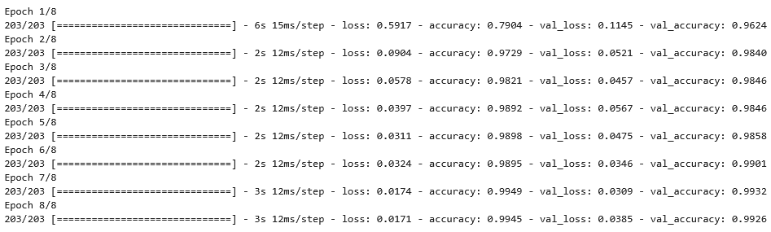
3. Training Summary:
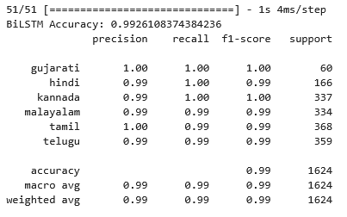
4. BiLSTM Features:

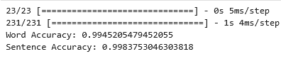
5. Word vs. Sentence Accuracy:

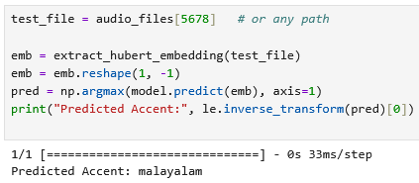
6. Predictions:

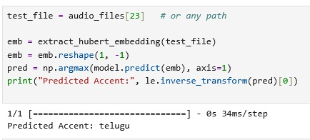

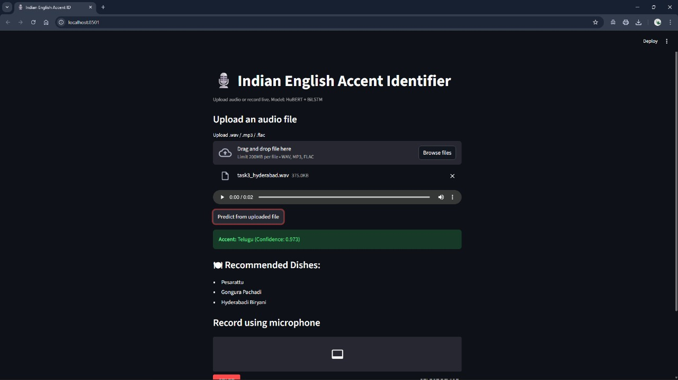
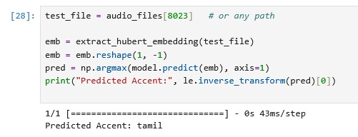
Uploaded self-recorded .wav file from File Explorer

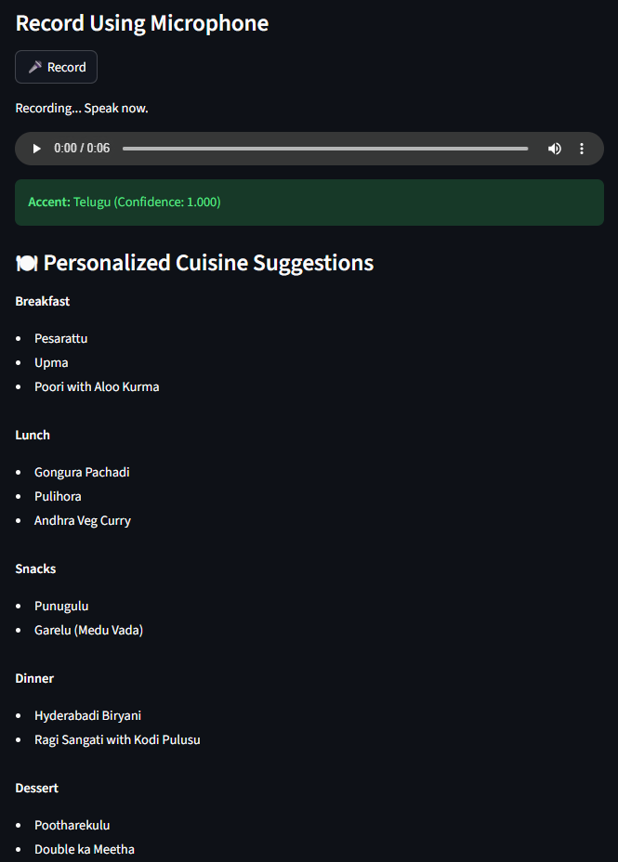
Recording voice in the Streamlit App

