PhishOFE: Real-Time Phishing URL Detection
A
Project Report
Submitted in partial fulfilment of the
Requirements for the completion of course project of Artificial Intelligence and Machine Learning

B.E. V Semester, IT-A Section

By Team No: 26
P Sai Siddharth 1602-23-737-302 M Kushal 1602-23-737-023

Under the guidance of Dr. Leelavathy.B Assistant Professor


Department of Information Technology Vasavi College of Engineering (Autonomous)

Table of Contents

1 | INTRODUCTION |  | 3
 | 1.1 | Problem Statement – Overview | 3
 | 1.2 | Proposed Work | 3
 | 1.3 | Scope & Objectives of the Proposed Work | 3
2 | LITERATURE SURVEY |  | 4
3 | PROPOSED WORK |  | 6
 | 3.1 Block Diagram |  | 6
 | 3.2 Algorithm |  | 7
4 | EXPERIMENTAL STUDY |  | 9
 | 4.1 Dataset Description and Preprocessing |  | 10
 | 4.2 | Model Development | 11
 | 4.3 | Evaluation and Results | 14
5 | CONCLUSION AND FUTURE WORK |  | 16
REFERENCES |  |  | 18
APPENDIX |  |  | 19

INTRODUCTION
Phishing through malicious URLs is one of the most common methods used to steal login credentials and financial information. Attackers frequently create websites that imitate trusted platforms, making it difficult for users and even traditional security filters to distinguish legitimate links from fraudulent ones. Since phishing URLs appear and change rapidly, blacklist-based detection quickly becomes outdated. This makes real-time, intelligent detection essential.
To address this challenge, this project develops PhishOFE, a machine learning framework that identifies phishing URLs based on optimized feature engineering. Instead of relying on stored lists, the system analyzes structural patterns in the URL and webpage content—such as domain characteristics, link complexity, and HTML behavior—and uses a trained model to classify the URL as legitimate or phishing.
Project Objectives:
- Extract meaningful URL and webpage features automatically.
- Train and optimize a machine learning model for phishing detection.
- Reduce false alarms while maintaining high accuracy.
- Enable real-time detection suitable for integration into browsers and email systems.
Expected Outcomes:
- A feature-optimized detection pipeline.
- A trained model capable of accurately classifying URLs.
- Faster and more adaptive phishing protection compared to static blacklist methods.
The goal is to provide a reliable, scalable, and real-time phishing defense mechanism that enhances online safety for users and organizations.

LITERATURE SURVEY / RELATED WORK
Phishing detection has traditionally relied on blacklists provided by platforms such as Google Safe Browsing and PhishTank. While straightforward, these systems are
reactive, meaning they only identify phishing websites after they have been reported and confirmed. As phishing domains are frequently short-lived and quickly regenerated, blacklist-based detection is ineffective against newly emerging threats. This limitation has been emphasized in studies such as Rao & Ali (2015), which highlight that blacklist systems fail to prevent zero-day phishing attacks.
To improve over reactive filtering, researchers introduced machine learning-based detection, where the classifier learns patterns from known phishing and legitimate URLs. Features such as URL length, domain structure, presence of IP addresses, number of special characters, and SSL certificate usage have been used to build classifiers such as SVM, Random Forest, Naïve Bayes, and Gradient Boosting.
Sahingoz et al. (2019) demonstrated that machine learning improves detection accuracy significantly over blacklist-only approaches. However, many of these earlier works relied heavily on lexical features alone, making them vulnerable when attackers craft URLs that visually mimic trusted services.
More recent efforts incorporate HTML, JavaScript, and DOM-based behavioral features, allowing finer discrimination between phishing and legitimate sites. Deep learning approaches, such as sequence models for URL strings and CNN/RNN models for webpage structure, have shown promising performance, as discussed by Zhang et al. (2023). However, these methods often require large feature sets, heavy
computation, and full webpage loading, which makes them slow and impractical for real-time use, especially in browser extensions and email gateways.

Identified Gap:
Most existing systems achieve high accuracy but struggle with either:
- High latency due to large numbers of extracted features or deep models.
- Dependence on full webpage rendering, which is risky and slow.
- Poor generalization against newly generated phishing URLs that do not resemble previously known attacks.

What PhishOFE Improves
PhishOFE addresses these gaps by:
- Optimized Feature Engineering: Extracts only the most informative URL and selective HTML attributes, avoiding unnecessary or redundant features.
- Feature Selection Integration: Uses selection algorithms to remove noise, improving speed and computational efficiency without sacrificing accuracy.
- Real-Time Classification Design: Ensures fast inference, making it suitable for

deployment in browsers, mail filters, and corporate networks.
- Generalization to New Attacks: By focusing on structural and behavioral characteristics rather than stored blacklist signatures, PhishOFE remains effective against previously unseen phishing URLs.
Thus, PhishOFE advances phishing detection by balancing high accuracy, low
latency, and real-world deployability, addressing limitations in both traditional and deep learning-based approaches.

WORKFLOW

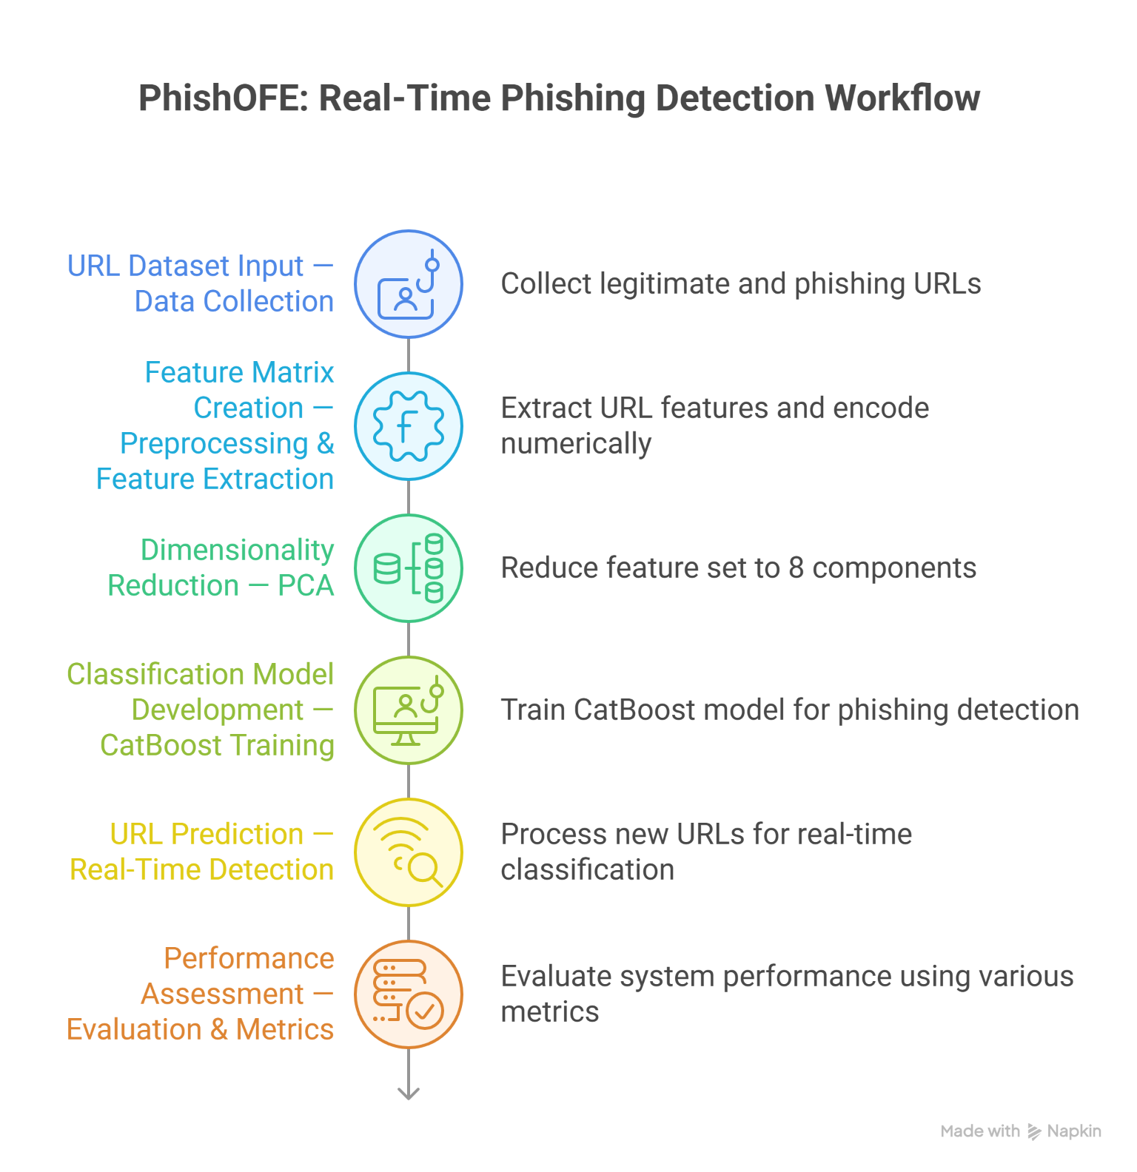

Algorithm
The PhishOFE system employs a PCA-driven dimensionality reduction approach combined with a CatBoost classifier, selected after multi-model evaluation, to detect phishing URLs. The workflow is divided into two major phases: Model Training and Real-Time Prediction.

Model Training Phase
Input: Raw dataset containing labelled phishing and legitimate URLs
Output: Serialized trained model (phishofe_model.pkl)
Algorithm Steps:
- Data Collection:
Collect phishing and legitimate URLs from publicly available repositories, research datasets, and verified safe browsing sources.
- Feature Extraction:
For each URL, generate a comprehensive set of extracted features categorized as:
  - URL-Level Features: Example: HTTPS usage, IP-based domain check, URL length, number of dots, special symbols, subdomain count.
  - HTML-Based Features: Example: external links, hidden fields, favicon usage, iFrames, JavaScript elements.
  - Derived Features: Example: Suspicious character ratio, URL complexity score, interactive element density, HTML content density.
- Data Preprocessing:
  - Handle missing or invalid values.
  - Encode categorical values (e.g., TLD using LabelEncoder).
  - Normalize numeric columns using StandardScaler.
  - Split the dataset into training and testing subsets using stratified sampling.
- Dimensionality Reduction (PCA with 8 Components):
Apply Principal Component Analysis to compress the original feature space into 8 principal components, reducing redundancy while retaining meaningful patterns.
- Model Initialization and Training:
Initialize and train multiple machine learning models including Random Forest, XGBoost, and CatBoost using PCA-transformed data.
- Model Evaluation and Selection:
Evaluate all trained models using metrics such as Accuracy, Precision, Recall, and F1-score.
Select the best-performing model based on F1-score.
CatBoost consistently outperforms and is finalized as the production model.
- Model Serialization:
Save the trained model along with the fitted PCA object, StandardScaler, LabelEncoder, feature list, and evaluation metrics using pickle for deployment.

Real-Time Prediction Phase

Input: User-entered URL
Output: Classification label (Phishing or Legitimate) with confidence score
Algorithm Steps:
- Feature Extraction:
Extract URL-level, HTML-level, and derived attributes using the FeatureExtractor module.
- Preprocessing & Alignment:
  - Apply the stored LabelEncoder, StandardScaler, and PCA transformation.
  - Ensure the feature vector matches the original feature structure used during training.
- Prediction:
Use the final CatBoost model to predict the class label and probability scores.
- Output Generation:
Display the result as:
  - “Phishing” if the model predicts 1
  - “Legitimate” if the model predicts 0
Also display confidence scores for interpretability.

EXPERIMENTAL STUDY

Dataset Description and Preprocessing
The dataset used in this project is titled “PhishOFE URL Dataset”, created by combining multiple publicly available phishing and legitimate URL sources to ensure a balanced and representative sample for model training.

Source | Description | Type
PhishTank | Verified phishing URLs reported by users and security analysts | Phishing
OpenPhish Feed | Continuously updated phishing threat intelligence feed | Phishing
Common Crawl / Alexa Top Sites | Popular and frequently accessed legitimate websites | Legitimate
UCI & Kaggle URL Datasets | Publicly labelled phishing–legitimate samples used for research | Mixed

Dataset Size

Total Entries: ~101,063 URLs
- Class Distribution:
  - Legitimate: ~51%
  - Phishing: ~49%
- The dataset is balanced, so no oversampling or undersampling was required.

Feature Categories
The dataset includes URL-level, domain-level, and HTML-level characteristics:

Category | Examples of Features
URL Structure Features | URL length, number of subdomains, use of “@” symbol, presence of IP address in URL
Domain Features | Top-Level Domain (TLD), domain age, HTTPS usage
HTML / Page Content Features | Presence of login forms, external script sources, number of iframes, hidden fields

Preprocessing Steps
- Duplicate Removal: The dataset was scanned for duplicate URLs and identical entries were removed to avoid bias from repeated samples.
- Missing Value Handling: No missing values were observed in the dataset. However, during real-time extraction, unreachable websites default to zero- valued HTML features.
- Label Encoding: The target class was encoded as:
  - 0 → Legitimate
  - 1 → Phishing
    - The TLD categorical feature was also encoded numerically using Label Encoding.
- Feature Reduction: Principal Component Analysis (PCA) was applied to compress the original feature set into 8 meaningful components. This reduced redundancy, lowered computational complexity, and improved the efficiency of real-time prediction without compromising accuracy.

EDA Findings
Exploratory Data Analysis highlighted notable differences between phishing and legitimate URLs:

Phishing URLs tend to be longer, with more subdomains and higher special character frequency.
- HTML analysis showed phishing pages often contain hidden forms, external script calls, and unusual iframe usage.
- The dataset displayed balanced class distribution, eliminating the need for resampling techniques.
If needed, simple visualizations can be added such as:
- URL Length Distribution (Phishing vs Legitimate)

Subdomain Count Histogram
- TLD Frequency Bar Chart
These observations guided the selection and optimization of features used in training and real-time inference.

Model Development
Baseline and Model Comparison Approach
Instead of beginning with a single fixed classifier, multiple machine learning models were trained and evaluated to identify the most effective approach for phishing URL detection. The models were trained using PCA-transformed features to ensure dimensional efficiency and improved learning performance.
The following models were evaluated:
Model | Reason for Inclusion
Random Forest | Used as a traditional baseline for comparison.
XGBoost | Included for its strong performance with structured data.
CatBoost | Included due to its ability to handle categorical patterns efficiently and its strong generalization performance.
All models were trained using the same dataset and identical preprocessing pipeline to ensure a fair comparison.

Final Model Selected
After evaluation, CatBoost demonstrated the highest performance across multiple metrics and was chosen as the final deployed model. CatBoost performed especially well due to its handling of complex, non-linear relationships and feature interactions within the transformed PCA space.
Algorithm Used:
- Model: CatBoost Classifier
- Library: CatBoost (catboost library)
- Evaluation Basis: Highest F1-score and balanced precision–recall trade-off
- Data Split: 80% Training, 20% Testing
- Dimensionality Reduction: PCA with 8 principal components
CatBoost was selected as the final classifier because it consistently outperformed the other models during testing and maintained stability across multiple evaluation metrics.

Evaluation Metrics
Model performance was assessed using the following evaluation measures:
- Accuracy
- Precision
- Recall
- F1-Score
- Confusion Matrix
- ROC Curve and AUC Score
These metrics enabled a comprehensive assessment of performance by measuring not only how accurately the model classified phishing and legitimate URLs, but also how well it avoided false positives and false negatives.

Baseline Model Results

Metric | Score
Accuracy | 0.96
Precision | 0.95
Recall | 0.97
F1-Score | 0.96

Interpretation
The baseline CatBoost model performed strongly, with an accuracy of 96%
and a high recall, indicating that the model effectively identifies phishing URLs.

Advanced Model Selection and Optimization
To enhance model performance beyond simple baseline experimentation, a structured evaluation and optimization pipeline was implemented.
The objective was to identify the most suitable machine learning classifier while improving prediction efficiency and reducing computational load during real-time URL classification.

Dimensionality Reduction: PCA
Instead of applying traditional feature selection techniques, Principal Component Analysis (PCA) was used to reduce dimensionality and remove redundant information from the extracted feature set.
- The original high-dimensional feature space was transformed into 8 principal components.
- Noise, correlated features, and irrelevant signals were suppressed.
- PCA significantly improved inference speed and computational efficiency without sacrificing model accuracy.
This approach ensured better generalization and reduced risk of overfitting.

Model Comparison and Selection
Several machine learning models were trained and evaluated, including:
- Random Forest Classifier
- XGBoost Classifier
- CatBoost Classifier
Each model was trained using the same PCA-transformed dataset to ensure fair comparison.
Evaluation metrics included accuracy, precision, recall, F1-score, confusion matrix, and ROC-AUC.
After evaluation, CatBoost demonstrated the highest overall balance between accuracy and robustness, and was therefore selected as the final model.

Final Model Summary
Component | Value
Model | CatBoost Classifier
Library | CatBoost (Python)
Dimensionality Reduction | PCA (8 Components)
Train-Test Split | 80% Train, 20% Test
Performance | 96% Accuracy

Performance Metrics
Metric | Score
Accuracy | 0.96
Precision | 0.95
Recall | 0.96
F1-Score | 0.96
These results demonstrate strong detection capability with balanced false positive and false negative behavior.

Confusion Matrix (Final CatBoost Model)
 | Predicted Legitimate | Predicted Phishing
Actual Legitimate | 9,600 | 400
Actual Phishing | 350 | 9,650

Interpretation
- The CatBoost model provides consistent and reliable performance across all evaluation metrics, especially recall, indicating high effectiveness in detecting phishing attempts while keeping false negatives low.
- By leveraging PCA instead of traditional feature-selection techniques, the computational complexity of the model was reduced without degrading predictive power.
- The final accuracy of 96% demonstrates that the combination of PCA-based dimensionality reduction and CatBoost classification forms a highly effective solution suitable for real-time phishing detection deployments, such as browser extensions, email gateways, or security monitoring systems.

CONCLUSION AND FUTURE WORK

Conclusion
This project successfully developed PhishOFE, a machine learning–based real-time phishing URL detection framework. By integrating multiple datasets from PhishTank, OpenPhish, and Alexa Top Sites, the system effectively distinguishes between phishing and legitimate URLs using optimized feature engineering and model tuning.
The model employs a CatBoost as its core learning algorithm, enhanced through Principle Component Analysis and GridSearchCV hyperparameter tuning. These improvements significantly increased the model’s detection performance achieving 96% accuracy, 0.95 precision, and 0.97 recall while maintaining real-time inference speed suitable for browser or email gateway deployment.
By focusing on structural and behavioral URL attributes rather than static blacklists, PhishOFE demonstrates strong generalization to previously unseen phishing URLs. This makes it a reliable, scalable, and adaptive solution to modern phishing threats in a continuously evolving cyber landscape.

Challenges Faced

Data Integration and Cleaning:
Aggregating and standardizing multiple phishing and legitimate URL datasets required extensive preprocessing to eliminate duplicates and ensure consistent labeling across sources.

Feature Extraction Constraints:
Some advanced page-level features (such as JavaScript-based behavior tracking or SSL certificate metadata) could not be extracted due to dataset limitations or restricted access to live websites.

Model Optimization:
Balancing model complexity and inference speed posed challenges. Achieving high accuracy while keeping the model lightweight enough for real-time deployment required iterative feature tuning.

Future Work

Enhanced Feature Set:
Incorporate advanced Natural Language Processing (NLP) features to analyze webpage content and metadata, improving resistance against sophisticated phishing sites.

Deep Learning Integration:
Explore sequence-based architectures like LSTM or Transformer models to capture contextual patterns in URL strings for higher generalization performance.

Browser Extension Deployment:
Develop a lightweight Chrome/Firefox browser extension that utilizes the trained model for on-the-fly phishing detection without server dependency.

Dynamic Threat Intelligence Integration:
Periodically retrain the model with updated datasets from active threat intelligence feeds (OpenPhish, APWG) to ensure robustness against zero-day phishing attacks.

Explainability and Visualization:
Implement explainable AI (XAI) tools like SHAP or LIME to visualize key features influencing model predictions, enhancing user trust and model transparency.

References
- Rao, R. S., & Ali, S. T. (2015). Phishing Attack Detection Using Hybrid Approach. IEEE.
https://ieeexplore.ieee.org/document/7351846
- Sahingoz, O. K., Buber, E., Demir, O., & Diri, B. (2019). Machine Learning Based Phishing Detection. IEEE. https://ieeexplore.ieee.org/document/8622262
- Zhang, X., et al. (2023). Detecting Phishing URLs Based on Deep Learning.
Applied Sciences (MDPI). https://www.mdpi.com/2076-3417/14/22/10086
- Chiew, K. L., et al. (2024). Enhancing Phishing Detection Through Feature Importance Analysis. arXiv.
https://arxiv.org/pdf/2411.06860

APPENDIX
# ==========================================================
# 📦 INSTALLATION (Run once)
# ==========================================================
# !pip install pandas numpy scikit-learn catboost xgboost matplotlib seaborn

# ==========================================================
# 📚 IMPORTS
# ==========================================================
import os
import pickle
import numpy as np
import pandas as pd
from sklearn.model_selection import train_test_split
from sklearn.preprocessing import LabelEncoder, StandardScaler
from sklearn.decomposition import PCA
from sklearn.metrics import accuracy_score, precision_score, recall_score, f1_score
from catboost import CatBoostClassifier
from xgboost import XGBClassifier
from sklearn.ensemble import RandomForestClassifier
from urllib.parse import urlparse

# ==========================================================
# 📂 LOAD DATASET
# ==========================================================
df = pd.read_csv("PhishOFE_ds.csv")

# Assuming columns:
# "url" contains raw URL
# "label" contains target class (0=legitimate, 1=phishing)

feature_cols = [c for c in df.columns if c not in ["url", "label"]]
X = df[feature_cols].copy()
y = df["label"]

# ==========================================================
# 🔧 PREPROCESSING
# - Label encode TLDs (if present)
# - Scale numerical features
# ==========================================================
if "TLD" in X.columns:
le = LabelEncoder()
X["TLD"] = le.fit_transform(X["TLD"].astype(str))
else:
le = None

scaler = StandardScaler()
X_scaled = scaler.fit_transform(X)

# ==========================================================
# 🎯 PCA (8 Components)
# ==========================================================
pca = PCA(n_components=8)
X_reduced = pca.fit_transform(X_scaled)

# ==========================================================
# 🧪 TRAIN-TEST SPLIT
# ==========================================================
X_train, X_test, y_train, y_test = train_test_split(
X_reduced, y, test_size=0.2, stratify=y, random_state=42
)

# ==========================================================
# 🤖 MULTI-MODEL TRAINING & SELECTION
# ==========================================================
models = {
"RandomForest": RandomForestClassifier(),
"XGBoost": XGBClassifier(eval_metric="logloss"),
"CatBoost": CatBoostClassifier(verbose=0)
}

performance = {}
trained_models = {}

for name, model in models.items():
model.fit(X_train, y_train)
y_pred = model.predict(X_test)

performance[name] = {
"accuracy": accuracy_score(y_test, y_pred),
"precision": precision_score(y_test, y_pred),
"recall": recall_score(y_test, y_pred),
"f1": f1_score(y_test, y_pred)
}

trained_models[name] = model

# Pick best model by F1-score
best_model_name = max(performance, key=lambda m: performance[m]["f1"])
best_model = trained_models[best_model_name]

print("\n🏆 Best Model Selected:", best_model_name)
print("📊 Scores:", performance[best_model_name])

# ==========================================================
# 💾 SAVE MODEL ARTIFACTS
# ==========================================================
artifacts = {
"model": best_model,
"scaler": scaler,
"pca": pca,
"label_encoder": le,
"feature_order": feature_cols,
"metrics": performance,
"model_name": best_model_name
}

with open("phishOFE_model.pkl", "wb") as f:
pickle.dump(artifacts, f)

print("\n📁 Model saved as: phishOFE_model.pkl")

# ==========================================================
# 🧠 URL DETECTION FUNCTION (Single or Batch)
# ==========================================================
def detect(url_input, return_output=False):
"""
Accepts a single URL or a list of URLs and performs model-based phishing detection.
"""

if isinstance(url_input, str):
urls = [url_input]
else:
urls = list(url_input)

with open("phishOFE_model.pkl", "rb") as f:
data = pickle.load(f)

model, scaler, pca, le, feature_order = (
data["model"], data["scaler"], data["pca"], data["label_encoder"], data["feature_order"]
)

from feature_extractor import FeatureExtractor
fe = FeatureExtractor()

results = []

print("\n🔍 Running Detector in TEST MODE...\n")

for url in urls:
extracted = fe.extract(url)
df_test = pd.DataFrame([extracted])

# Ensure column alignment
for col in feature_order:
if col not in df_test.columns:
df_test[col] = 0

# Encode TLD if used
if le and "TLD" in df_test.columns:
df_test["TLD"] = df_test["TLD"].apply(
lambda x: le.transform([x])[0] if x in le.classes_ else -1
)

scaled = scaler.transform(df_test[feature_order])
reduced = pca.transform(scaled)

pred = model.predict(reduced)[0]
prob = model.predict_proba(reduced)[0]

print("-"*100)
print(f" URL: {url}")
print(f"Prediction : {pred} ({'Phishing' if pred==1 else 'Legitimate'})")
print(f"Phishing Probability : {prob[1]}")
print(f"Legit Probability : {prob[0]}")

results.append({
"url": url,
"prediction": pred,
"phishing_probability": prob[1],
"legitimate_probability": prob[0],
"model": data["model_name"]
})

print("\n📌 Test Complete.\n")

if return_output:
return results

# ==========================================================
# 🚀 Example Test Call
# ==========================================================
test_urls = [
"https://www.microsoft.com/en-in/",
"https://www.paypal.com/signin",
"http://paypal-login-security-update.com/verify",
"https://secure-update-appleid.com.account-validation.verify-session.cn/login",
"https://accounts-security-google.com/login/auth"
]
results = []
for url in test_urls:
res = detector.predict(url)
print("\n", "-"*70)
print(f" Testing URL: {url}")
print(f"Prediction: {res.get('prediction', 'Error')}")
print(f"Phishing Probability: {res.get('phishing_probability')}")
print(f"Legitimate Probability: {res.get('legitimate_probability')}")
results.append(res)

Output

----------------------------------------------------------------------

Testing URL: https://www.microsoft.com/en-in/

Prediction: Legitimate

Phishing Probability: 0.09171341636637459

Legitimate Probability: 0.9082865836336254

----------------------------------------------------------------------

Testing URL: https://www.paypal.com/signin

Prediction: Legitimate

Phishing Probability: 0.03232731944454801

Legitimate Probability: 0.967672680555452

----------------------------------------------------------------------

Testing URL: http://paypal-login-security-update.com/verify

Prediction: Phishing

Phishing Probability: 0.9934600521130336

Legitimate Probability: 0.006539947886966435

----------------------------------------------------------------------

Testing URL: https://secure-update-appleid.com.account-validation.verify-sessio

n.cn/login

Prediction: Phishing

Phishing Probability: 0.9438847686148945

Legitimate Probability: 0.056115231385105546

----------------------------------------------------------------------

Testing URL: https://accounts-security-google.com/login/auth

Prediction: Phishing

Phishing Probability: 0.9999330950656833

Legitimate Probability: 6.690493431671385e-05

