TEST CASES:

Q1:

1. Given A 4\*4 Matrix to Find Inverse

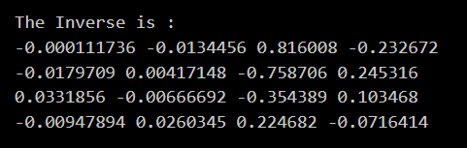

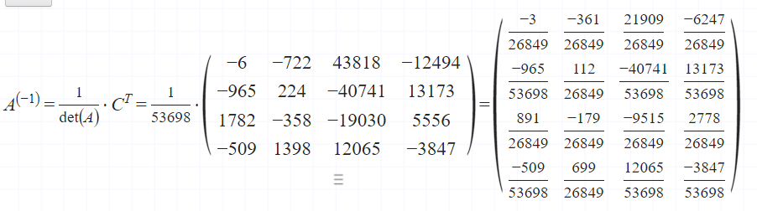

b) Given A 5\*5 Matrix to Find Inverse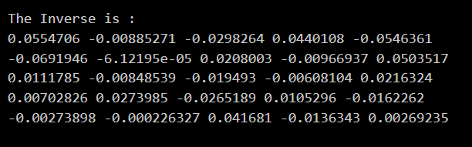

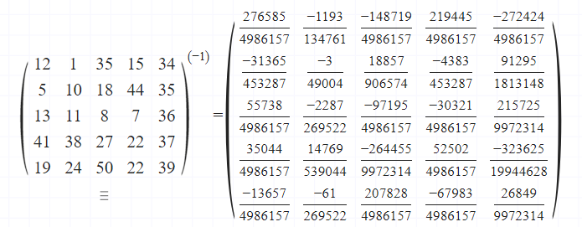

Q2:

1. Given 2 Matrix of 4\*4 Matrix to Find Multiplication

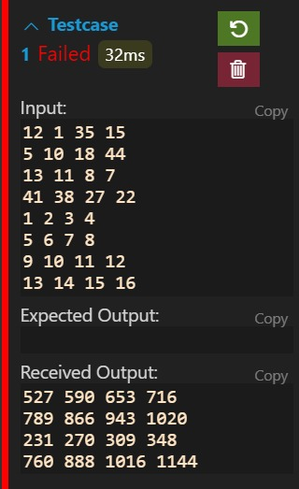

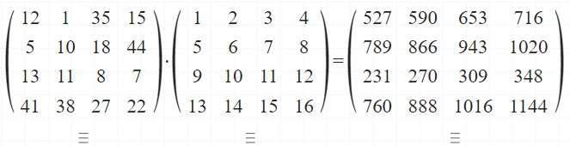

1. Given 2 Matrix of 5\*5 Matrix to Find Multiplication

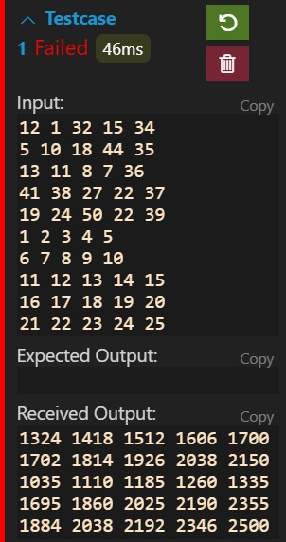

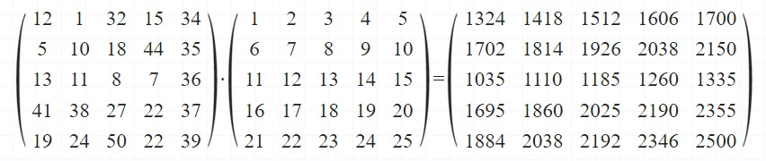

Q4:

1. Representing the Vector in 2-D & 3-D Plane

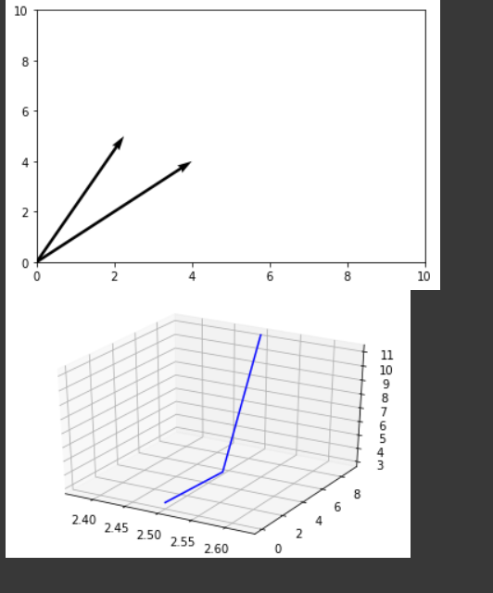

Q5:

1. Given A 2\*2 Matrix to Find Norm

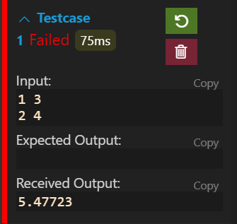

1. Given A 3\*4 Matrix to Find Norm

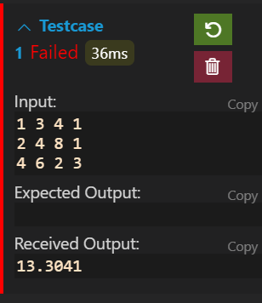

Q6:

1. Given A 4\*4 Matrix to Reduce into Echelon Form

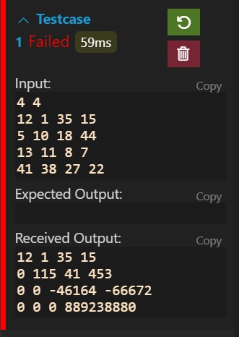

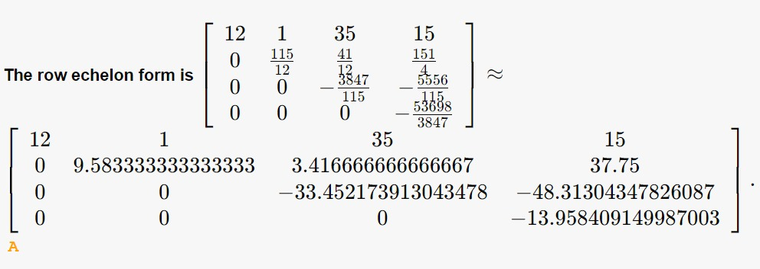

1. Given A 5\*5 Matrix to Reduce into Echelon Form

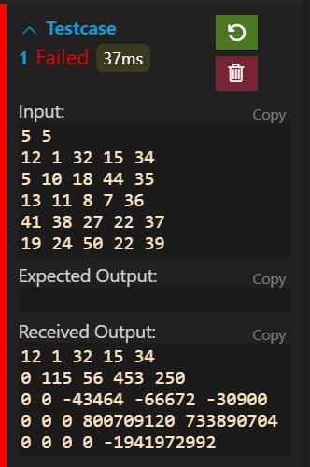

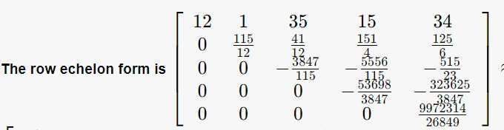

Q7:

1. Given A 4\*4 Matrix to find Rank of Matrix

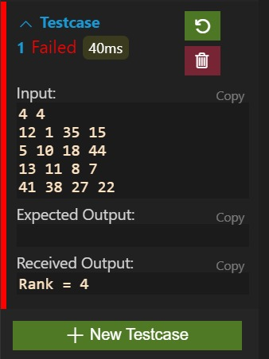

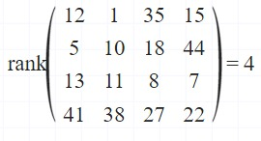

1. Given A 5\*5 Matrix to find Rank of Matrix

