|  |  |  |  |  |
| --- | --- | --- | --- | --- |
|  | INTERNATIONAL TELECOMMUNICATION UNION  **TELECOMMUNICATION** **STANDARDIZATION SECTOR**  STUDY PERIOD 2022-2024 | | **Focus Group on AI Native Networks** | |
| **AINN-I-xx** | |
| **Original: English** | |
| **Question(s):** | | N/A | Virtual, TBD 2024 | |
| **INPUT DOCUMENT** | | | | |
| **Source:** | | *Vajra IITB* | | |
| **Title:** | | *Team Vajra IITB - Report on ITU WTSA Hackathon 2024 – Rainfall Forecasting and Emergency Warning* | | |
| **Contact:** | |  | | E-mail: |

|  |  |
| --- | --- |
| **Abstract:** | This document contains the submission of a report for Team Vajra IITB towards ITU WTSA Hackathon 2024 for the use case *Rainfall Forecasting and Emergency Warning* |

## Use case introduction: “Rainfall Forecasting and Emergency Warning”

In Mumbai City, sudden, heavy rainfall can cause severe waterlogging and flooding, resulting in potential damage to property and loss of life. This situation requires immediate action and response from both authorities and residents to mitigate the damage. To this end, a rainfall forecasting model is required that can predict extreme rainfall 15 minutes to 1 hour in advance. Upon detecting an extreme weather event, the system triggers emergency alerts that are distributed to the residents, emergency responders, and relevant authorities. Network resource allocation in the affected regions is increased for better communication of emergency responders and residents when rescue operations are being carried out.

|  |
| --- |
| *It is the season of monsoon. The city of Mumbai is buzzing with its activities like usual. Suddenly, a rainfall forecasting model, which predicts rainfall in several regions of Mumbai forecasts extreme rainfall in some regions in the coming minutes, which are thus likely to get waterlogged. An emergency warning system, based on the model’s forecast, sends alerts to the residents to either avoid the region, if possible, or to be prepared for a possible waterlogging scenario. It also sends alerts to the relevant authorities and emergency responders so that they can prepare to tackle the harsh situation. The alerts are sent through the 5G network to ensure that they reach the destination as soon as possible. Network resource allocation in the region to be affected is increased to ensure that communication between relevant parties is not a bottleneck during the emergency.* |

Consider the scene map below:

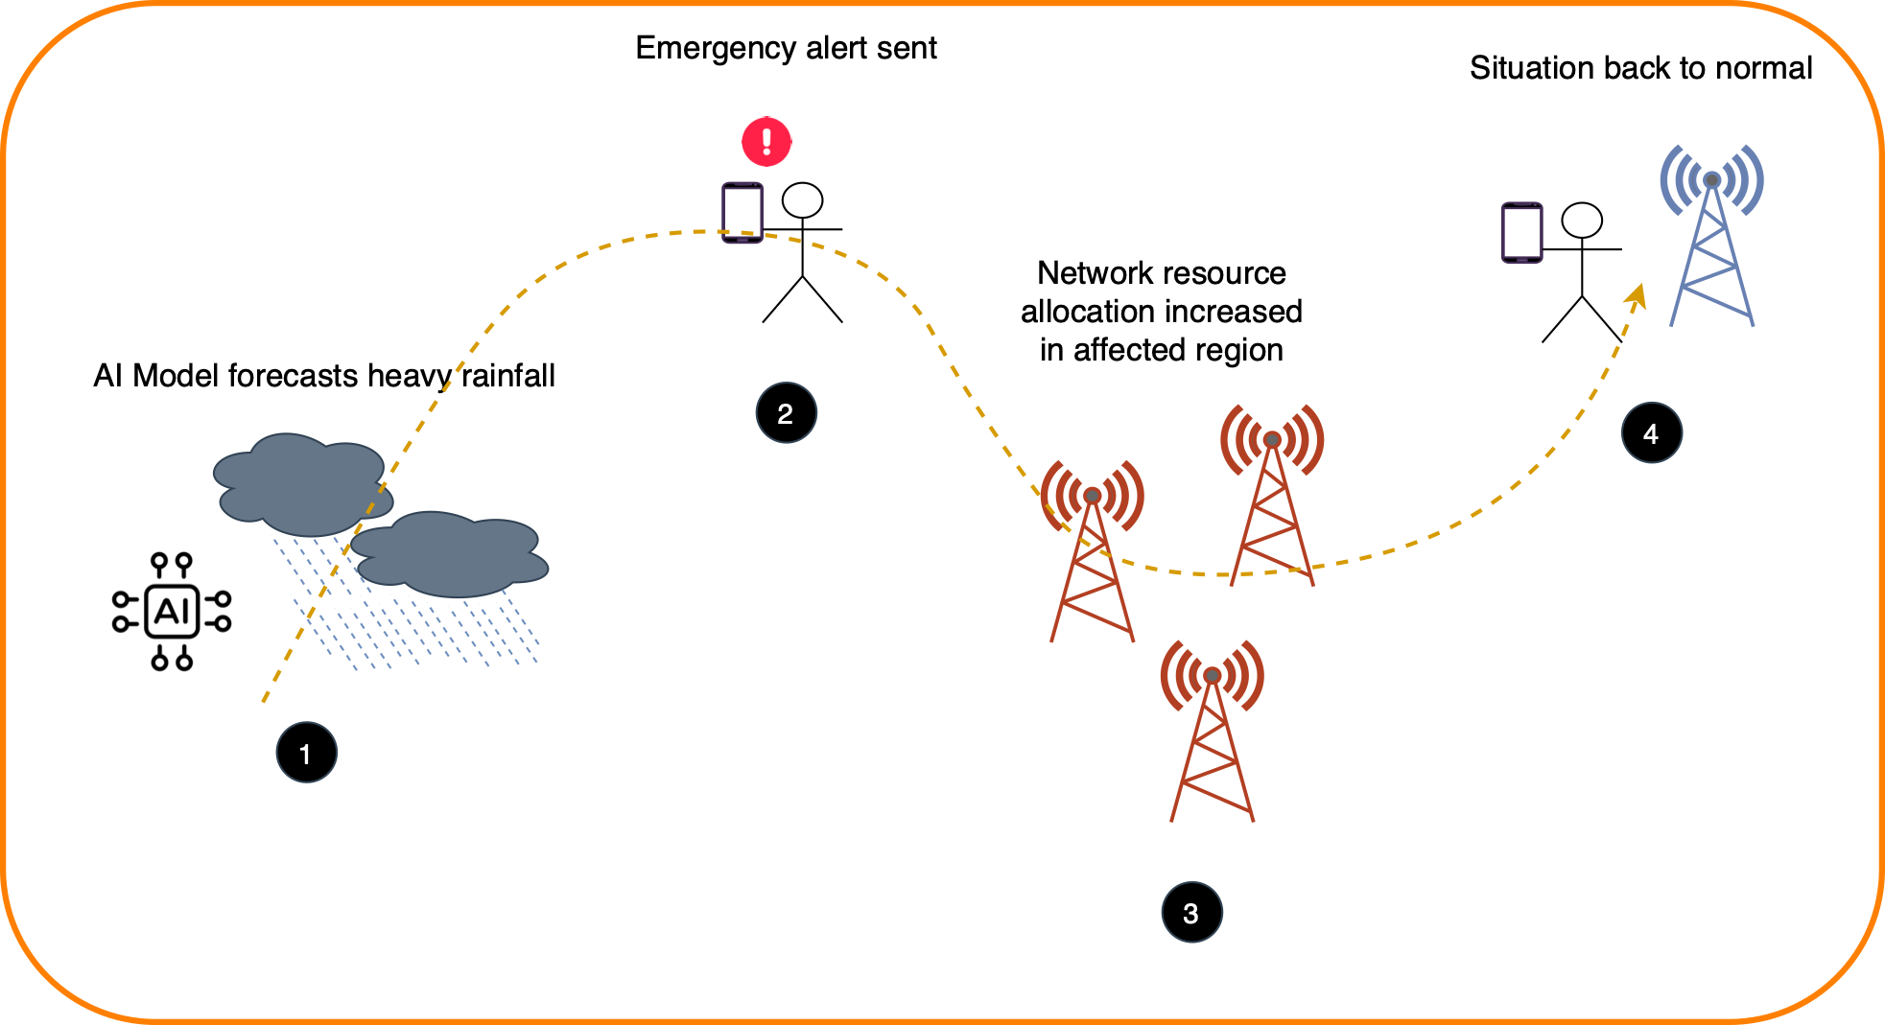

Phase 1: “*Forecasting heavy rainfall”*: Based on the forecast data available from Global Forecasting System (GFS) over a huge region in coarse intervals, and the observed historical data from local weather stations, rainfall for next 15 minutes to next 1 hour predicted using machine learning models.

Phase 2: “*Sending emergency alerts”*: System sends emergency alerts to residents in affected and surrounding areas via mobile applications / SMS. Emergency responders and other relevant authorities are also notified about the same.

Phase 3: “*Resource allocation increase in affected areas”*: The affected regions are allocated more network resources to make sure that important communication regarding emergency response isn’t hindered and all the operations are carried out effectively in the duration of extreme rainfall

Phase 4: “*Emergency situation resolved”*: Eventually, the situation resolves as rainfall slows down. The forecasting system stops sending alert and network resource allocation is brought back to normal.

## Use case requirements

Requirement-1: It is critical that rainfall forecasting models are deployed on the edge or cloud, enabling low-latency processing of weather data and issuing accurate, near real-time predictions.

Requirement-2: It is critical that emergency alerts are distributed to relevant stakeholders with minimal delay, ensuring timely response to the predicted rainfall.

Requirement-3: It is critical that high priority communication resources are allocated to authorities and emergency responders based on geographical location to effectively manage rescue operations

Requirement-4: It is critical that after the extreme weather event is over, the system stops sending alerts and high priority resource allocation is brought back to normal.

## PS1: Pipeline design

* AI /ML Concept used is time series forecasting, anomaly detection
* **In Relation with ITU Y.3172** – for **submission**

**Requirements for this type of application?**

* SRC of data: Global Forecasting System (GFS) forecasts, analysis data; Automated Weather Station (AWS) observed rainfall data
* Collector: cloud
* Models: time series forecasting, anomaly detection (cloud)
* Policies: determining to-be-affected locations, network resource allocation (cloud)
* Distributors : cloud
* Sink : Residents’, emergency responders’, authorities’ UEs, xApp

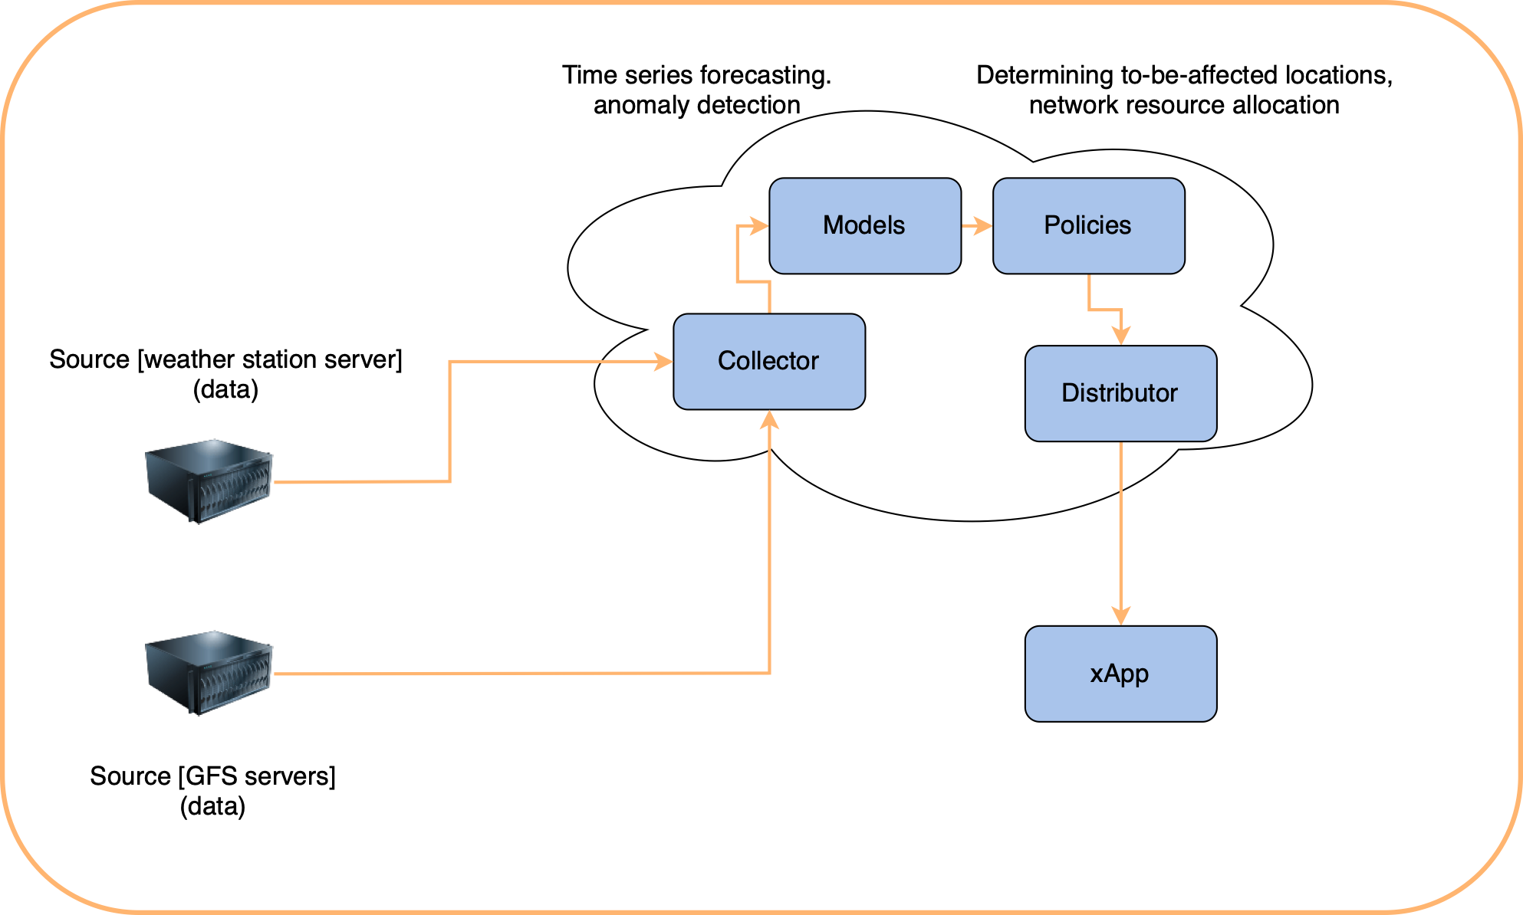

## PS2: xApp design

(To be updated)

## Relation to Standards

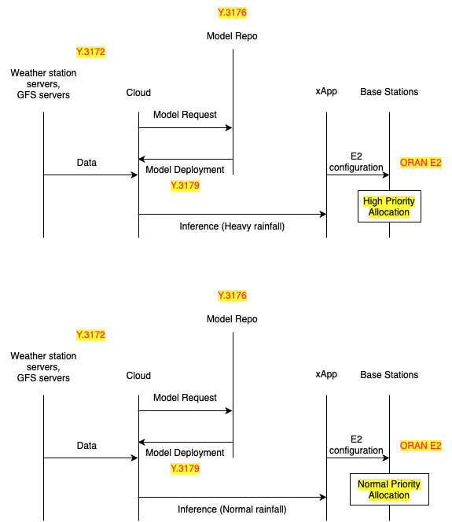

## Code submission details

1. All the program-related files and dataset information are submitted in the github repository mentioned below
2. Github Repo link: (To be updated)

## Self-Testing results

(To be updated)

_________________