## PRACTICE SHEET SOLUTION

Q1)

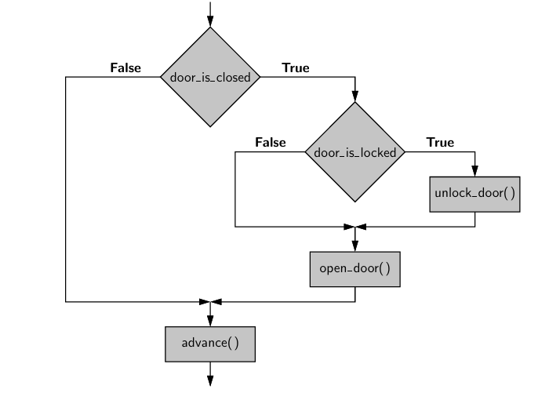

Q4)

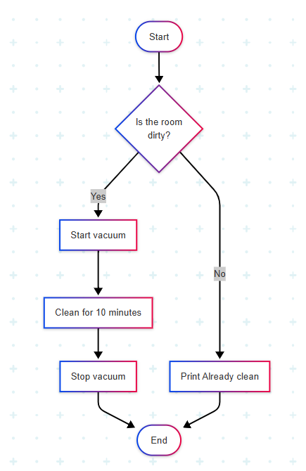

Q5) Pseudocode:

Start

Check if battery is charged

Check if solar or main supply is ON

Check if load < max limit

If battery charged AND (solar ON OR main supply ON) AND load OK:

Enable power supply

Else:

Do not supply

End

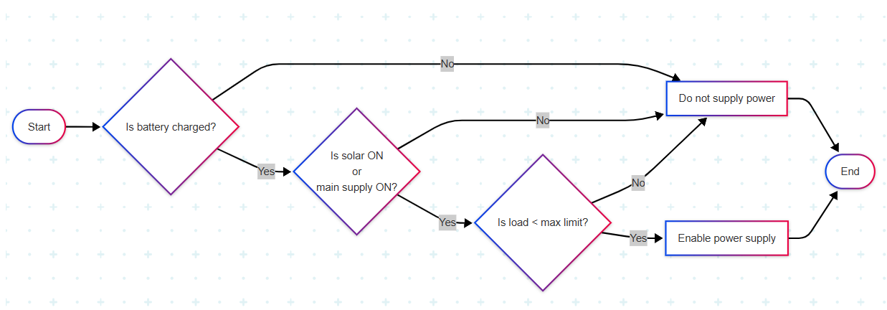

Q6)

Start

While pH != 7:

Read pH

If pH < 3 or pH > 11:

Print "Danger! Stop stirring!"

break

If pH in [4-6] or [8-10]:

Print "Unstable, wait..."

continue

Stir the tank

Print "Mixture is neutral"

End

Q7)

Start

count = 0

processed = 0

While processed < 100:

Check product

processed += 1

If defective:

Print "Defective. Skipped."

continue

count += 1

Print "Total good products:", count

End

Q8)

1. Start (First Fork)
   * Left
     + Swim
       - Friendly Dragon → Success (Escape)
       - Snake → Back to First Fork
     + Back → Back to First Fork
   * Right
     + Enter Cave
       - Maze Exit 1 → Success (Escape)
       - Maze Exit 2 → Dark Pit (Failure)
     + Back → Back to First Fork

Q9) Q10)

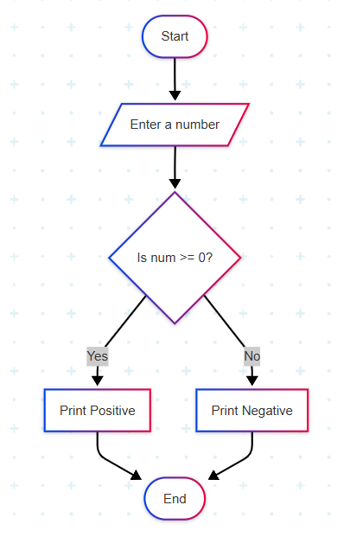 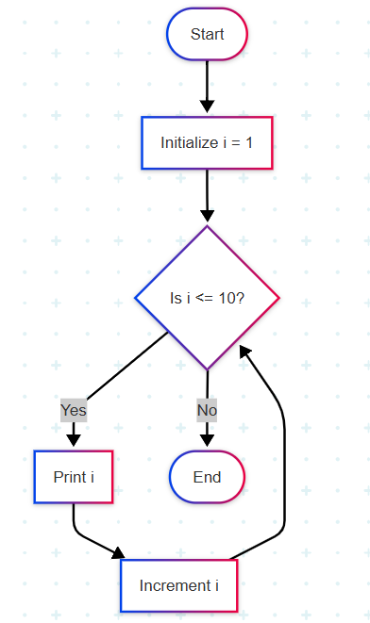

Q11) Q12)

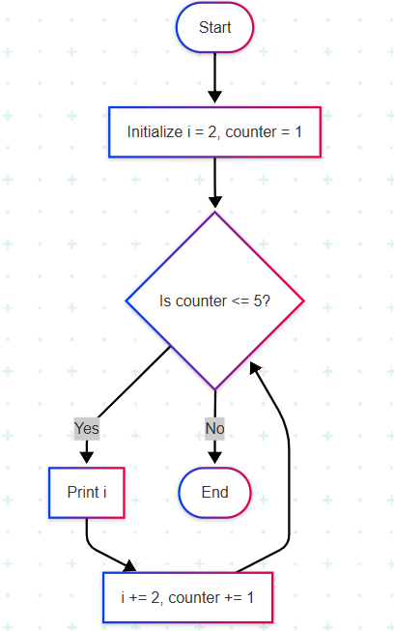 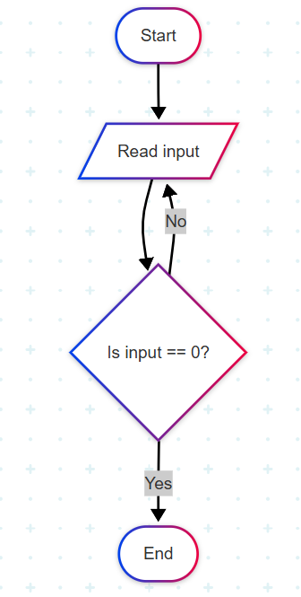

Q13)

1. **Path:** Alice → Charlie → David *or* Alice → Bob → David.

**Answer:** Charlie and Bob are mutual friends.

1. **Answer:** Eve → David → Charlie → Alice.
2. Use arrows.

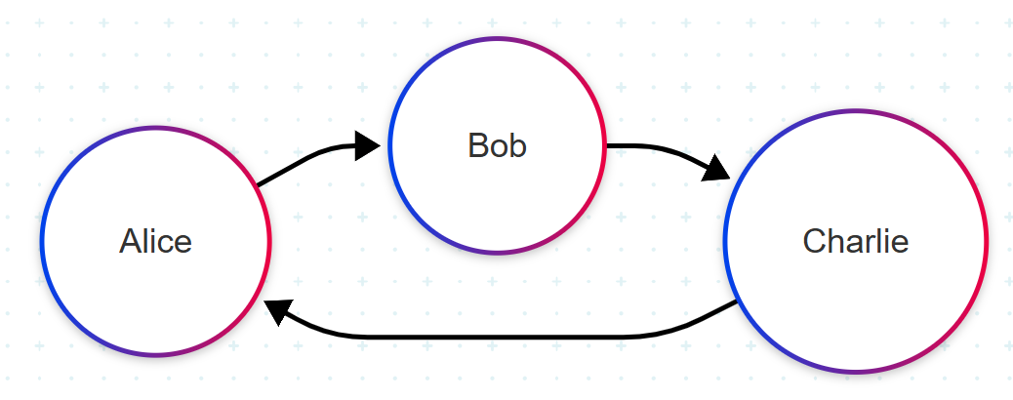

Q14) The shape formed is a **diagonal cross (X shape)**.

**Explanation:**

* The 0s (black pixels) are positioned at the corners and center.
* The 1s (white pixels) form the diagonal lines connecting them.
* This creates an **X pattern.**



Q15)

1. AND gate (both conditions must be true).
2. 0, 0 → 0 (No)

0, 1 → 0 (No)

1, 0 → 0 (No)

1, 1 → 1 (Yes)