2D Arcade Game

By: Kushal Parmar

Student Number: 100973898

Due Date: October 30th 2016

Table of Contents

**Title Page**………………………………………………………………………………………………………………………………………………**1**

**Table of Contents**………………………………………………………………………………………………………………………………….**2**

**Game Description**…………………………………………………………………………………………………………………………………**3**

**Control Description**……………………………………………………………………………………………………………………………….**4**

**Screen Description** ……………………………………………………………………………………………………………………………5-**6**

**Enemies**…………………………………………………………………………………………………………………………………………………**7**

**Scoring………………………………………………………………………………………………………………………………………………7**

**Sound Index………………………………………………………………………………………………………………………………………7**

**Art/Multimedia…………………………………………………………………………………………………………………………………7**

Game Description

This is a simple 2D arcade game. Your fellow comrades are stuck in an asteroid belt and your goal is to save at least 10 of them whilst dodging the oncoming meteors. As you start the game you will be shown the Start state screen, where the friendly and enemies are already zooming on the screen. When the start button is clicked the game will begin and a Blue UFO will appear on the screen which will be controlled by the player using the Arrow keys or WASD keys. There are specific boundaries set up around the camera’s view so that they player won’t be able to leave the camera’s view. The game ends when the player has no more lives and that is when the user will be prompted with a screen showing “Game over” and a start button to try again also the number of points they failed achieve. If the player achieves the targeted points, the You Win label will be displayed with the start button to play again.

Controls Descriptions

The player can control the blue UFO using the arrow keys or the wasd keys.

up

up

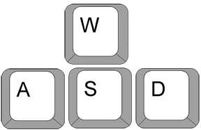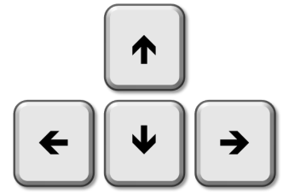

left

down

right

left

down

right

Screen Descriptions

Start State: Points label, Lives Label displayed start button to start the game and enemy and friendly zooming through background

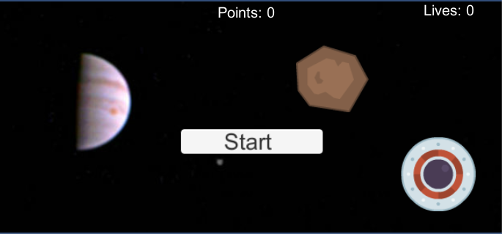

Gameplay State: Points Label displaying 100 points and lives 3, blue UFO enters game. Controls enabled to move the UFO to achieve the target.

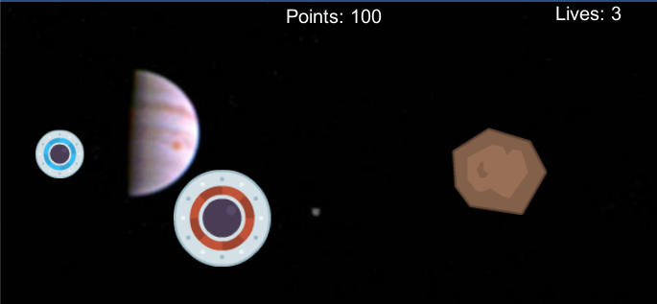

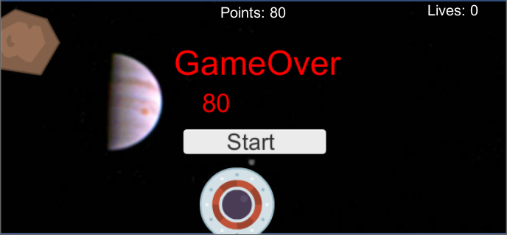

Lose End Game State: Displays the amount of points you failed to achieve as well as start button to try again:

Win End Game State: Displays You Win label as well as number of lives you still have. Start button to play again:

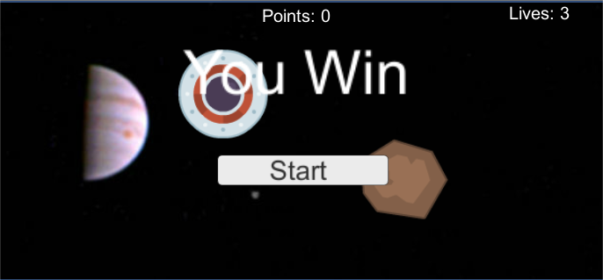

Enemies

The enemies are coded to move in the same direction as the friendly space ships and appear randomly onto the scene as soon as they exit the scene. If enemies and player collide the player loses 1 life point.

Scoring

The player has a target of 100 points which can be accomplished by colliding with a friendly UFO. Each time the player collides with a friendly UFO the points decrease by 10 until you reach 0 where the Win End Game State is displayed.

Sound Index

Background Music: Alan Walker Fade - Background music

Enemy Collision: Cha Ching money Sound Effect

Friendly Collision: Explosion Sound Effect (Powerpuff Girls Version)

Art/Multimedia Index

Enemy

Background Image



RedUFO(friendly)

BlueUFO(player)