**CAS Project: Be Cognizant Featured News**

**Framework Overview**

The given project is built using the following frameworks and libraries:

**Selenium:** Selenium is a popular open-source framework for automating web browsers.

**TestNG:** TestNG is a testing framework that provides advanced features like parallel test execution, data-driven testing, and test configuration through annotations.

**Cucumber:** Cucumber is a tool for behaviour-driven development (BDD)that allows you to write test scenarios in a human-readable format.

**Apache POI:** Apache POI is a library for working with Microsoft Office documents, including Excel files.

**Extent Reports:** Extent Reports is a powerful reporting library used for generating HTML reports in testing automation frameworks.

**Folder Structure:**

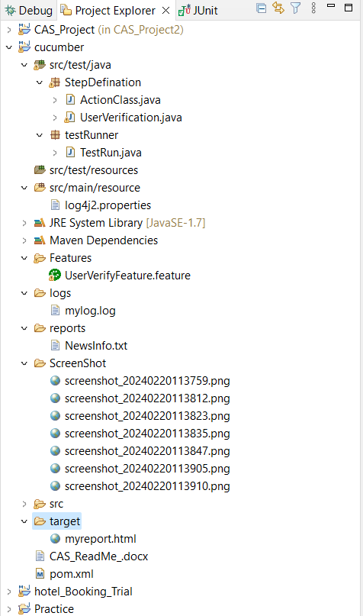

**Changes to Run the Project:**

To run the project, you need to make the following changes:

You need to change the file path of excel.

To view the Cucumber report, follow the link provided in the console. To view the Extent report, go to the target folder and open the myreport.html file.

Please note that the provided instructions assume familiarity with the project structure and configuration files. Make sure to have the necessary dependencies and configurations in place before running the project.