**Hackathon Project :**

**Book one way outstation cab and display the lowest charge**

Detailed Description:

1. Book one way outstation cab, From Delhi to Manali, Himachal Pradesh

give future date & time & Car type should be SUV; Display the lowest charges.

2. Find wedding Gift Card in Gift Cards, fill card details & give invalid email,

capture & display the error message.

3. On the Hotel booking page, extract all the numbers for adult persons and store in a List,

Display the same.

Framework Overview

The given project is built using the following frameworks and libraries:

Selenium: Selenium is a popular open-source framework for automating web browsers.

TestNG: TestNG is a testing framework that provides advanced features like parallel test execution, data-driven testing, and test configuration through annotations.

Apache POI: Apache POI is a library for working with Microsoft Office documents, including Excel files.

Extent Reports: Extent Reports is a powerful reporting library used for generating HTML reports in testing automation frameworks.

Selenium Grid: Selenium grid is a tool used to run multiple tests simultaneously across different browsers and operating systems.

Git: Git is distributed version control system that tracks changes in source code during testing in local scope.

GitHub: GitHub is a web-based platform build on top of git and offers features such as repository hosting, tracking and continuous integration.

Jenkins: Jenkins is an open-source automation server used for continuous integration and continuous deployment. It automates the building, testing, and deployment of application and enables to integrate changes frequently and efficiently.

Folder Structure:

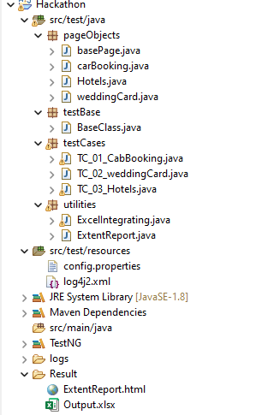

Changes to Run the Project:

To run the project, you need to make the following changes:

You need to change the file path of excel.

To view the Extent report, go to the Result folder and open the Extentreport.html file.

Please note that the provided instructions assume familiarity with the project structure and configuration files. Make sure to have the necessary dependencies and configurations in place before running the project.