LAB – 3
PYTHON BASIC PRACTICE – III

210905189
Kushala Sarada A V
Roll No. 33

22/01/2024

import numpy as np

# 1. Array creation
A = np.array([2, 5, 10])
print(A.dtype) # int64

B = np.array([2.4, 10.6, 5.2])
print(B.dtype) # float64

# Creating a 2-dimensional array
C = np.array([(3, 4, 5), (12, 6, 1)])

# Creating zero matrix of dimension 2x4
Z = np.zeros((2, 4))
print(Z)

# Creating ones matrix of dimension 3x3
O = np.ones((3, 3))
print(O)

# Creating a sequence of data using arange
S = np.arange(10, 30, 5)
print(S) # [10 15 20 25]

# arange with float arguments
F = np.arange(0, 2, 0.3)
print(F)
# [0. 0.3 0.6 0.9 1.2 1.5 1.8]
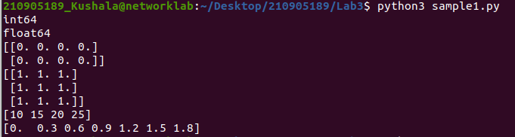
import numpy as np
import random

# Using linspace to specify the total number of elements in the array
S1 = np.linspace(0, 2, 9)
print(S1)
# [0. 0.25 0.5 0.75 1. 1.25 1.5 1.75 2. ]

# Random number generation using random module
print(random.choice([1, 2, 3, 4, 5])) # Pick one number randomly from the list
print(random.choice('python')) # Pick one character randomly from the string

# Pick one integer between 25 to 50
print(random.randrange(25, 50))

# Pick one integer between 25 to 50 with a step size of 2
print(random.randrange(25, 50, 2))

# Pick a random number between 0 to 1
print(random.random())

# Pick a floating-point number between 5 to 10
print(random.uniform(5, 10))

# Shuffle the elements of the list
my_list = [1, 2, 3, 4, 5]
random.shuffle(my_list)
print(my_list)

# Set the seed to get the same random value during every execution
random.seed(10)
print(random.random())

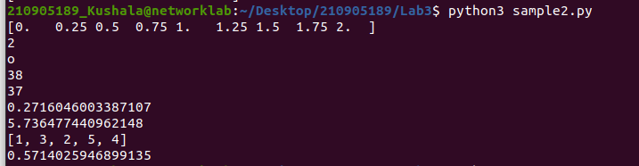
import numpy as np
a = np.arange(15).reshape(3, 5)
print(a)
print(a.shape) # (3, 5)
print(a.size) # 15
print(a.T) # Transpose to a 5x3 matrix

c = np.arange(24).reshape(2, 3, 4)
print(c)
print(c.shape) # (2, 3, 4)
print(c[1, ...]) # Equivalent to c[1, :, :]
print(c[..., 2]) # Equivalent to c[:, :, 2]
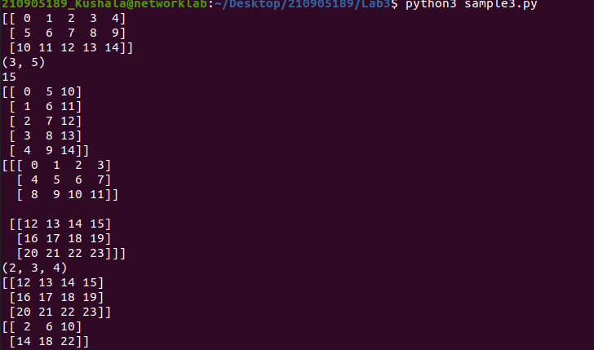
import numpy as np

a = np.array([20, 30, 40, 50])
b = np.arange(4)
c = a - b
print("a - b:", c)
print("b^2:", b**2)
print("10 * sin(a):", 10 * np.sin(a))
print("a < 35:", a < 35)

A = np.array([[1, 1], [0, 1]])
B = np.array([[2, 0], [3, 4]])
print("A * B (Elementwise product):", A * B)
print("np.dot(A, B) (Matrix product):", np.dot(A, B))

b = np.arange(12).reshape(3, 4)
print("Sum of each column:", b.sum(axis=0))
print("Sum of each row:", b.sum(axis=1))

print("Flattened array:", b.ravel())
B1 = b.reshape(2, 6)
print("Reshaped matrix (4x5):", B1)

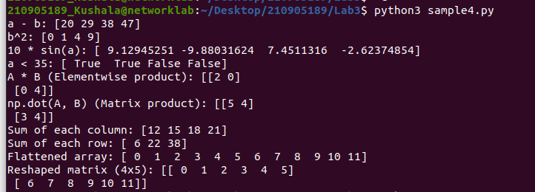
import numpy as np
a = np.arange(10)**3
print(a[2:5])
print(a[0:6:2])

b = np.array([[0, 1, 2, 3], [10, 11, 12, 13], [20, 21, 22, 23], [30, 31, 32, 33], [40, 41, 42, 43]])
print(b[2, 3])
print(b[0:5, 1])
print(b[-1, :])

for row in b:
print(row)

for element in b.flat:
print(element)

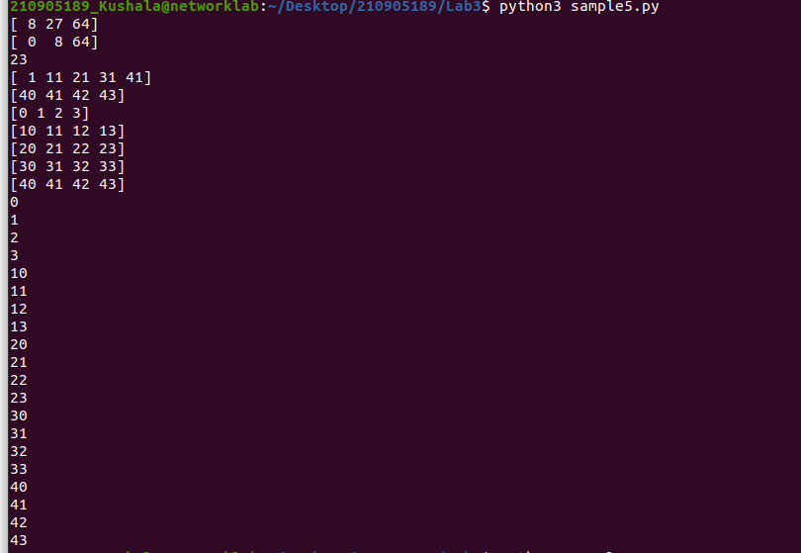
import numpy as np

# Array Operations
a = np.array([20, 30, 40, 50])
b = np.arange(4)
c = a - b
print("a - b:", c)
print("b^2:", b**2)
print("10 * sin(a):", 10 * np.sin(a))
print("a < 35:", a < 35)

# Matrix Operations
A = np.array([[1, 1], [0, 1]])
B = np.array([[2, 0], [3, 4]])
print("A * B (Elementwise product):", A * B)
print("np.dot(A, B) (Matrix product):", np.dot(A, B))

# Another Matrix Sum Operations
b = np.arange(12).reshape(3, 4)
print("Sum of each column:", b.sum(axis=0))
print("Sum of each row:", b.sum(axis=1))

# Changing the Shape of a Matrix
print("Flattened array:", b.ravel())
try:
B1 = b.reshape(4, 5) # Raises ValueError
except ValueError as e:
print("Error:", e)

# Stacking Operations
A1 = np.array([(3, 4, 5), (12, 6, 1)])
A2 = np.array([(1, 2, 6), (-4, 3, 8)])
D1 = np.vstack((A1, A2))
print("Vertical Stack D1:\n", D1)

D2 = np.hstack((A1, A2))
print("Horizontal Stack D2:\n", D2)

a = np.array([4., 2.])
b = np.array([3., 8.])
result_column_stack = np.column_stack((a, b))
print("Column-wise Stack:\n", result_column_stack)

# Indexing with Array of Indices
a = np.arange(12)**2
i = np.array([1, 1, 3, 8, 5])
result_i = a[i]
print("Indexing with array i:", result_i)

j = np.array([[3, 4], [9, 7]])
result_j = a[j]
print("Indexing with array j:\n", result_j)

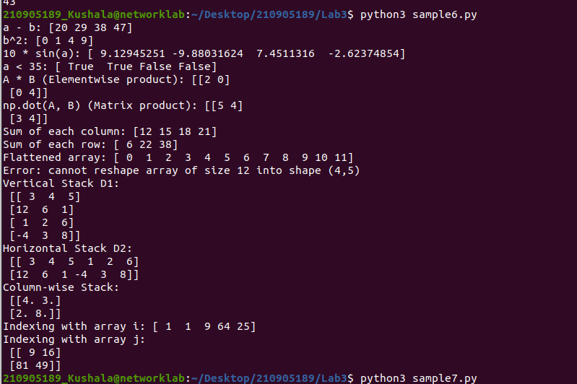
import numpy as np

# Mapping by Value
a = np.array([(3, 2, 9), (1, 6, 7)])
s1 = 0

for row in a:
for col in row:
s1 += col

print("Sum using value mapping:", s1)

# Mapping by Index
a = np.array([(3, 2, 9), (1, 6, 7)])
s = 0

for i in range(a.shape[0]):
for j in range(a.shape[1]):
s += a[i, j]

print("Sum using index mapping:", s)

