1. Word Count Program
Mapper:
import sys

# Input comes from STDIN (standard input)
for line in sys.stdin:
# Remove leading and trailing whitespace
line = line.strip()
# Split the line into words
words = line.split()
# Increase counters
for word in words:
# Write the results to STDOUT (standard output);
# what we output here will be the input for the
# Reduce step, i.e. the input for reducer.py
# Tab-delimited; the trivial word count is 1
print("%s\t\t%s" % (word, 1))
Reducer:
import sys

current_word = None
current_count = 0
word = None

# Input comes from STDIN
for line in sys.stdin:
# Remove leading and trailing whitespace
line = line.strip()
# Parse the input we got from mapper.py
word, count = line.split('\t', 1)
# Convert count (currently a string) to int
try:
count = int(count)
except ValueError:
# Count was not a number, so silently
# ignore/discard this line
continue
# This IF-switch only works because Hadoop sorts map output
# by key (here: word) before it is passed to the reducer
if current_word == word:
current_count += count
else:
if current_word:
# Write result to STDOUT
print('%s\t%s' % (current_word, current_count))
current_count = count
current_word = word

# Do not forget to output the last word if needed!
if current_word == word:
print('%s\t%s' % (current_word, current_count))

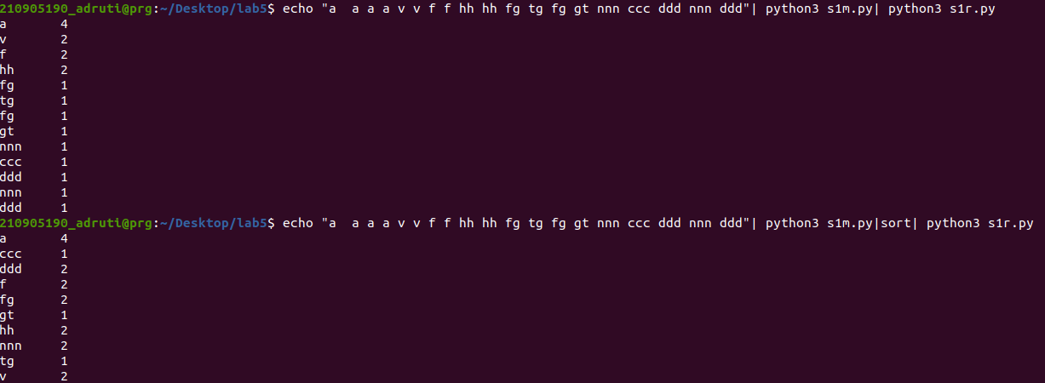

2. MapReduce Program to Find Frequent Words
Mapper:
import sys

for line in sys.stdin:
L = [(word.strip().lower(), 1) for word in line.strip().split()]
for word, n in L:
print('%s\t%d' % (word, n))
Reducer:
import sys

lastWord = None
sum = 0

for line in sys.stdin:
word, count = line.strip().split('\t', 1)
count = int(count)

if lastWord == None:
lastWord = word
sum = count
continue

if word == lastWord:
sum += count
else:
print("%s\t%d" % (lastWord, sum))
sum = count
lastWord = word

if lastWord == word:
print('%s\t%s' % (lastWord, sum))

Mapper:
#!/usr/bin/env python
# A basic mapper function/program that
# takes whatever is passed on the input and
# outputs tuples of all the words formatted
# as (word, 1)
from __future__ import print_function
import sys

# input comes from STDIN (standard input)
for line in sys.stdin:
word, count = line.strip().split('\t', 1)
count = int(count)
print('%d\t%s' % (count, word))
Reducer:
#!/usr/bin/env python
# reducer.py
from __future__ import print_function
import sys

mostFreq = []
currentMax = -1

for line in sys.stdin:
count, word = line.strip().split('\t', 1)
count = int(count)

if count > currentMax:
currentMax = count
mostFreq = [word]
elif count == currentMax:
mostFreq.append(word)

# Output most frequent word(s)
for word in mostFreq:
print('%s\t%s' % (word, currentMax))
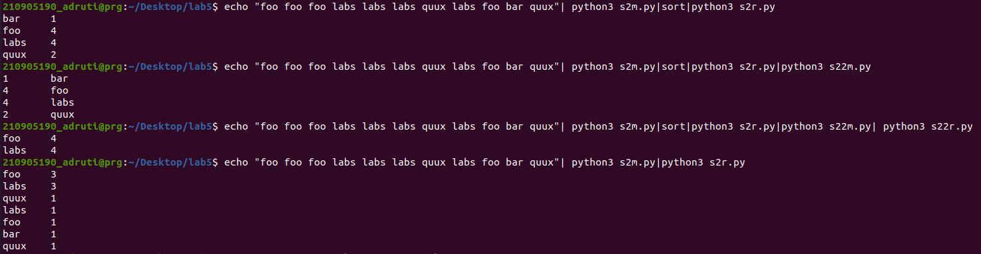

3. MapReduce Program to Explore and Filter Dataset
Mapper:
import fileinput
# Loop through each line of input from file or stdin
for line in fileinput.input():
# Split the line into fields
data = line.strip().split("\t")
# Check if the line has 6 fields (assuming it's properly formatted)
if len(data) == 6:
# Extract location and cost fields
date, time, location, item, cost, payment = data
# Output location and cost as key-value pairs
print("{0}\t{1}".format(location, cost))
Reducer:
import fileinput

# Initialize counters
transactions_count = 0
sales_total = 0

# Loop through each line of input from file or stdin
for line in fileinput.input():
# Split the line into key-value pairs
data = line.strip().split("\t")
# Check if the line has 2 fields (assuming it's properly formatted)
if len(data) != 2:
# Something has gone wrong. Skip this line.
continue
# Extract key and value
current_key, current_value = data
# Increment transaction count
transactions_count += 1
# Add current transaction value to total sales
sales_total += float(current_value)

# Print the total number of transactions and the total sales amount
print(transactions_count, "\t", sales_total)

