4. Write a mapper and reducer program for word count by defining separator
instead of using “\t”.

# sepmap.py
# A more advanced Mapper, using Python iterators and generators
import sys

def read_input(file):
for line in file:
# split the line into words
yield line.split()

def main(separator='\t'):
# input comes from STDIN (standard input)
data = read_input(sys.stdin)
for words in data:
# write the results to STDOUT (standard output);
# what we output here will be the input for the
# Reduce step, i.e. the input for reducer.py
# tab-delimited; the trivial word count is 1
for word in words:
print('%s%s%d' % (word, separator, 1))

if __name__=="__main__":
main()

# sepred.py
# more advanced Reducer, using Python iterators and generators
from itertools import groupby
from operator import itemgetter
import sys

def read_mapper_output(file, separator='\t'):
for line in file:
yield line.rstrip().split(separator, 1)

def main(separator='\t'):
# input comes from STDIN (standard input)
data = read_mapper_output(sys.stdin, separator=separator)
# groupby groups multiple word-count pairs by word,
# and creates an iterator that returns consecutive keys and their group:
# current_word - string containing a word (the key)
# group - iterator yielding all ["<current_word>", "<count>"] items
for current_word, group in groupby(data, itemgetter(0)):
try:
total_count = sum(int(count) for current_word, count in group)
print ("%s%s%d" % (current_word, separator, total_count))
except ValueError:
# count was not a number, so silently discard this item
pass

if __name__=="__main__":
main()

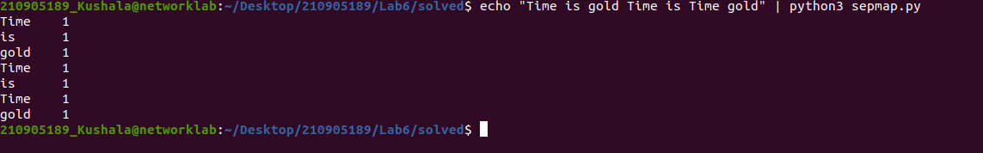
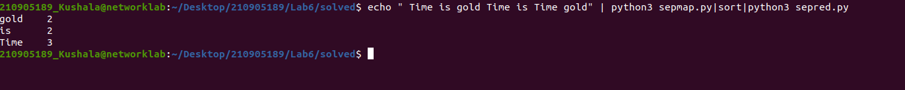
5. Write a map reduce program that returns the cost of the item that is most
expensive, for each location in the dataset example.txt

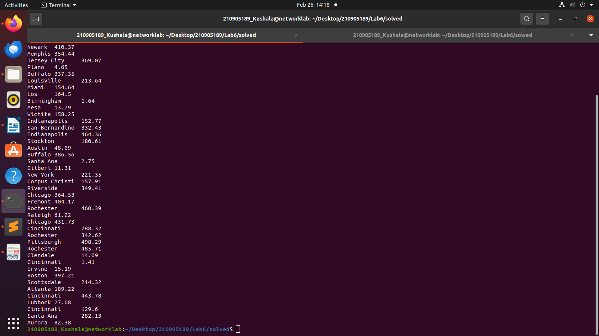
import fileinput

for line in fileinput.input():
data = line.strip().split("\t")
if len(data) == 6:
date, time, location, item, cost, payment = data
print("{0}\t{1}".format(location, cost))

import fileinput

max_value = 0
old_key = None

for line in fileinput.input():
data = line.strip().split("\t")
if len(data) != 2:
# Something has gone wrong. Skip this line.
continue

current_key, current_value = data

# Refresh for new keys (i.e. locations in the example context)
if old_key and old_key != current_key:
print(old_key,"\t", max_value)
max_value = 0

if float(current_value) > float(max_value):
max_value = float(current_value)

old_key = current_key

if old_key is not None:
print(old_key, "\t", max_value)

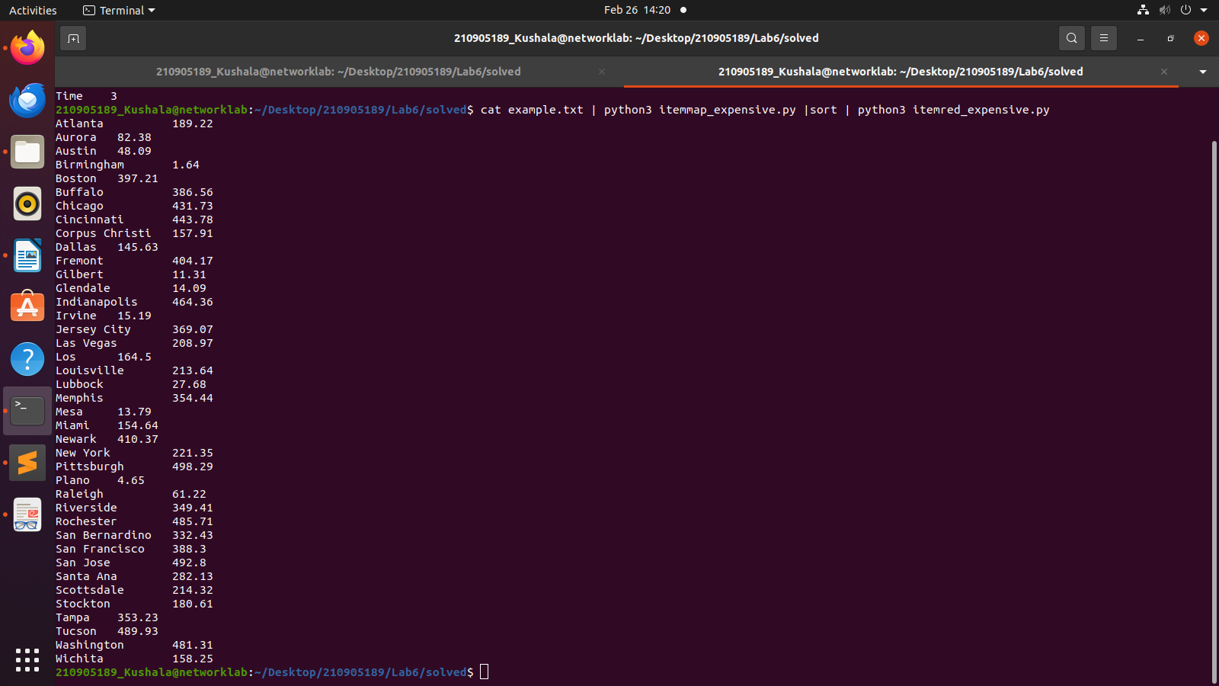
6. Write a mapreduce program to evaluate the PI.

import sys

def f(x):
return 4.0 / (1.0 + x * x)

# input comes from STDIN (standard input)
for line in sys.stdin:
# remove leading and trailing whitespace
line = line.strip()
# split the line into words
words = line.split()
N = int(words[0])
deltaX = 1.0 / N
for i in range(0, N):
print("1\t%1.10f" % (f(i * deltaX) * deltaX))

from __future__ import print_function
import sys

sum = 0

# input comes from STDIN
for line in sys.stdin:
# remove leading and trailing whitespace
line = line.strip()
# parse the input we got from mapper.py
word, count = line.split('\t', 1)
# convert count (currently a string) to float
try:
count = float(count)
except ValueError:
# count was not a number, so silently
# ignore/discard this line
continue
sum += count

# print the total sum
print('%1.10f\t0' % sum)

