Lab 7:

sample1. Cristian’s algorithm

server:
import socket
import datetime
import time
# function used to initiate the Clock Server
def initiateClockServer():
s = socket.socket()
print("Socket successfully created")
# Server port
port = 8011
s.bind(('', port))
# Start listening to requests
s.listen(5)
print("Socket is listening...")
# Clock Server Running forever
while True:
# Establish connection with client
connection, address = s.accept()
print('Server connected to', address)
# Respond the client with server clock time
connection.send(str(datetime.datetime.now()).encode())
# Close the connection with the client process
connection.close()
# Driver function
if __name__== '__main__':
# Trigger the Clock Server
initiateClockServer()
O/P:
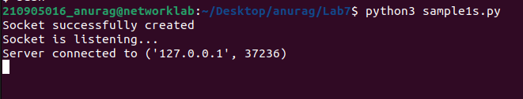

client prototype:
import socket
import datetime
from dateutil import parser
from timeit import default_timer as timer# function used to Synchronize client process time
def synchronizeTime():
s = socket.socket()
# Server port
port = 8011
# connect to the clock server on local computer
s.connect(('127.0.0.1', port))
request_time = timer()
# receive data from the server
server_time = parser.parse(s.recv(1024).decode())
response_time = timer()
actual_time = datetime.datetime.now()
print("Time returned by server: " + str(server_time))
process_delay_latency = response_time - request_time
print("Process Delay latency: " + str(process_delay_latency) + " seconds")
print("Actual clock time at client side: " + str(actual_time))
# synchronize process client clock time
client_time = server_time + datetime.timedelta(seconds = (process_delay_latency) / 2)
print("Synchronized process client time: " + str(client_time))
# calculate synchronization error
error = actual_time - client_time
print("Synchronization error : " + str(error.total_seconds()) + " seconds")
s.close()
if __name__== '__main__':
# synchronize time using clock server
synchronizeTime()

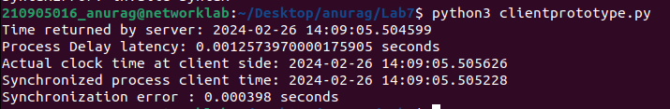
sample2 :Berkeley’s algorithm:

server:
from functools import reduce
from dateutil import parser
import threading
import datetime
import socket
import time

# datastructure used to store client address and clock data
client_data = {}

''' nested thread function used to receive
clock time from a connected client '''
def startRecieveingClockTime(connector, address):
while True:
# recieve clock time
clock_time_string = connector.recv(1024).decode()
clock_time = parser.parse(clock_time_string)
clock_time_diff = datetime.datetime.now() - clock_time
client_data[address] = {
"clock_time": clock_time,
"time_difference": clock_time_diff,
"connector": connector
}
print("Client Data updated with: " + str(address), end="\n\n")
time.sleep(5)

''' master thread function used to open portal for
accepting clients over given port '''
def startConnecting(master_server):
# fetch clock time at slaves / clients
while True:
# accepting a client / slave clock client
master_slave_connector, addr = master_server.accept()
slave_address = str(addr[0]) + ":" + str(addr[1])
print(slave_address + " got connected successfully")
current_thread = threading.Thread(
target=startRecieveingClockTime,
args=(master_slave_connector, slave_address,))
current_thread.start()

# subroutine function used to fetch average clock difference
def getAverageClockDiff():
current_client_data = client_data.copy()
time_difference_list = list(client['time_difference'] for client_addr, client in client_data.items())
sum_of_clock_difference = sum(time_difference_list, datetime.timedelta(0, 0))
average_clock_difference = sum_of_clock_difference / len(client_data)
return average_clock_difference

def synchronizeAllClocks():
while True:
print("New synchroniztion cycle started.")
print("Number of clients to be synchronized: " + str(len(client_data)))
if len(client_data) > 0:
average_clock_difference = getAverageClockDiff()
for client_addr, client in client_data.items():
try:
synchronized_time = datetime.datetime.now() + average_clock_difference
client['connector'].send(str(synchronized_time).encode())
except Exception as e:
print("Something went wrong while sending synchronized time through " + str(client_addr))
else:
print("No client data. Synchronization not applicable.")
print("\n\n")
time.sleep(5)

# function used to initiate the Clock Server / Master Node
def initiateClockServer(port=8080):
master_server = socket.socket()
master_server.setsockopt(socket.SOL_SOCKET, socket.SO_REUSEADDR, 1)
print("Socket at master node created successfully\n")
master_server.bind(('', port))
# Start listening to requests
master_server.listen(10)
print("Clock server started...\n")
# start making connections
print("Starting to make connections...\n")
master_thread = threading.Thread(target=startConnecting, args=(master_server,))
master_thread.start()
# start synchroniztion
print("Starting synchronization parallely...\n")
sync_thread = threading.Thread(target=synchronizeAllClocks, args=())
sync_thread.start()

# Driver function
if __name__ == '__main__':
# Trigger the Clock Server
initiateClockServer(port=8080)

O/P:
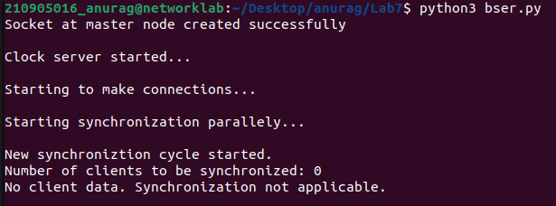

client:
from timeit import default_timer as timer
from dateutil import parser
import threading
import datetime
import socket
import time

# client thread function used to send time at client side
def startSendingTime(slave_client):
while True:
# provide server with clock time at the client
slave_client.send(str(datetime.datetime.now()).encode())
print("Recent time sent successfully", end="\n\n")
time.sleep(5)

# client thread function used to receive synchronized time
def startReceivingTime(slave_client):
while True:
# receive data from the server
Synchronized_time = parser.parse(slave_client.recv(1024).decode())
print("Synchronized time at the client is: " + str(Synchronized_time), end="\n\n")

# function used to Synchronize client process time
def initiateSlaveClient(port=8080):
slave_client = socket.socket()
# connect to the clock server on local computer
slave_client.connect(('127.0.0.1', port))
# start sending time to server
print("Starting to receive time from server\n")
send_time_thread = threading.Thread(target=startSendingTime, args=(slave_client,))
send_time_thread.start()
# start recieving synchronized from server
print("Starting to recieving synchronized time from server\n")
receive_time_thread = threading.Thread(target=startReceivingTime, args=(slave_client,))
receive_time_thread.start()

# Driver function
if __name__ == '__main__':
# initialize the Slave / Client
initiateSlaveClient(port=8080)

O/P:

