LAB – 2
PYTHON BASIC PRACTICE – II

210905189
Kushala Sarada A V
Roll No. 33

15/01/2024

import pandas as pd
from IPython.display import display
data = [['Dinesh',10],['Nithya',12],['Raji',13]]
df = pd.DataFrame(data,columns=['Name','Age'])
display(df)
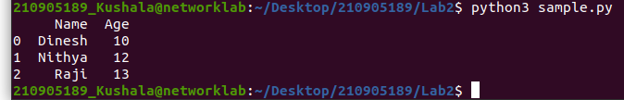
import pandas as pd
from IPython.display import display
data = {'Name':['Kavitha', 'Sudha', 'Raju','Vignesh'],'Age':[28,34,29,42]}
df = pd.DataFrame(data, index=['rank1','rank2','rank3','rank4'])
display(df)

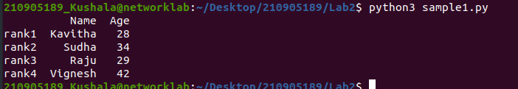
import pandas as pd
import numpy as np
from IPython.display import display

# Create DataFrame df1
df1 = pd.DataFrame({
'A': pd.Timestamp('20130102'),
'B': np.array([3] * 4, dtype='int32'),
'C': pd.Categorical(['Male', 'Female', 'Male', 'Female'])
})

# Display df1
display(df1)

# Display dtypes of df1
print("Data Types:")
print(df1.dtypes)

# Display the first few rows of df1
print("\nHead:")
print(df1.head())

# Display the last few rows of df1
print("\nTail:")
print(df1.tail())

# Display summary statistics of df1
print("\nSummary:")
print(df1.describe())

# Transpose df1 and display
print("\nTranspose:")
print(df1.T)
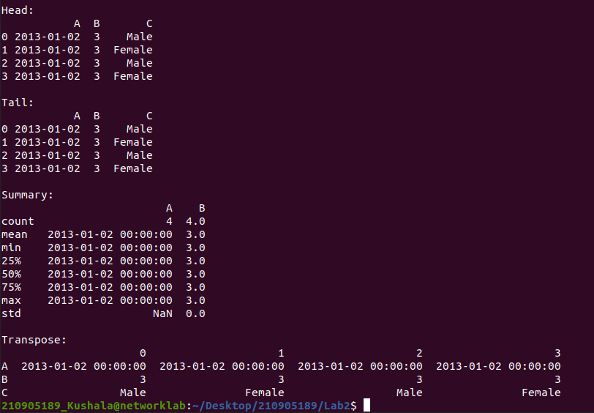
import pandas as pd
import numpy as np

# Creating a DataFrame with random data
dates = pd.date_range('20130101', periods=100)
df = pd.DataFrame(np.random.randn(100, 4), index=dates, columns=list('ABCD'))

# Viewing the first 5 records
print("First 5 records:")
print(df.head())

# Viewing the last 5 records
print("\nLast 5 records:")
print(df.tail())

# Viewing the index
print("\nIndex:")
print(df.index)

# Viewing the column names
print("\nColumn names:")
print(df.columns)

# Transposing the DataFrame
print("\nTransposed DataFrame:")
print(df.T)

# Sorting by axis (columns in this case) in descending order
print("\nSorting by Axis:")
print(df.sort_index(axis=1, ascending=False))

# Sorting by values in column 'B'
print("\nSorting by Values in Column 'B':")
print(df.sort_values(by='B'))

# Slicing the first 3 records (rows)
print("\nSlicing the first 3 records:")
print(df[0:3])

# Slicing with index name for a specific date range
print("\nSlicing with index name for a date range:")
print(df['20130105':'20130110'])

# Slicing with row and column index
print("\nSlicing with row and column index:")
# Fetching entire 1st row
print(df.iloc[0])
# Fetching 1st row, first 2 columns
print(df.iloc[0, :2])
# Fetching a single element (1st row, 1st column)
print(df.iloc[0, 0])

# Selecting a single column ('A'), which yields a Series
print("\nSelecting a single column ('A'):")
print(df['A'])

# Selecting more than one column ('A' and 'B'), entire 2 columns
print("\nSelecting more than one column ('A' and 'B'):")
print(df[['A', 'B']])

# Selecting more than one column ('A' and 'B') with the first 5 records
print("\nSelecting more than one column with the first 5 records:")
print(df[['A', 'B']][:5])
# Alternatively using loc for a specific date range and selected columns
print(df.loc['20130101':'20130105', ['A', 'B']][:5])

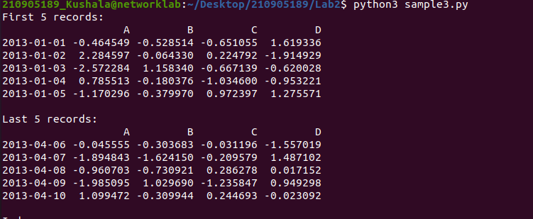
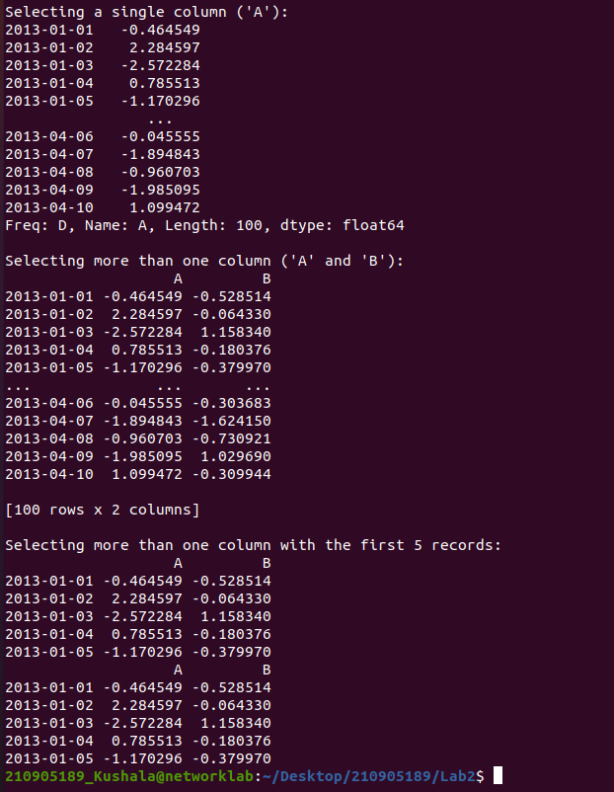

import pandas as pd
import numpy as np

# Creating a DataFrame with random data
dates = pd.date_range('20130101', periods=10)
df = pd.DataFrame(np.random.randn(10, 4), index=dates, columns=list('ABCD'))

# Boolean Indexing: Fetching all rows where column 'A' has positive values
print("Boolean Indexing:")
print(df[df['A'] > 0])

# Adding a new column 'F' with categorical character data
df['F'] = ['Male', 'Female', 'Female', 'Male', 'Female', 'Female', 'Male', 'Male', 'Female', 'Male']

# Setting by assigning with a numpy array: Replacing the 'D' column with all 5
df.loc[:, 'D'] = np.array([5] * len(df))
print("\nSetting 'D' column with all 5:")
print(df)

# Deleting a column: Dropping the 'C' column
df.drop('C', axis=1, inplace=True)
print("\nAfter dropping 'C' column:")
print(df)

# Deleting a row: Dropping the row with index 20130104
df.drop(pd.Timestamp('20130104'), axis=0, inplace=True)
print("\nAfter dropping row with index 20130104:")
print(df)

# Concatenating two DataFrames horizontally
df1 = pd.DataFrame(np.random.randn(10, 5), columns=list('ABCDE'))
df2 = pd.DataFrame(np.random.randn(10, 3), columns=list('FGH'))

df_new = pd.concat([df1, df2], axis=1)
print("\nConcatenation horizontally:")
print(df_new)
print("Shape after concatenation:", df_new.shape)

# Concatenating two DataFrames vertically
A = pd.DataFrame(np.random.randn(10, 5), columns=list('ABCDE'))
B = pd.DataFrame(np.random.randn(15, 5), columns=list('ABCDE'))

D = pd.concat([A, B], axis=0)
print("\nConcatenation vertically:")
print(D)
print("Shape after concatenation:", D.shape)
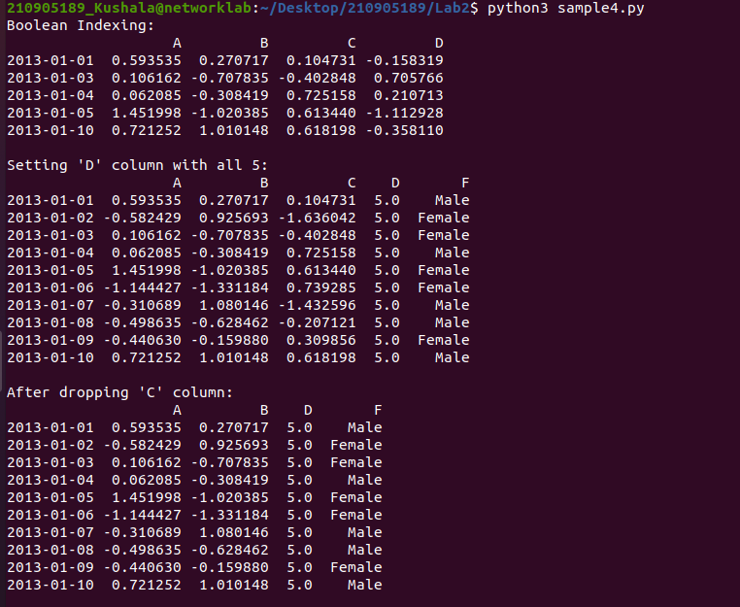
import pandas as pd

# Create the DataFrame
data = {
'rank1': [28, 34, 29, 42],
'rank2': ['Kavitha', 'Sudha', 'Raju', 'Vignesh'],
'rank3': [10, 20, 15, 30],
'rank4': [5, 8, 12, 7],
'Age': [28, 34, 29, 42],
'Name': ['Kavitha', 'Sudha', 'Raju', 'Vignesh']
}

A = pd.DataFrame(data)

# Sort the DataFrame by the 'Age' column
A_sorted = A.sort_values(by='Age')

# Display the sorted DataFrame
print(A_sorted)
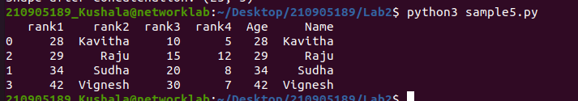
import pandas as pd

# Reading CSV file with no header
df = pd.read_csv('xyz.csv', header=None)

# Displaying the first 5 records
print("First 5 records:")
print(df.head())

# Displaying the last 5 records
print("\nLast 5 records:")
print(df.tail())

# Assigning custom column names
df.columns = ['preg', 'glu', 'bp', 'sft', 'ins', 'bmi', 'dpf', 'age', 'class']
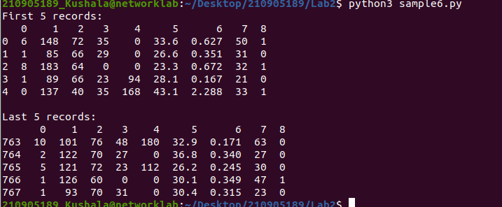
import pandas as pd
import matplotlib.pyplot as plt

# Reading CSV file with no header and assigning column names
df = pd.read_csv('xyz.csv', header=None)
df.columns = ['preg', 'glu', 'bp', 'sft', 'ins', 'bmi', 'dpf', 'age', 'class']

# Displaying the first 5 records
print("First 5 records:")
print(df.head())

# Displaying the last 5 records
print("\nLast 5 records:")
print(df.tail())

# Scatter plot of 'bmi' against 'glu'
plt.scatter(df['bmi'], df['glu'])
plt.xlabel('BMI')
plt.ylabel('Glucose')
plt.title('Scatter Plot: BMI vs Glucose')
plt.show()

# Histogram for the 'age' column
df['age'].hist()
plt.xlabel('Age')
plt.ylabel('Frequency')
plt.title('Histogram: Age Distribution')
plt.show()

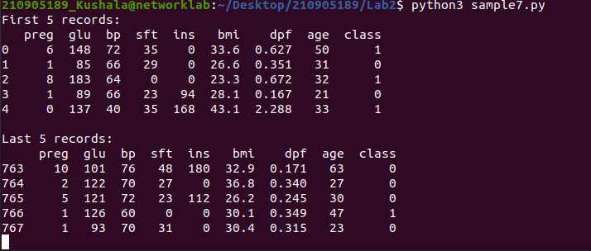
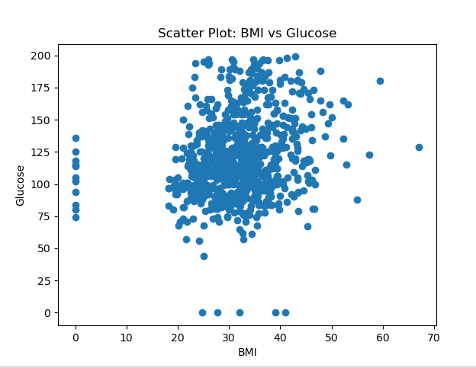
jy

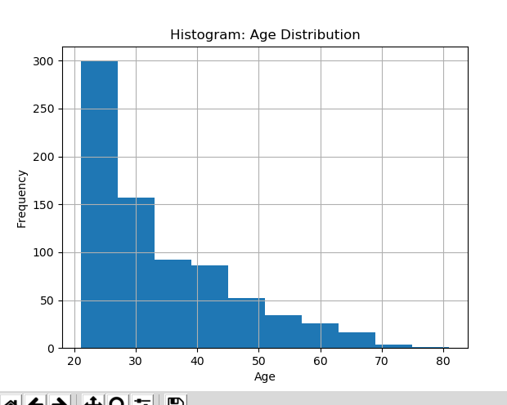
l

import pandas as pd

# Reading CSV file with no header
W = pd.read_csv('xyz.xls', header=None)

# Displaying the first 5 records
print("CSV File (xyz.xls):")
print(W.head())

# Reading Excel file with sheet name specified
G = pd.read_excel('xyz.xlsx', sheet_name='Sheet1')

# Displaying the first 5 records
print("\nExcel File (xyz.xlsx):")
print(G.head())

import pandas as pd
import matplotlib.pyplot as plt

# Reading a text file with tab-separated values
H = pd.read_table('HR.txt')

# Extracting value counts for the 'Department' column
f = H['Department'].value_counts()

# Visualizing the distribution of categorical values using a bar plot
f.plot(kind='bar', color='skyblue', edgecolor='black')
plt.title('Department Distribution')
plt.xlabel('Department')
plt.ylabel('Count')
plt.show()

# Visualizing the above bar plot as a Pie chart
f.plot(kind='pie', autopct='%1.1f%%', startangle=90, colors=['lightcoral', 'lightgreen', 'lightblue'])
plt.title('Department Distribution (Pie Chart)')
plt.axis('equal') # Equal aspect ratio ensures that the pie chart is circular.
plt.show()
