EX NO: 4 Kushalini H S
240701280
DASHBOARDS IN ZOHO CREATOR
AIM
To create an interactive Vehicle Service & Repair Request Management dashboard using Zoho Creator to monitor service requests, repair status, priority levels, and other important service information through reports, charts, and summary panels.
PROCEDURE
- Open the Vehicle Service application in Zoho Creator.
- Create a new Dashboard/Page named Vehicle Service & Repair Request Management.
- Add the required reports, such as All Service Requests and Repair Status, to the dashboard.
- Create summary panels to display important information such as:
- Total Service Requests
- Completed Repairs
- Cancelled Requests
- Pending Requests
- Add charts to visualize the service request data, such as:
- Request Status using a Pie Chart
- Priority Level using a Bar Chart
- Repair Status using a Donut or Radar Chart
- Arrange the reports, charts, and summary panels properly on the dashboard.
- Add a search option to easily find service request information by vehicle number, customer name, or request ID.
- Preview the dashboard and verify that the reports and charts display the correct service request data.
OUTPUT
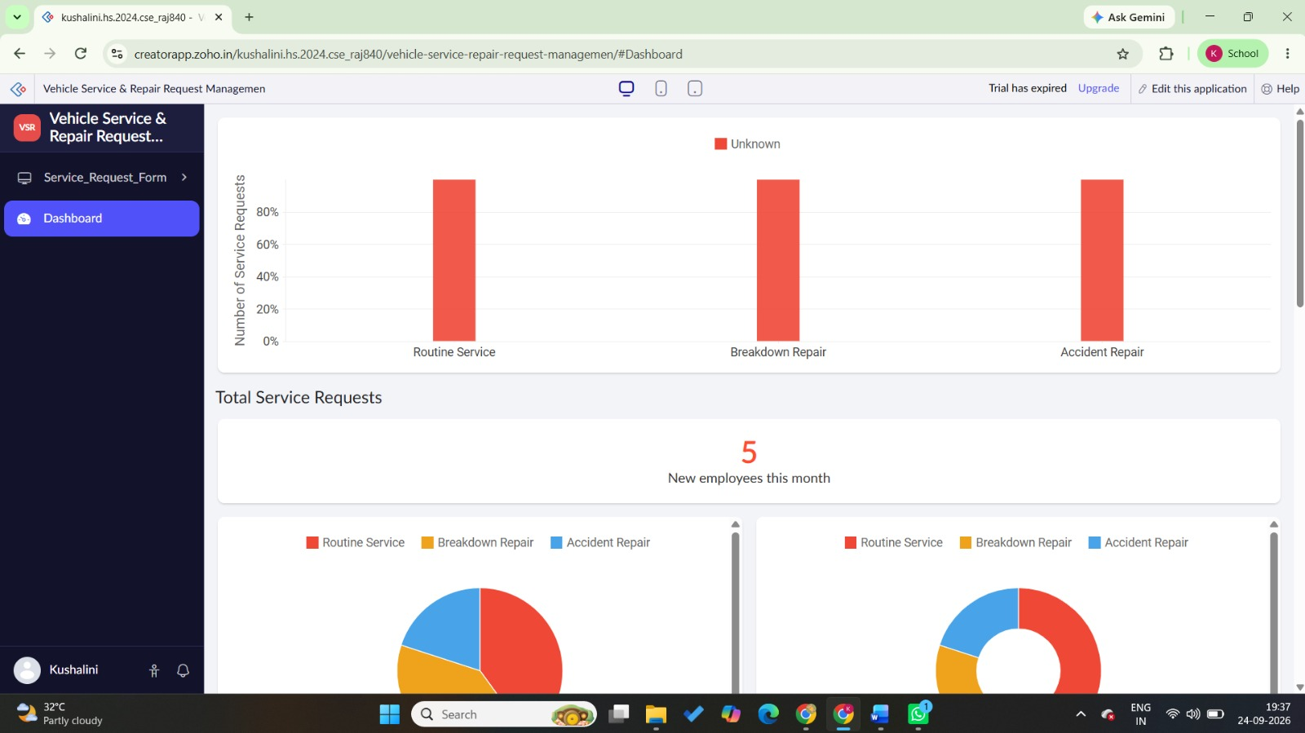
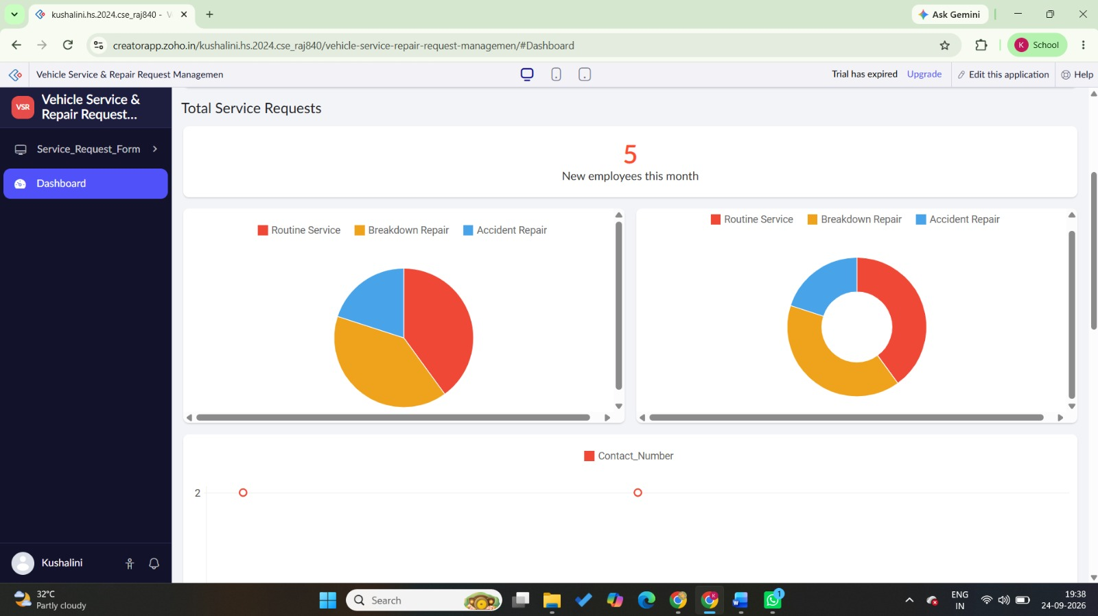

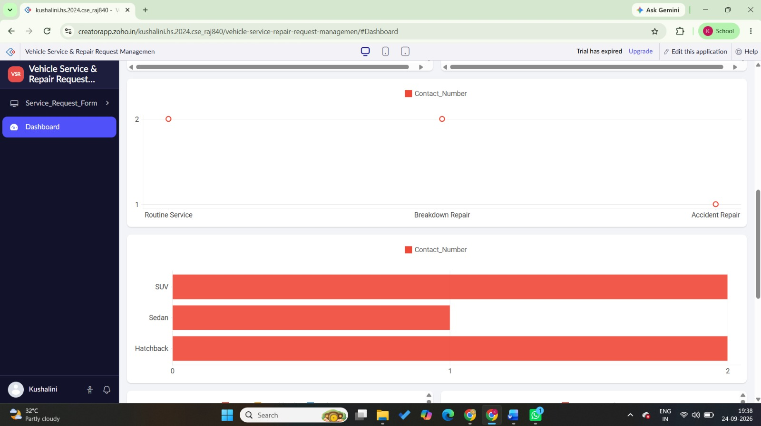
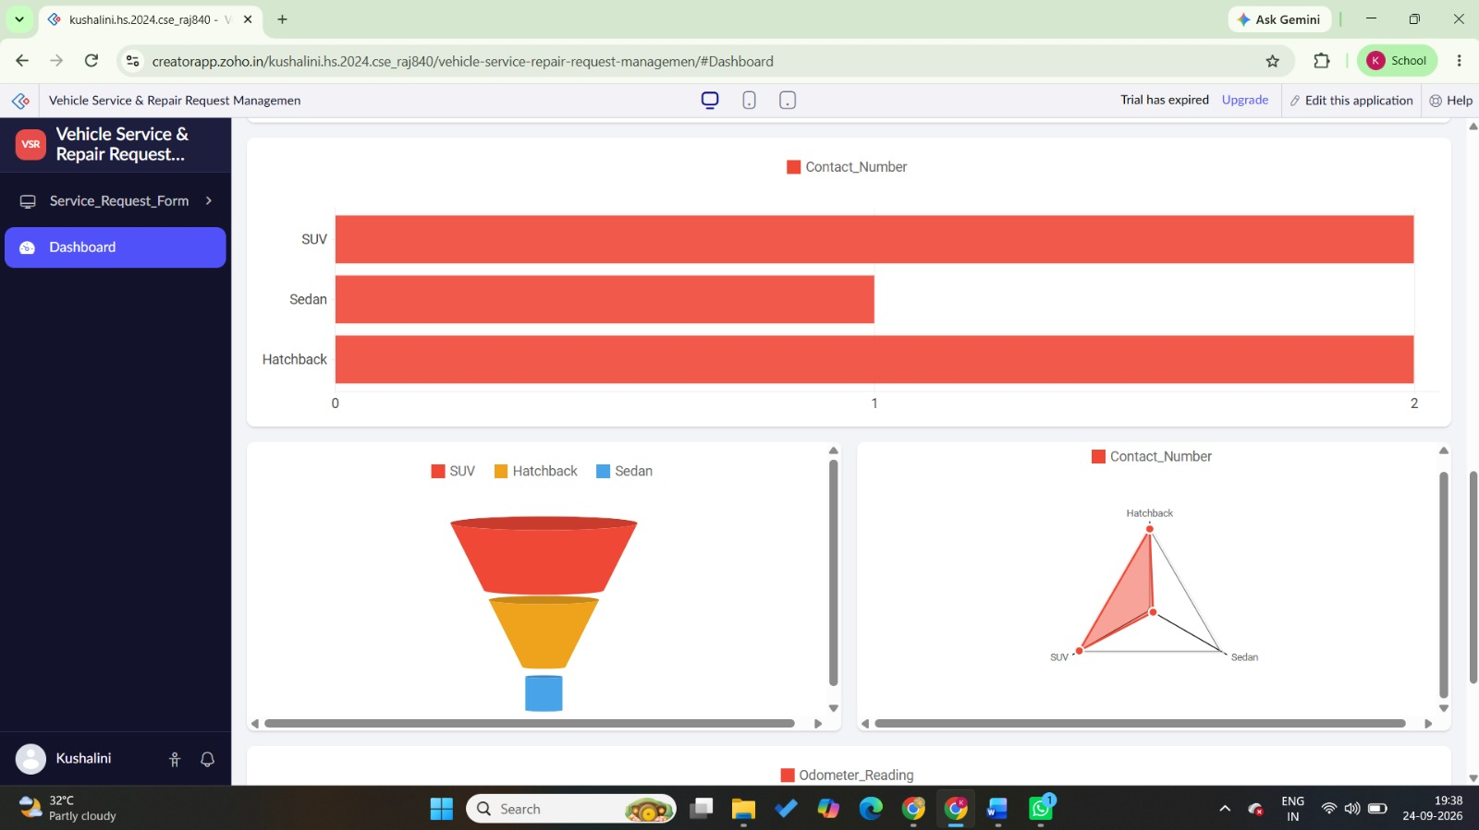
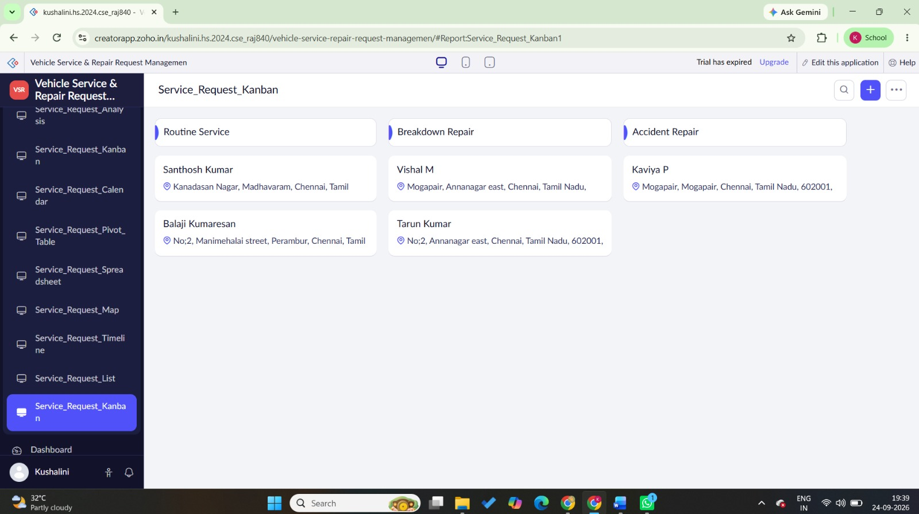
RESULT
Thus, an interactive Vehicle Service & Repair Request Management dashboard was successfully created in Zoho Creator to monitor service requests, repair status, priority levels, and other service-related information using reports, charts, and summary panels.

