**AWT TASK 19/08/2021**

**AIM: -**

**Create SignIn and Signup Page layout using Handlebars.**

Instructions

Include Header and Footer in layout.

**File- Structure: -**

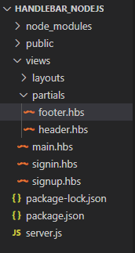

**Code:-**

1. server.js :

const express=require("express");

const PORT=3000;

const app=express();

const handlebars=require("express-handlebars");

app.use(express.static("public"));

app.use(express.urlencoded({extended:false}));

app.set('view engine', 'hbs');

app.engine("hbs",handlebars({

    layoutsDir:`${__dirname}/views/layouts`,

    extname:"hbs",

    defaultLayout:"index",

    partialsDir:`${__dirname}/views/partials`

}))

app.get("/",(req,res)=>{

    res.render("main");

});

app.get("/signin",(req,res)=>{

    res.render("signin");

});

app.post("/signin",(req,res)=>{

    res.end(`

    <div>

    <h1>${req.body.email}</h1>

    <h1>${req.body.password}</h1>

    </div>`)

});

app.get("/signup",(req,res)=>{

    res.render("signup");

});

app.post("/signup",(req,res)=>{

    res.end(`

    <div>

    <h1>${req.body.email}</h1>

    <h1>${req.body.name}</h1>

    <h1>${req.body.password}</h1>

    <h1>${req.body.confirmpassword}</h1>

    </div>`)

});

app.listen(PORT,()=>{

    console.log(`Server is listening on port ${PORT}`);

})

1. views/layouts/index.hbs :

<!DOCTYPE html>

<html lang="en">

<head>

    <meta charset="UTF-8">

    <meta http-equiv="X-UA-Compatible" content="IE=edge">

    <meta name="viewport" content="width=device-width, initial-scale=1.0">

    <title>Profile Form Nodejs</title>

    <link

      rel="stylesheet"

      href="https://bootswatch.com/5/sketchy/bootstrap.min.css"

    />

    <script src="https://bootswatch.com/_vendor/bootstrap/dist/js/bootstrap.bundle.min.js"></script>

    <script src="https://bootswatch.com/_vendor/jquery/dist/jquery.min.js"></script>

    <link href="https://cdnjs.cloudflare.com/ajax/libs/bootstrap-datepicker/1.5.0/css/bootstrap-datepicker.css" rel="stylesheet">

    <script src="http://ajax.googleapis.com/ajax/libs/jquery/1.9.1/jquery.js"></script>

    <script src="https://cdnjs.cloudflare.com/ajax/libs/bootstrap-datepicker/1.5.0/js/bootstrap-datepicker.js"></script>

    <script src="https://kit.fontawesome.com/fd15636b22.js" crossorigin="anonymous"></script>

</head>

<style>

  .mainbox {

        margin: 2rem auto;

        text-align: center;

      }

      body{

        /* background-color: #ffffff;

        background-image: url("data:image/svg+xml,%3Csvg xmlns='http://www.w3.org/2000/svg' width='100' height='100' viewBox='0 0 100 100'%3E%3Cg stroke='%23CCC' stroke-width='0' %3E%3Crect fill='%23F5F5F5' x='-60' y='-60' width='110' height='240'/%3E%3C/g%3E%3C/svg%3E"); */

        background-color: #ffffff;

background-image: url("data:image/svg+xml,%3Csvg xmlns='http://www.w3.org/2000/svg' viewBox='0 0 1600 900'%3E%3Cdefs%3E%3ClinearGradient id='a' x1='0' x2='0' y1='1' y2='0'%3E%3Cstop offset='0' stop-color='%230FF'/%3E%3Cstop offset='1' stop-color='%23CF6'/%3E%3C/linearGradient%3E%3ClinearGradient id='b' x1='0' x2='0' y1='0' y2='1'%3E%3Cstop offset='0' stop-color='%23F00'/%3E%3Cstop offset='1' stop-color='%23FC0'/%3E%3C/linearGradient%3E%3C/defs%3E%3Cg fill='%23FFF' fill-opacity='0' stroke-miterlimit='10'%3E%3Cg stroke='url(%23a)' stroke-width='2'%3E%3Cpath transform='translate(0 0)' d='M1409 581 1450.35 511 1490 581z'/%3E%3Ccircle stroke-width='4' transform='rotate(0 800 450)' cx='500' cy='100' r='40'/%3E%3Cpath transform='translate(0 0)' d='M400.86 735.5h-83.73c0-23.12 18.74-41.87 41.87-41.87S400.86 712.38 400.86 735.5z'/%3E%3C/g%3E%3Cg stroke='url(%23b)' stroke-width='4'%3E%3Cpath transform='translate(0 0)' d='M149.8 345.2 118.4 389.8 149.8 434.4 181.2 389.8z'/%3E%3Crect stroke-width='8' transform='rotate(0 1089 759)' x='1039' y='709' width='100' height='100'/%3E%3Cpath transform='rotate(0 1400 132)' d='M1426.8 132.4 1405.7 168.8 1363.7 168.8 1342.7 132.4 1363.7 96 1405.7 96z'/%3E%3C/g%3E%3C/g%3E%3C/svg%3E");

background-attachment: fixed;

background-size: cover;

      }

</style>

<body>

    {{> header}}

    {{{body}}}

    {{>footer}}

</body>

</html>

1. views/layouts/partials/header.hbs :

<nav class="navbar navbar-expand-lg navbar-dark bg-primary">

        <div class="container-fluid">

          <a class="navbar-brand" href="/">UseHandlebars</a>

          <button class="navbar-toggler" type="button" data-bs-toggle="collapse" data-bs-target="#navbarColor01" aria-controls="navbarColor01" aria-expanded="true" aria-label="Toggle navigation">

            <span class="navbar-toggler-icon"></span>

          </button>

          <div class="navbar-collapse collapse show" id="navbarColor01">

            <ul class="navbar-nav me-auto">

              <li class="nav-item">

                <a class="nav-link active" href="/">Home

                </a>

              </li>

              <li class="nav-item">

                <a class="nav-link " href="/signin">SignIn</a>

              </li>

              <li class="nav-item ">

                <a class="nav-link" href="/signup">SignUp</a>

              </li>

            </ul>

          </div>

        </div>

      </nav>

1. views/layouts/partials/footer.hbs :

 <!-- footer Section -->

<style>

    .foot{

        margin-top: 0%;

    }

    </style>

 <footer class="navbar-static-bottom foot">

    <div class="container-fluid">

      <p class="text-center p-4">© Copyright 2021 19CE083 Kushal Panchal</p>

    </div>

  </footer>

</body>

</html>

1. views/main.hbs :

<div class="row justify-content-md-center">

    <img class="text-center" src="1.jpg" alt="Profile Image" style="width:50%;">

</div>

1. views/signin.hbs :

<nav class="navbar-dark bg-dark navbar">

  <a href="Signup" class="navbar-brand">Signup</a>

  <a href="Signin" class="navbar-brand">Signin</a>

</nav>

<div class="jumbotron">

  <div class="container">

    <h2>Welcome to Sign In Page!</h2>

  </div>

</div>

<div class="row justify-content-center">

  <form>

    <legend action="/" method="post">

      <h1>Enter Details and SignIn Now</h1>

    </legend>

    <div class="form-group">

      <label for="exampleInputEmail1">Email address</label>

      <input type="email" name="email" class="form-control" id="email" aria-describedby="emailHelp" placeholder="Enter email">

    </div>

    <div class="form-group">

      <label for="exampleInputPassword2">Password</label>

      <input type="password" name="cpw" class="form-control" id="exampleInputPassword2" placeholder="Password">

    </div>

    <div>

      <button type="submit" class="btn btn-primary">Submit</button>

    </div>

  </form>

</div>

<br /><br />

<nav class="navbar-dark bg-dark navbar" >

  <center>

    <h3 style="color:white;text-align:center;">Thank you for Visiting </h3>

  </center>

</nav>

1. views/signup.hbs :

<nav class="navbar-dark bg-dark navbar">

  <a href="Signup" class="navbar-brand">Signup</a>

  <a href="Signin" class="navbar-brand">Signin</a>

</nav>

<div class="jumbotron">

  <div class="container">

    <h2>Welcome to Sign Up Page!</h2>

  </div>

</div>

<div class="row justify-content-center">

  <form>

    <legend action="/" method="post">Enter Registration Information Here</legend>

    <div class="form-group">

      <label for="first_name">First Name</label>

      <input type="text" class="form-control" name="first_name" id="first_name" placeholder="Enter first name">

    </div>

    <div class="form-group">

      <label for="last_name">Last Name</label>

      <input type="text" class="form-control" name="last_name" id="last_name" placeholder="Enter last name">

    </div>

    <div class="form-group">

      <label for="exampleInputEmail1">Email address</label>

      <input type="email" name="email" class="form-control" id="email" aria-describedby="emailHelp" placeholder="Enter email">

    </div>

    <div class="form-group">

      <label for="exampleInputPassword1">New Password</label>

      <input type="password" name="pw" class="form-control" id="exampleInputPassword1" placeholder="Password">

    </div>

    <div class="form-group">

      <label for="exampleInputPassword2">Confirm Password</label>

      <input type="password" name="cpw" class="form-control" id="exampleInputPassword2" placeholder="Password">

    </div>

    <button type="submit" class="btn btn-primary">Submit</button>

  </form>

</div>

<nav class="navbar-dark bg-dark navbar">

  <center>

    <h3 style="color:white;text-align:center;">Thank you for Visiting </h3>

  </center>

</nav>

**Output:**

1. Server:

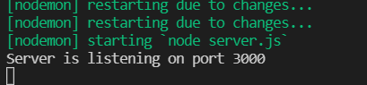

1. localhost:3000/

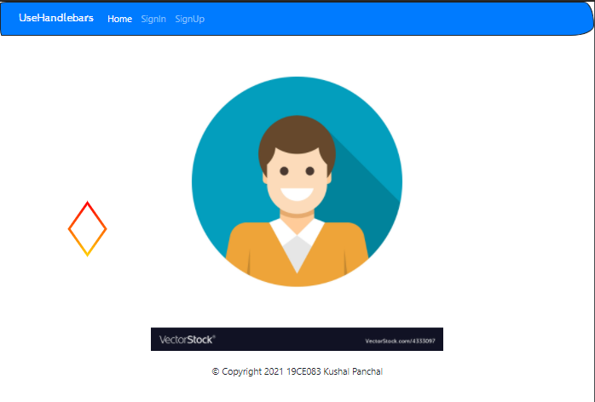

1. localhost:3000/signin

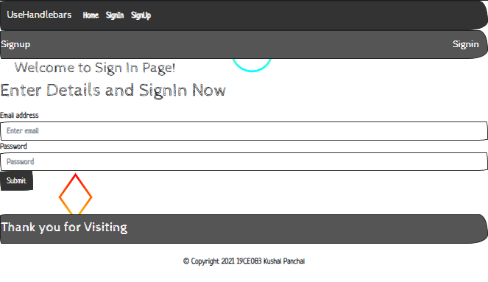

1. localhost:3000/signup

