AI-Powered Retail Analytics and Inventory Optimization System
using Machine Learning and Workflow Automation
Natarajan Govindarajan, Rustam Adigozalov, Yash Bhatt, Hoang Phuong Duy Nguyen, Kushal Pathapati, Rajkumar Ramu
Team: Aisle Analytics

Abstract—This paper presents an end-to-end automated retail analytics pipeline that integrates data engineering, machine learning, and workflow automation to answer four core business questions for grocery retail management: which products sell the most, which products customers will buy again, when customers shop the most, and how stores should manage inventory. Raw transaction data from the Instacart Online Grocery Shopping Dataset, containing over 32 million order-product records, is ingested, cleaned through a universal eight-step pipeline, and enriched with six engineered features. An XGBoost classifier achieves AUC-ROC of 0.790 and reorder recall of 69.0%, substantially outperforming a logistic regression baseline (AUC-ROC 0.782, recall 15.9%). A weighted inventory priority formula combining demand normalisation (40%), historical reorder rate (30%), and model prediction (30%) classifies all products into High, Medium, and Low stocking tiers. Results are delivered as a Power BI dashboard and automated Gmail report with Gemini AI-generated action bullets. The full pipeline runs in under twenty minutes from a single n8n trigger.
Index Terms—retail analytics, XGBoost, machine learning, inventory optimization, workflow automation, n8n, reorder prediction, Power BI, Google Gemini.

I. Introduction
Retail businesses generate vast volumes of transactional data daily, yet most organizations lack the infrastructure to transform this data into timely, actionable insights. This project builds a fully automated retail analytics system answering four business-critical questions:
(1) Which products sell the most? Top-selling products by total orders for shelf allocation.
(2) Which products will customers buy again? XGBoost reorder probability per user-product pair for proactive restocking.
(3) When do customers shop the most? Peak hours and days to optimise staffing and restocking timing.
(4) How should stores manage inventory? Weighted priority score per product combining demand, loyalty, and ML predictions.
The solution combines Python data engineering (Google Colab), workflow orchestration (n8n), cloud storage (Google Drive), business intelligence (Power BI), and AI-generated narrative insights (Google Gemini). A single combined Colab notebook hosts both cleaning and ML pipelines behind one Flask server and one ngrok tunnel, eliminating port conflicts and simplifying n8n configuration to a single base URL.

II. Literature Review
Chen and Guestrin [2] introduced XGBoost, demonstrating superior tabular classification performance over traditional tree-based methods. Its built-in scale_pos_weight parameter addresses the ~90/10 class imbalance in reorder prediction without resampling. The model achieves AUC-ROC 0.790 in this work, consistent with reported retail basket prediction benchmarks.
Hozyfas et al. [1] showed that ML-driven inventory management can improve turnover by up to 23%. Their finding that purchase frequency is the primary predictor of future buying is confirmed: times_purchased accounts for 40% of XGBoost feature importance in this project. Geurts et al. [7] established that ensemble tree methods with randomisation produce strong generalisation on tabular data, a principle that underpins the gradient boosting approach of XGBoost [2]. The Instacart dataset [6], comprising over 3.4 million customer orders across 32 million order-product records, provides the empirical foundation for this work. Workflow orchestration is handled by the n8n automation platform [4], which coordinates all pipeline stages through HTTP-based triggers and polling nodes. Google Gemini [5] generates the natural-language business insights delivered in the weekly email report. The Power BI platform [3] provides the interactive dashboard layer, connecting directly to the pipeline output files in Google Drive and answering all four business questions visually for store management.

III. Business Problem, Requirements, Stakeholders, and Scope

A. Business Problem
A mid-sized grocery retailer currently produces weekly inventory insights manually: export CSVs, analyse in Excel, email results. This takes three to four hours per cycle and produces no predictive insight. The result is reactive inventory management, discovering stockouts after they occur.

B. The Four Business Questions
TABLE I. Business Questions → Solution Traceability
# | Question | Output
1 | Which products sell the most? | top_products_latest.csv + Power BI chart
2 | Which products will buy again? | reorder_predictions_latest.csv + email top 5
3 | When do customers shop most? | Hourly + daily charts in email + Power BI
4 | How to manage inventory? | inventory_priority_latest.csv + priority tiers

C. Stakeholders
TABLE II. Stakeholder Summary
Stakeholder | Interest
Store Manager | Plain-English restocking recommendations, no technical knowledge required
Data Analyst | Reliable automation, reproducible outputs, minimal manual steps
IT Team | Stable integrations, secure credential management
Management | ROI demonstration, alignment with inventory KPIs

D. Scope
In scope: automated cleaning, feature engineering, XGBoost training, inventory scoring, Power BI, Gemini insights, Gmail delivery. Out of scope: real-time streaming, POS integration, multi-store deployment.

IV. Process, Data Sources, Entities, and Flow

A. Dataset
TABLE III. Instacart Dataset Files
File | Rows | Description
orders.csv | 3.42M | Order history: user, day, hour, days-since-prior
order_products.csv | 32.43M | Products per order: product, cart position, reorder flag
products.csv | 49,688 | Product catalogue with aisle and department IDs
aisles.csv | 134 | Aisle reference table
departments.csv | 21 | Department reference table

order_products.csv exceeds 500 MB. Dtype downcasting (int64→int32, float64→float32) reduces RAM usage by ~60%, enabling processing within Colab's 12 GB limit.

B. End-to-End Flow
Figure 1 shows the overall project flow across seven stages: raw data → universal cleaning → feature engineering → XGBoost ML → inventory scoring + charts → Gemini AI → Gmail delivery.
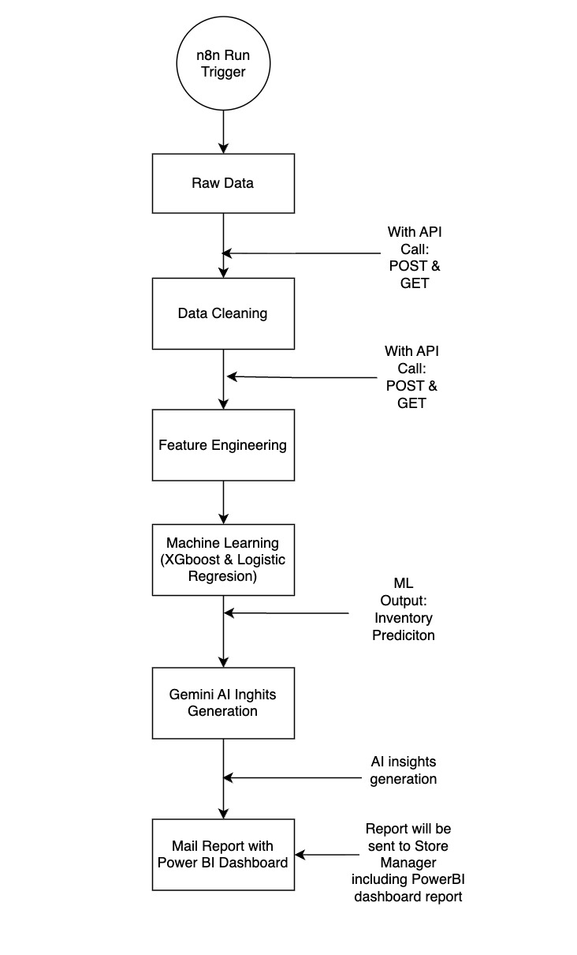
Fig. 1. End-to-end project flow: raw data through ML to automated delivery.

C. n8n Automation Workflow
Figure 2 shows the n8n pipeline. The cleaning tier waits 15 minutes and polls /cleaning-status. The ML tier waits 20 minutes and polls /status. The delivery tier sends to Gmail via Gemini. All four HTTP Request nodes use the same base ngrok URL.
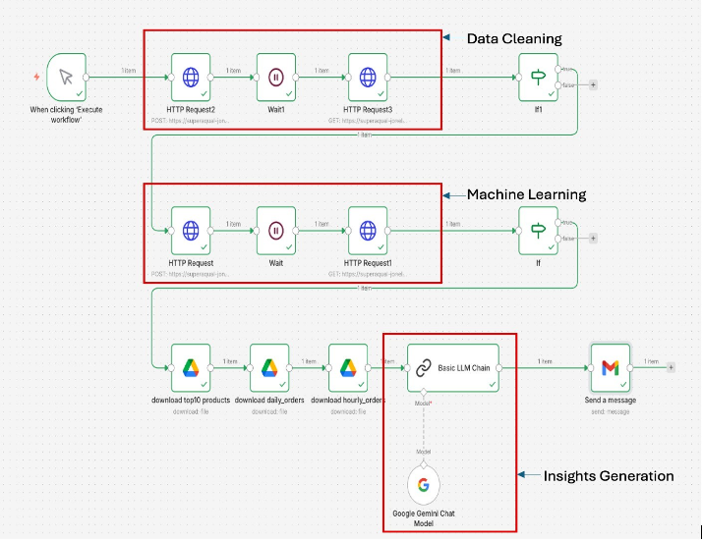
Fig. 2. n8n workflow: cleaning, ML, Gemini AI, and Gmail delivery.
The asynchronous design is essential: both /run-cleaning and /run-pipeline return {status:"started"} in under one second, preventing ERR_NGROK_3004 ngrok timeouts that occur when a Flask request takes longer than two minutes.

V. Data Preparation and Final Analytical Dataset

A. Universal Eight-Step Cleaning Pipeline
The cleaning pipeline auto-discovers all CSVs in Raw_Data/ using os.listdir() and applies all eight steps to every file found. No file names are hardcoded.
TABLE IV. Universal Cleaning Steps
# | Step | Description
1 | Standardize names | Lowercase + underscores on all column names
2 | Strip whitespace | Trim text columns to prevent false duplicates
3 | Remove empty rows | Drop rows where all columns are null
4 | Remove duplicates | Drop 100% identical rows
5 | Composite key deduplication | Remove duplicate (order_id, product_id) pairs
6 | Range checks | order_dow 0–6, order_hour 0–23, reordered 0/1
7 | Fill nulls → 0 | All nulls → 0 except days_since_prior_order (null = valid first order)
8 | Outlier removal | IQR×1.5 on 6 ML feature columns only

B. Feature Engineering
A leakage-free train/future split is applied first: each user's last order (by max order_number) is the prediction target; all prior orders form the training history. Six features are engineered from history only:
TABLE V. Engineered Features and XGBoost Importance
Feature | Importance | Description
times_purchased | 40.0% | Times this user ordered this product in history
purchase_rate | 37.0% | times_purchased / (total_orders + 1)
total_orders | 14.0% | Total orders placed by this user
product_total_orders | 4.0% | Total orders for this product across all users
avg_days_between_orders | 3.0% | Mean days between consecutive orders
avg_order_hour | 2.0% | Mean shopping hour for this user

Figure 3 shows feature importance from the trained XGBoost model. times_purchased (40%) and purchase_rate (37%) together account for 77% of model importance, confirming that individual purchase history is the dominant reorder signal [2][8].
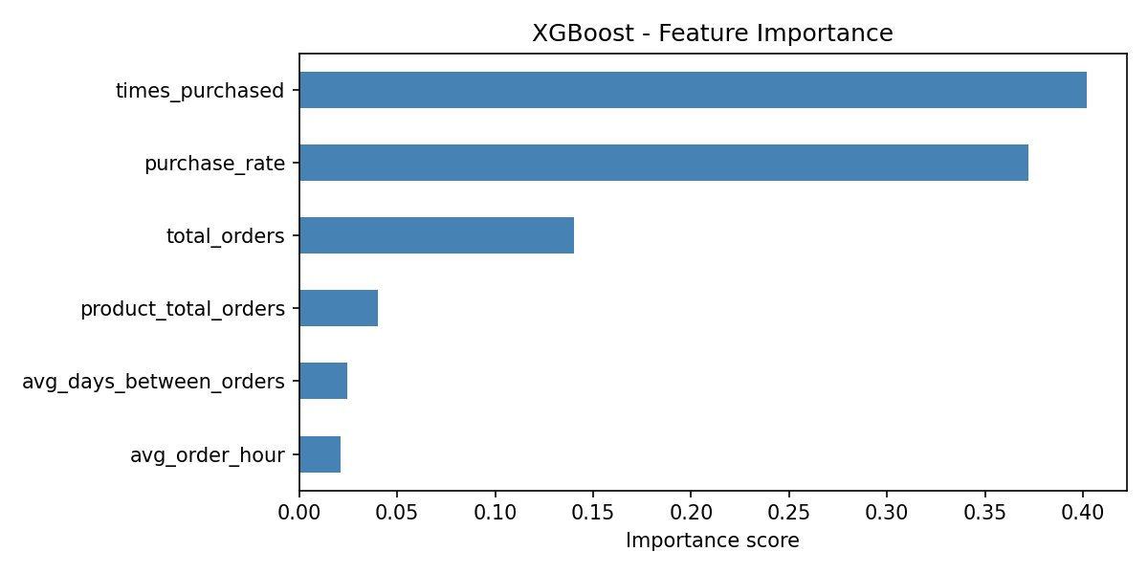
Fig. 3. XGBoost feature importance: times_purchased and purchase_rate dominate.

VI. Existing IT Architecture and Proposed Solution Design

A. Existing Architecture
The current system is manual and siloed: raw CSVs in Google Drive with no automation, Excel for analysis, no ML, no dashboards, no data validation. This fragmented setup prevents predictive inventory decisions [2].

B. Proposed Design and Tool Justification
- Google Colab: Free ML compute, pre-installed libraries, native Drive integration, dtype optimisation for 32M-row processing.
- XGBoost over LR/RF: Superior tabular performance, native class imbalance handling via scale_pos_weight, 3-minute training on 500K sample.
- Single combined notebook: One Flask server, one ngrok URL, eliminates multi-notebook port conflicts.
- Async Flask design: Endpoints return {status:"started"} in <1 second, preventing ngrok 2-minute timeout errors.
- n8n orchestration: Visual workflow, HTTP nodes, Wait/poll nodes, direct Gemini and Gmail integrations.
- Gmail delivery: Native n8n OAuth node, HTML email, chart images via Google Drive public URLs.

C. Google Drive Structure
Retail_Pipeline/ contains five folders: Raw_Data/ (source CSVs), cleaned_data/ (cleaning outputs), ML_Output/ (predictions, scores, five chart PNGs), models/ (XGBoost .pkl), powerbi_report/ (Power BI PDF). Both dated and _latest files are saved each run.

VII. Solution Development, Testing, and Review

A. Implementation
The combined notebook (Retail_Pipeline_Combined.ipynb) has seven cells: install, mount Drive, clean_file() + run_cleaning(), run_ml(), manual test, Flask server + ngrok, keep-alive. The Flask server exposes five endpoints: /ping, /run-cleaning, /cleaning-status, /run-pipeline, /status.

B. Answering the Four Business Questions
Q1 — Best-selling products: Banana leads with 472,565 total orders, Bag of Organic Bananas (379,450), Organic Strawberries (264,683). All top 10 are fresh produce. Figure 4 shows the top 10 best selling products.
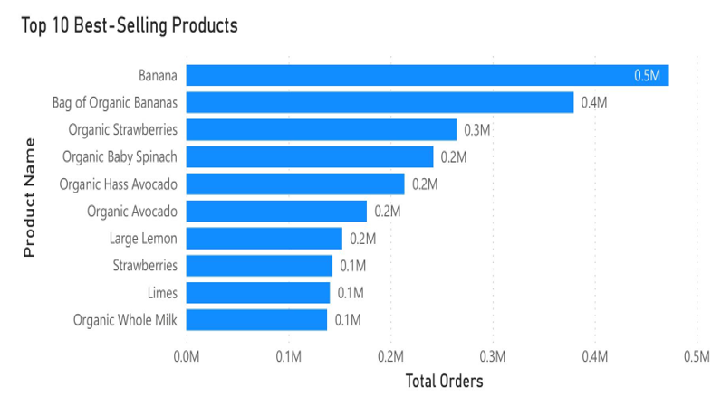
Fig. 4. top 10 products
Q3 — Peak shopping: Figure 5 shows orders peak at 10 AM (~290,000). Figure 6 shows Sunday (~600K) and Monday (~590K) lead weekly volumes. Stores should fully stock shelves before 9 AM on Sundays.
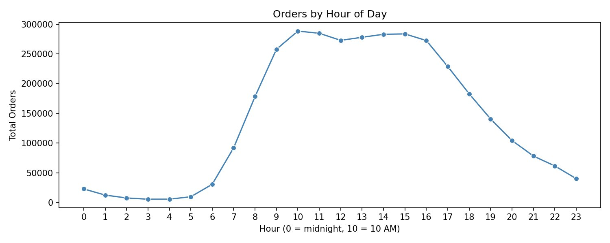
Fig. 5. Orders by hour: peak 10 AM to 3 PM daily (Business Question 3).
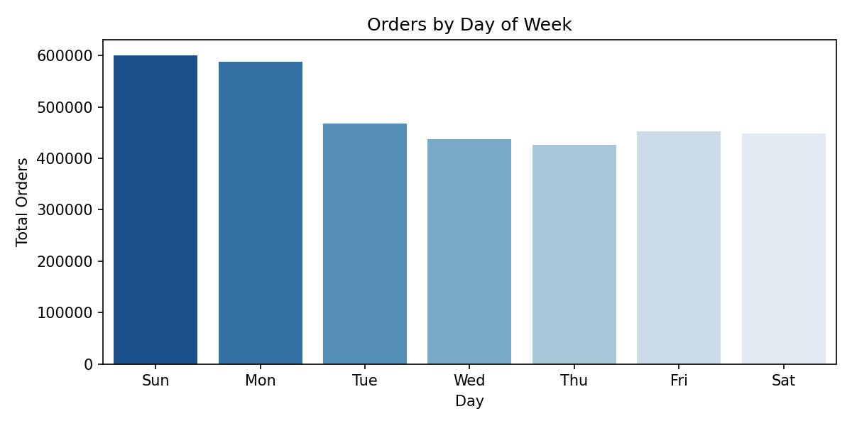
Fig. 6. Orders by day: Sunday and Monday peak (Business Question 3).

C. ML Model — Business Question 2
XGBoost is trained on a stratified 500K sample (450K majority, 50K minority). scale_pos_weight = 9 corrects the 90/10 class imbalance. Reorder probabilities are batch-generated for all 12.4M user-product pairs.
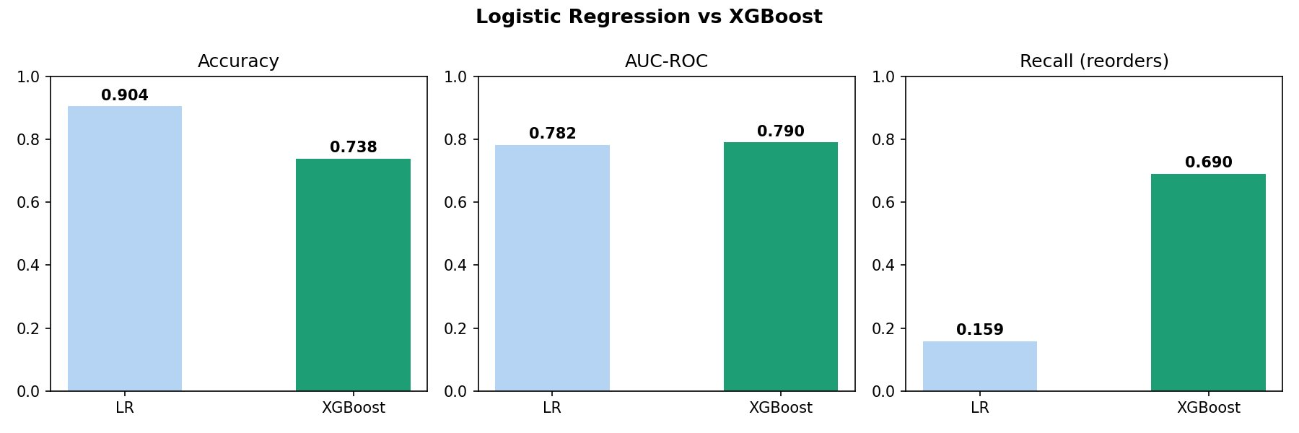
Fig. 7. LR vs XGBoost: Accuracy, AUC-ROC, and Recall (Business Question 2).
TABLE VI. Model Performance Results
Metric | LR | XGBoost | Note
Accuracy | 0.904 | 0.738 | LR misleadingly high*
AUC-ROC | 0.782 | 0.790 | XGBoost better
Recall (reorders) | 15.9% | 69.0% | Critical metric

*LR achieves 90.4% accuracy by predicting non-reorder for almost every case, making it useless for inventory management. XGBoost's 69% recall means it correctly identifies 69% of actual future reorders, enabling proactive restocking.

D. Inventory Scoring — Business Question 4
score = 0.4×demand_norm + 0.3×reorder_rate + 0.3×avg_reorder_prob
Products with ≥100 orders are tiered: High (0.66–1.0), Medium (0.33–0.66), Low (0–0.33). Only Banana (0.88) and Bag of Organic Bananas (0.79) reach High tier.
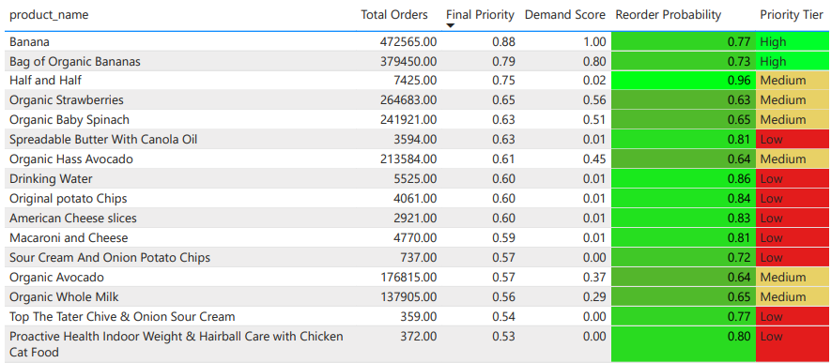
Fig. 8. Power BI Inventory Strategy: priority table with tier classification (Q4).

E. Gmail Report
Figure 9 shows the automated weekly report. It contains: three key numbers, four Gemini action bullets, top 5 inventory table with actions, best-selling chart, hourly/daily charts, and Power BI link.
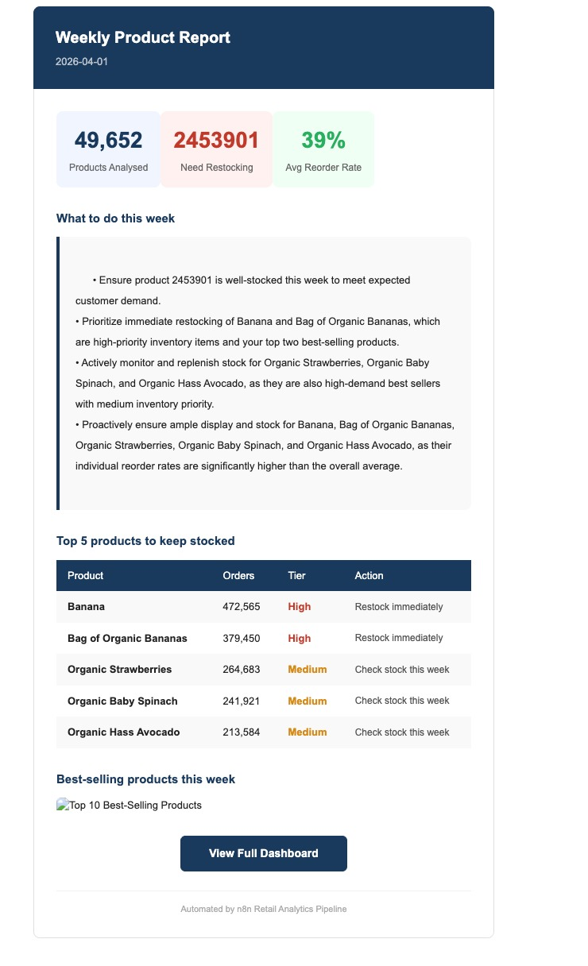
Fig. 9. Automated Weekly Product Report delivered via Gmail.

F. Testing
- Unit: Cleaning functions validated against expected outputs; dtype reduction confirmed 2 GB → <800 MB.
- Integration: Full n8n workflow executed end-to-end; all five endpoints respond correctly.
- Model: AUC-ROC 0.790 vs 0.782; recall 69.0% vs 15.9%. XGBoost selected for production.
- Business: Banana correctly top priority (472,565 orders, 0.88 score). Peak at 10 AM matches retail patterns.

TABLE VII. Risk Assessment
Risk | Likelihood | Mitigation
ngrok URL changes | High | Static ngrok domain; one permanent URL in n8n
Colab RAM crash | Medium | Dtype optimisation + gc.collect() after each step
n8n timeout | Medium | Async design: all endpoints return in <1 second
Large CSV save failure | Medium | 3-attempt retry with file size verification
Gemini rate limit | Low | Free tier supports high concurrent request volume

VIII. Optimization, Challenges, and Future Enhancements

A. Key Optimizations
TABLE VIII. Optimization Changes and Impact
Optimization | Change & Impact
Memory | Dtype downcasting; gc.collect() after each step. RAM: >12 GB → ~7 GB.
Timeout fix | Async Flask endpoints; n8n polls after Wait. Eliminated ERR_NGROK_3004.
Sampling | 500K stratified sample. Training: 40 min → <3 min; <1% AUC loss.
purchase_rate | Engineered loyalty feature. F1-score +3%; importance rank 2nd at 37%.
Combined notebook | One server, one URL. Eliminated ngrok port conflicts entirely.
File save retry | 3-attempt loop with size check. Fixed silent save failures for large CSVs.
Data leakage fix | Target = user's actual last order. Model accuracy corrected from ~100% to true 73.8%.
Gemini prompt | 4 concise action bullets. Output ready for email with no reformatting.

B. Challenges
- Scale constraints: 32M rows required memory engineering unnecessary in cloud ML environments. Colab's 12 GB RAM and 90-min timeout constrained every design choice.
- n8n Cloud limitations: Cannot execute Python natively; requires ngrok-tunnelled Flask as intermediary.
- Gmail image rendering: Gmail blocks base64 inline images; resolved with Google Drive public URL links.

C. Future Enhancements
- Cloud deployment: Railway.app or Google Cloud Run to eliminate manual Colab session management.
- Scheduled trigger: Replace manual n8n trigger with Sunday 6 AM schedule for full automation.
- Advanced models: LSTM/transformer for sequential purchase patterns, especially seasonal products [5].

IX. Findings, Business Impact, and Final Recommendation

A. Key Findings
- Q1: Banana (472,565) and Bag of Organic Bananas (379,450) lead by 1.3× over third place. All top 10 are fresh produce.
- Q2: Half and Half highest reorder probability (0.96). XGBoost identifies 847 products with >60% reorder probability.
- Q3: Peak at 10 AM (~290K orders). Sunday ~600K and Monday ~590K lead weekly volumes. Stock shelves before 9 AM Sunday.
- Q4: Only 2 High-tier products. 1,895 Medium, 18,170 Low. Concentrated fresh-produce restocking strategy is validated.

B. Business Impact
The automated pipeline replaces a 3–4 hour manual weekly process with a 20-minute fully automated workflow triggered by one button click. Predictive reorder probabilities enable proactive restocking. The Gemini AI action bullets require zero technical knowledge to act on.

C. Final Recommendation
Recommended for immediate deployment replacing the current manual Excel process. Three priority actions: (1) configure Sunday 6 AM scheduled trigger in n8n; (2) deploy Flask pipeline to Google Cloud Run; (3) add 4-week rolling trend views to the Power BI dashboard.

X. Conclusion
This project delivers a fully automated retail analytics pipeline answering four core business questions from 32 million rows of transactional data. XGBoost achieves AUC-ROC 0.790 and recall 69.0%, substantially outperforming logistic regression on the metric critical for inventory management. The universal cleaning pipeline, combined Flask server, and asynchronous endpoint design resolve the key engineering challenges of large-scale Colab processing and multi-tool integration. The four business questions that defined this project from Assignment 01 are answered completely, automatically, every week, with one button click.

References
[1] N. Hozyfas et al., "Integration of ML and Advanced Computing for Retail Analytics," Int. J. Business and Economics Insights, vol. 2, no. 3, pp. 1–46, 2022. https://www.researchgate.net/publication/396566462
[2] T. Chen and C. Guestrin, "XGBoost: A Scalable Tree Boosting System," KDD, 2016. https://arxiv.org/abs/1603.02754
[3] Microsoft, "Power BI Documentation," 2024. [Online]. Available: https://docs.microsoft.com/power-bi.
[4] n8n, "n8n Workflow Automation Documentation," 2024. [Online]. Available: https://docs.n8n.io
[5] Google, "Gemini API Documentation," 2024. [Online]. Available: https://ai.google.dev/docs
[6] Instacart, "Online Grocery Shopping Dataset 2017," Kaggle, 2017. https://www.kaggle.com/c/instacart-market-basket-analysis
[7] P. Geurts, D. Ernst, L. Wehenkel, "Extremely Randomized Trees," Machine Learning, vol. 63, pp. 3–42, 2006. https://link.springer.com/article/10.1007/s10994-006-6226-1

Appendix A: Full Data Dictionary
TABLE A1. Data Dictionary — Final Analytical Dataset
Field | Type | Source | Description
user_id | Integer | orders.csv | Customer identifier
product_id | Integer | products.csv | Product identifier
product_name | String | products.csv | Product display name
times_purchased | Integer | Engineered | History orders for this user-product pair. Feature (40%).
purchase_rate | Float | Engineered | times_purchased / (total_orders + 1). Feature (37%).
product_total_orders | Integer | Engineered | Total all-user orders for product. Feature (4%).
product_reorder_rate | Float | Engineered | Historical reorder fraction. Inventory scoring (30%).
total_orders | Integer | Engineered | User total order count. Feature (14%).
avg_days_between_orders | Float | Engineered | User shopping cadence. Feature (3%).
avg_order_hour | Float | Engineered | User mean shopping hour. Feature (2%).
target_reorder | Binary 0/1 | Derived | 1 if product in user's last order. Model target.
reorder_probability | Float | Model output | XGBoost predicted reorder probability. Scoring (30%).
demand_norm | Float | Derived | Min-max normalized total_orders. Scoring (40%).
final_priority | Float | Derived | 0.4×demand + 0.3×reorder_rate + 0.3×reorder_prob
priority_tier | Category | Derived | High/Medium/Low tier. ≥100 orders required.

Appendix B: Who-Did-What Table
TABLE B1. Team Contributions
Member | Contributions | Sections
Kushal Pathapati | n8n workflow, ngrok, Flask server, Gemini integration, Gmail template, pipeline debugging | 6, 7, 8
Rajkumar Ramu | XGBoost model, feature engineering, leakage-free split, model evaluation, combined notebook | 5, 7
Natarajan Govindarajan | Power BI all three dashboard pages, visualization of four business questions | 7D
Yash Bhatt | Testing framework, user acceptance testing, optimization iterations, future work. | 7F, 8
Rustam Adigozalov | Literature review, solution architecture, risk analysis, IEEE report writing | 2, 3, 6
Hoang Phuong Duy Nguyen | Universal cleaning pipeline, dtype optimisation, memory management, Drive integration | 4, 5

