Q1.

Code:

|  |
| --- |
| ***package Q_01; import javax.swing.*;  public class Q_01 {  public static void main(String[] args) {  JFrame frame;  frame = new JFrame();  frame.setVisible(true);  frame.setSize(800, 600);  frame.setTitle("Welcome to Java.");  frame.setDefaultCloseOperation(WindowConstants.EXIT_ON_CLOSE);  } }*** |

Output:

Q2.

Code:

|  |
| --- |
| ***package Q_02; import java.util.Scanner;  public class Q_02 {  public static void main(String[] args) {  Scanner scanner = new Scanner(System.in);  System.out.print("Enter First Name: ");  String firstName = scanner.next();  System.out.print("Enter Last Name: ");  String lastName = scanner.next();   System.out.println(firstName+" "+lastName);  } }*** |

Output:

Q3.

Code:

|  |
| --- |
| ***package Q_03; import java.util.Scanner;  public class Q_03 {  public static void main(String[] args) {  Scanner scanner = new Scanner(System.in);  System.out.print("Enter First Name: ");  String firstName = scanner.next();  System.out.print("Enter Midlle Name: ");  String middlerName = scanner.next();  System.out.print("Enter Last Name: ");  String lastName = scanner.next();   System.out.println(firstName+" "+middlerName.charAt(0)+". "+lastName);  } }*** |

Output:

Q4.

Code:

|  |
| --- |
| ***package Q_04;  import java.time.LocalDate; import java.time.format.DateTimeFormatter;  public class Q_04 {  public static void main(String[] args) {  LocalDate toDay = LocalDate.now();  DateTimeFormatter format;  format = DateTimeFormatter.ofPattern("dd MMM yyyy");   System.out.println(toDay.format(format));  } }*** |

Output:

Q5.

Code:

|  |
| --- |
| ***package Q_05; import java.time.LocalDate; import java.time.format.DateTimeFormatter;  public class Q_05 {  public static void main(String[] args) {  LocalDate toDay;  toDay = LocalDate.now();   DateTimeFormatter formatdate = DateTimeFormatter.ofPattern("EEEE, MMMM dd yyyy");  System.out.println(toDay.format(formatdate));  } }*** |

Q6.

Code:

|  |
| --- |
| ***package Q_06; import javax.swing.*; import java.util.Scanner;  public class Q_06 {  public static void main(String[] args) {  Scanner scanner = new Scanner(System.in);   System.out.print("Enter Width: ");  int W = scanner.nextInt();  System.out.print("Enter High: ");  int H = scanner.nextInt();  System.out.print("Enter Title: ");  String title = scanner.next();   JFrame newFrame = new JFrame();  newFrame.setSize(W,H);  newFrame.setTitle(title);  newFrame.setVisible(true);  newFrame.setDefaultCloseOperation(WindowConstants.EXIT_ON_CLOSE);  } }*** |

Q7.

Code:

|  |
| --- |
| ***package Q_07; import javax.swing.*; import java.time.LocalDateTime; import java.time.format.DateTimeFormatter;  public class Q_07 {  public static void main(String[] args) {  LocalDateTime time = LocalDateTime.now();   DateTimeFormatter formatTime = DateTimeFormatter.ofPattern("HH:mm:ss a.");   JFrame newWindow = new JFrame();  newWindow.setVisible(true);  newWindow.setSize(800,600);  newWindow.setTitle(formatTime.format(time));  newWindow.setDefaultCloseOperation(WindowConstants.EXIT_ON_CLOSE);  } }*** |

Output:

Q8.

Code:

|  |
| --- |
| ***package Q_08; import java.util.Scanner;  public class Q_08 {  public static void main(String[] args) {  Scanner scanner = new Scanner(System.in);   System.out.print("Enter sentence including !: ");  String sentence = scanner.nextLine();   String[] newArray = sentence.split("!");  for (String s:newArray) {  System.out.println(s);  }  } }*** |

Output:

Q9.

Code:

|  |
| --- |
| ***package Q_09; import java.util.Scanner;  public class Q_09 {  public static void main(String[] args) {  Scanner scanner = new Scanner(System.in);   System.out.print("Enter Sentence: ");  String sentence = scanner.nextLine();   System.out.println(sentence.length());  System.out.println(sentence.charAt(0));  System.out.println(sentence.charAt(sentence.length()-1));  } }*** |

Output:

Q10.

Code:

|  |
| --- |
| ***package Q_10; import java.util.Scanner;  public class Q_10 {  public static void main(String[] args) {  Scanner scanner = new Scanner(System.in);   System.out.print("Enter String: ");  String sentence = scanner.next();   int lengthString = sentence.length();   if (lengthString%2 == 0){  System.out.println("You have entered the even number sentence!!!!");  }else {  System.out.println(sentence.charAt((sentence.length())/2));  }  } }*** |

Output:

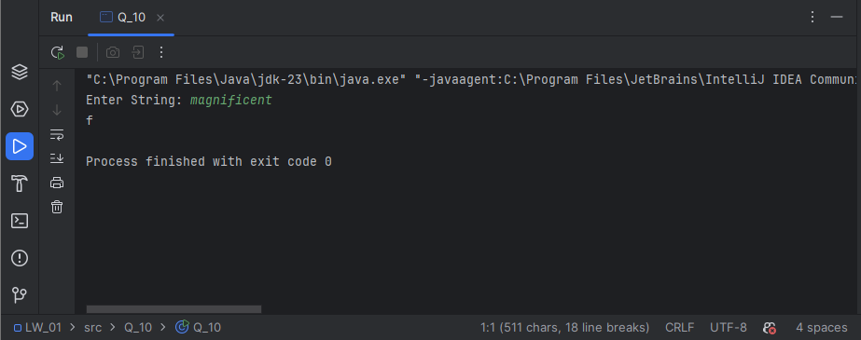

Q11.

Code:

|  |
| --- |
| ***package Q_11; import java.util.Scanner;  public class Q_11 {  public static void main(String[] args) {  Scanner scanner = new Scanner(System.in);   System.out.println("Enter Name in format of (first middle last): ");  String name = scanner.nextLine();   String [] partOfName = name.split(" ");   if (partOfName.length != 3){  System.out.println("Invalid Input: ");  }else {  String firstName = partOfName[0];  String middleName = partOfName[1];  String lastName = partOfName[2];   System.out.println(lastName+", "+firstName+" "+middleName.charAt(0)+".");  }  } }*** |

Output:

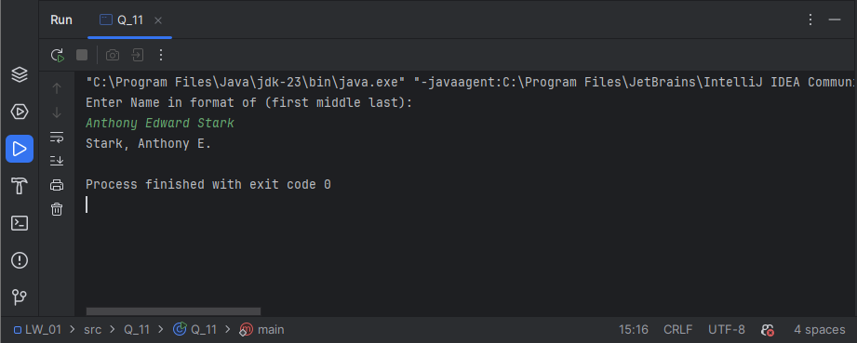

Q12.

Code:

|  |
| --- |
| ***package Q_12;  import javax.swing.*;  public class Q_12 {  public static void main(String[] args) {  JFrame window = new JFrame();  window.setSize(300, 200);  window.setVisible(true);  window.setTitle("My first Frame");  window.setLocation(100, 50);  window.setDefaultCloseOperation(WindowConstants.EXIT_ON_CLOSE);  } }*** |

Output:

Q13.

Code:

|  |
| --- |
| ***package Q_13;  import javax.swing.*;  public class Q_13 {  public static void main(String[] args) {  JFrame myWindow;  myWindow = new JFrame();  myWindow.setSize(500, 250);  myWindow.setTitle("UOK");  myWindow.setVisible(true);  try {Thread.sleep(500);} catch (Exception e) { }  myWindow.setVisible(false);  try {Thread.sleep(500);} catch (Exception e) { }  myWindow.setVisible(true);  } }*** |

Output: