Q1.

Code:

|  |
| --- |
| ***package Q_01; import java.util.Scanner;  class Temperature {  private double celsius;   public Temperature(){  this.celsius = 0.0;  }  public Temperature(double celsius){  this.celsius=celsius;  }  public double toCelsius(){  return celsius;  }  public double toFahrenheit(){  return (celsius * 9/5 )+32;  }   public double getCelsius() {  return celsius;  }   public void setCelsius(double celsius) {  this.celsius = celsius;  }  public void setFahrenheit(double fahrenheit) {  this.celsius = (fahrenheit - 32) * 5 / 9;  }  }*** |

|  |
| --- |
| ***package Q_01;  import java.util.Scanner;  public class Main {  public static void main(String[] args) {  Scanner scanner=new Scanner(System.in);   System.out.print("Enter temperature in celsius:");  double celsiusInput = scanner.nextDouble();   Temperature temp = new Temperature(celsiusInput);   System.out.print("Temperature in Fahrenheit: "+ temp.toFahrenheit());   scanner.close();  } }***  ***}***  ***}*** |

Output:

Q2.

Code:

|  |
| --- |
| ***package Q_02;  import java.util.Scanner;  public class FahrenheitToCelsiusConverter {  public static void main(String[] args) {  Scanner scanner = new Scanner(System.in);  Temperature temp = new Temperature();   System.out.print("Enter temperature in Fahrenheit: ");  double fahrenheit = scanner.nextDouble();   temp.setFahrenheit(fahrenheit);   System.out.printf("Equivalent temperature in Celsius: %.2f\n", temp.getCelsius());   scanner.close();  } }*** |
| ***package Q_02; import java.util.Scanner; class Temperature {  private double celsius;   public void setFahrenheit(double fahrenheit) {  this.celsius = (fahrenheit - 32) * 5 / 9;  }   public double getCelsius() {  return celsius;  } }*** |

Q3.

Code:

|  |
| --- |
| ***package Q_03;  class Circle {  private double radius;   // Constructor  public Circle(double radius) {  this.radius = radius;  }   // Method to set radius  public void setRadius(double radius) {  this.radius = radius;  }   // Method to compute area  public double computeArea() {  return Math.PI * Math.pow(radius, 2);  }   // Method to compute circumference  public double computeCircumference() {  return 2 * Math.PI * radius;  }  }*** |

|  |
| --- |
| ***package Q_03; import java.util.Scanner; public class CircularRegionAreaCalculator {  public static void main(String[] args) {  Scanner scanner = new Scanner(System.in);   // Get the outer and inner radii from the user  System.out.print("Enter the radius of the outer circle : ");  double ro = scanner.nextDouble();  System.out.print("Enter the radius of the inner circle : ");  double ri = scanner.nextDouble();   // Ensure outer radius is greater than inner radius  if (ro <= ri) {  System.out.println("Error: Outer radius must be greater than inner radius.");  } else {  Circle outerCircle = new Circle(ro);  Circle innerCircle = new Circle(ri);   // Compute the shaded area  double shadedArea = outerCircle.computeArea() - innerCircle.computeArea();   // Display the result  System.out.printf("The area of the circular region is: %.2f\n", shadedArea);  }   scanner.close();  } }*** |

Q4.

Code:

|  |
| --- |
| ***package Q_04; public class Bicycle {  private Owner owner;   public Bicycle() {  this.owner = new Owner("Unknown","Unknown");  }  public Owner getOwner() {  return owner;  }  public void setOwner(String name,String phoneNo) {  owner.setOwnerName(name);  owner.setPhoneNo(phoneNo);  } }*** |

|  |
| --- |
| ***package Q_04; class Owner{  private String ownerName;  private String phoneNo;  public Owner(String ownerName, String phoneNo){  this.ownerName = ownerName;  this.phoneNo = phoneNo;  }  public String getOwnerName() {  return ownerName;  }  public void setOwnerName(String ownerName) {  this.ownerName = ownerName;  }  public String getPhoneNo() {  return phoneNo;  }  public void setPhoneNo(String phoneNo) {  this.phoneNo = phoneNo;  } }*** |

|  |
| --- |
| ***package Q_04;  public class BicycleOwnerTest {  public static void main(String[] args) {  Bicycle bike1 = new Bicycle();  bike1.setOwner("Bhanuka","0760772649");   System.out.println("Bike 1 owner: "+ bike1.getOwner().getOwnerName());  System.out.println("Bike 1 owner Phone No: "+ bike1.getOwner().getPhoneNo());  } }*** |

Output: 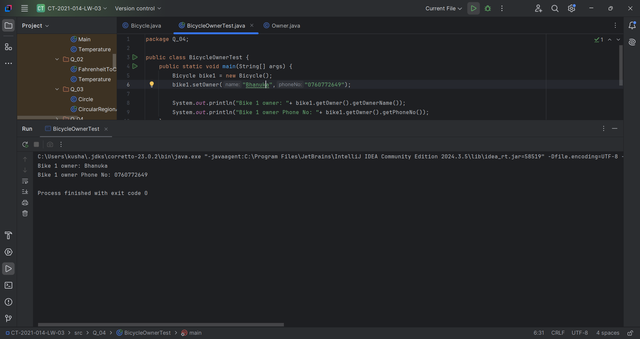

Q5.

Code:

|  |
| --- |
| ***package Q_05;  public class Course {  private String courseName;  private String courseCode;  private Lecture lecture= new Lecture();   public void lecture(String courseName, String courseCode){  this.courseCode=courseCode;  this.courseName=courseName;  }  public String getCourseName() {  return courseName;  }  public void setCourseName(String courseName) {  this.courseName = courseName;  }  public String getCourseCode() {  return courseCode;  }  public void setCourseCode(String courseCode) {  this.courseCode = courseCode;  } }*** |

|  |
| --- |
| ***package Q_05;  public class Lecture {  private String lectureName;  private String courseTeaching;   public String getLectureName() {  return lectureName;  }  public void setLectureName(String lectureName) {  this.lectureName = lectureName;  }  public String getCourseTeaching() {  return courseTeaching;  }  public void setCourseTeaching(String courseTeaching) {  this.courseTeaching = courseTeaching;  } }*** |

|  |
| --- |
| ***package Q_05;  public class Student {  private String studentName;  private String degreeName;  private String courseFollowing;   public String getStudentName() {  return studentName;  }  public void setStudentName(String studentName) {  this.studentName = studentName;  }  public String getDegreeName() {  return degreeName;  }  public void setDegreeName(String degreeName) {  this.degreeName = degreeName;  }  public String getCourseFollowing() {  return courseFollowing;  }  public void setCourseFollowing(String courseFollowing) {  this.courseFollowing = courseFollowing;  } }*** |

|  |
| --- |
| ***package Q_05;  public class Main {  public static void main(String[] args) {  Course course1 = new Course();  course1.setCourseName("OOP");  course1.setCourseCode("CTEC 001");   Lecture lecture1 = new Lecture();  lecture1.setLectureName("Kesevan");  lecture1.setCourseTeaching("CTEC 001");   Student student1 = new Student();  student1.setStudentName("Kushan");  student1.setCourseFollowing("CTEC 001");  student1.setDegreeName("BICT");   System.out.println("Student Name: "+student1.getStudentName());  System.out.println("Student CourseFollowing: "+student1.getCourseFollowing());  System.out.println("Student DegreeName: "+student1.getDegreeName());  System.out.println("Lecture Name: "+lecture1.getLectureName());  System.out.println("lecture CourseTeaching: "+lecture1.getCourseTeaching());  System.out.println("Course Name: "+course1.getCourseName());  System.out.println("Course Code: "+course1.getCourseCode());  } }*** |

