Q1.

Code:

|  |
| --- |
| ***package Q_01; import java.util.Scanner; public class ifStatement {  public static void main(String[] args) {  int a,b,c;  Scanner scanner = new Scanner(System.in);  System.out.print("Enter Number 1: ");  a = scanner.nextInt();  System.out.print("Enter Number 2: ");  b = scanner.nextInt();  System.out.print("Enter Number 3: ");  c = scanner.nextInt();   if (a<b && a<c){  System.out.println("The smallest Number is "+a);  }else if (b<a && b<c){  System.out.println("The smallest Number is "+b);  }else{  System.out.println("The smallest Number is "+c);  }  } }*** |

Output:

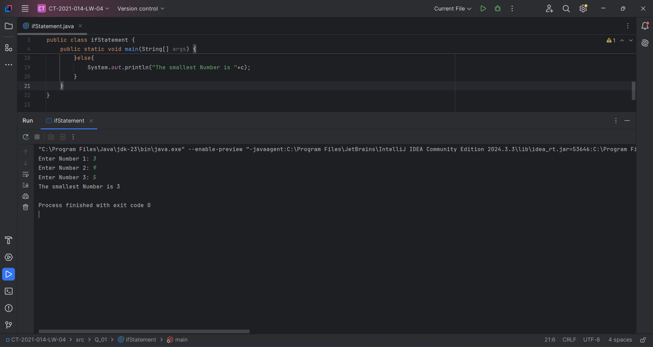

Q2.

Code:

|  |
| --- |
| ***package Q_02; import java.util.Scanner; public class SwitchCase {  public static void main(String[] args) {  Scanner scanner = new Scanner(System.in);  System.out.println("0.Magenta");  System.out.println("1.Cyan");  System.out.println("2.Red");  System.out.println("3.Blue");  System.out.println("4.Green");  System.out.print("Select one color from the above list: ");  int selection = scanner.nextInt();  switch (selection){  case 0:  System.out.println("You selected Magenta");  break;  case 1:  System.out.println("You selected Cyan");  break;  case 2:  System.out.println("You selected Red");  break;  case 3:  System.out.println("You selected Blue");  break;  case 4:  System.out.println("You selected Green");  break;  default:  System.out.println("Invalid selection");  break;  }  } }*** |

Output: 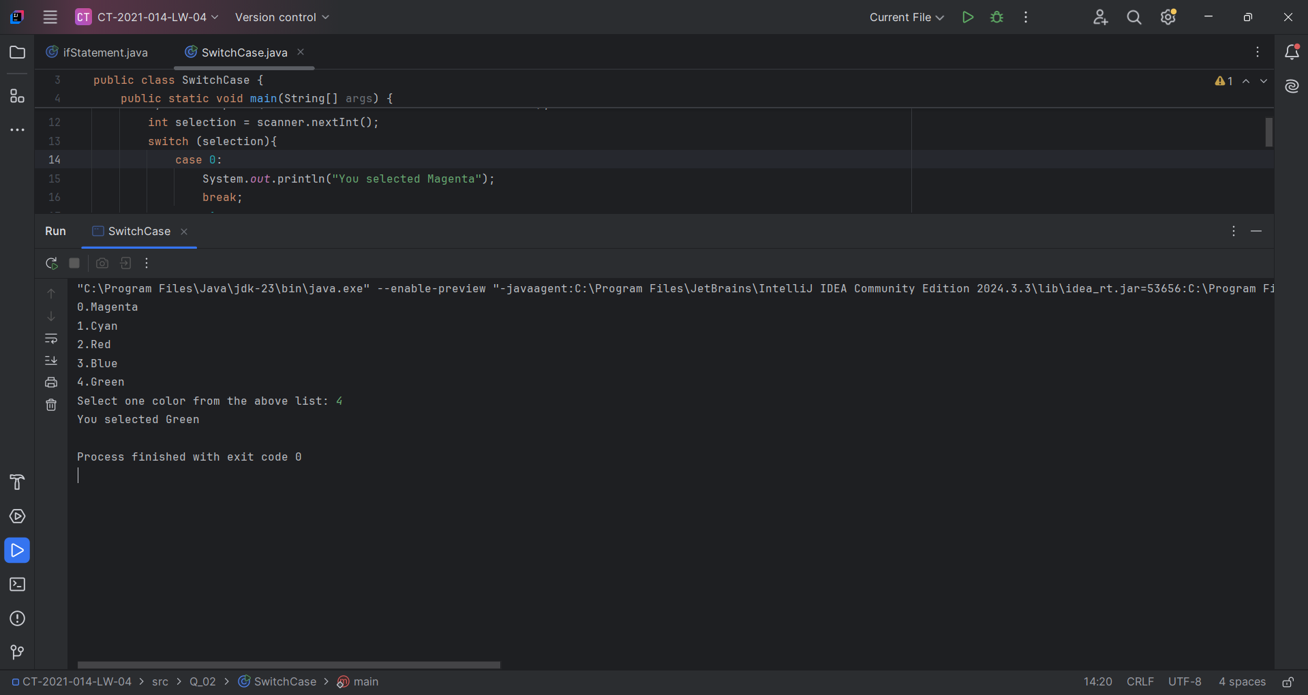

Q3.

Code:

|  |
| --- |
| ***package Q_03; import java.util.Scanner; public class NumSelection {  public static void main(String[] args) {  Scanner scanner = new Scanner(System.in);  int pow;  System.out.print("Enter power of 10: (ex: 6, 9, 12, 15,18,21,30,100) : ");  pow = scanner.nextInt();  if (pow == 6){  System.out.println("Power of 10^"+pow+" is a Million");  }else if (pow == 9){  System.out.println("Power of 10^"+pow+" is a Billion");  } else if (pow == 12) {  System.out.println("Power of 10^"+pow+" is a Trillion");  } else if (pow == 15) {  System.out.println("Power of 10^"+pow+" is a Quadrillion");  } else if (pow == 18) {  System.out.println("Power of 10^"+pow+" is a Quintillion");  } else if (pow == 21) {  System.out.println("Power of 10^"+pow+" is a Sextillion");  } else if (pow == 30) {  System.out.println("Power of 10^"+pow+" is a Nonillion");  } else if (pow == 100) {  System.out.println("Power of 10^"+pow+" is a Googol");  } else  System.out.println("Invalid selection!!!!!");  } }*** |

Output: 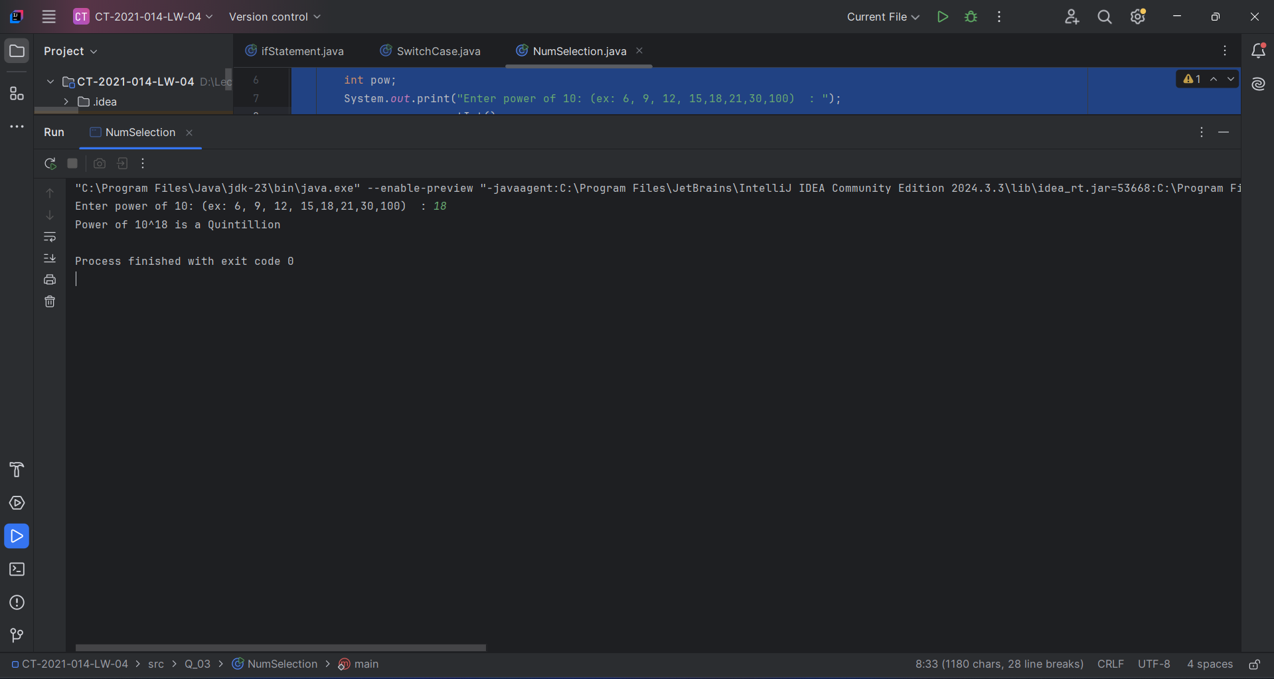

Q4.

Code:

|  |
| --- |
| ***package Q_04; import java.util.Scanner; public class YearSelection {  public static void main(String[] args) {  Scanner scanner=new Scanner(System.in);  int year;   System.out.print("Enter Year: ");  year= scanner.nextInt();   if ( (year % 4==0 && year % 100 != 0 ) || (year % 400 == 0)){  System.out.println("Leap Year.");  }else {  System.out.println("Not a leap Year.");  }  } }*** |

Output: 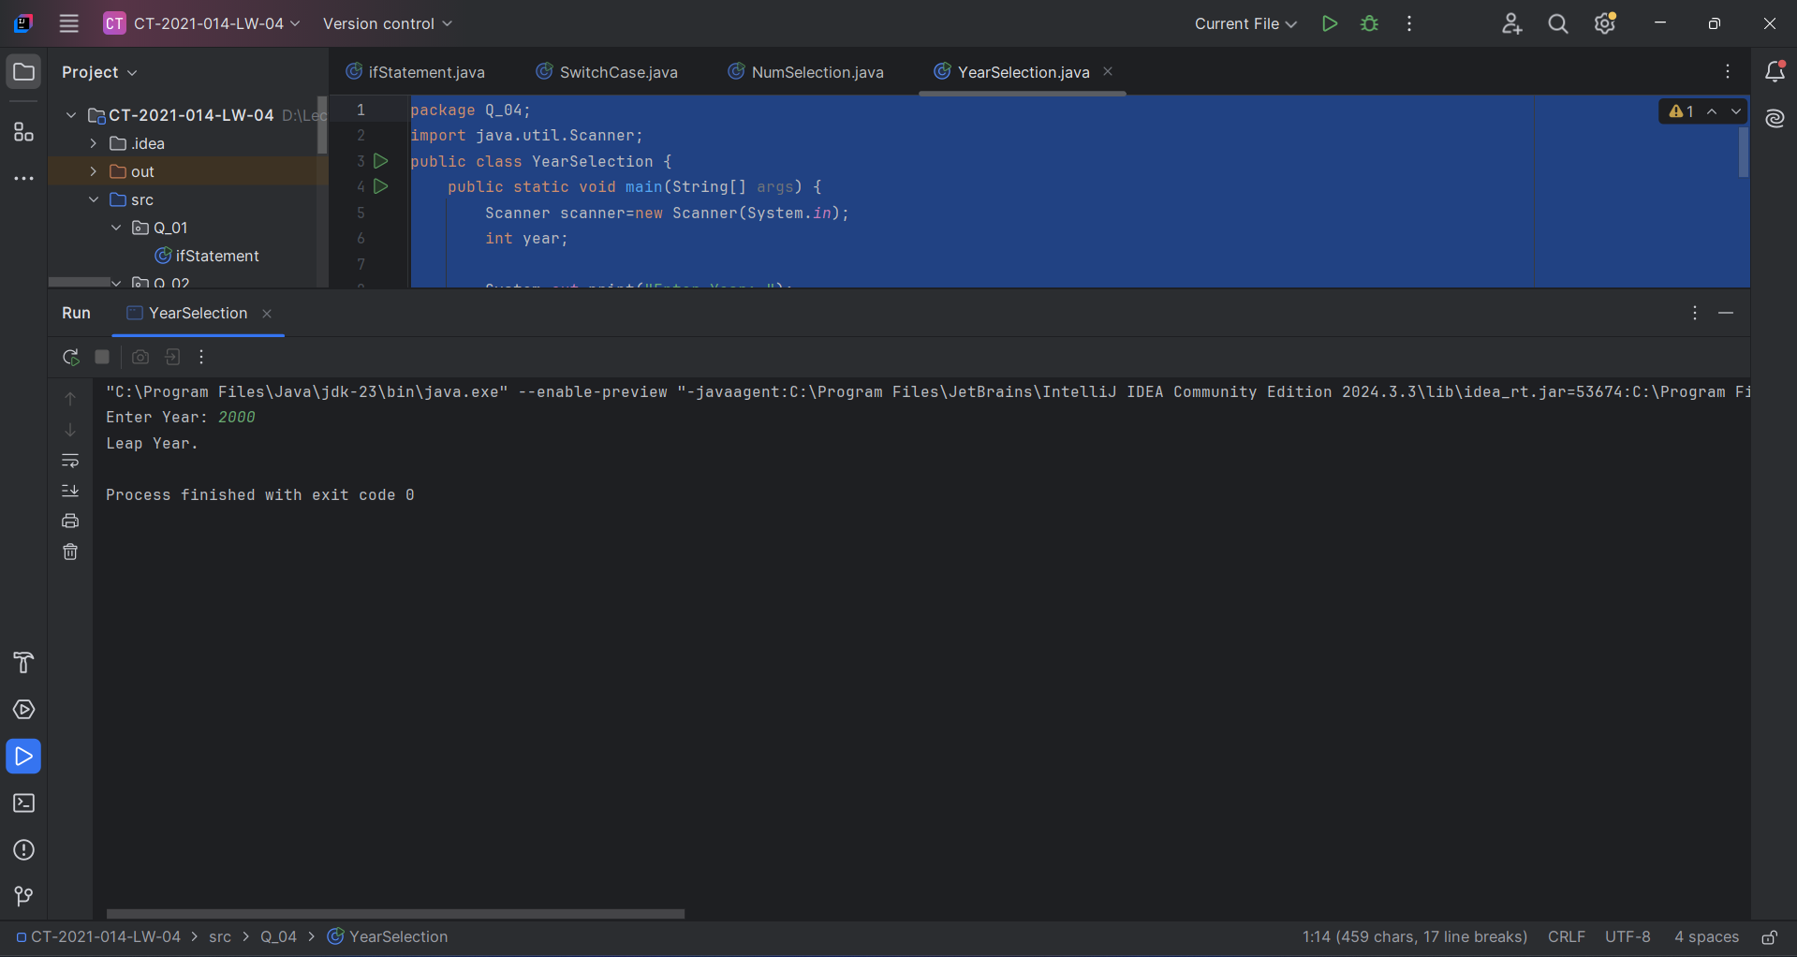

Q5.

Code:

|  |
| --- |
| ***package Q_05; import java.util.Scanner; public class MyJavaLoFatBurgers {  public static void main(String[] args) {  Scanner scanner = new Scanner(System.in);   String entree;  double entreePrice;   String side;  double sidePrice;   String drink;  double drinkPrice;   System.out.println("Entree Menu:");  System.out.println("1. Tofu Burger - $3.49");  System.out.println("2. Cajun Chicken - $4.59");  System.out.println("3. Buffalo Wings - $3.99");  System.out.println("4. Rainbow Fillet - $2.99");  System.out.print("Select an entree (1-4): ");  int entreeChoice = scanner.nextInt();   if (entreeChoice == 1) {  entree = "Tofu Burger";  entreePrice = 3.49;  } else if (entreeChoice == 2) {  entree = "Cajun Chicken";  entreePrice = 4.59;  } else if (entreeChoice == 3) {  entree = "Buffalo Wings";  entreePrice = 3.99;  } else if (entreeChoice == 4) {  entree = "Rainbow Fillet";  entreePrice = 2.99;  } else {  System.out.println("Invalid entree choice.");  return;  }   System.out.println("\nSide Dish Menu:");  System.out.println("1. Rice Cracker - $0.79");  System.out.println("2. No-Salt Fries - $0.69");  System.out.println("3. Zucchini - $1.09");  System.out.println("4. Brown Rice - $0.59");  System.out.print("Select a side dish (1-4): ");  int sideChoice = scanner.nextInt();   if (sideChoice == 1) {  side = "Rice Cracker";  sidePrice = 0.79;  } else if (sideChoice == 2) {  side = "No-Salt Fries";  sidePrice = 0.69;  } else if (sideChoice == 3) {  side = "Zucchini";  sidePrice = 1.09;  } else if (sideChoice == 4) {  side = "Brown Rice";  sidePrice = 0.59;  } else {  System.out.println("Invalid side dish choice.");  return;  }   System.out.println("\nDrink Menu:");  System.out.println("1. Cafe Mocha - $1.99");  System.out.println("2. Cafe Latte - $1.90");  System.out.println("3. Espresso - $2.49");  System.out.println("4. Oolong Tea - $0.99");  System.out.print("Select a drink (1-4): ");  int drinkChoice = scanner.nextInt();   if (drinkChoice == 1) {  drink = "Cafe Mocha";  drinkPrice = 1.99;  } else if (drinkChoice == 2) {  drink = "Cafe Latte";  drinkPrice = 1.90;  } else if (drinkChoice == 3) {  drink = "Espresso";  drinkPrice = 2.49;  } else if (drinkChoice == 4) {  drink = "Oolong Tea";  drinkPrice = 0.99;  } else {  System.out.println("Invalid drink choice.");  return;  }   double total = entreePrice + sidePrice + drinkPrice;  System.out.println("\nOrder Summary:");  System.out.println("Entree: " + entree + " - $" + entreePrice);  System.out.println("Side: " + side + " - $" + sidePrice);  System.out.println("Drink: " + drink + " - $" + drinkPrice);  System.out.printf("Total Price: $%.2f\n", total);   scanner.close();  } }*** |

Output: 