Q1.

Code:

|  |
| --- |
| ***package Q_01;  public class NumPrint {  public static void main(String[] args) {  for (int i = 10; i < 50; i++){  System.out.print(i+" ");  if ((i-9) % 10 == 0){  System.out.println();  }  }  } }*** |

Output: 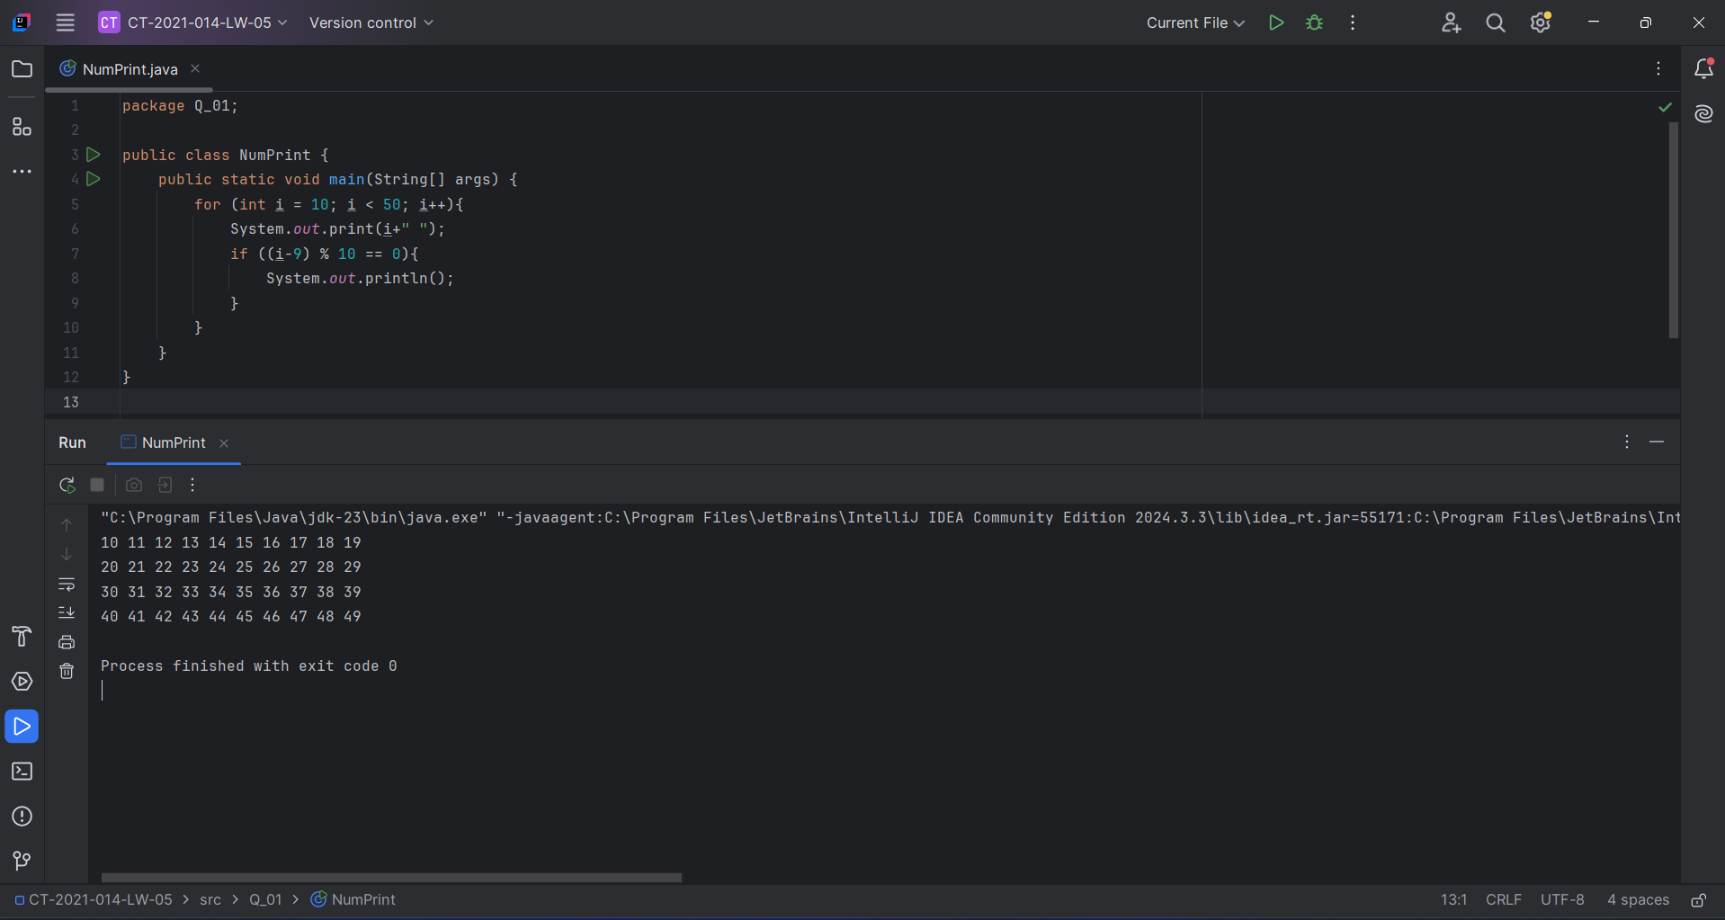

Q2.

Code:

|  |
| --- |
| ***package Q_02;  import java.util.Scanner;  public class DigiCount {  public static void main(String[] args) {  Scanner scanner= new Scanner(System.in);  int count = 0;  int num = 0;  while (num >= 0){  System.out.print("Enter Number (Negative to stop): ");  num = scanner.nextInt();  count = String.valueOf(Math.abs(num)).length();  System.out.println("Digits: "+count);  }  } }*** |

Output: 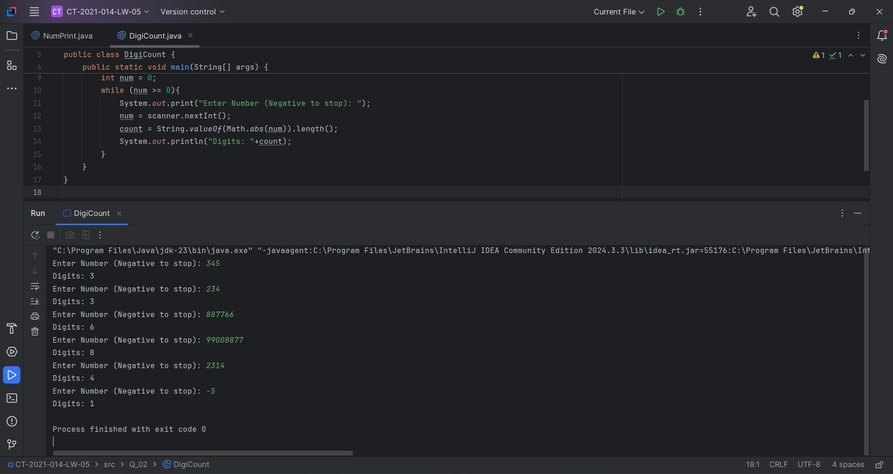

Q3.

Code:

|  |
| --- |
| ***package Q_03;  import java.util.Scanner;  public class Multiplication {  public static void main(String[] args) {  Scanner scanner=new Scanner(System.in);  System.out.print("Enter Number for multiplication: ");  int num = scanner.nextInt();   for (int i =1;i>=1 && i<=10;i++){  int ans;  ans = num*i;  System.out.println(num+" * "+i+" = "+ans);  }  } }*** |

Output: 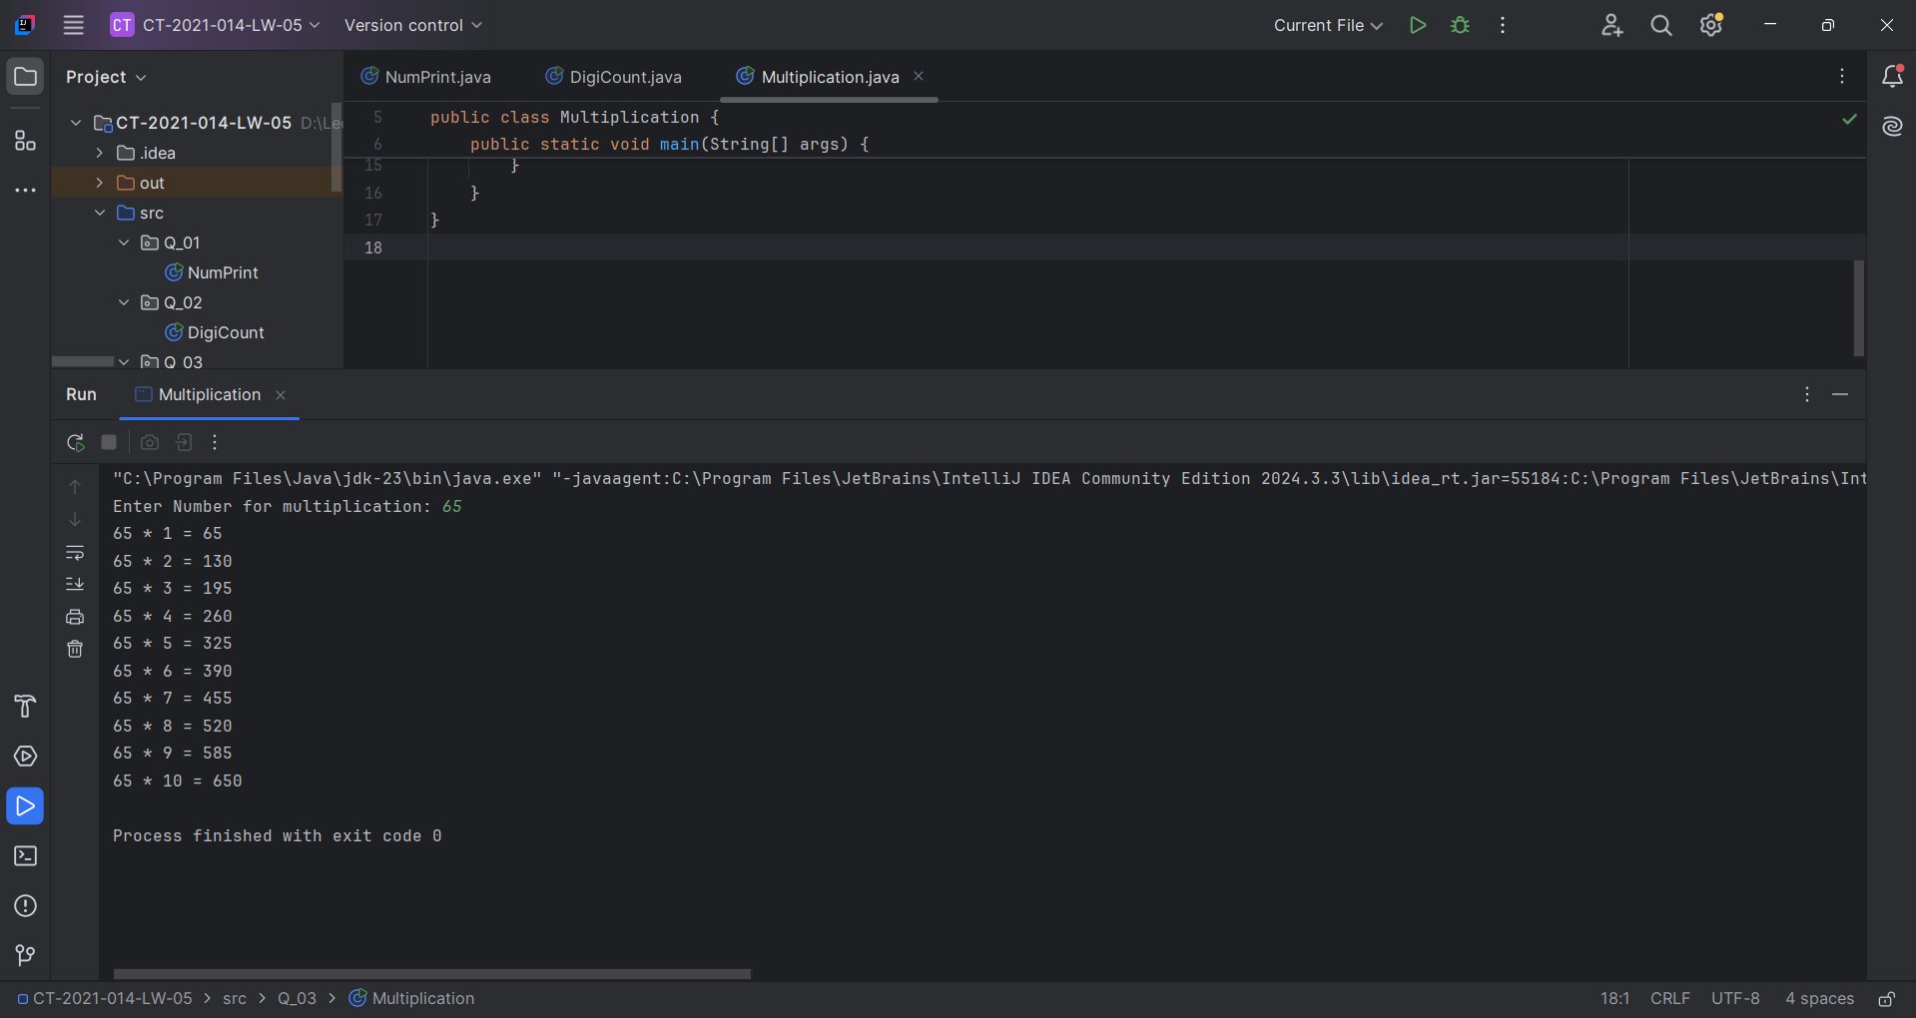

Q4.

Code:

|  |
| --- |
| ***package Q_04;  import java.util.Scanner;  public class Pyramid {  public static void main(String[] args) {  Scanner scanner=new Scanner(System.in);  System.out.print("Enter number of Rows: ");  int row = scanner.nextInt();   for (int i = 1; i <= row; i++){  for (int j = 1; j <= row-i; j++){  System.out.print(" ");  }  for (int k = 1; k <=(2*i-1); k++ ){  System.out.print("*");  }  System.out.println();  }  } }*** |

Output: 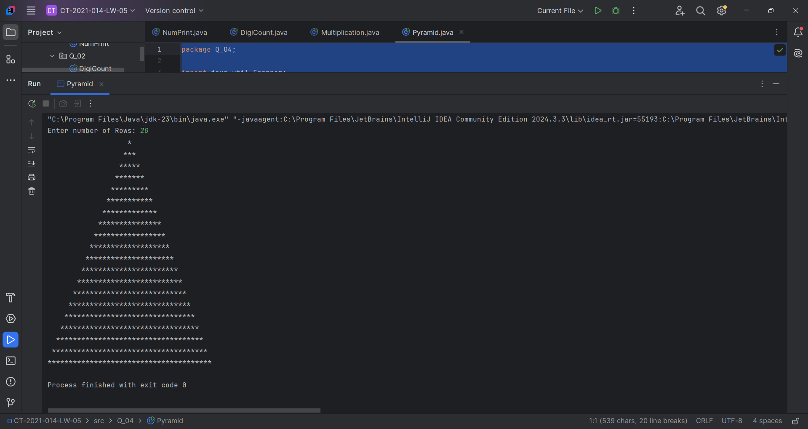

Q5.

Code:

|  |
| --- |
| ***package Q_05; import java.util.Scanner; public class PlaindromeNum {  public static void main(String[] args) {  Scanner scanner=new Scanner(System.in);   System.out.print("Enter word or phrase: ");  String input = scanner.nextLine();   int start = 0;  int end = input.length()-1;  boolean chkplnd = true;   while (start<end){  if (input.charAt(start) != input.charAt(end)){  chkplnd = false;  break;  }else {  chkplnd = true;  }  start++;  end--;  }  if (chkplnd == true){  System.out.println(input+" is palindrome.");  }else{  System.out.println(input+" is not paalindrome!!");  }  } }*** |

Output: 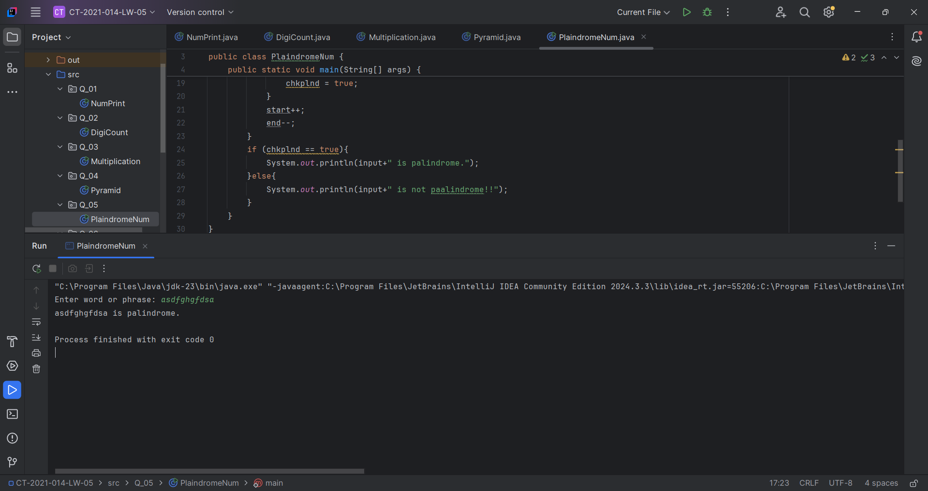

Q6.

Code:

|  |
| --- |
| ***package Q_06;  import java.util.Random; import java.util.Scanner;  public class NumGuess {  public static void main(String[] args) {  Scanner scanner=new Scanner(System.in);  Random random = new Random();   int secNum = random.nextInt(100) +1;  int guess = 0;  System.out.println("Guess number (1-100)!!!!");   while (guess != secNum){  System.out.print("Guess Number:");  guess = scanner.nextInt();  if (guess < secNum ){  System.out.println("Too low!!!. Guess again");  } else if (guess > secNum) {  System.out.println("Too High!!!. Guess again");  }else{  System.out.println("Congratulations! Guessed correctly.");  }  }  } }*** |

Output: 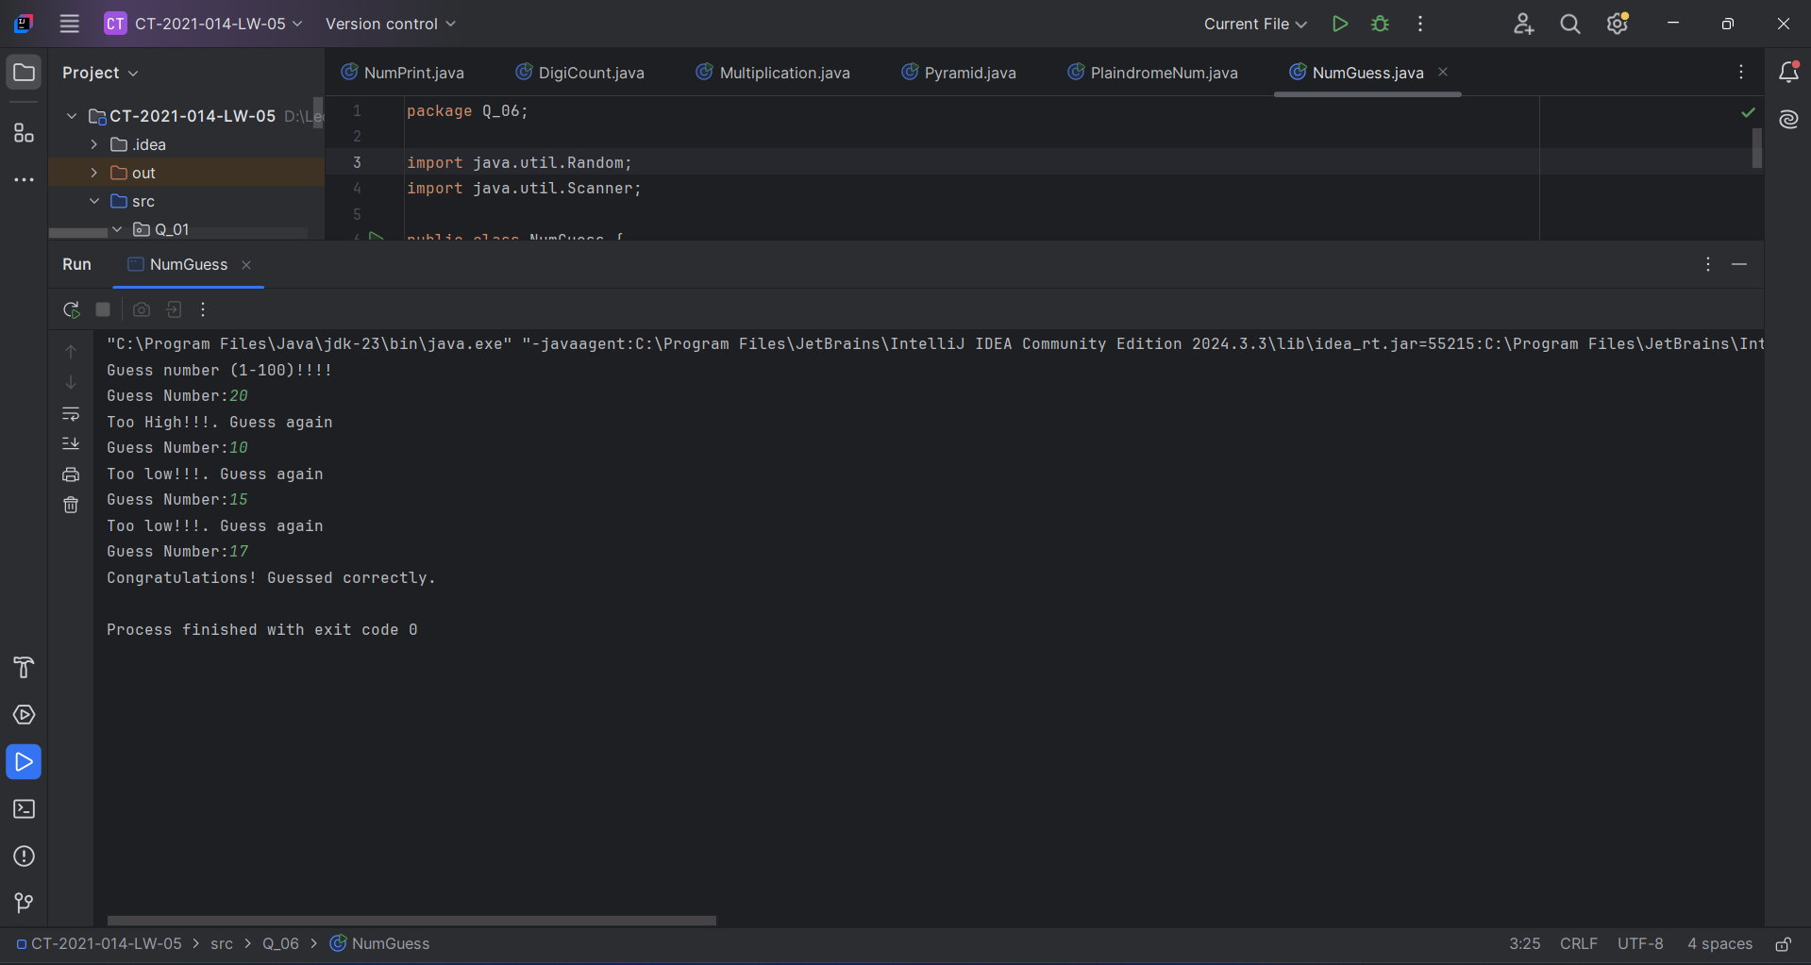

Q7.

Code:

|  |
| --- |
| ***package Q_07;  import java.util.Scanner;  public class ReplaceOccurrence {  public static void main(String[] args) {  Scanner scanner= new Scanner(System.in);   System.out.print("Enter Sentence: ");  String sentence = scanner.nextLine();   System.out.print("Enter the word to be replaced: ");  String toChange = scanner.nextLine();   System.out.print("Enter the replacement word: ");  String replace = scanner.nextLine();   String[] words = sentence.split(" ");  StringBuilder result = new StringBuilder();   int i=0;  while (i< words.length){  if (words[i].equals(toChange)){  result.append(replace);  }else{  result.append(words[i]);  }  if (i< words.length - 1){  result.append(" ");  }  i++;  }  System.out.println("Updated sentence: "+ result.toString());  } }*** |

Output: 