Q1.

Code:

|  |
| --- |
| ***package Q_01;  import javax.swing.*; import java.awt.*;  public class SumThreeIntegers {  public static void main(String[] args) {  String input1 = JOptionPane.showInputDialog("Enter the first integer:");  String input2 = JOptionPane.showInputDialog("Enter the second integer:");  String input3 = JOptionPane.showInputDialog("Enter the third integer:");  int num1 = Integer.parseInt(input1);  int num2 = Integer.parseInt(input2);  int num3 = Integer.parseInt(input3);  int sum = num1 + num2 + num3;  JOptionPane.showMessageDialog((Component)null, "The sum is: " + sum);  } }*** |

Output: 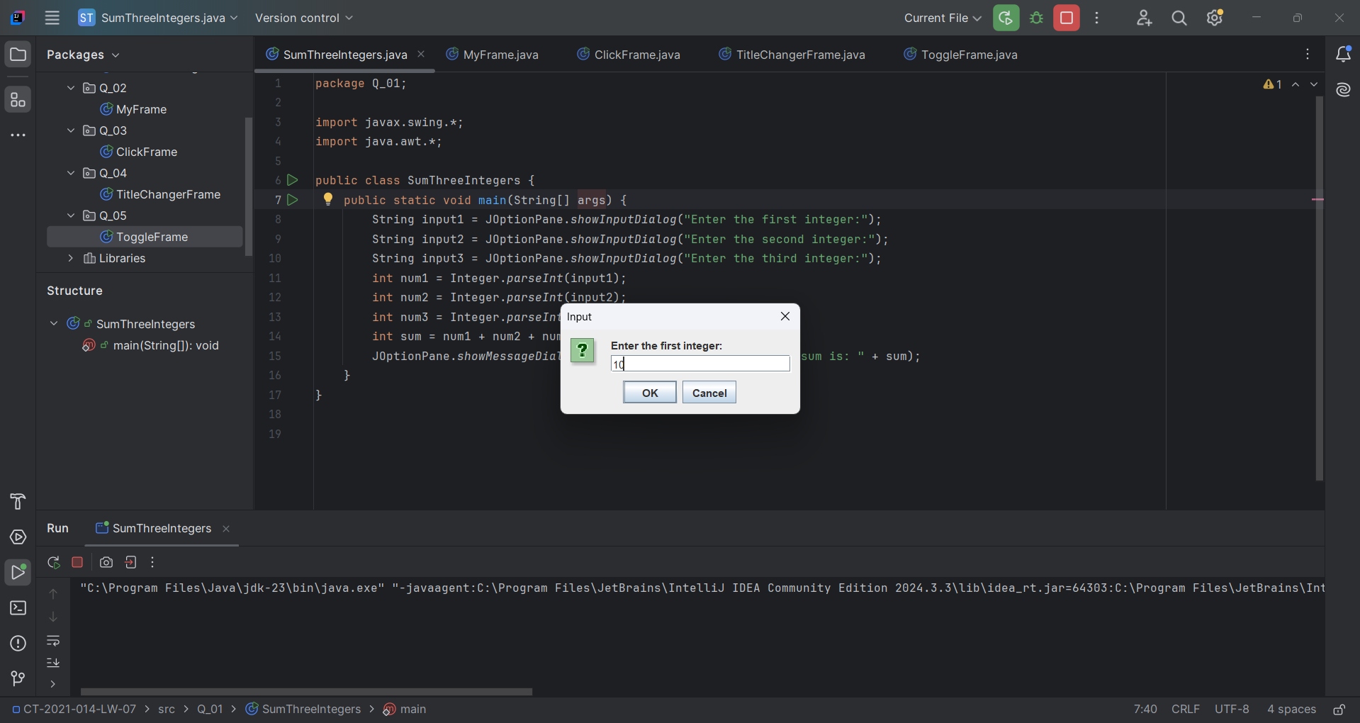

Q2.

Code:

|  |
| --- |
| ***package Q_02;  import java.awt.Color; import java.awt.LayoutManager; import javax.swing.JFrame; import javax.swing.SwingUtilities;  public class MyFrame extends JFrame {  public MyFrame() {  this.setTitle("MyFrame Example");  this.setSize(400, 450);  this.setDefaultCloseOperation(3);  this.getContentPane().setBackground(Color.BLUE);  this.setLayout((LayoutManager)null);  }   public static void main(String[] args) {  SwingUtilities.invokeLater(() -> {  MyFrame frame = new MyFrame();  frame.setVisible(true);  });  } }*** |

Output: 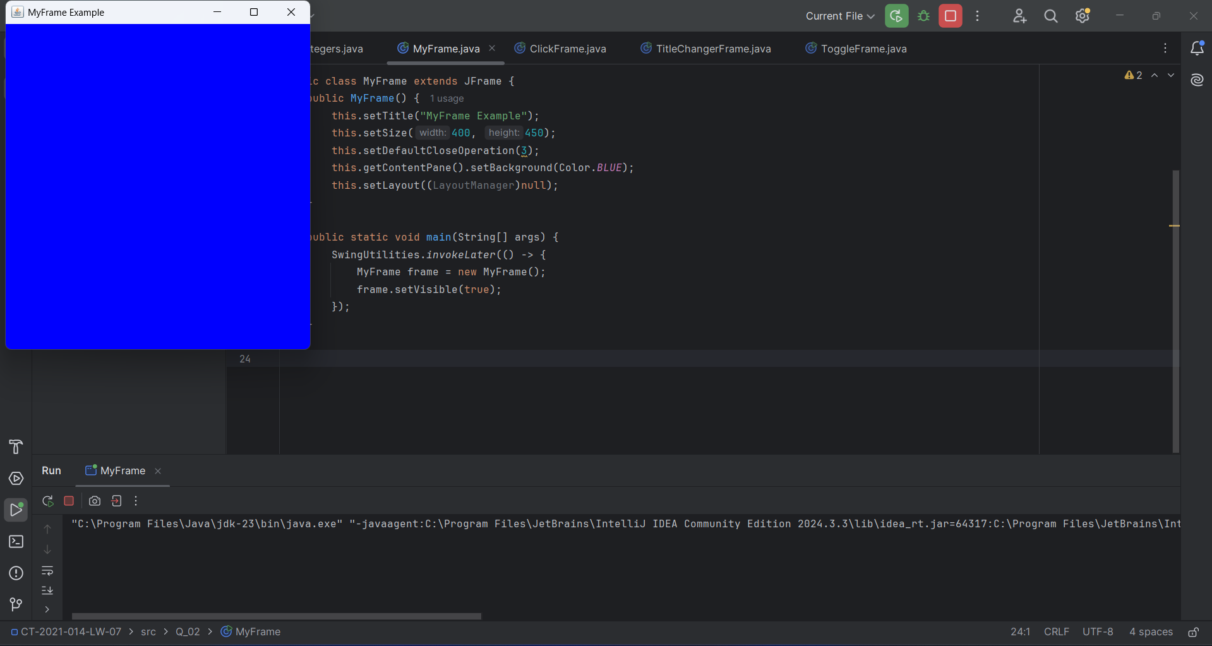

Q3.

Code:

|  |
| --- |
| ***package Q_03;  import java.awt.Component; import java.awt.FlowLayout; import java.awt.event.ActionEvent; import java.awt.event.ActionListener; import javax.swing.JButton; import javax.swing.JFrame; import javax.swing.JOptionPane; import javax.swing.SwingUtilities;  public class ClickFrame extends JFrame {  public ClickFrame() {  this.setTitle("Click Button Example");  this.setSize(300, 200);  this.setDefaultCloseOperation(3);  this.setLayout(new FlowLayout());  JButton button = new JButton("Click Me");  button.addActionListener(new ActionListener() {  public void actionPerformed(ActionEvent e) {  JOptionPane.showMessageDialog((Component)null, "You clicked!");  }  });  this.add(button);  }   public static void main(String[] args) {  SwingUtilities.invokeLater(() -> {  ClickFrame frame = new ClickFrame();  frame.setVisible(true);  });  } }*** |

Output: 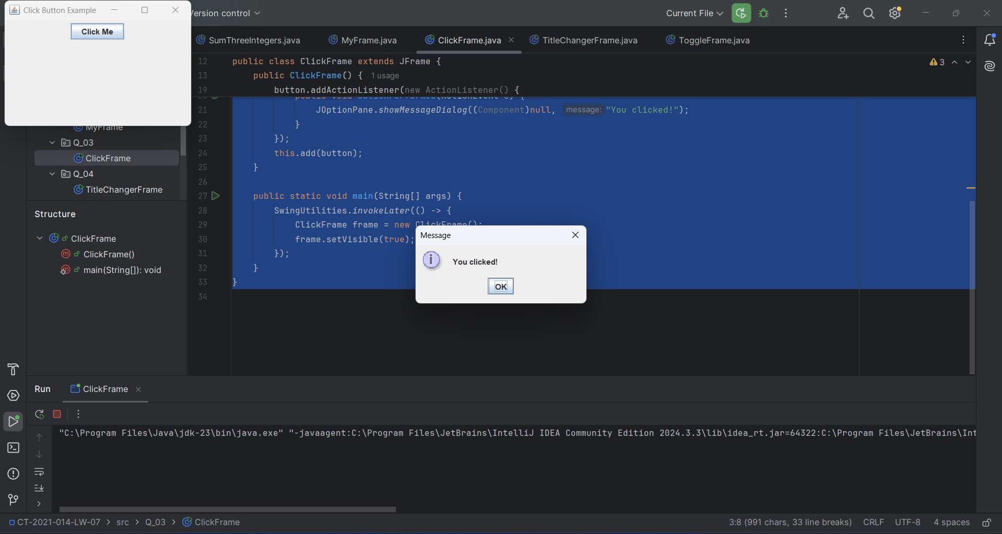

Q4.

Code:

|  |
| --- |
| ***package Q_04;  import java.awt.FlowLayout; import java.awt.event.ActionEvent; import java.awt.event.ActionListener; import javax.swing.JButton; import javax.swing.JFrame; import javax.swing.JTextField; import javax.swing.SwingUtilities;  public class TitleChangerFrame extends JFrame {  private JTextField textField;  private JButton button;   public TitleChangerFrame() {  this.setTitle("Title Changer");  this.setSize(400, 150);  this.setDefaultCloseOperation(3);  this.setLayout(new FlowLayout());  this.textField = new JTextField(20);  this.button = new JButton("Set Title");  this.button.addActionListener(new ActionListener() {  public void actionPerformed(ActionEvent e) {  TitleChangerFrame.this.setTitle(TitleChangerFrame.this.textField.getText());  }  });  this.add(this.textField);  this.add(this.button);  }   public static void main(String[] args) {  SwingUtilities.invokeLater(() -> {  TitleChangerFrame frame = new TitleChangerFrame();  frame.setVisible(true);  });  } }*** |

Q5.

Code:

|  |
| --- |
| ***package Q_05;  import java.awt.Color; import java.awt.FlowLayout; import java.awt.event.ActionEvent; import java.awt.event.ActionListener; import javax.swing.JButton; import javax.swing.JFrame; import javax.swing.SwingUtilities;  public class ToggleFrame extends JFrame {  private JButton toggleButton;  private boolean isOn = false;   public ToggleFrame() {  this.setTitle("Toggle Frame");  this.setSize(300, 200);  this.setDefaultCloseOperation(3);  this.getContentPane().setBackground(Color.GREEN);  this.setLayout(new FlowLayout());  this.toggleButton = new JButton("OFF");  this.toggleButton.addActionListener(new ActionListener() {  public void actionPerformed(ActionEvent e) {  ToggleFrame.this.toggleState();  }  });  this.add(this.toggleButton);  }   private void toggleState() {  if (this.isOn) {  this.getContentPane().setBackground(Color.GREEN);  this.toggleButton.setText("OFF");  } else {  this.getContentPane().setBackground(Color.RED);  this.toggleButton.setText("ON");  }   this.isOn = !this.isOn;  }   public static void main(String[] args) {  SwingUtilities.invokeLater(() -> {  ToggleFrame frame = new ToggleFrame();  frame.setVisible(true);  });  } }*** |

