1. Code:

|  |
| --- |
| ***package Q_01; import java.util.Scanner;  public class Q_01 {  public static void main(String[] args) {  Scanner scanner= new Scanner(System.in);  System.out.print("Enter A: ");  double A = scanner.nextFloat();  System.out.print("Enter B: ");  double B = scanner.nextFloat();  System.out.print("Enter C: ");  double C = scanner.nextFloat();  System.out.print("Enter X: ");  double X = scanner.nextFloat();  System.out.print("Enter Y: ");  double Y = scanner.nextFloat();  System.out.print("Enter r: ");  double r = scanner.nextFloat();   if (A!=C){// Answer for part a  double resultA = Math.sqrt(Math.pow(B, 2) + 4 * A * C);  System.out.println("The square root of B^2 + 4AC is: " + resultA);   // b. Answer for part b  double resultB = Math.sqrt(X + 4 * Math.pow(Y, 3));  System.out.println("The square root of X + 4Y^3 is: " + resultB);   // c. Answer for part c  double resultC = Math.cbrt(X * Y);  System.out.println("The cube root of the product of X and Y is: " + resultC);   // d. Answer for part d  double resultD = Math.PI * Math.pow(r, 2);  System.out.println("The area of the circle with radius r is: " + resultD);  }else {  System.out.println("Your A & C are same!!!!!!");  }  } }*** |

1. Code:

|  |
| --- |
| ***package Q_02;  import java.util.Scanner;  public class Q_02 {  public static void main(String[] args) {  Scanner scanner = new Scanner(System.in);  System.out.print("Enter Distance in Centimeter: ");  double input = scanner.nextFloat();   double cmToInch = 2.54;   System.out.println("Distance in Inches: "+input/cmToInch);  } }*** |

Output(Q_02): 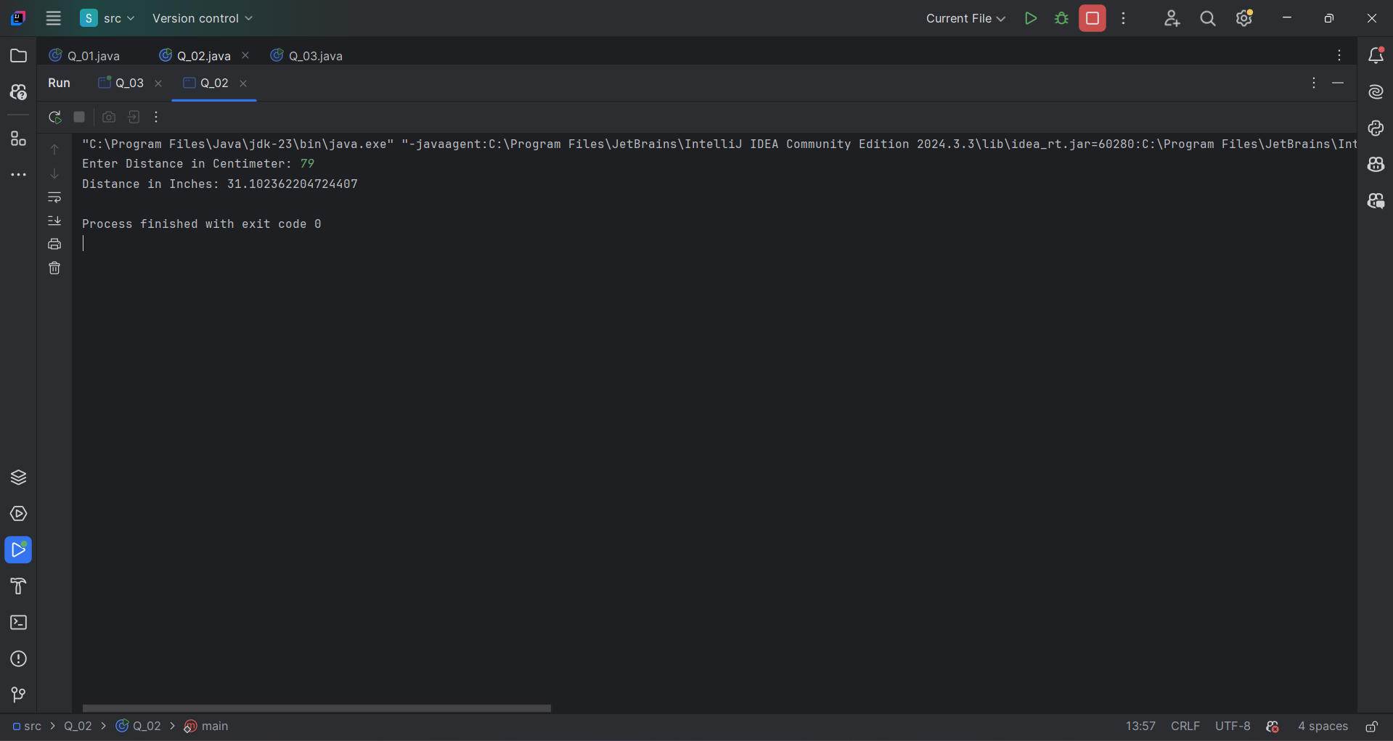

1. Code:

|  |
| --- |
| ***package Q_03;  import java.util.Scanner;  public class Q_03 {  public static void main(String[] args) {  Scanner scanner = new Scanner(System.in);  System.out.print("Enter temperature in Celsius : ");  double input = scanner.nextFloat();   double Fahrenheit ;  double output = ((1.8 * input) + 32);   System.out.println("Temperature in Fahrenheit: "+output);  } }*** |

1. Code:

|  |
| --- |
| ***package Q_04;  import java.util.Scanner;  public class Q_04 {  public static void main(String[] args) {  Scanner scanner = new Scanner(System.in);   System.out.print("Enter your Weight in pound : ");  double weight = scanner.nextDouble();   double calories = weight*19;   System.out.print("Your daily wanted calories: "+calories);  } }*** |

1. Code:

|  |
| --- |
| ***package Q_05;  import java.util.Scanner;  public class Q_05 {  public static void main(String[] args) {  Scanner scanner = new Scanner(System.in);  System.out.print("Enter temperature in Fahrenheit : ");  double input = scanner.nextFloat();   double output = (((double) 5 /9)*(input-32));   System.out.println("Temperature in Celsius : "+output);  } }*** |

Output (Q_05): 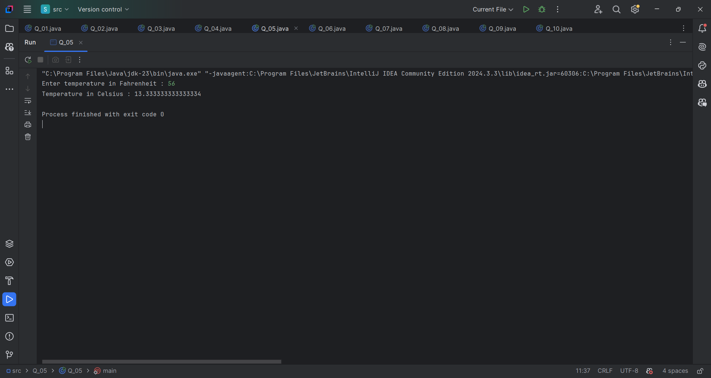

1. Code:

|  |
| --- |
| ***package Q_06; import java.time.LocalDate; import java.util.Scanner;  public class Q_06 {  public static void main(String[] args) {  Scanner scanner = new Scanner(System.in);   int currentYear = LocalDate.now().getYear();   System.out.print("Enter your Birth Year : ");  int birthYear = scanner.nextInt();   if (birthYear>currentYear){  System.out.println("You entered invalid Birth Year!!!!! ");  }else {  int age = currentYear - birthYear;  System.out.println("You were born in " + birthYear + " and will be (are) " + age + " this year.");  }  scanner.close();  } }*** |

1. Code:

|  |
| --- |
| ***package Q_07;  import java.util.Scanner; public class Q_07 {  public static void main(String[] args) {  Scanner scanner = new Scanner(System.in);  System.out.print("Enter your mass in kilograms: ");  float w = scanner.nextFloat();  System.out.print("Enter your height in centimeters: ");  float h = scanner.nextFloat();   double BMI = w/Math.pow(h/100.0,2);   if (BMI < 20){  System.out.println("Your BMI category: UnderWeight.");  System.out.print("BMI value: "+BMI);  }else if (BMI >= 20 && BMI <=25){  System.out.println("Your BMI category: Normal.");  System.out.print("BMI value: "+BMI);  }else{  System.out.println("your BMI category: OverWeight");  System.out.print("BMI value: "+BMI);  }  } }*** |

1. Code:

|  |
| --- |
| ***package Q_08;  import java.util.Scanner;  import static java.lang.Math.PI;  public class Q_08 {  public static void main(String[] args) {  Scanner scanner = new Scanner(System.in);   System.out.print("Enter radius of your Sphere: ");  float r = scanner.nextFloat();   double V = (4.0/3)*(PI*Math.pow(r,3));   System.out.println("Volume of your sphere: "+V);  } }*** |

1. Code:

|  |
| --- |
| ***package Q_09;  import java.util.Scanner;  public class Q_09 {  public static void main(String[] args) {  Scanner scanner = new Scanner(System.in);   System.out.print("Enter your investment in Dollars: ");  float P = scanner.nextFloat();  System.out.print("Enter your investment percentage: ");  float R = scanner.nextFloat();  System.out.print("Enter your investment Period in Years: ");  int N = scanner.nextInt();   double grow = P*Math.pow((1+(R/100)),N);  System.out.println("You earned "+grow+ " dollars in "+N+" Years.");  } }*** |

1. Code:

|  |
| --- |
| ***package Q_10;  import java.util.Scanner;  public class Q_10 {  public static void main(String[] args) {  Scanner scanner = new Scanner(System.in);   int MONTHS_IN_YEAR = 12;   System.out.print("Enter loan amount ($): ");  float loanAmount = scanner.nextFloat();  System.out.print("Enter Annual Interest Rate: ");  float annualInterestRate = scanner.nextFloat();  System.out.print("Enter loan period: ");  float loanPeriod = scanner.nextFloat();   double monthlyInterestRate = annualInterestRate/100.0/MONTHS_IN_YEAR;  double numberOfPayments = loanPeriod*MONTHS_IN_YEAR;  double monthlyPayment = (loanAmount*monthlyInterestRate)/(1-Math.pow(1/(1+monthlyInterestRate),numberOfPayments));  double totalPayment = monthlyPayment*numberOfPayments;   System.out.println("Your Monthly Payment: "+monthlyPayment+" $");  System.out.println("Your Total Payment: "+totalPayment+" $");  } }*** |

