**Fire Detection Application using**

**Convolution Neural Networks**

**Requirements:**

* Environment [Anaconda]
* Dataset
* Model Creation [create.py, cnn.h5]
* Application [app.py]

**Environment**:

* Open **anaconda Prompt** and create, activate environment using
  + - * conda create -n ecvironment_name python=3.10:: Ex.: **conda create -n drtln python=3.10**
      * activate environment_name :: Ex:: **activate drtln**
* And in your environment install the required libraries

**pip install tensorflow**

**pip install flask**

**pip install keras**

**pip install pillow**

**pip install -U scikit-learn**

**pip install scipy**

**pip install seaborn**

**pip install matplotlib**

**Dataset**

* Model Creation (create.py)

**Input from**

**dataset**

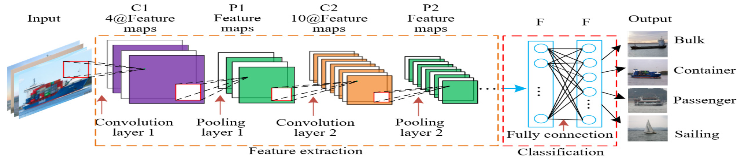

**Output**

**Classification**

* **no**

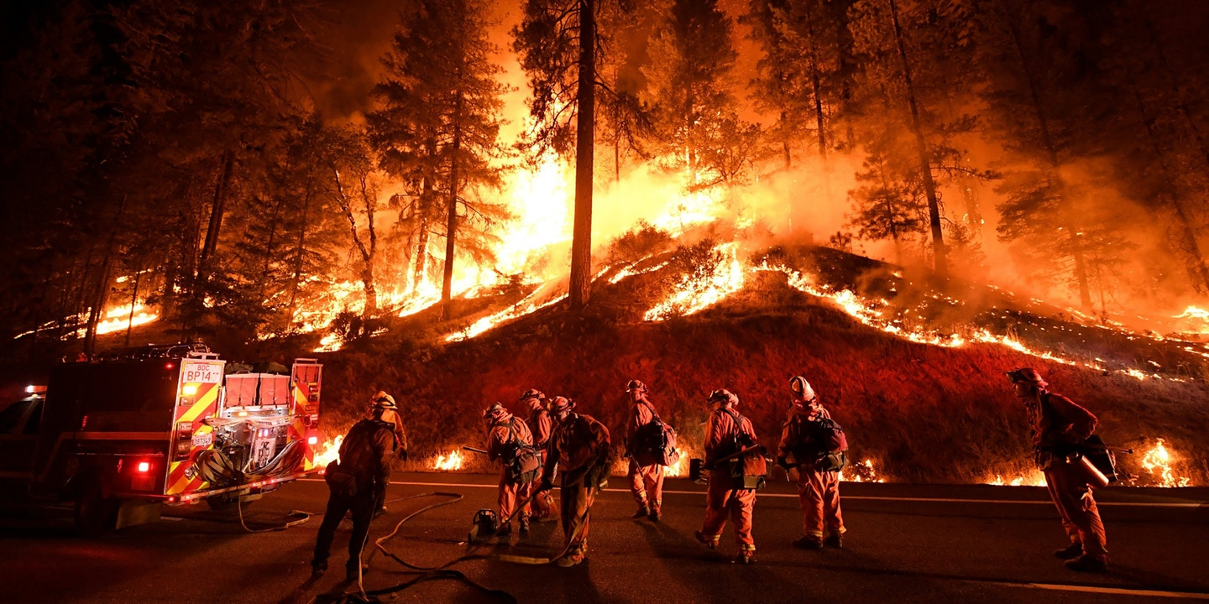

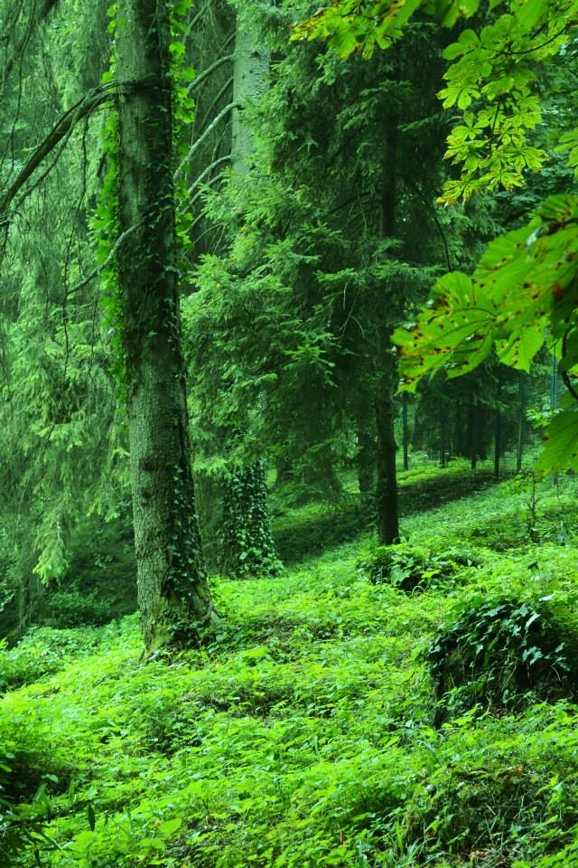

* **fire**

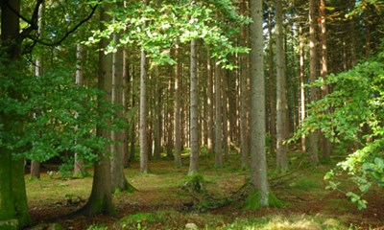

* Modify the dataset paths in create.py file
* train_dir = r'C:\Users\USER\Desktop\CNN\dataset\train' # Modify this to your local train data folder
* test_dir = r'C:\Users\USER\Desktop\CNN\dataset\test' # Modify this to your local test data folder
* model_save_path = r'C:\Users\USER\Desktop\CNN\cnn.h5'
* Change working directory path in anaconda prompt to modelcreate directory, EX: **cd C:\Users\USER\Desktop\drtln\modelcreate**
* Run the create.py file using , **python create.py**
* AI Model file name: **cnn.h5**

**Application (app.py)**

* Copy the cnn.h5 model file in application directory
* Change the directory path to applications using, EX: **cd C:\Users\USER\Desktop\drtln\application**
* **Python app.py**

