**HW-6**

Ans-1

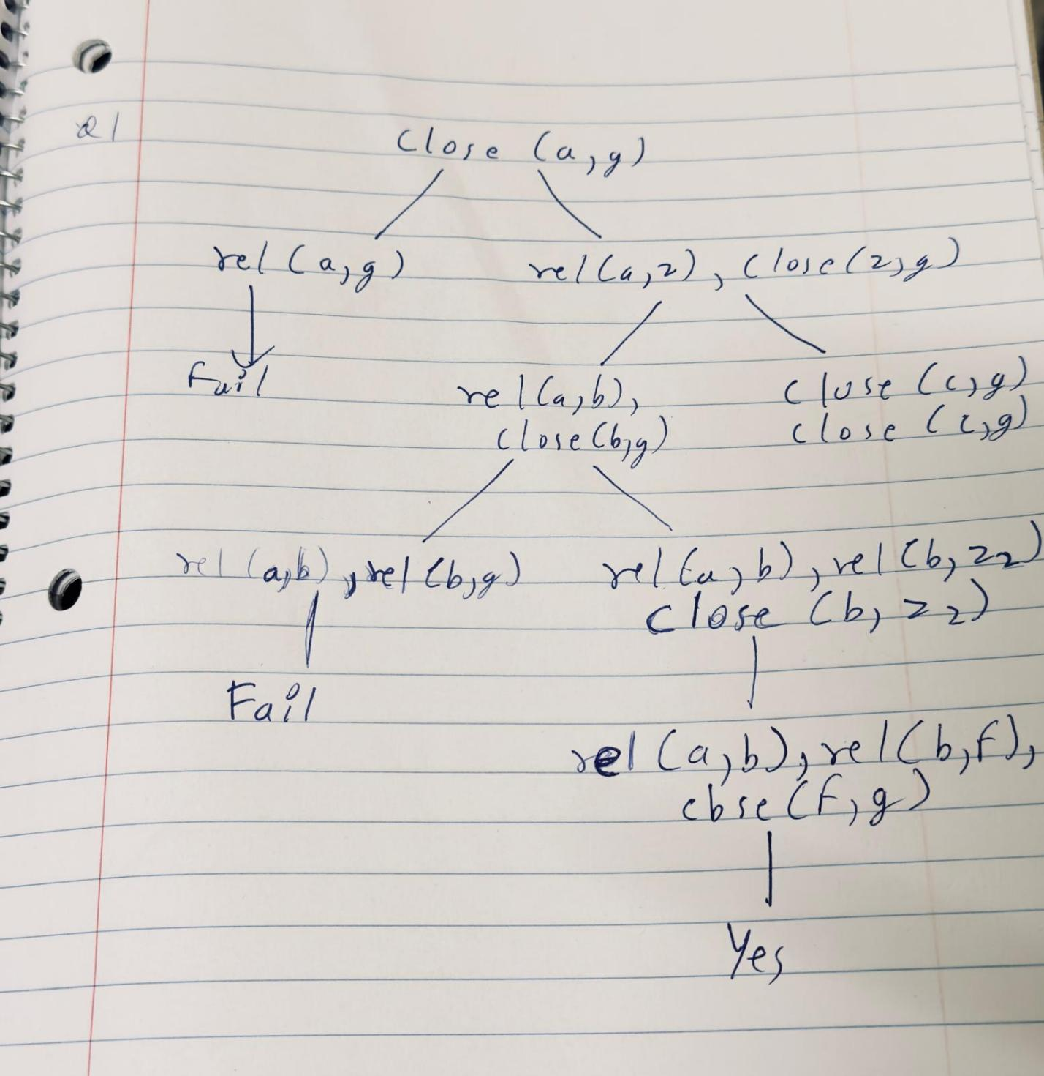

Ans-2:

1. p (X, Y) = p (Y, X) → Succeeds: X = Y

2. q (X, X) = q (1, 2) → Fails: X cannot both be 1 and 2

3. m(f(X), Y) = m(f(a), b) → Succeeds: X = a, Y = b

4. k (X, Y) = k(a) → Fails: Arity mismatch

5. [A, B | X] = [1, 2] → Succeeds: A = 1, B = 2, X = []

Ans-3:

In Peano arithmetic, we can formally define the predicate of exponentiation as:

%. Base case: any number raised to the power 0 equals 1.

exp(_, 0, s(0)).

% Recursive case: exp(X, Y, Z) if Y = s(Y1) => Z = X * exp(X, Y1)

exp(X, s(Y), Z) :-

exp(X, Y, Z1), mult(X, Z1, Z).

Ans-4:

Rotate left and right predicates for a BST:

rotateRight(tree(Z, KZ, tree(Y, KY, A, B), C), tree(Y, KY, A, tree(Z, KZ, B, C))).

rotateLeft(tree(X, KX, A, tree(Y, KY, B, C)), tree(Y, KY, tree(X, KX, A, B), C)).

ltree(tree(3, c, tree(2, b, tree(1, a, empty, empty), empty), empty)).

rtree(tree(1, a, empty, tree(2, b, empty, tree(3, c, empty, empty)))).