NAME: KUSHI NC
USN: 23BTRCB018
ID: HCLTFP2294059
BRANCH: CSBS
BATCH: 2027
CLG: Jain University
SECTION A: ADVANCED SQL
Question 1: Database Design and Advanced Queries
a. Display employee names, department names, and manager names using joins.

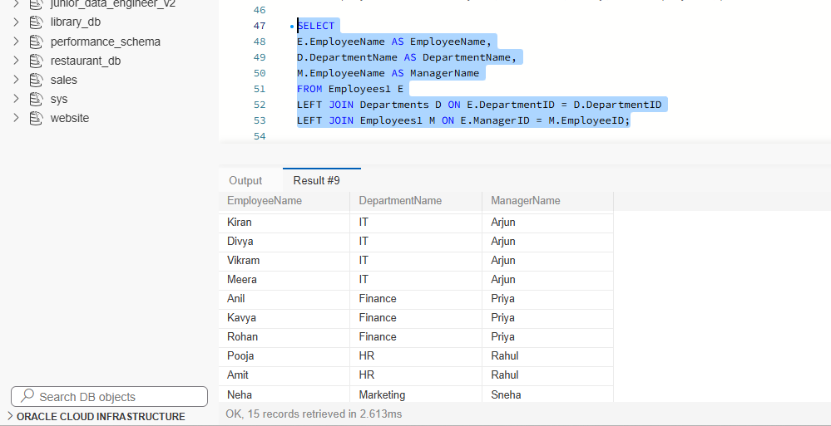

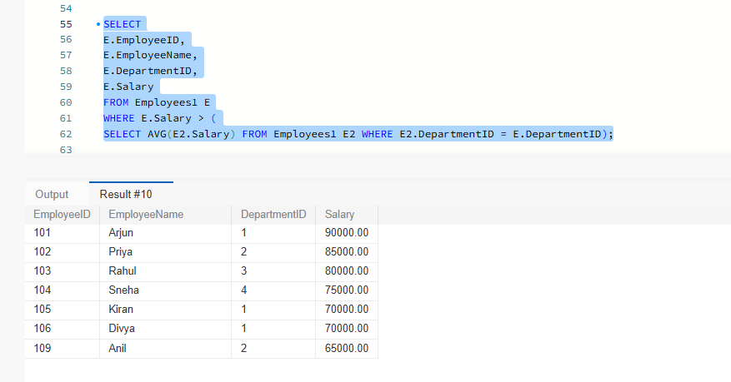
B. Find employees earning more than their department's average salary

C. Find the second-highest distinct salary without using LIMIT, TOP, or FETCH FIRST
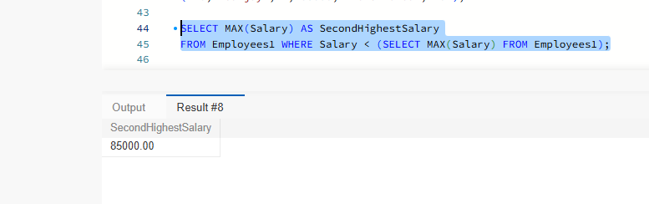
2a. Calculate total revenue for each product.

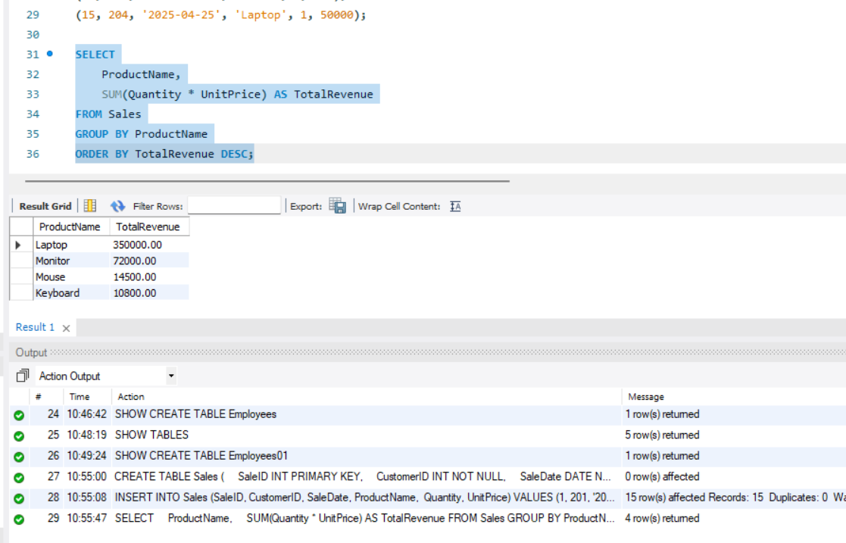
b. Calculate monthly revenue and month-over-month revenue change using a window function.
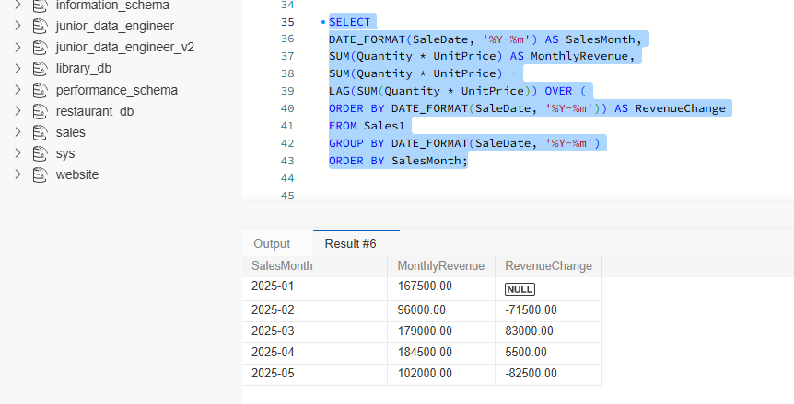

c. Rewrite the following query to improve the potential for index usage and explain why your version may perform better.
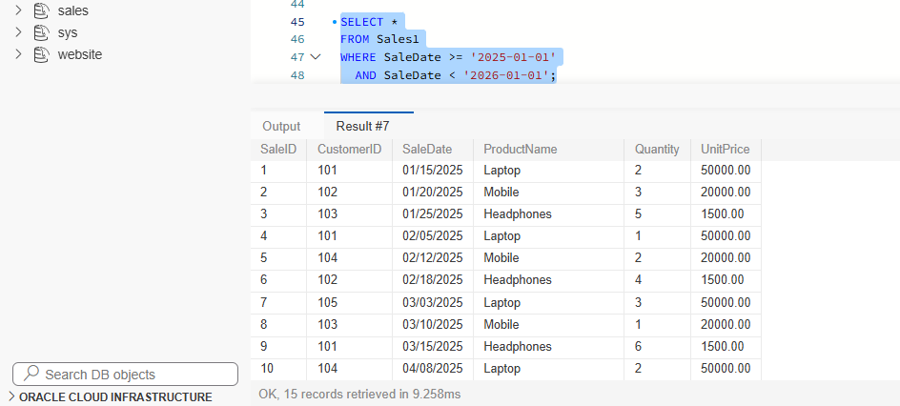

Question 3: SQL Troubleshooting
1.Explain how an execution plan helps identify expensive operations in a query.
An execution plan shows how a database runs a query. It helps us find which operations are taking more time, such as scanning a whole table or joining large amounts of data. By identifying these issues, we can improve the query and make it run faster.
By analayzing the execution plan, we can identify operations with high cost and optimize the query using appropriate indexes and better query structure. This improves query performance and reduces execution time.

2.Recommend an appropriate index strategy for queries filtering employees by DepartmentID and Salary. Explain your reasoning.
We can create a combined index on DepartmentID and Salary. This helps the database find employees faster when searching by department and salary. It reduces the need to check every employee record and improves query performance.
CREATE INDEX idx_department_salary
ON Employees (DepartmentID, Salary);

3. Write a query to find duplicate customer email addresses.
This query groups customers with the same email address and counts how many times each address appears. The having condition displays only those email addresses that occur more than once.
SELECT Email, COUNT(*) AS DuplicateCount
FROM Customers
GROUP BY Email
HAVING COUNT(*) > 1;
HAVING COUNT(*) > 1;
SECTION B: LINUX
Question 4: Log Analysis
1.Find all lines containing ERROR
grep "ERROR" /var/log/application.log

2.Display the 20 most recent error entries in the file.
grep "ERROR" /var/log/application.log | tail -n 20

3. Count the total number of error entries.
grep -c "ERROR" /var/log/application.log

4. Extract error entries for a specified date into a separate file.
grep "^2026-10-28 .*ERROR" /var/log/application.log > /var/log/errors_2026-10-28.log

5. Explain how you would calculate the number of errors occurring in each hour.
grep "ERROR" /var/log/application.log | awk '{print substr($2,1,2)}' | sort | uniq -c

Question 5: Permissions and System Troubleshooting
1.Create a group named finance and a report file, assuming you have the required privileges.
sudo groupadd finance
touch report.txt
2. Set permissions so the owner can read and write, the finance group can read, and other users have no access.
sudo chown "$USER":finance report.txt
chmod 640 report.txt
3. Identify the processes consuming the most CPU.
Top
4. Display memory usage and filesystem disk utilization.
free -h
df -h
5. Find files larger than 100 MB under a specified application directoryfind /var/www/application -type f -size +100M
SECTION C: PYSPARK DATA ENGINEERING
- Display the schema and first five records.
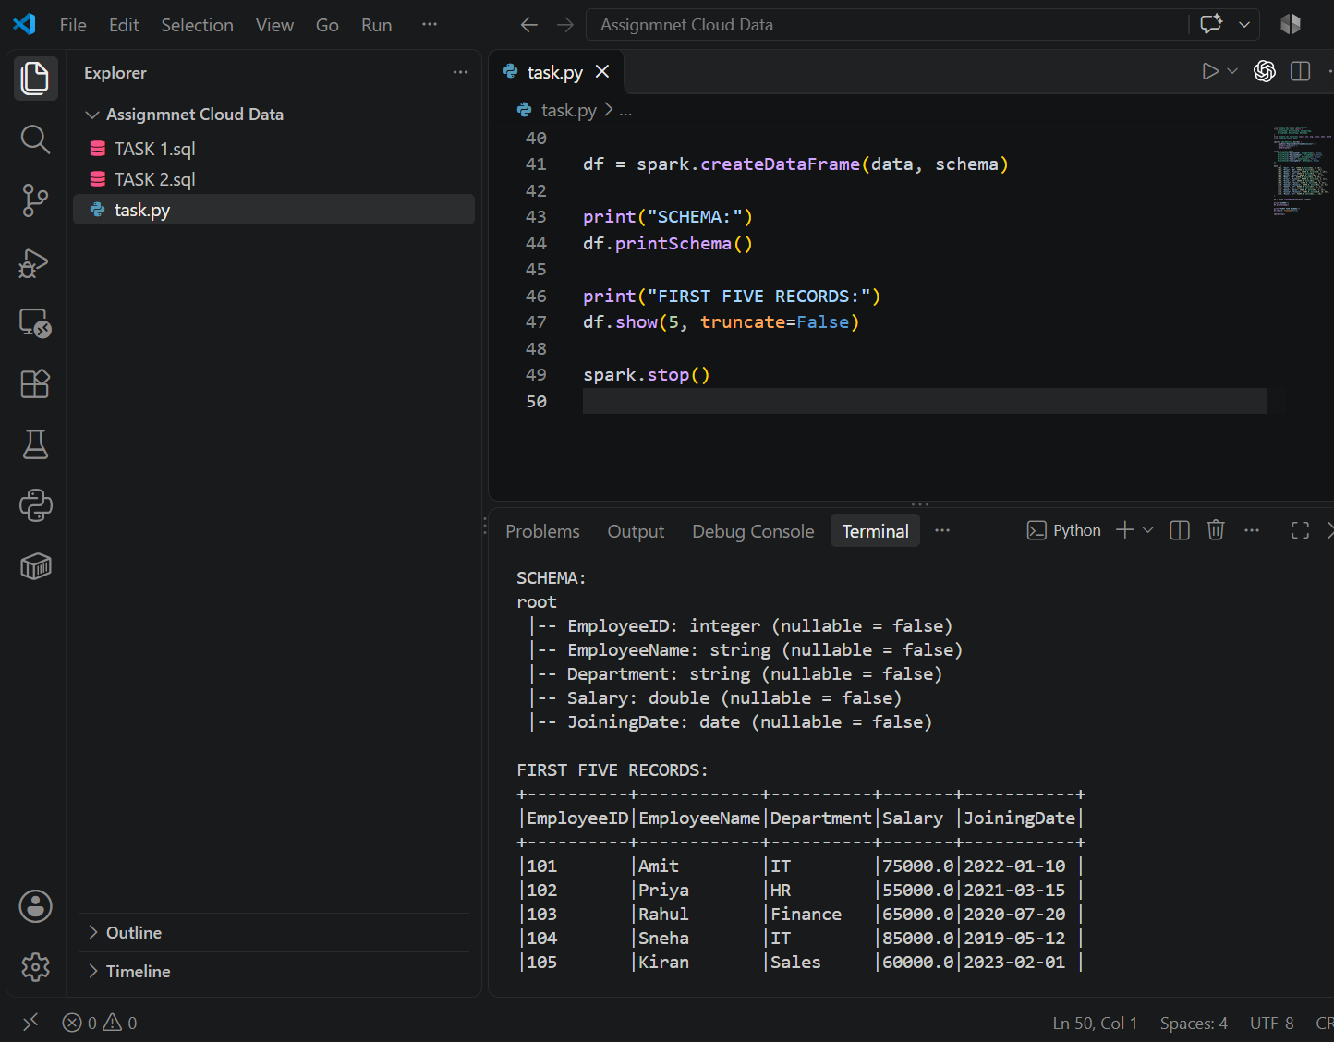
- Filter employees whose monthly salary is greater than ₹60,000.
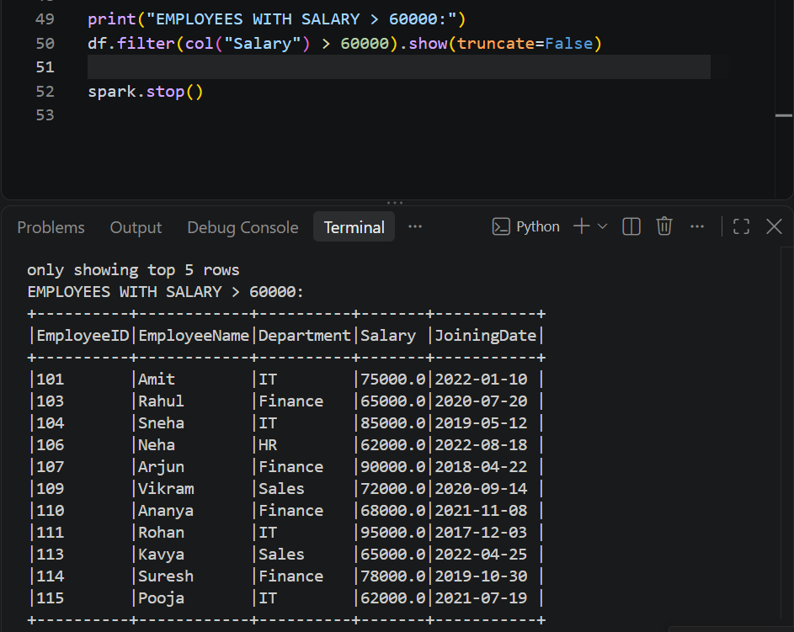

C.Add an AnnualSalary column calculated from the monthly salary.
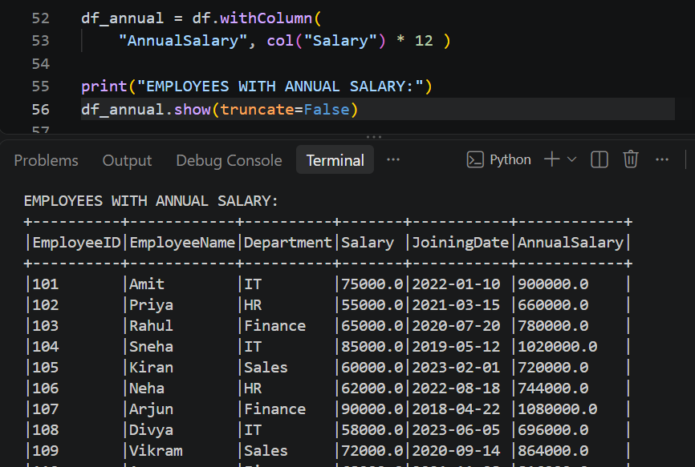
D. Group employees by department and calculate the average salary and employee count.
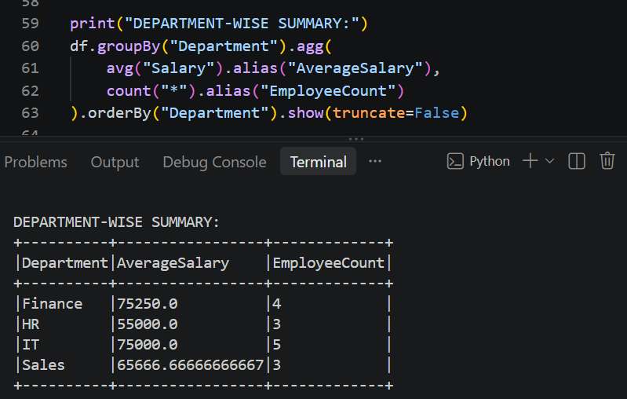
E. Display the five highest-paid employees.
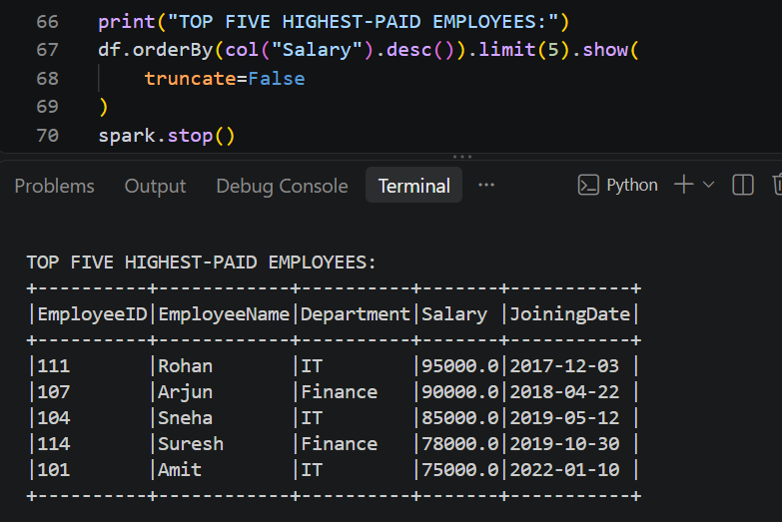
SECTION D: AWS CLOUD SERVICES
a.Create an S3 bucket with Block Public Access enabled and upload a sample file.

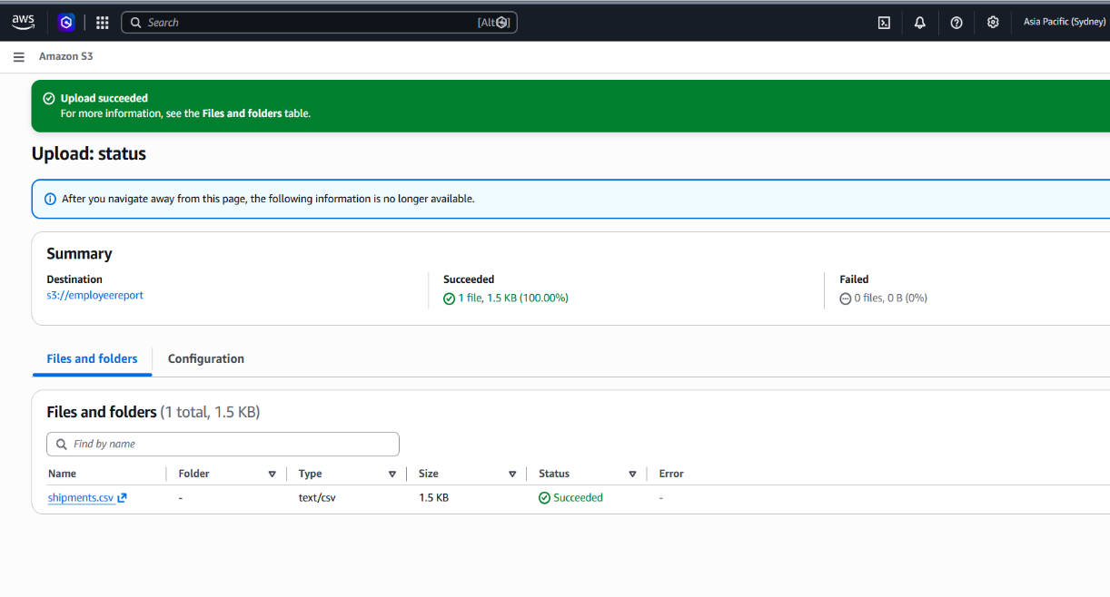
b. Design an IAM policy that grants read access to objects in the designated bucket without granting access to unrelated buckets.
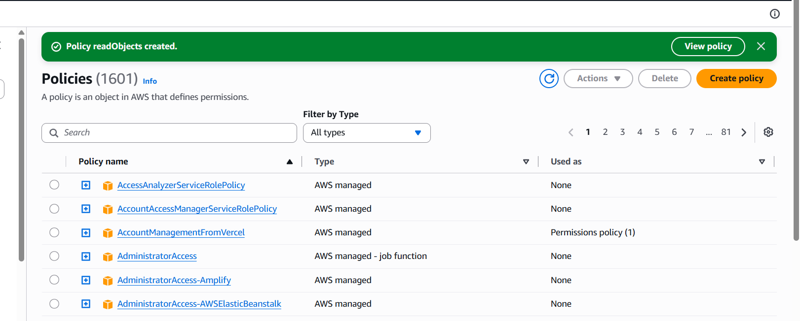

c. Explain how you would verify that an unauthorized user cannot read the file.
Log in as an unauthorized IAM user and attempt to download the file. Verify that the request fails with an AccessDenied error.

d. Explain how encryption at rest protects the stored data.
Enable server side encryption using S3 Encryption converts stored data into ciphertext, protecting confidential reports from unauthorized access to the underlying storage.

Question 11
a. Check the EC2 instance state and status checks.
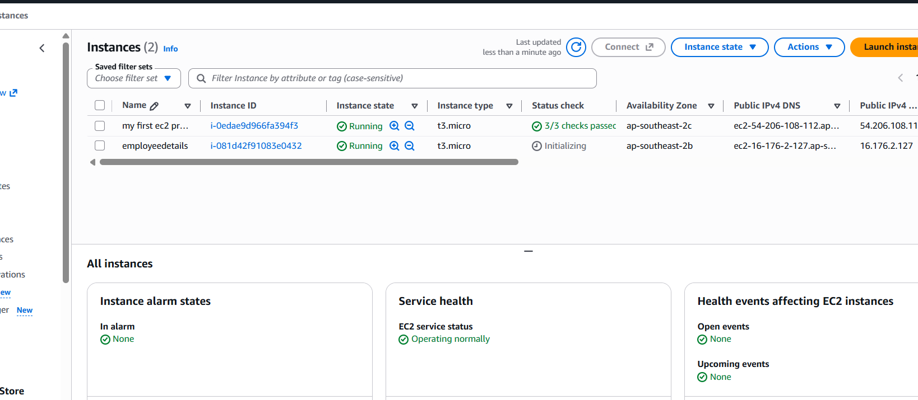

b. Explain how security groups and route tables can affect application connectivity.
Security groups control inbound and outbound traffic. Incorrect rules can block application ports such as HTTP and HTTPS .
Route tables determine network traffic paths; incorrect routes can prevent requests from reaching the instance or returning to clients.

c. Explain how to configure a CloudWatch alarm when CPU utilization exceeds 85% for a defined evaluation period.
1. Open CloudWatch → Alarms → Create alarm.
2. Select the EC2 instance’s CPUUtilization metric.
3. Set the threshold to greater than 85%.
4. Configure the evaluation period, for example, five consecutive one-minute periods.
5. Configure an Amazon SNS notification and create the alarm.
The alarm triggers when CPU utilization exceeds 85% for the configured evaluation period.
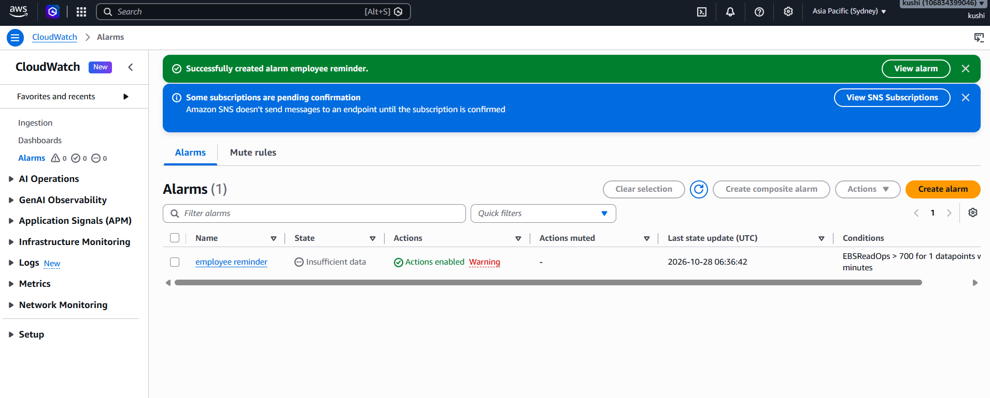

d. Identify one method for investigating the root cause of high CPU utilization.
Use the top or htop command on the EC2 instance to identify processes consuming excessive CPU resources.
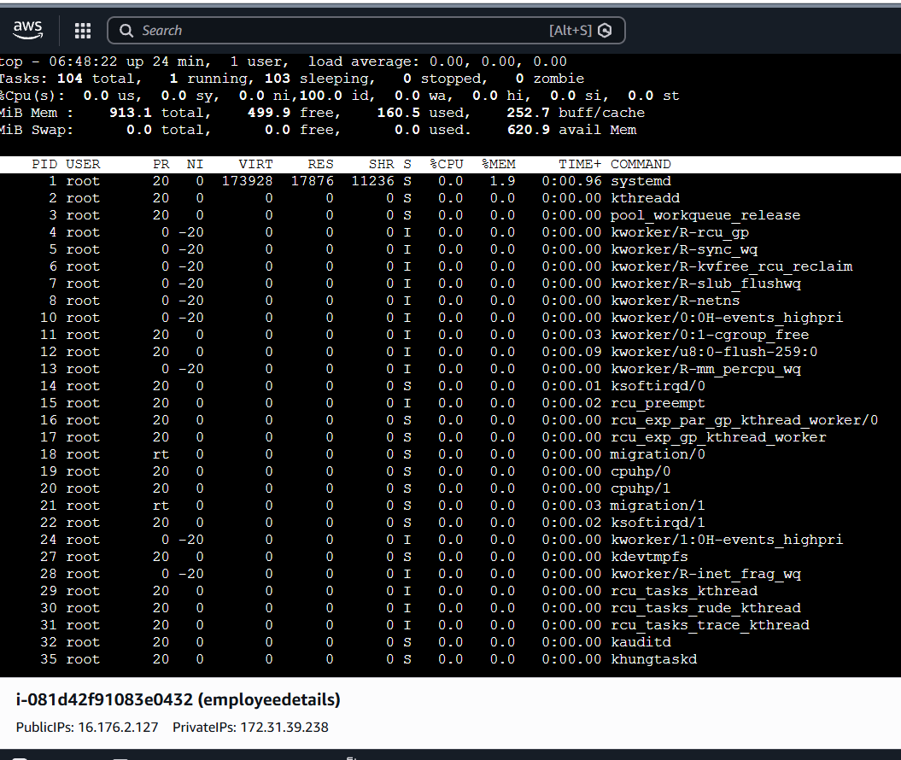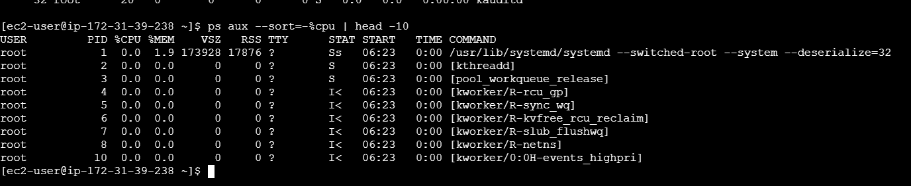
Question 12:
a.Identify a suitable service for executing the processing code.
Use AWS Lambda to execute code that validates and processes uploaded CSV files without managing servers.

b.Explain how S3 triggers processing.
Configure an S3 ObjectCreated event notification to invoke the Lambda function whenever a CSV file is uploaded.

c. Explain the IAM permissions needed to read the input file and write the results. The Lambda execution role requires:
s3:GetObject permission for input files.
s3:PutObject permission for output files.
CloudWatch Logs permissions to record execution logs.

d. Explain how errors and processing logs can be captured.
Use Amazon CloudWatch Logs to store Lambda execution logs and error messages. Configure CloudWatch alarms and a dead-letter queue to monitor and handle failures.

e. Explain how to prevent duplicate processing or recursive triggering.
Use an idempotency mechanism, such as DynamoDB, to track processed files and prevent duplicate processing. Store results in a separate output bucket or configure event notifications to trigger only for a specific input prefix.

SECTION E: AWS STEP FUNCTIONS
Question 13: State Machine Design
- Identify suitable states for validation, processing, storage, and notification.
The following states can be used in the AWS Step Functions state machine:
- Validate File (Task): Invokes an AWS Lambda function to validate the input sales file.
- Transform Data (Task): Cleans and transforms the sales data.
- CalculateSales (Task): Calculates total sales for each product.
- Store Results (Task): Stores the processed results in Amazon S3.
- Send Notification (Task): Sends a completion notification using Amazon SNS.
- Workflow Succeeded (Succeed): Indicates successful completion.
- Processing Failed (Fail): Terminates the workflow if processing fails.
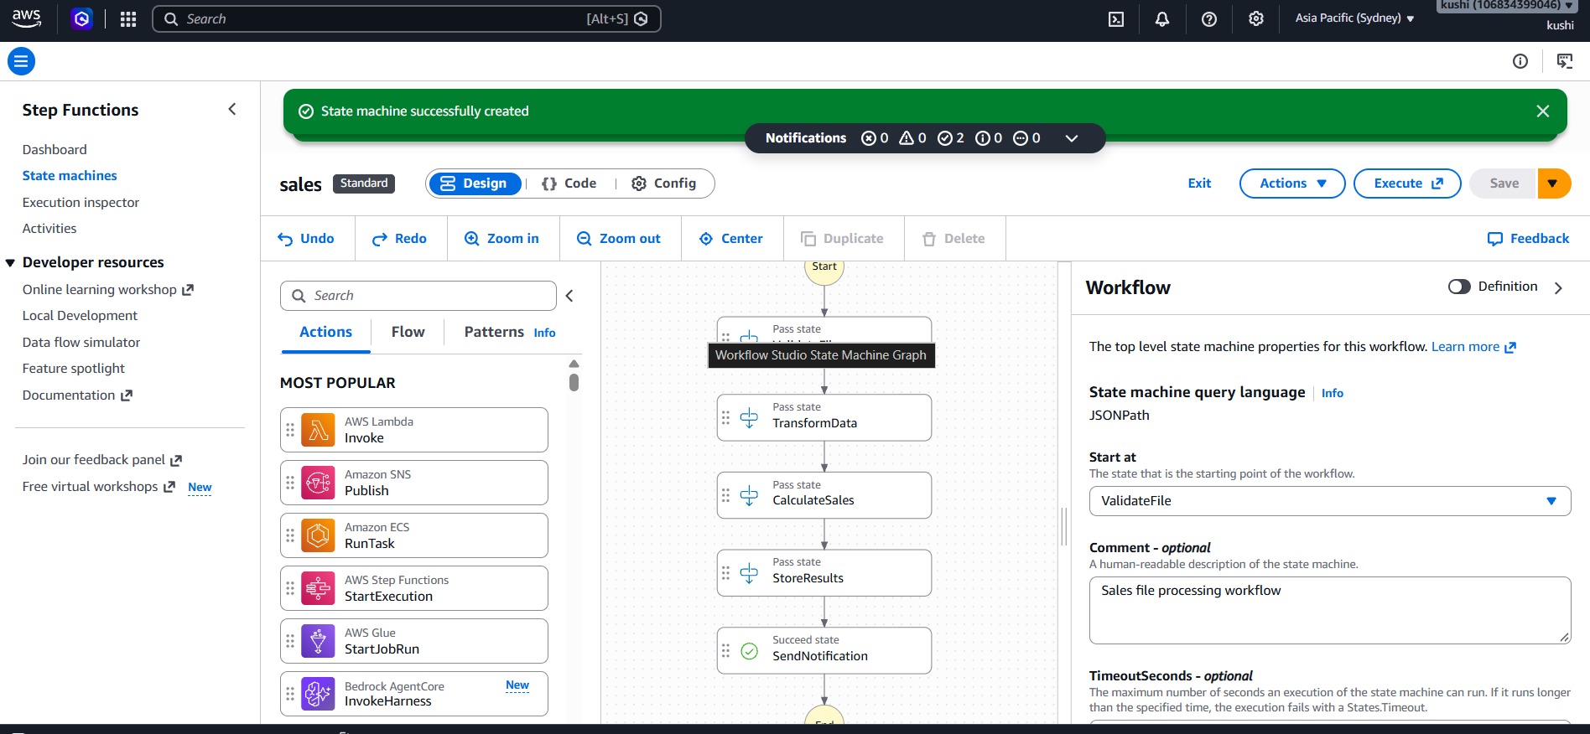
(b) Explain how a Choice state can route invalid files to a failure path and valid files to processing.
The Choice state checks the validation result returned by the Lambda function.
- If isValid = true, the workflow proceeds to TransformData.
- If isValid = false, the workflow routes to InvalidFile, a Fail state, and stops processing.
(c) Explain how Retry and Catch can handle transient failures and permanent errors.
- Retry: Automatically retries a task when a temporary error occurs, such as a service timeout or temporary unavailability.
- Catch: Handles errors that cannot be recovered from through retries and routes the workflow to an appropriate failure state.
- Fail state: Terminates the workflow when an unrecoverable error occurs.

(d) Explain how the state machine can invoke Lambda functions or other supported AWS services.
AWS Step Functions uses Task states to invoke Lambda functions through their Amazon Resource Names . Lambda functions can validate, transform and calculate sales data. The workflow can also integrate with supported AWS services, such as Amazon S3 for storing results and Amazon SNS for sending notifications, using direct service integrations where appropriate.

(e) Explain how execution history helps troubleshoot a failed workflow.
Execution history records the status, input, output and errors of each state. By opening the execution details in the AWS Step Functions console, developers can identify the failed state, examine its error message, and troubleshoot issues such as invalid files, Lambda errors or insufficient S3 permissions.

Question 14: Step Functions Implementation
(a) Write an ASL JSON definition containing the three sequential tasks. (3 marks)
Steps to create it in AWS Console:
- Open AWS Management Console and search for Step Functions.
- Click Create state machine.
- Choose the code-based authoring option and select Standard.
- Enter the following Amazon States Language (ASL) JSON definition.
- Replace the placeholder resource ARNs with the actual Lambda function ARNs if you want to execute it.

(b) Configure a retry policy for the transformation task.
"Retry": [
{
"ErrorEquals": [
"Lambda.ServiceException",
"Lambda.TooManyRequestsException",
"States.Timeout"
],
"IntervalSeconds": 2,
"MaxAttempts": 3,
"BackoffRate": 2
}
]
(c) Configure a Catch transition for the loading task.
a. Configure a storage account with hierarchical namespace enabled
"Catch": [
{
"ErrorEquals": ["States.ALL"],
"ResultPath": "$.error",
"Next": "HandleLoadFailure"
}
]
If loading fails, the Catch block stores error information in $.error and transfers execution to HandleLoadFailure. The Pass state records a failure message and ends the execution. In a production workflow, the handler could also log the error or send an alert.

(d) Explain how data from one task is passed to the next task.
- ValidateFile receives the input file details and returns validation information.
- TransformData receives that output and returns the transformed data.
- LoadResults receives the transformed data and loads it into the destination.
The InputPath, ResultPath and OutputPath fields can be used to control which data is passed between states. The default behavior assumes each Lambda returns the data required by the next task.

(e) Explain how you would test successful and failed executions.
- Open the state machine and click Start execution.
- Provide valid JSON input and verify that ValidateFile, TransformData and LoadResults execute in sequence, ending at Success.
- Simulate a temporary transformation error and verify that the retry policy is applied.
- Simulate a loading failure and verify that the workflow transitions to HandleLoadFailure.
- Inspect the execution history to review state inputs, outputs, errors and retry attempts.

Section F:
Question15:

Steps in Azure Portal:
- Log in to the Azure Portal
- Search for Storage accounts and click Create.
- Select your Subscription and Resource Group.
- Enter a unique Storage account name, such as companydatalake2026.
- Select the required Region and redundancy option.
- Open the Advanced tab and enable Hierarchical namespace.
- then Create.
Azure Data Lake Storage Gen2 is created by enabling the hierarchical namespace option in an Azure Storage account. This supports directory-based organization and big-data analytics workloads.
b. Create a filesystem or container and upload a sample dataset (1 mark)
Steps:
- Open the created Storage account.
- Select Data storage → Containers.
- Click + Container and enter a name, such as confidential-data.
- Click Create.
- Open the container and click Upload.
- Select a sample CSV file, such as sales.csv, and upload it.
A container named confidential-data is created, and a sample dataset named sales.csv is uploaded for analytics.
c. Explain how Microsoft Entra ID and Azure RBAC manage access
- Microsoft Entra ID: Authenticates users and verifies their identities before they access Azure resources.
- Azure RBAC: Assigns permissions to users or groups according to their job responsibilities.
Microsoft Entra ID provides authentication, while Azure RBAC provides authorization. Assigning roles based on the principle of least privilege ensures that users can access only the data and operations required for their jobs.

d. Verify that unauthorized users cannot access the dataset
- Ensure that the test user has no applicable data-access role or ACL permission.
- Sign in as that test user.
- Try to open or download sales.csv from the container.
- Verify that access is denied, typically with an HTTP AuthorizationPermissionMismatch response or an authorization error.
Question 16:
a. Verify the VM's provisioning and power states (1 mark)
Steps in Azure Portal:
- Search for Virtual machines.
- Select the affected VM.
- On the Overview page, check:
  - Provisioning state: Should be Succeeded.
  - Power state: Should be Running.
Verify that the VM provisioning state is Succeeded and its power state is Running. If the VM is stopped or provisioning has failed, resolve that issue first.

b. Explain how Network Security Group (NSG) rules can prevent connectivity
- NSGs control inbound and outbound network traffic.
- If an inbound rule blocks SSH or RDP administrators cannot connect.
- Check the NSG associated with both the VM's network interface and its subnet.
c. Explain how subnet and routing configuration affect connectivity
- The VM must be connected to the correct virtual network and subnet.
- Incorrect route tables or User Defined Routes may send traffic through the wrong network path.
- Missing VPN or ExpressRoute connectivity, or incorrect peering, can prevent administrators from reaching the VM.

d. Recommend a secure troubleshooting method
- Open the Azure Portal and search for Bastion.
- Configure Azure Bastion in the VM's virtual network if it is not already available.
- Open the VM and select Connect
- Authenticate using the appropriate credentials.
- Connect to the VM without exposing its SSH or RDP port directly to the public internet.

Question 17
a. Select a service to orchestrate data movement
- Create an Azure Data Factory instance in the Azure Portal.
- Create a pipeline to automate the movement and preparation of customer transaction data.
b. Copy the CSV file into Azure Data Lake Storage Gen2
- Create an Azure Storage account with Hierarchical namespace enabled.
- Create a container named transactions.
- In Azure Data Factory, create a pipeline and add a Copy Data activity.
- Configure the source dataset to point to the incoming CSV file.
- Configure the sink dataset to point to the ADLS Gen2 container.
- Run the pipeline to copy the file.
c. Organize files by ingestion date
transactions/
ingestion_date=2026-10-27/
transactions.csv
ingestion_date=2026-10-28/
transactions.csv

d. Handle malformed records and missing values
- Use Azure Data Factory Mapping Data Flows to validate and transform records.
- Identify missing values and either replace them with appropriate defaults or flag them for review.
- Route malformed records to a separate error folder for investigation.
- Store valid records in the processed-data folder.
e. Monitor pipeline execution and validate completeness
- Use Azure Data Factory Monitor to check pipeline runs, failures, and execution duration.
- Configure alerts for failed pipeline runs.
- Compare the number of source records with the total number of processed and rejected records.
- Check required columns, null values, and duplicate transaction IDs.

