**MINI PROJECT ACTIVITY**

**PROJECT TITLE : IRIS DATASET [PHASE-1]**

1. **PROBLEM STATEMENT: [IRIS DATASET]**

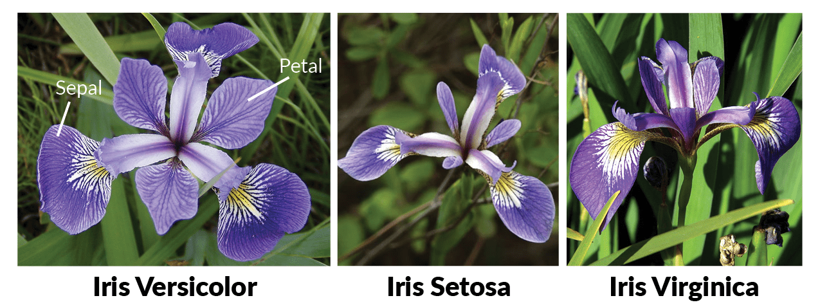

The Iris dataset, a well-known dataset in the field of machine learning and data analysis, contains measurements of different species of iris flowers. This project aims to perform an in-depth exploratory Data analysis (EDA) and statistical analysis in iris dataset to gain insights into the characteristics of these flowers. And make meaningful conclusions.

**2.Create project plan and product backlog**

Creating a project plan and product backlog for a mini project involving the Iris dataset can be a simplified version of the previous example, tailored to a smaller scope. This mini project aims to develop a basic Iris data analysis and visualization tool. Here's a concise project plan and product backlog:

**Project Plan for Mini Iris Data Analysis and Visualization Tool**

**Project Objectives**:

* Develop a simple software application for basic analysis and visualization of the Iris dataset.
* Provide basic descriptive statistics and visualizations.
* Learn and demonstrate fundamental data analysis and visualization skills.

**Project Team:**

* Project Manager
* Junior Software Developer (Single resource for a small-scale project)

**Project Phases:**

**1.Project Initiation**

* Define project scope and objectives.
* Set up development environment.

1. **Requirements Gathering)**

* Identify essential features and user requirements.
* Create a high-level project plan.

**3.Design and Development**

* Develop a simple user interface for data upload and basic visualization.
* Implement basic data summary statistics.
* Create a chart for visualizing Iris data.

**4.Testing**

* Conduct basic testing to ensure functionality.

**5.Documentation**

* Create minimal user documentation.
* Prepare a brief user guide.

**6.Deployment**

* Deploy the application to a development/staging environment for testing.

**7.Final Testing and Demonstration**

* Conduct final testing.
* Prepare a demonstration of the application.

**Product Backlog:**

**User Stories:**

* As a user, I want to upload the Iris dataset to the application.
* As a user, I want to view basic statistics for the Iris dataset (mean, median, etc.).
* As a user, I want to visualize the Iris data with a scatter plot.
* As a user, I want a simple and intuitive user interface.
* As a user, I want to access basic help information.

**Tasks (Examples):**

* Create a data upload feature.
* Implement the calculation of basic statistics.
* Develop a scatter plot component for data visualization.
* Design a simple user interface.
* Create minimal user documentation.
* Deploy the application to a development/staging server.
* Perform final testing and debugging.
* Prepare a demonstration of the application.

For a mini project like this, the product backlog and tasks should remain minimal and focused on delivering essential features. It's important to keep the scope manageable and the timeline relatively short. Additionally, this project can serve as a valuable learning experience for individuals or small teams looking to practice data analysis and software development skills.