PROJECT REPORT
Summer Training — Power BI

Project Title | HR Attrition & Employee Overview
Student Name | Kushika Sharma
Roll Number | 2405039144
Course & Batch | B. Tech
Department | CSE
Institute | CCE, CGC University
Training Period | 8 June 2026 to 6 July 2026
Submission Date | 2 July 2026
Guided By | Mrs. Ashima and Mrs. Mandeep

1. Declaration

I hereby declare that the project report entitled "HR Attrition & Employee Overview" submitted in partial fulfilment of the Summer Training Programme is an original piece of work carried out by me. The data used in this report has been collected from publicly available sources. The dashboards, visuals shown in this report have been independently created by me in Microsoft Power BI Desktop.

I further confirm that this report or any part of it has not been submitted previously for any academic award.

Signature: 
Name: Kushika Sharma
Date: 02 / 07 / 2026

2. Abstract

Write a 150–200 word summary of your project here. Cover the following points in 3–4 sentences each:
- What business problem does your dashboard solve?
- What dataset did you use (source, size, key fields)?
- What Power BI features did you apply (Power Query, DAX, visuals)?
- What insights or outcomes does the final dashboard deliver?

This project addresses the critical HR challenge of identifying employee turnover patterns by resolving the team's lack of visibility into which departments and demographic groups face the highest attrition. Utilizing the standard IBM HR Analytics dataset, which contains 1,470 employee rows, the analysis focuses on key attributes such as age, department, job role, business travel frequency, and attrition status. Data transformation and modeling were conducted using Power Query for data cleansing, while tailored DAX measures were implemented to build metrics like accurate attrition rates, total attrition counts, and specialized interactive slicers. The dashboard delivers an analytical overview containing KPI cards, a department-based attrition donut chart, an age-group horizontal bar chart, and a comprehensive job-role breakdown table. Key insights reveal that the Research & Development department accounts for the majority of departures (56.12%), employees under the age of 25 exhibit the highest attrition rate (nearly 40%), and Sales Representatives experience severe turnover at 40%. These targeted findings empower the HR department to implement strategic retention initiatives for high-risk demographics.

3. Introduction

3.1 Background
This project belongs to the domain of HR Analytics, where organizations leverage human capital datasets to optimize employee retention. Data visualization is crucial here because raw text files obscure overlapping demographic patterns. Without interactive visuals, HR teams cannot easily identify whether high turnover is driven by specific age brackets, department environments, or job roles. Organizations use tracking dashboards to transform these complex data pools into actionable metrics, allowing leadership to make proactive, data-driven decisions, such as launching targeted retention programs before critical talent exits the pipeline.

3.2 Problem Statement
The target users for this dashboard are HR managers and executive leadership who need to manage workforce retention. Previously, the HR team lacked an accessible, visual method to pinpoint exactly which departments and demographic age groups were experiencing the highest employee turnover. By consolidating disjointed workforce data into clear, interactive metrics, this dashboard makes it much easier for leadership to diagnose critical attrition drivers. Consequently, stakeholders can transition from reactive management to launching targeted, proactive retention initiatives before high-risk talent exits the organization.

3.3 Objectives
- Connected to the IBM HR Analytics dataset and performed comprehensive data cleansing using Power Query.
- Designed an optimized data model with robust table relationships to enable accurate and efficient interactive filtering.
- Developed custom DAX measures to calculate key HR metrics, including Total Attrition, Headcount, and Attrition Rate.
- Built an interactive Power BI dashboard using more than five visual types to analyze workforce trends and HR performance.
- Implemented cross-filtering and Department slicers to support detailed analysis of specific employee segments.
- Published the completed report to the Power BI Service for secure organizational access, sharing, and monitoring.
- Identified key workforce insights, including a 40% attrition rate among Sales Representatives, enabling data-driven talent retention strategies.

4. Dataset Description

4.1 Data Source

Source Name | Kaggle
Dataset Name | IBM HR Analytics Employee Attrition & Performance
File Format | Excel
Number of Records | 1471 rows
Number of Columns | 35 columns
Time Period Covered | Not Mentioned
Download Link | https://www.kaggle.com/code/mragpavank/ibm-hr-analytics-employee-attrition-performance/input

4.2 Key Fields / Columns
List and describe the important columns used in your analysis:

Column Name | Data Type | Description / Role in Analysis
Attrition | Text | Target variable (Yes/No) indicating employee turnover; used in KPI cards and attrition rate % DAX measures.
Department | Text | The department the employee works in (e.g., Sales, R&D); used for row headers in matrices and slicers.
JobRole | Text | Specific role breakdown; used in matrix table to identify high-attrition positions.
YearsAtCompany | Integer | Continuous variable representing tenure; used to create conditional bins or age/tenure X-axes.
JobSatisfaction | Integer | Survey score used for satisfaction matrix breakdowns and conditional formatting.
MonthlyIncome | Decimal | Employee monthly salary; used in Average or SUM or DAX calculations to analyse income disparities.

4.3 Data Quality Issues & Cleaning Steps
Describe what problems you found in the raw data and how you fixed them in Power Query:
- Imported Excel dataset into Power BI.
- Checked for duplicate employee records.
- Verified that there were no missing values in key columns.
- SUM and DAX calculations to ensure smooth working.
- Renamed columns for better readability.
- Ensured data consistency before visualization.

5. Dashboard & Visuals

Describe the page in your Power BI report. Include a screenshot.

5.1 Page Overview
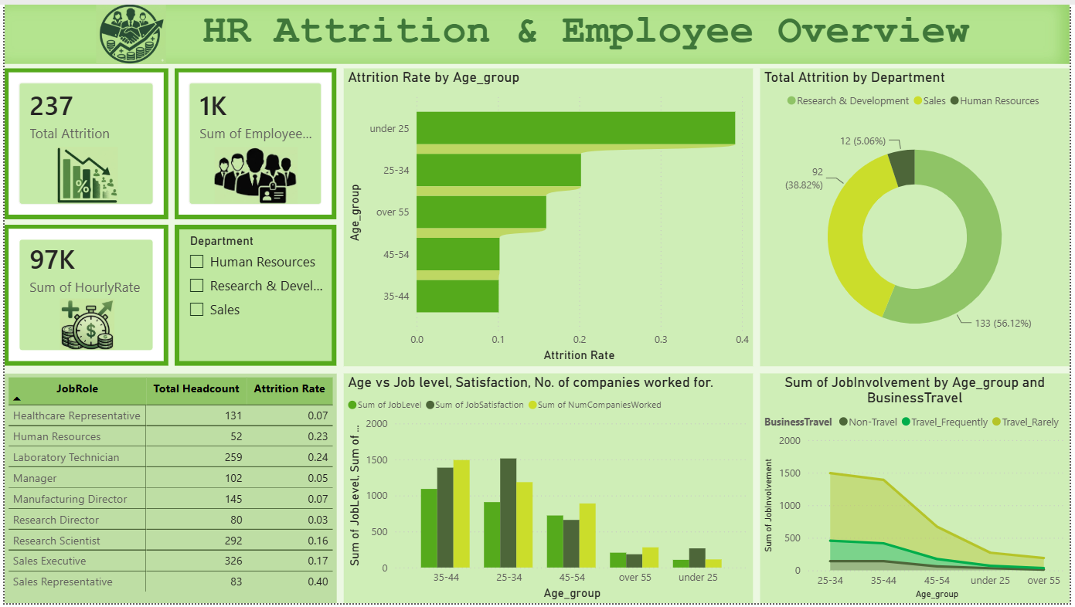
[ Screenshot — Overview Page ]
Visuals used on this page:
- KPI Cards — Total Attrition, Total Employees, and Total Hourly Rate
- Horizontal Bar Chart — Attrition Rate by Age Group
- Donut Chart — Total Attrition by Department
- Clustered Column Chart — Job Level, Job Satisfaction, and Number of Companies Worked by Age Group
- Line Chart — Job Involvement by Age Group and Business Travel
- Table — Job Role-wise Headcount and Attrition Rate
- Department Slicer — Human Resources, Research & Development, and Sales

Key insight from this page:
The dashboard provides a comprehensive overview of employee attrition across different age groups, departments, and job roles. It highlights that employees under 25 and Sales Representatives have the highest attrition rates, while the Research & Development department contributes the largest share of employee departures.
7. Key Findings & Insights

• Employees under the age of 25 experience the highest attrition rate, indicating that younger employees are the most likely to leave the organization.
• The Research & Development (R&D) department accounts for 56% of all employee attrition, making it the most affected department.
• Sales Representatives have the highest attrition rate among all job roles at 40%, highlighting a significant retention challenge.
• The Sales department contributes approximately 39% of total employee attrition (92 employees), making it one of the organization's highest-turnover departments.
• Employees aged 35–44 exhibit the highest levels of job involvement, while those under 25 report the lowest engagement.
• Employees who travel frequently for business show lower job involvement and higher attrition trends compared to employees who travel less often.

8. Learnings & Challenges

8.1 Skills Learned
- Connecting to and transforming raw CSV/Excel data using Power Query.
- Writing DAX measures using SUM, CALCULATE, FILTER, DIVIDE, and DATEADD.
- Designing user-friendly dashboards with slicers, drill-through, and cross-filtering.
- Building optimized data models with relationships to support accurate reporting.
- Publishing and sharing interactive reports using the Power BI Service.
- Analysing HR data to identify workforce trends and support data-driven decision-making.

8.2 Challenges Faced
- Cleaning and transforming the IBM HR Analytics dataset in Power Query by correcting data types, removing unnecessary columns, and handling inconsistent values before analysis.
- Creating accurate DAX measures for Total Attrition, Headcount, and Attrition Rate while ensuring the calculations responded correctly to slicers and filters.
- Designing an optimized data model with proper table relationships to avoid incorrect aggregations and enable smooth cross-filtering across visuals.

9. Conclusion

Write a 100–150 word conclusion summarising the project. Mention:
- Whether the original problem statement was addressed.
- The value the dashboard adds to the intended user.
- What you would improve or add if given more time.

This project successfully addressed the objective of analysing employee attrition and workforce trends using Power BI. Through data cleaning in Power Query, data modeling, DAX calculations, and interactive visualizations, the dashboard provides HR teams with valuable insights into employee turnover, departmental performance, and engagement patterns. Features such as slicers and cross-filtering allow users to explore specific departments and employee groups, supporting informed, data-driven decisions. Key findings, including the high attrition rate among Sales Representatives and employees under 25, highlight areas requiring immediate attention. Given additional time, I would enhance the dashboard by incorporating predictive attrition analysis, advanced drill-through reports, and AI-powered forecasting to identify employees at risk of leaving. Overall, this project strengthened my Power BI, DAX, data modeling, and business intelligence skills while demonstrating the practical value of data analytics in HR decision-making.

10. References

- Microsoft Power BI Documentation — https://docs.microsoft.com/en-us/power-bi/
- Dataset Source — https://www.kaggle.com/code/mragpavank/ibm-hr-analytics-employee-attrition-performance/input
- DAX Reference Guide — https://dax.guide/
- Power Query M Reference — https://docs.microsoft.com/en-us/powerquery-m/
END OF REPORT

