Student Record System
Software Requirements Specification
Deliverable 1 of 4 - Mini-Project Part 1
Prepared following the IEEE 830-1998 recommended practice for SRS
Document ID: SRS-SRSYS-01 | Version 1.0 | 28 September 2026
TEAM-E12
Team Members
Monika PM - PES1UG24CS275
Kushita K - PES1UG24CS247
Nagashree R Patil - PES1UG24CS289
Nidhi L - PES1UG24CS298

Software Engineering Mini-Project - Part 1

Table of Contents
1. Introduction 2. Overall Description 3. Specific Requirements (Functional) 4. Non-Functional Requirements 5. Security Requirements (Objectives and Requirements) 6. External Interface Requirements 7. Use Case Diagram 8. Appendices

Revision History
Version | Date | Description | Author
1.0 | 28 September 2026 | Initial SRS for Mini-Project Part 1. | TEAM-E12 (all members)

1. Introduction

1.1 Purpose
This Software Requirements Specification (SRS) describes the functional, non-functional and security requirements of the Student Record System, developed as the Software Engineering Mini-Project (Part 1) by TEAM-E12. It is written for the course instructor/evaluator, and for the development team itself during design, implementation and testing. This document follows the structure recommended by IEEE Std 830-1998.

1.2 Scope
The Student Record System is a web-based application that centralises the storage and retrieval of student academic and attendance data for an educational institution. The system shall:
- Allow Administrators to manage student records, faculty accounts and courses.
- Allow Faculty to record grades and attendance for the courses assigned to them.
- Allow Students to view their own grades/attendance and download a report card.
- Allow Parents/Guardians to view the records of their linked child.
- Generate class-wise and student-wise reports, low-attendance notifications, and maintain a tamper-evident audit trail.
Out of scope for Part 1: mobile native apps, offline mode, fee/finance management, and integration with an external Learning Management System (LMS). These may be considered as future scope.

1.3 Definitions, Acronyms and Abbreviations
Term | Definition
FR | Functional Requirement
NFR | Non-Functional Requirement
SRS | Software Requirements Specification
RBAC | Role-Based Access Control
JWT | JSON Web Token - a signed token used to carry an authenticated session
RTM | Requirements Traceability Matrix
Admin | Administrator role - institution staff who configures and manages the system
Actor | A role or external system that interacts with the Student Record System

1.4 References
- IEEE Std 830-1998, IEEE Recommended Practice for Software Requirements Specifications.
- OWASP Top 10:2021 - Open Web Application Security Project.
- Project brief: 'Software Engineering Mini-Project Deliverables Part-1', course instructor, ETA 28 Sept 2026.

1.5 Overview of the Document
Section 2 gives the product perspective, user classes and constraints. Section 3 lists the Functional Requirements (FRs). Section 4 lists the Non-Functional Requirements (NFRs). Section 5 gives the security objectives and security requirements. Section 6 describes external interfaces. Section 7 presents the UML use case diagram. Section 8 contains supporting appendices, including the Requirements Traceability Matrix.

2. Overall Description

2.1 Product Perspective
The Student Record System is a new, self-contained, three-tier web application (presentation, application, data). It is not a modification of an existing system. It exposes a REST API consumed by a single-page web front end, and may later integrate with an institutional e-mail/SMS gateway for notifications.

2.2 Product Functions (Summary)
Authentication and role-based access; student record management; faculty and course management; grade entry and correction; attendance marking and computation; report generation and export; low-attendance notification; grievance raising and resolution; and audit logging. Full detail is given as functional requirements in Section 3.

2.3 User Classes and Characteristics
Actor | Characteristics
Administrator | Institution staff; not necessarily technical; needs full CRUD control over students, faculty and courses, and institution-wide reporting.
Faculty | Teaching staff; moderately technical; needs quick entry of grades/attendance for assigned courses only.
Student | End user, read-mostly access to own data, occasional profile update and grievance raising.
Parent / Guardian | Read-only access to the linked student's data and notifications.

2.4 Operating Environment
Server: Linux-based host running Node.js/Express (or an equivalent framework) and a PostgreSQL/MySQL relational database. Client: any evergreen desktop or mobile browser (Chrome, Firefox, Edge) with a screen width of 360 px or greater, and an internet connection.

2.5 Design and Implementation Constraints
- The system must be delivered as a web application reachable over HTTPS.
- The academic timeline (single semester) constrains the technology choice to frameworks the team already knows (React front end; Node.js/Express or Django back end; PostgreSQL/MySQL).
- All source code and data must reside on infrastructure the team controls for the duration of grading.

2.6 Assumptions and Dependencies
- The institution provides an initial list of students, faculty and courses for seeding the database.
- A working SMTP/SMS gateway is assumed to be available for the notification feature (FR-13); if unavailable, the feature degrades to in-app notifications only.
- Users have access to a modern browser and a stable internet connection.

3. Specific Requirements - Functional Requirements (FR)
Each functional requirement below is written to be clear (a single testable statement), unambiguous (one interpretation), concise, and measurable/verifiable (an explicit acceptance criterion is given so it can be validated by a test case in the Test Plan).
ID | Priority | Actor(s) | Requirement (clear, unambiguous, verifiable) | Acceptance / Verification Criterion
FR-01 | High | All | The system shall authenticate every user with a username and password and grant access only to the functions permitted for the user's role (Administrator, Faculty, Student, Parent). | Valid credentials open the role dashboard within 2 s; invalid credentials show an error message and create no session.
FR-02 | High | Admin | The system shall allow an Administrator to create a student record containing roll number, name, date of birth, department, semester and guardian contact. | Record is saved and searchable within 2 s; a duplicate roll number is rejected with an error message; all mandatory fields are validated.
FR-03 | High | Admin | The system shall allow an Administrator to update a student record and to deactivate (soft-delete) it after a confirmation prompt. | Updates are visible immediately; a deactivated student is hidden from lists but the record is retained in the database.
FR-04 | High | Admin | The system shall allow an Administrator to create, edit and deactivate Faculty accounts. | A new Faculty user can log in with a temporary password and is forced to change it at first login.
FR-05 | Medium | Admin | The system shall allow an Administrator to create courses for a semester and assign each course to one or more Faculty. | A Faculty user sees only the courses assigned to him/her.
FR-06 | High | Faculty | The system shall allow a Faculty member to enter marks (0-100) for students enrolled in the courses assigned to that Faculty member and shall compute the letter grade automatically. | Marks outside 0-100 or non-numeric are rejected; entry for an unassigned course is rejected with HTTP 403; letter grade follows the configured grading scale.
FR-07 | Medium | Faculty | The system shall allow a Faculty member to correct previously entered marks only by providing a mandatory reason. | Update without a reason is rejected; old value, new value and reason are stored.
FR-08 | High | Faculty | The system shall allow a Faculty member to mark attendance (Present / Absent / Late) per session for assigned courses and to edit it within 24 hours of marking. | Edits by Faculty after 24 h are rejected; only an Administrator may edit later.
FR-09 | High | Faculty | The system shall compute course-wise and overall attendance percentage automatically after every attendance update. | Displayed percentage equals the manual calculation to 1 decimal place and refreshes within 2 s.
FR-10 | High | Student | The system shall allow a Student to view only his/her own grades and attendance. | A request for another student's data returns HTTP 403 and no data.
FR-11 | Medium | Student | The system shall allow a Student to download a report card as a PDF file. | PDF is generated within 5 s and contains name, roll number, course-wise marks, grades and attendance.
FR-12 | Medium | Parent | The system shall allow a Parent/Guardian to view grades and attendance of only the student(s) linked to that Parent account. | A request for an unlinked student returns HTTP 403 and no data.
FR-13 | Medium | Parent, Student, Admin | The system shall notify the Student and the linked Parent when course-wise or overall attendance falls below a threshold (default 75 %, configurable by the Administrator). | Notification is generated within 5 min of the attendance update and sent only once per threshold crossing.
FR-14 | High | Admin, Faculty | The system shall allow an Administrator (all classes) and a Faculty member (own classes only) to generate class-wise and student-wise reports and export them as PDF or CSV. | A report for up to 100 students is displayed and exported within 3 s; totals equal database totals.
FR-15 | Low | Student, Faculty | The system shall allow a Student to raise a grievance against a grade or attendance entry and the concerned Faculty member to respond, with status Open, In Review or Resolved. | Faculty is notified within 5 min of a new grievance; the Student sees every status change.
FR-16 | High | Admin | The system shall record every create, update and delete operation on student, grade and attendance data in an audit log (user, role, timestamp, entity, old value, new value) that the Administrator can view. | 100 % of such operations produce an audit entry; entries cannot be edited or deleted through the application.
FR-17 | Low | Student | The system shall allow a Student to update his/her own contact details (phone, e-mail, address) but not academic data. | Contact changes are saved and shown immediately; any attempt to modify marks or attendance is rejected with HTTP 403.

4. Non-Functional Requirements (NFR)
Non-functional requirements are stated with a measurable target so each one can be verified objectively (see Test Plan, Section 5).
ID | Category | Requirement (measurable)
NFR-01 | Performance | At least 95 % of user requests (excluding report generation) shall complete within 2 seconds with 200 concurrent users.
NFR-02 | Performance | A class report for up to 100 students shall be generated within 3 seconds.
NFR-03 | Scalability | The system shall store 10,000 student records and 200,000 attendance records while still meeting NFR-01.
NFR-04 | Availability | The system shall be available at least 99 % of the time between 07:00 and 22:00 IST, measured monthly.
NFR-05 | Usability | A first-time Faculty user shall be able to enter marks for a class within 10 minutes without training, and every core function shall be reachable within 3 clicks from the dashboard.
NFR-06 | Portability | The system shall run on the latest two versions of Chrome, Firefox and Edge and render correctly on screens 360 px wide or larger.
NFR-07 | Maintainability | The code shall be modular by service, the service layer shall have at least 70 % unit-test statement coverage, and the REST API shall be documented in OpenAPI 3.0.
NFR-08 | Recoverability | The system shall take an automatic daily backup with a recovery point objective (RPO) of at most 24 hours and a recovery time objective (RTO) of at most 4 hours.
NFR-09 | Data integrity | Every write to grade and attendance data shall be atomic (ACID transaction); no partial record shall remain after a failure.
NFR-10 | Accessibility | The main pages shall meet WCAG 2.1 Level AA with zero critical violations reported by an automated accessibility scan.

5. Security Requirements

5.1 Security Objectives
The following security objectives are derived from the sensitivity of student academic data (a form of educational record) and guide the security requirements in Section 5.2:
ID | Objective | Description
SO-1 | Confidentiality | Student personal and academic data shall be disclosed only to authorised roles and only for records they are entitled to see.
SO-2 | Integrity | Grades, attendance and student records shall be modified only by authorised users, and every change shall be traceable.
SO-3 | Availability | The application shall be resilient against abuse and application-level denial-of-service so that legitimate users can work.
SO-4 | Authentication & Accountability | Every action shall be attributable to a verified identity that cannot be repudiated.

5.2 Security Requirements
Each security requirement below is traceable to one or more security objectives above, and to a verification test case (see Test Plan Section 5.1).
ID | Objective(s) | Security Requirement
SEC-01 | SO-1, SO-4 | Passwords shall be at least 8 characters with upper-case, lower-case and a digit, and shall be stored only as a bcrypt hash (cost factor >= 10); passwords shall never be logged or sent in plain text.
SEC-02 | SO-1, SO-2 | Every API endpoint shall enforce role-based access control on the server side; a request from an unauthorised role shall be rejected with HTTP 403.
SEC-03 | SO-1, SO-2 | All client-server traffic shall use TLS 1.2 or higher; plain HTTP requests shall be redirected to HTTPS.
SEC-04 | SO-4 | Sessions shall use signed JWTs that expire after 30 minutes of inactivity; expired or tampered tokens shall be rejected with HTTP 401.
SEC-05 | SO-3, SO-4 | After 5 consecutive failed logins an account shall be locked for 15 minutes.
SEC-06 | SO-1, SO-2 | All input shall be validated on the server, database access shall use parameterised queries and all output shall be encoded, so that SQL injection and cross-site scripting (OWASP Top 10) are not possible.
SEC-07 | SO-2, SO-4 | The audit log shall be append-only (the application database user shall have no UPDATE or DELETE privilege on it) and shall be retained for at least 1 year.
SEC-08 | SO-1 | Students and Parents shall be able to access only their own / linked records (object-level authorisation); changing an identifier in a request shall not expose another person's data.
SEC-09 | SO-3 | The API shall limit each client IP to 100 requests per minute; excess requests shall receive HTTP 429.

6. External Interface Requirements

6.1 User Interfaces
- Role-specific web dashboards (Admin, Faculty, Student, Parent) built as a React single-page application; responsive down to a 360 px viewport (NFR-06).

6.2 Hardware Interfaces
None beyond a standard client device (desktop, laptop or smartphone) capable of running a modern web browser.

6.3 Software Interfaces
- REST API over HTTPS between the front end and the application server (JSON payloads).
- SQL interface between the application server and the relational database (PostgreSQL/MySQL).
- SMTP/API interface to an external e-mail/SMS gateway for low-attendance notifications (FR-13).

6.4 Communications Interfaces
All communication uses HTTPS (TLS 1.2 or higher) as required by SEC-03.

7. Use Case Diagram
Figure 1 shows the four actors (Administrator, Faculty, Student, Parent/Guardian) and their use cases. 'Login/Authenticate' is a shared use case included by every actor-initiated use case that needs a verified session (shown explicitly for 'Enter/Update Grades' and 'Mark Attendance'). 'Raise Grievance' extends 'View Grades' and 'Respond to Grievance' extends 'View Class Records'.
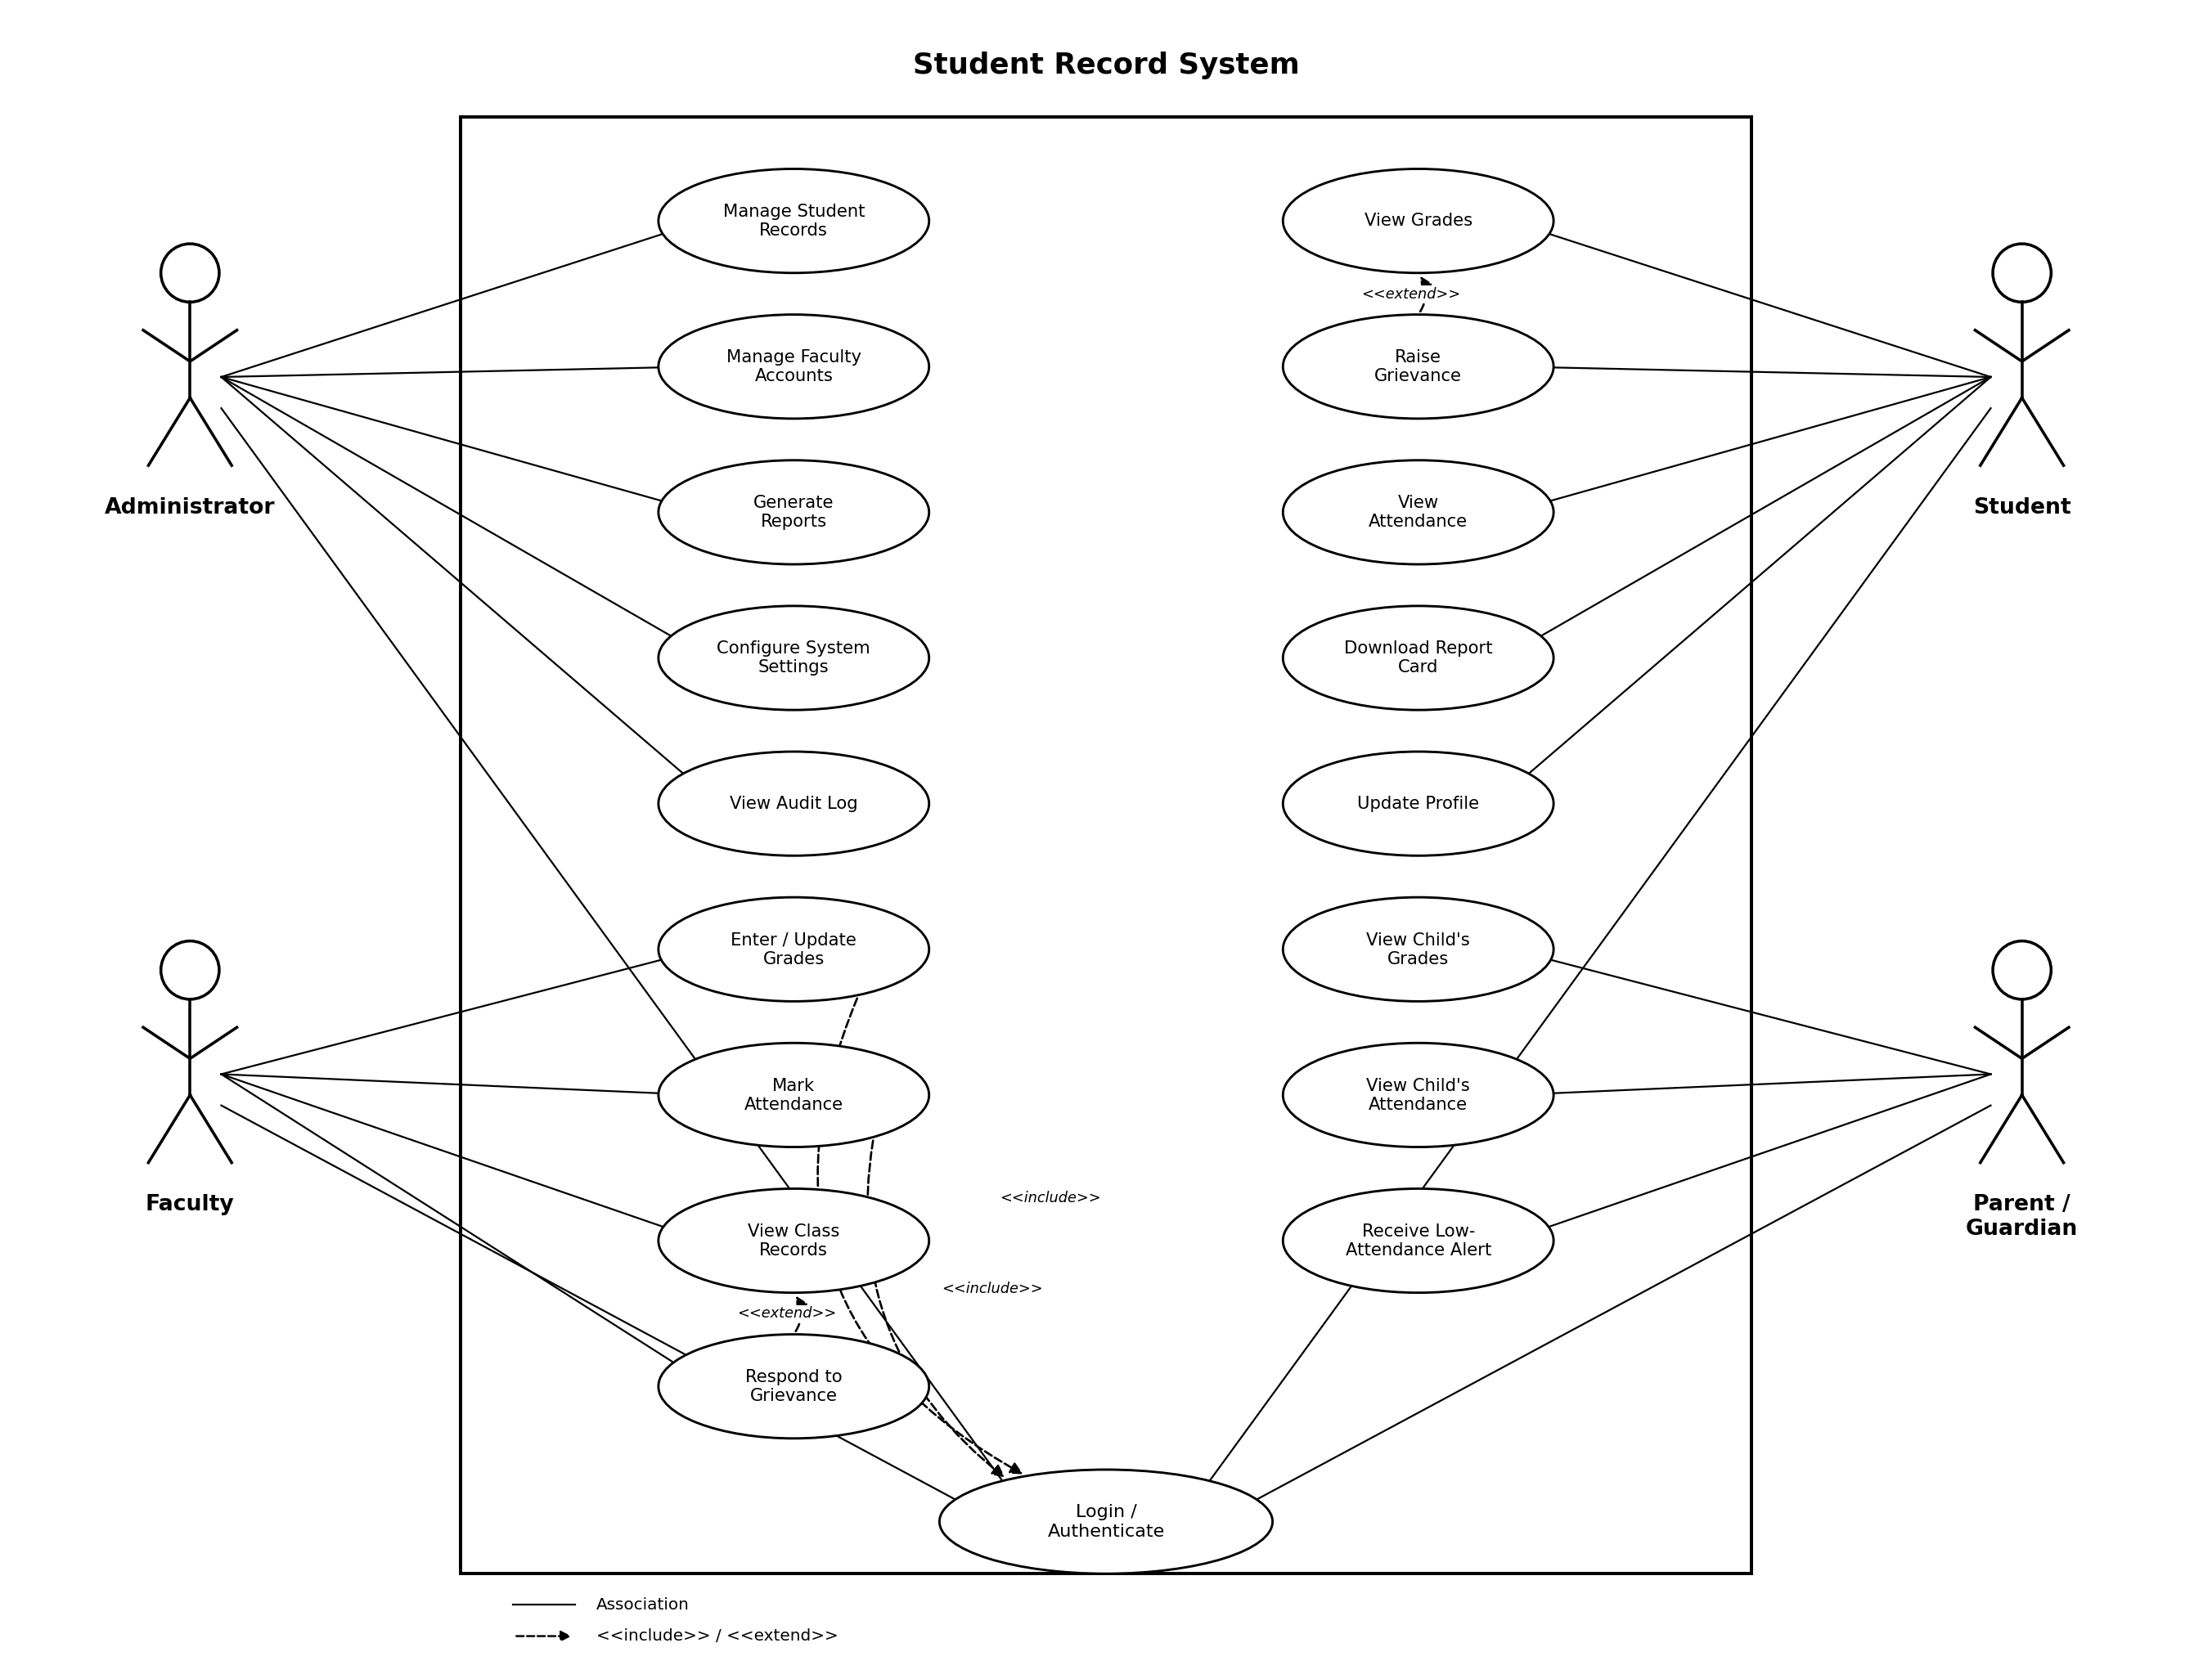
Figure 1: UML Use Case Diagram - Student Record System

7.1 Use Case Descriptions (Representative Sample)
Use Case ID | Name | Primary Actor | Brief Description
UC-01 | Login / Authenticate | All | Verify a user's credentials and issue a role-scoped session token.
UC-02 | Manage Student Records | Admin | Create, update and deactivate student records.
UC-07 | Enter / Update Grades | Faculty | Record or correct marks for an assigned course; system computes the letter grade.
UC-08 | Mark Attendance | Faculty | Record per-session attendance and view the computed percentage.
UC-11 | View Grades | Student | View own grades across enrolled courses.
UC-13 | Download Report Card | Student | Generate and download a PDF summary of grades and attendance.
UC-16 | View Child's Grades | Parent | View the grades of the linked student.
UC-10 | Raise Grievance | Student | Dispute a grade or attendance entry; extends UC-11.

8. Appendices

Appendix A - Requirements Traceability Matrix
A full Requirements Traceability Matrix, linking every FR/NFR/security requirement to its use case, architecture component and test case, is maintained in the companion Test Plan document (Section 4) and the Architecture & Design Specification (Section on Traceability), to avoid duplication and keep a single source of truth.

Appendix B - Analysis Models
Data entities referenced by the requirements above: User, Student, Faculty, Course, Enrolment, Grade, AttendanceRecord, Grievance, AuditLogEntry, Notification. Their attributes and relationships are detailed in the Architecture & Design Specification.

