SOFTWARE ENGINEERING LAB2
NAME:KUSHITA K
SRN:PES1UG24CS247
SECTION:E

PROBLEM STATEMENT: AUTOMATED RUBRIC ASSIGNMENT EVALUATOR
The project is divided into major Epics representing Requirement Analysis, UML Modelling, and Documentation. Each Epic contains smaller User Stories/Tasks that represent specific project activities.
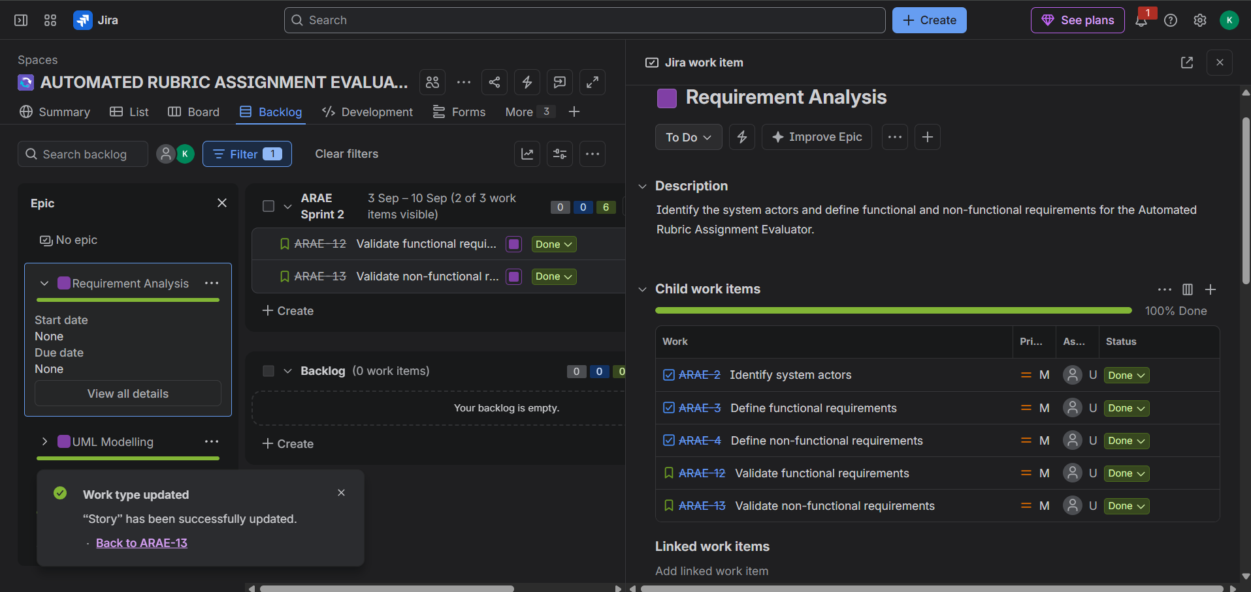
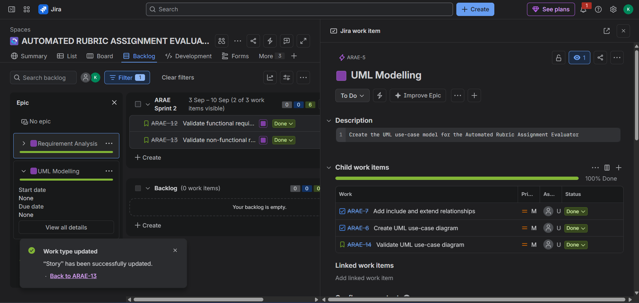

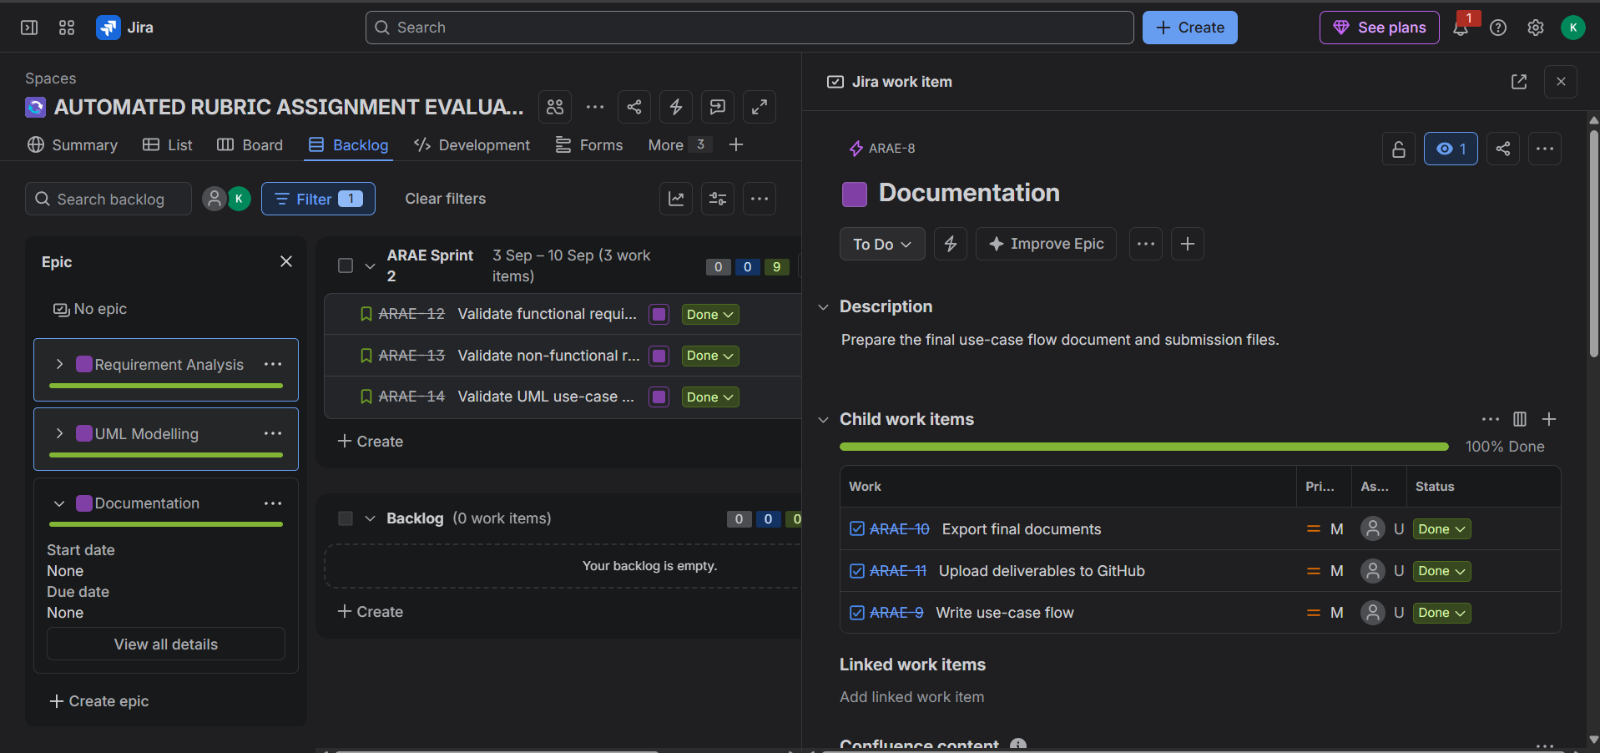
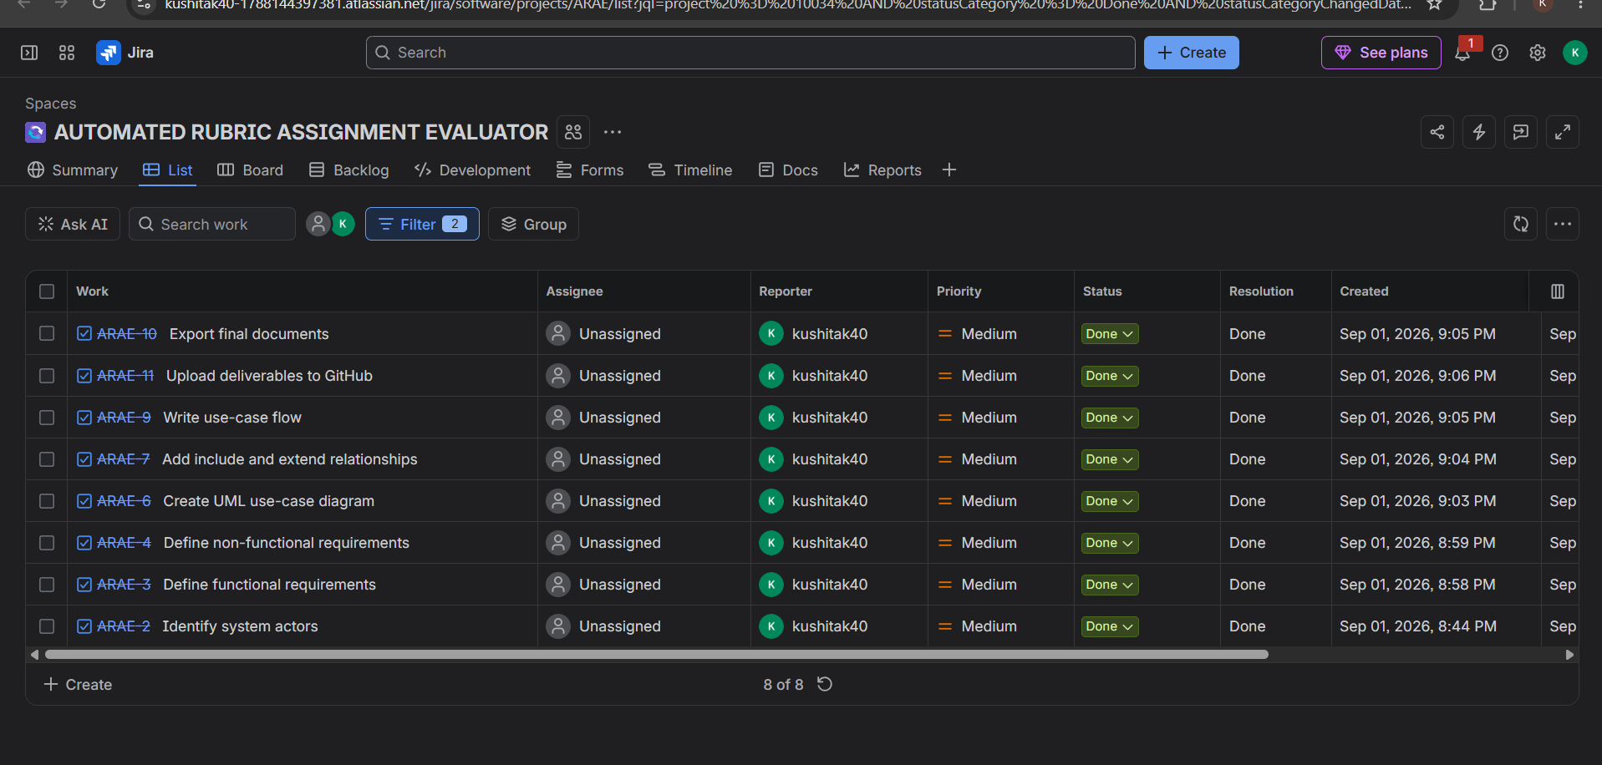
Sprint 1 was created to execute the planned project activities. The selected work items were assigned to the sprint and progressed through the Scrum workflow from To Do to Done.
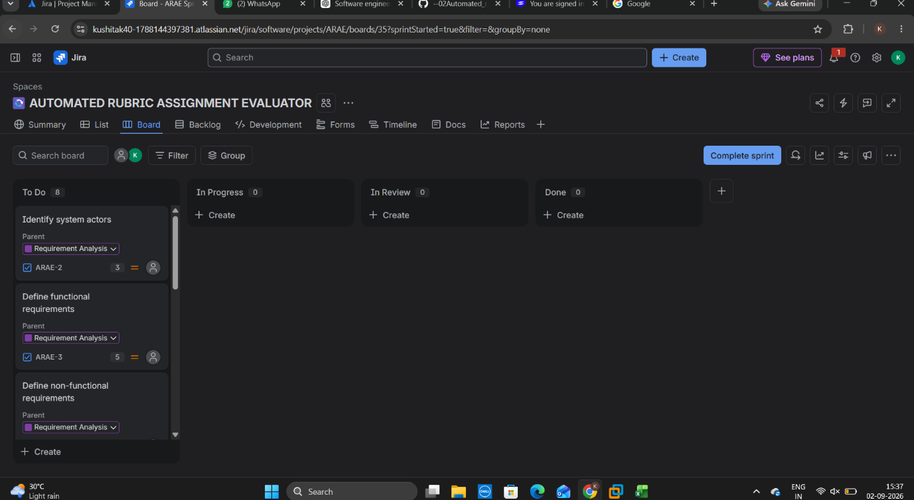
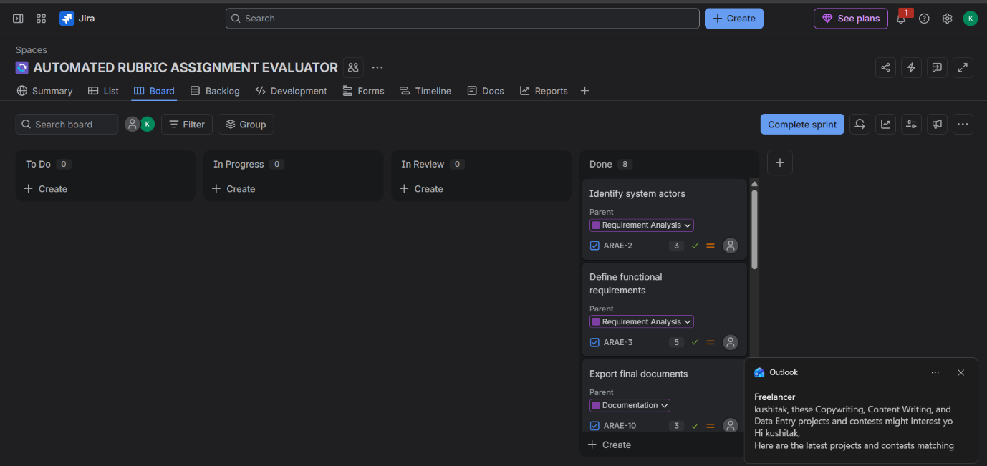
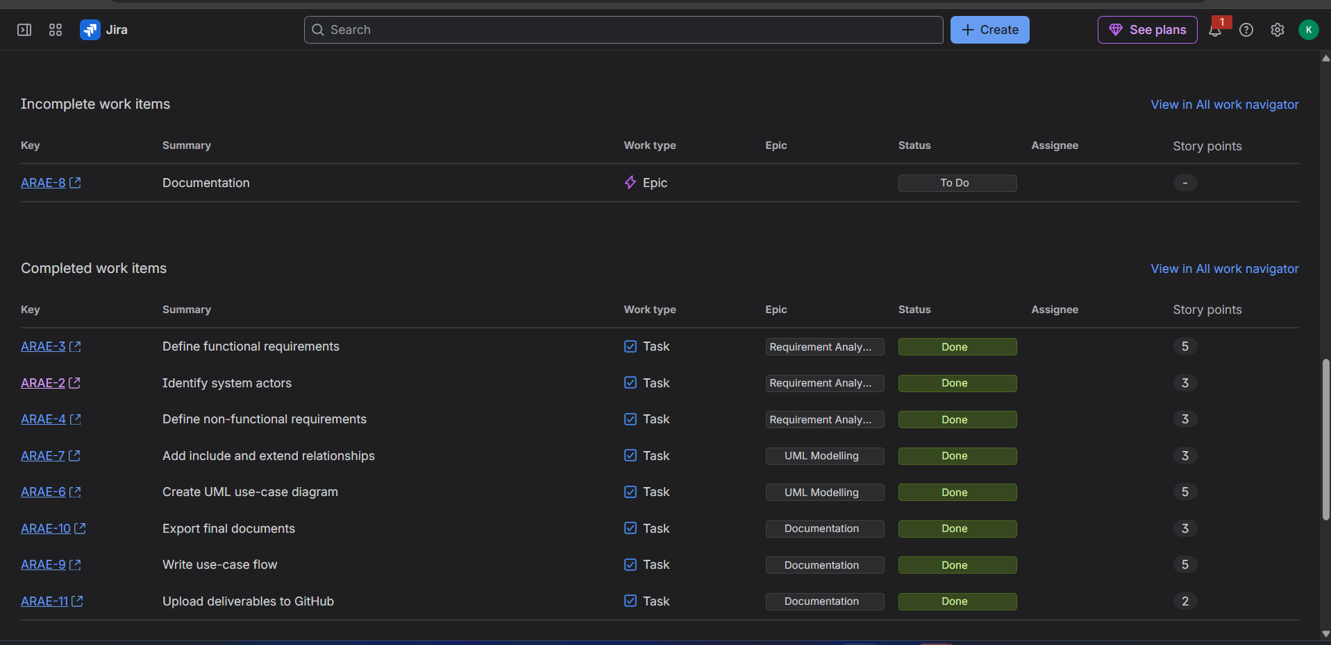
The Sprint 1 completion report shows the status of the work items at the end of the sprint. Completed items are shown as Done, demonstrating that the planned sprint activities were completed.

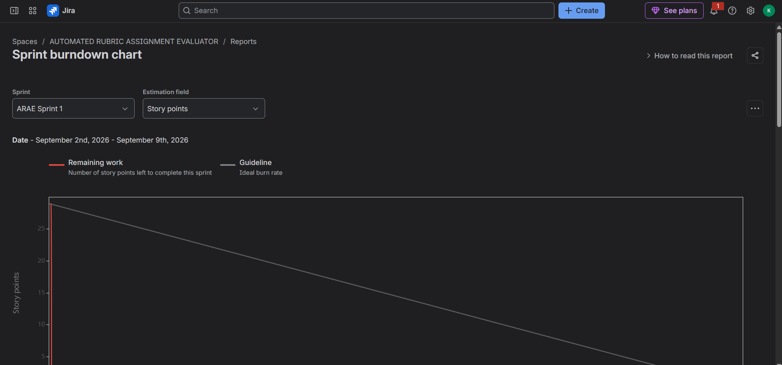
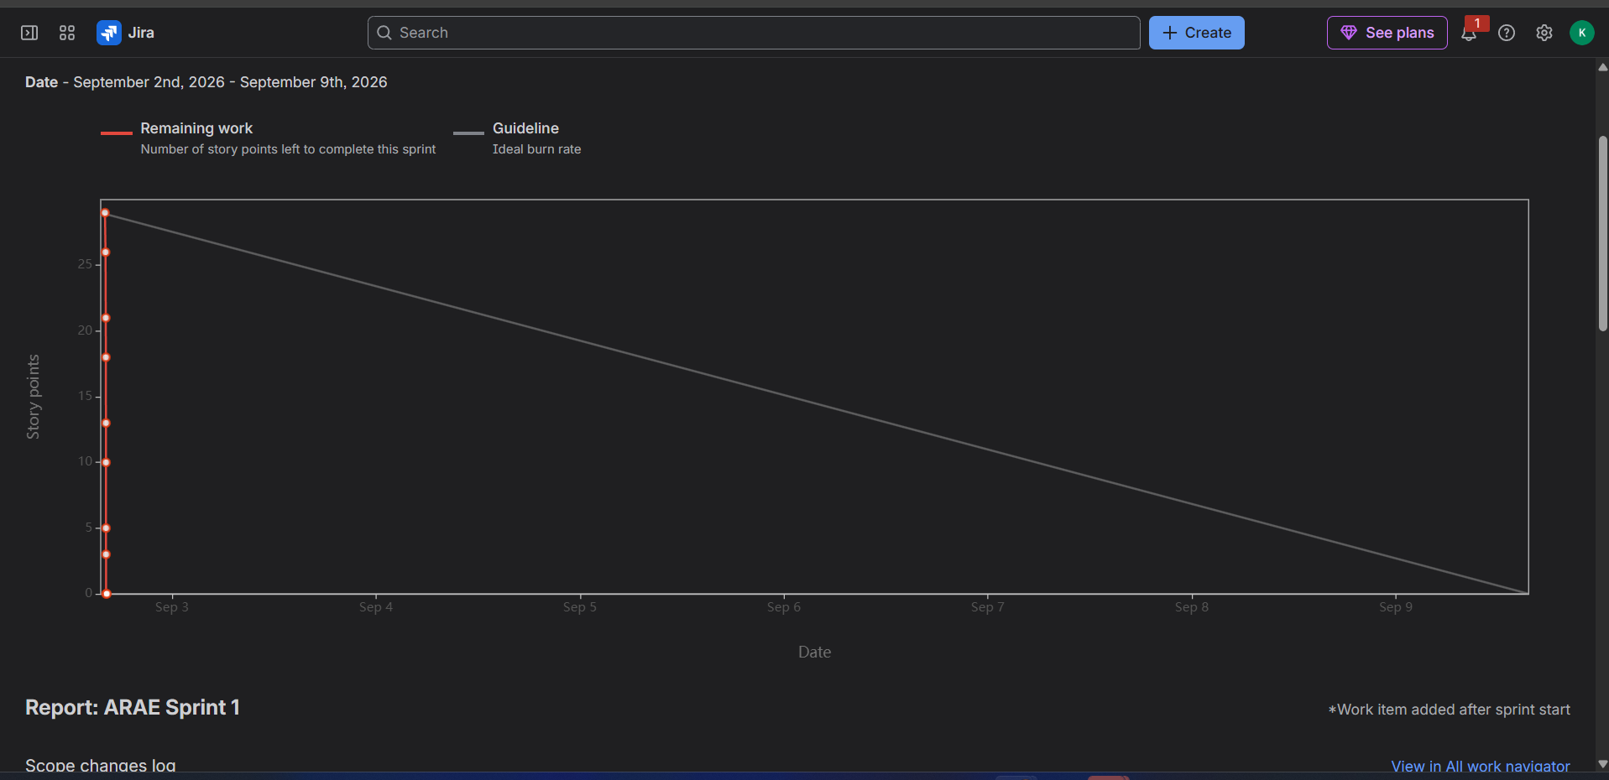

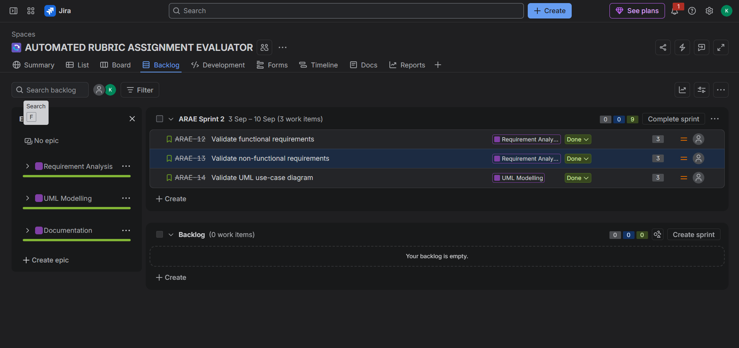
Sprint 2 was created with the remaining planned User Stories. The selected stories were assigned to Sprint 2 and initially placed in the To Do column.
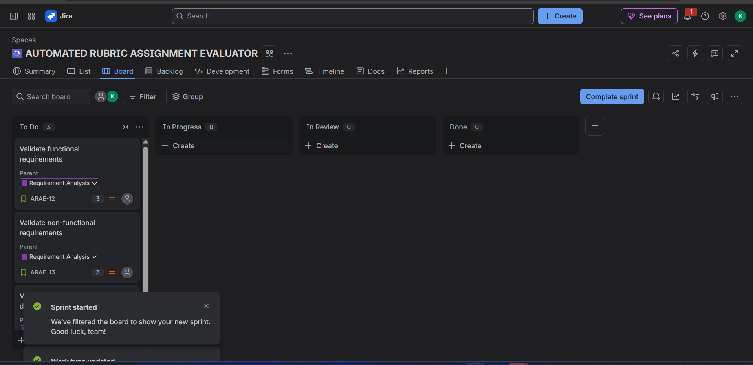

The Sprint 2 board shows the selected User Stories progressing through the Scrum workflow. The work items were moved from To Do to the appropriate workflow stages as the work progressed.
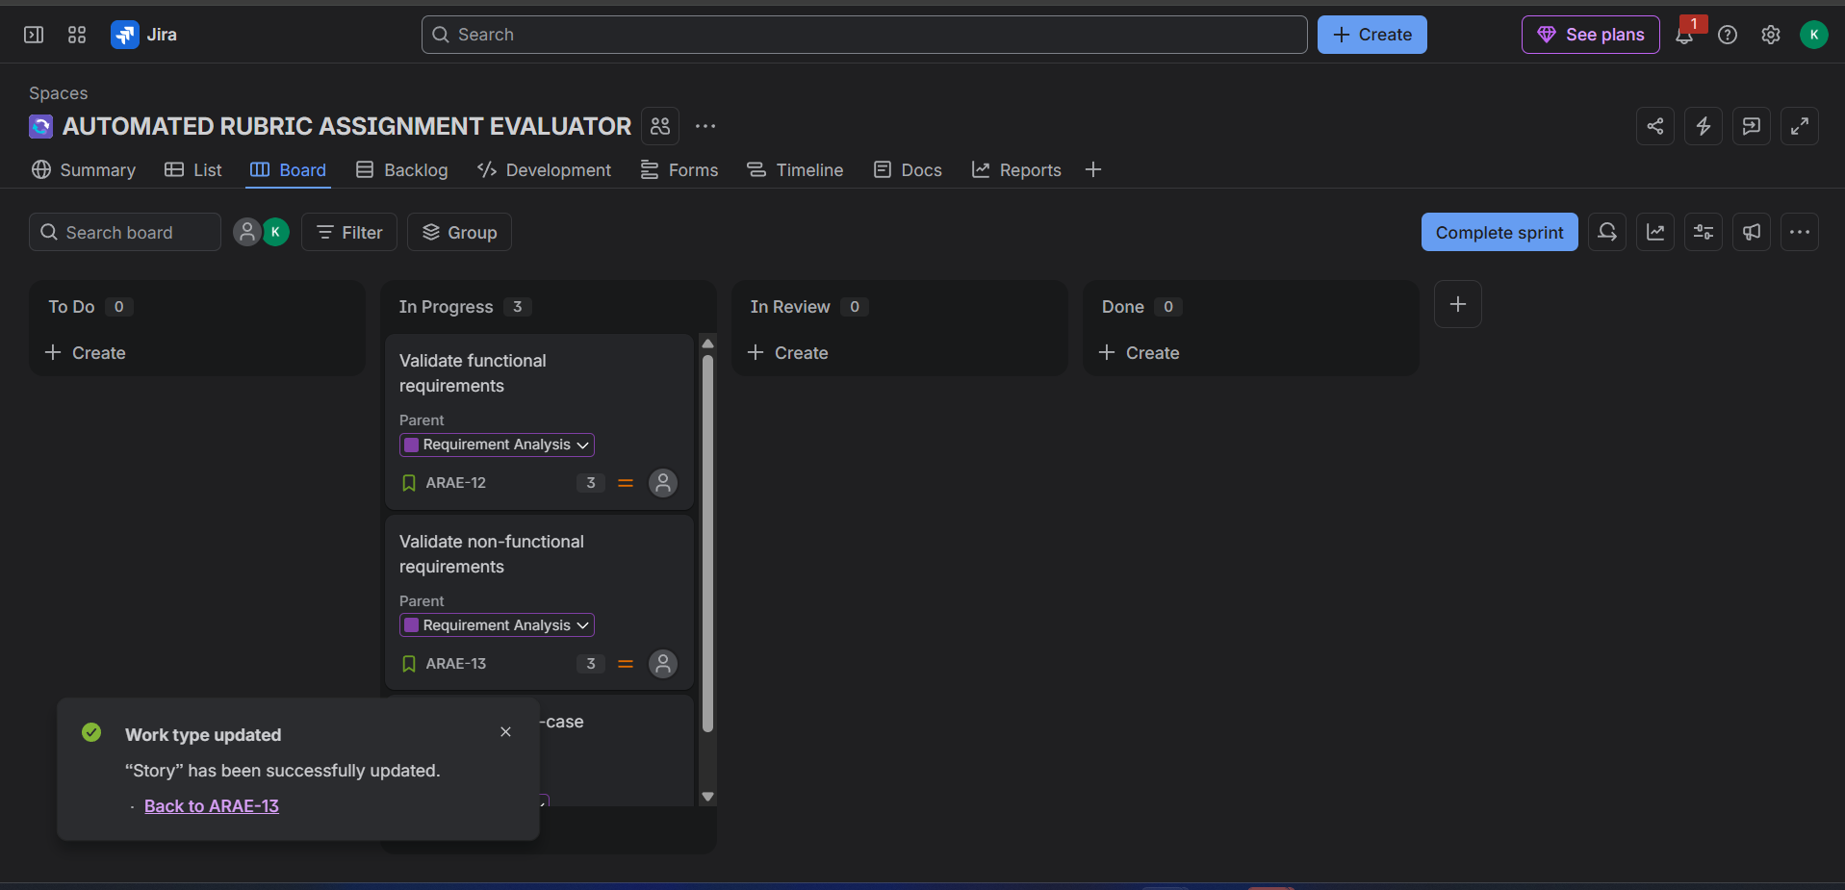

All planned Sprint 2 work items were moved to Done, indicating that the sprint workload was successfully completed.
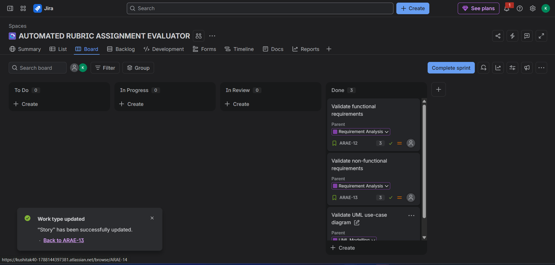

The Sprint 2 burndown chart represents the remaining story points throughout the sprint and compares the actual progress with the ideal guideline. The chart shows the planned workload being reduced toward completion.
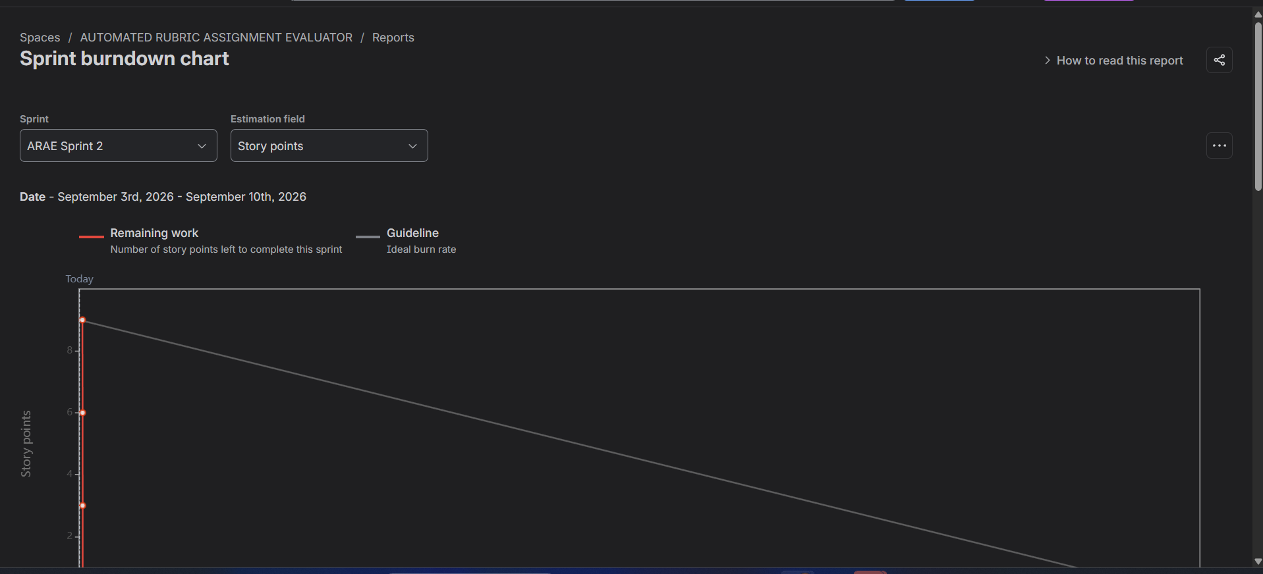
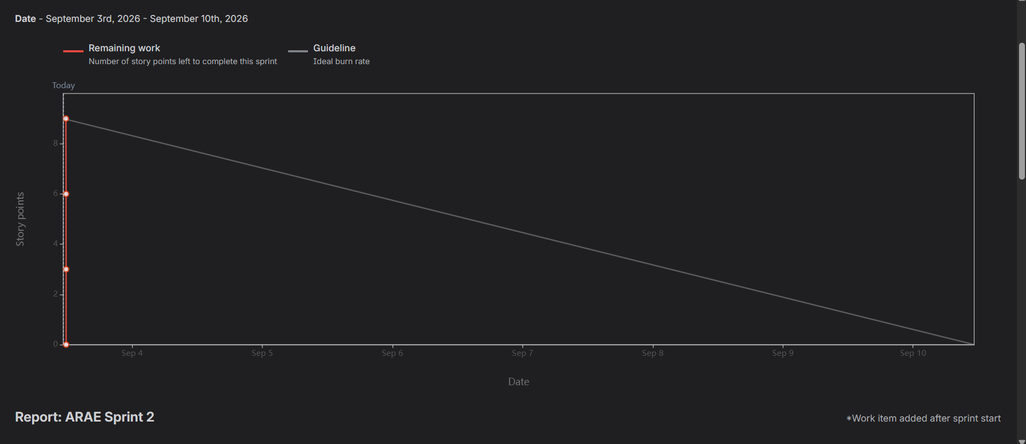
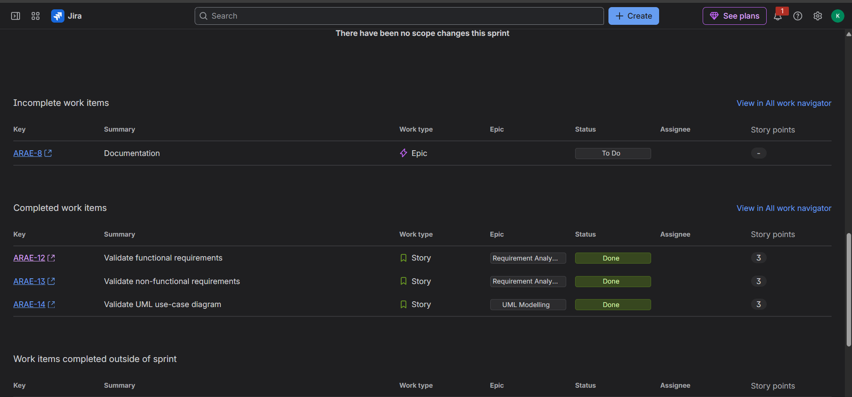
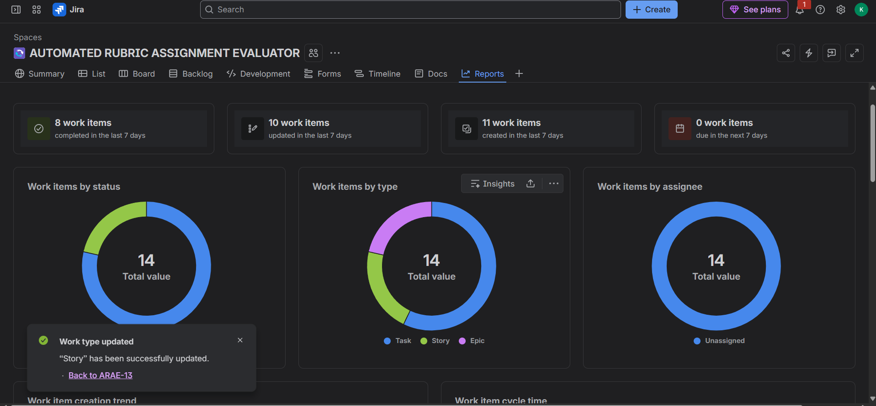

1. Did your estimations reflect the actual effort?
Yes. The three User Stories were estimated at 3 story points each, giving a total sprint estimate of 9 story points. All three stories were successfully completed during the sprint, so the estimation was reasonable for the simulated workload.
2. Was your backlog well-prioritized?
Yes. The backlog was organized according to the project's major areas of work: Requirement Analysis, UML Modelling, and Documentation. The User Stories were assigned to their appropriate Epics and selected for the sprint based on the planned work. This provided a clear and structured order for completing the project activities.
3. How did your simulated sprint align with your plan?
The simulated sprint aligned well with the plan. The sprint contained three User Stories with a total estimate of 9 story points. All three stories were moved through the workflow and completed, resulting in 0 remaining story points at the end of the sprint. This indicates that the planned sprint workload was successfully achieved.
4. What insights did the burndown chart give about your team’s capacity?
The burndown chart showed that the sprint started with 9 story points and finished with 0 remaining story points. This indicates that the team was able to complete the planned workload within the sprint. The chart also provides a comparison between the team's actual progress and the ideal burn rate, helping evaluate whether the planned sprint capacity was realistic.

