**Abstract:**

The rapid growth of the electric vehicle (EV) market in India presents a significant opportunity for new entrants. This report analyzes the Indian EV market using segmentation analysis to identify the most feasible entry strategy. By evaluating market trends, geographic adoption patterns, consumer behavior, and pricing strategies, this study aims to provide a data-driven approach to target the most promising customer and vehicle segments. The study also addresses challenges in data availability and proposes methods for making unbiased decisions in the absence of complete datasets.

**Introduction:**

The global transition towards sustainable transportation has led to a surge in electric vehicle adoption. India, as one of the largest automotive markets, is witnessing rapid EV adoption driven by government incentives, environmental concerns, and rising fuel costs. However, for a new EV startup, entering the market requires a strategic approach based on an in-depth analysis of market segmentation and consumer preferences. This report explores market trends, identifies key customer segments, and recommends pricing and market entry strategies.

**Problem Statement:**

An EV startup is exploring the Indian market to determine the most suitable vehicle and customer segments for its product launch. The challenge is to analyze the available data, segment the market effectively, and identify the early adopters who align with the Innovation Adoption Life Cycle. Additionally, understanding pricing strategies and infrastructure challenges such as charging station availability is crucial for market penetration.

**Data Overview:**

The dataset contains monthly EV sales data across different vehicle categories:

* **2-Wheelers (2 W)**: Includes electric scooters and motorcycles.
* **3-Wheelers (3 W)**: Includes electric rickshaws and cargo vehicles.
* **4-Wheelers (4 W)**: Includes electric cars.
* **Buses (BUS)**: Includes electric public transport buses.
* **Total Sales**: Aggregated sales of all categories.

The data spans multiple years, capturing trends over time. This data will be analyzed to determine growth patterns, geographic demand, and customer preferences.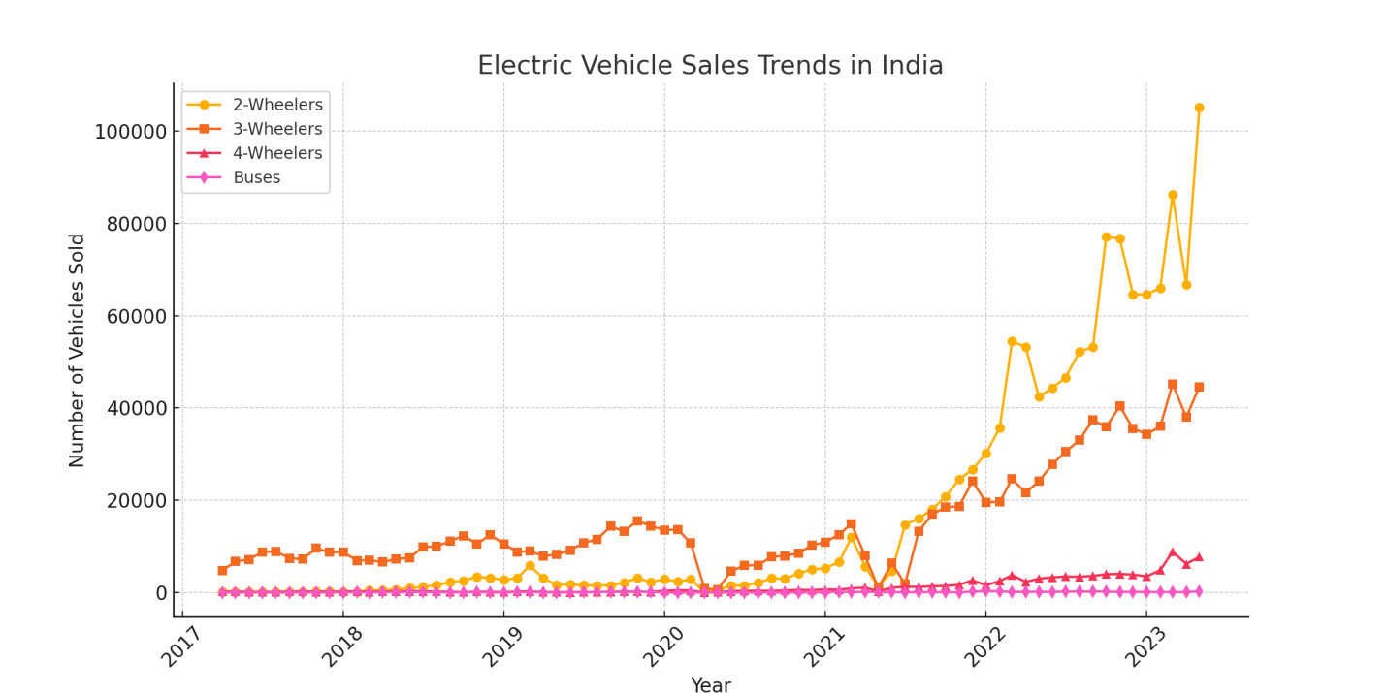

**Market Segmentation Analysis:**

1. **Geographic Segmentation**: Identifying regions with the highest EV adoption rates.
2. **Demographic Segmentation**: Analyzing target groups based on age, income, and occupation.
3. **Psychographic Segmentation**: Understanding consumer motivations such as environmental concerns, cost savings, and technology affinity.
4. **Behavioral Segmentation**: Studying purchasing patterns, brand loyalty, and charging habits.
5. **Category-Based Segmentation**: Assessing demand across 2W, 3W, 4W, and buses to determine the most viable vehicle segment for market entry.

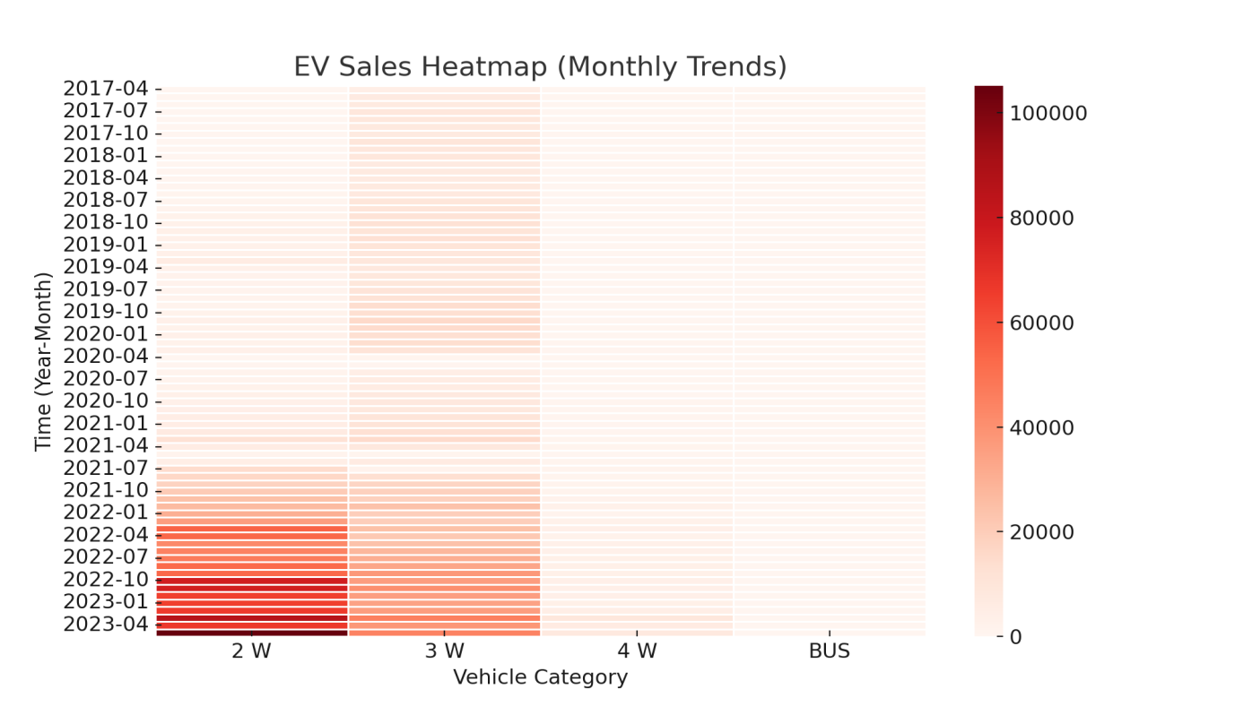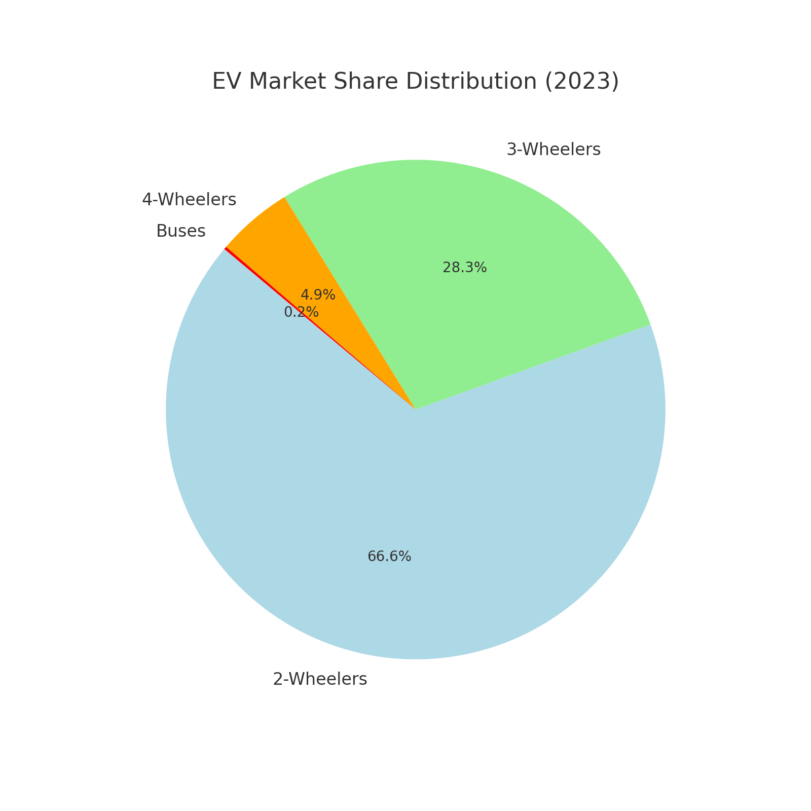

**Strategic Pricing and Market Entry Approach:**

* Determining the optimal pricing strategy based on early adopters’ willingness to pay.
* Evaluating the impact of government subsidies and incentives.
* Infrastructure analysis for charging stations and battery swapping solutions.

**Conclusion:**

Based on the market segmentation analysis and sales data trends, it is recommended that the company start by producing electric **3-wheelers** (e-rickshaws and cargo vehicles) and **2-wheelers** (electric scooters and motorcycles). These segments show strong adoption in urban and semi-urban areas due to affordability, last-mile connectivity needs, and government incentives. Entering the market with these vehicle types will allow the company to establish a strong foothold before expanding into 4-wheelers or electric buses.

**Colab Link:**

https://colab.research.google.com/drive/11i6GUrE6teHWoiteLVcd6CAGogMxh-lJ?usp=sharing