**Collections**

1. **What is collection?**

Collection is a framework which provides an architecture to store and manipulate the group of object. It has inbuilt interfaces, classes and methods to perform different operations.

Following operations can be performed: Searching, Insertion, Manipulation, Deletion, Sorting.

1. **What are the interfaces present in java?**

Set, List, Queue, Deque

1. **What are the classes available in Java?**

ArrayList, Vector, LinkedList, Stack, HashSet, TreeSet, PriorityQueue etc.

1. **Name the package which have all the collections?**

Java.util package

**Collections:** Complete concept is called Collections

**Collection:** it’s a interface

**Rectangle box:** Denotes interface

**Circular box:** Denotes class

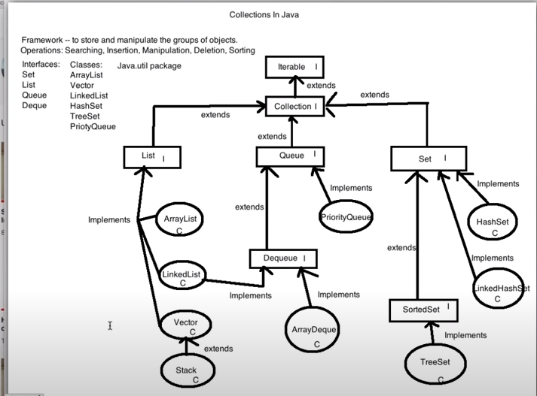

Limitations of array:

1. Arrays are fixed in size
2. Arrays can hold only homogenous data element. For e.g., a int array can only store the integer.
3. For array there is no underlying data structure used. Hence, there is no inbuilt methods for array operation. User have to write code for all operations such as: insert, delete, search and sort etc.

For resolving these issues, we move to collections:

1. Collections are growable in nature.
2. Collections can hold both homogenous & heterogenous data
3. Every collection class is implemented on standard data structure. Readymade methods are available.

When to use array over collection is:

* When size is fixed.
* Performance is an constraint

Difference Between Collection & Collections

* Collection is a interface while Collections is a class

9 Key collection interfaces are:

1. Collection interface
2. List interface
3. Set