using web camera for improving image quality from a projector

**Motivation:** Now in the epoch when computer vision used more and more extensively and becomes a common part of user experience. This trend changes ordinary Human-Computer Interaction. But usually, it requires special devices to use all bennefits of those technologies (as a rule: new, highly specified and expensive ones). But there are lots of “old” and cheeper devices which perform tasks they’ve been made for rally good, and we are still capable of benefiting from them. I want to use several tactics to “improve” or even “augment” user experience from canonical and widely spread devises.

*User experience of interacting with old conventional display devices can be changed drastically, now they can become an active extension of our computerized systems. Usually, there are kind of PC proxy or other operation modules who sends the signal to display. Therefore we can use those elements to combine those components into the loosely coupled system to improve the experience of using usual displays without a need to buy a whole new costly system. To make it possible we don’t need to make them “smart”, we can alter the video signal itself (a.e. rotate or augment the picture the picture and display it already rotated).*

**Goal:**

*In this particular work we’ve implemented only part of bigger idea of augmenting environment using not bearable device (like glasses or etc) but device which will make exact projections.*

*This part is projected picture refinement. As generally there are not something like a whitescreen or white-room in our environment, we shold adapt usual projector to do be able to reproduce image on surfuces with colour, texture, shape, gloss and exterior luminosity. This project can be not only the part of a described system, but can help in situations when you don’t have expensive projector or ideal enironment, but still whant to have best possible experince.*

*As the closest step from the future this project can be used to exatract shape and properties of a surfece and use it to build the model of an evironment.*

IMPLEMENTATION:

Components used:

1) Computing station;

2) Projector [MINI LED PROJECTOR “RD-802”, example ref: {<https://www.hibargain.com/rd-802-mini-led-projector-with-hdmi-av-vga-sd-usb-tv-home-theater.html>}]

3) Built-in 720p Web-camera for workstation HP 8770-W.

**In code there been used many functions from openCV library. Some of them are used in a “contextual code” taken from openCV distributive demo samples.**

SOLUTION:

0) Calibration?

Step 1) Detecting “Region of interest” (ROI), as the projected image, corresponding to our original one. For this purpuse we use features extractor for detecting image position works with option of manual tuning (as we made this project aiming to work in unpleasant conditions, therefore even state of art detectors are failing to work after some threashhold of unplesent conditions, as when image becomes blurred too much due to focus breakdown or external lightsources overwhelming low-power projector capabilities).

**It can be done eather in auto mode or manually adjust detector settings (as condition of usage are intended to be unpleasant, this tradeoff seems inevitable).**

**The same task kan be done using "changing" picture to detect altering region of picture.**

**But we refused to use this approach as it has other tradeoffs:**

**1) recalibration interrupts ordinary usage process.**

**2) other movig or altering regions of captured picture can spoil the results**

Step 2) Calculating homography matrix between those images, as the result, obtaining “coupling” between elements of our system.

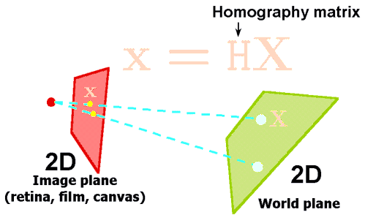

Step 3) Creating learing “feedback-loop” and changing image being projected with ‘difference matrix’.

As our fitness function we apply different approaches of estimation difference between original and projected image. Even simple pixelwise difference can be useful: moda of it’s difference gives us approximate value of surface colour.

<pix, pix, pix>

Aplying this approach to different partitions of imagem keeping in track our fitness function result we estimate optimal value of “difference matrix” we want to apply to our src image in order to improve projection quality.

<training log>

Here we apply adaptive granularity approach and image analysing difference between original image (our aim) and resulting

<difference matrix>

<original> --> <resulting>

**Current project results:**

GITHUB: <https://github.com/KushnirDmytro/Active_displays_project/tree/master/ML_course_project_Projection_refinement>

General research results (branches in development or ones which met dead ends) :

GITHUB: <https://github.com/KushnirDmytro/Active_displays_project>