**PURBANCHAL UNIVERSITY**

**Biratnagar Nepal**



A Project report on

**“VOTING SYSTEM”**

In the partial fulfillment for the requirement of the 1st Semester Project-I (subject code- BIT 106CO) in the completion of **Bachelor of Information Technology (BIT)** degree at **KIST college** **of Information Technology**, under **Purbanchal University.**

|  |  |  |  |  |  |  |
| --- | --- | --- | --- | --- | --- | --- |
|  | **Submitted By:-** | | |  | **Submitted To:-** | |
| **1)** |  | **Pranam Rai** |  |  |  |  |
| **2)** |  | **Priya Kushawaha** | | **Purbanchal University** | | |

**Under The Guidance of**

**Mr. Prawesh Dhungana**

**Lecturer, BIT**

**KIST COLLEGE OF INFORMATION AND TECHNOLOGY KAMALPOKHARI, KATHMANDU NEPAL**

**KIST COLLEGE OF INFORMATION AND TECHNOLOGY KAMALPOKHARI, KATHMANDU NEPAL**



**CERTIFICATE**

This is to certify that the project work entitled **“VOTING SYSTEM”** is carried out by **PRANAM RAI (5415), PRIYA KUSHAWAHA (5431),** bona fide students of **KIST COLLEGE OF INFORMATION AND TECHNOLOGY** in partial fulfillment for the award of **BACHELOR IN INFORMATION AND TECHNOLOGY** of the **PURBANCHAL UNIVERSITY, BIRATNAGAR NEPAL**, during the year **2021-2022**. It is certified that all corrections indicatedfor internal assessment have been incorporated in the report submitted in the department library. The project report has been approved, as it satisfied the academic requirements in respect of the project work prescribed for the said degree.

The details of the students are as follows:-

|  |  |  |
| --- | --- | --- |
| **NAME** | **REGISTRATION NO.** | **SYMBOL NO.** |
| Pranam Rai | 058-3-2-04729-2020 | 313430 |
| Priya Kushawaha | 058-3-2-04730-2020 | 313431 |
|  |  |  |
|  |  |  |

Course Semester: - 1st Semester

Subject: - Project-I

Subject Code: - BIT (106CO)



Mr. Deepak Khadka

Program Coordinator, BIT



**KIST COLLEGE OF INFORMATION AND TECHNOLOGY KAMALPOKHARI, KATHMANDU**

**Examiner’s Certification**

The Project Report

On

**“VOTING SYSTEM”**

**Developed by**

**Pranam Rai**

**Priya Kushawaha**

Is approved and is acceptable in qualify form.

___________________________ ______________________________

**Internal Examiner External Examiner**

Name: Name:

Designation: Designation:

**Acknowledgement**

We would like to take this opportunity to express our profound application and regards to the Information Technology (IT) department for this commendable guidance, monitoring and constant encouragement throughout the course of this project. The help and guidance given by shall carry us the long way, in the journey in which we are about to commence.

We would like to express our deepest appreciation to all those who provided us the possibility to complete this project.  A special gratitude to our project manager, **Mr. Prawesh Dhungana** and coordinator **Mr. Deepak Khadka** who guided us through tout the project. I would also like to thank my friends and family who continuously supported, motivated us and offered deep insight into the study.

We are grateful to all KIST members for providing the valuable suggestion and support which helped us a lot in our project work.

Finally, we would also like to express our special thanks of gratitude to **Purbanchal University** who gave us the beautiful opportunity to explore on this wonderful project. This project helped us in doing a lot of research and we came to know about so many new things we are really thankful.

We hope our university will accept out attempt as a successful project.

Thank you!

**STUDENT’S DECLARATION**

We hereby declare that the project report entitled “**VOTING SYSTEM**” is based on our own work carried out during the course of our study under the supervision of **Mr. Prabesh Dhungana** and **Mr. DIPAK KHADKA** sir**.** We assert the statements made and conclusions drawn are an outcome of our research work.

Furthermore, we certify that this project submitted is our original work and has never been submitted in any institution for any other titles or awards.

|  |  |  |  |
| --- | --- | --- | --- |
| S.N. | Name | Registration No. | Symbol No. |
| 1 | Pranam Rai | 058-3-2-04729-2020 | 313430 |
| 2 | Priya Kushawaha | 058-3-2-04730-2020 | 313431 |

**TO WHOM IT MAY CONCERN**

This is to certify that Mr. Pranam Rai, Mrs. Priya Kushwaha of **Bachelor in Information Technology** (**BIT**) has studied as per the curriculum of BIT 1st Semester and completed the project entitled “**VOTING SYSTEM”**.This project is the original work of Mr. Pranam Rai, Mrs. Priya Kushawaha was carried out under the supervision of Mr. **Prawesh Dhungana** as per the guidelines provided by Purbanchal University and certified as per the student’s declaration that project “**Voting System**” has not been presented anywhere as a part of any other academic work.

The detail of the student is as follows:

Name of Students : Pranam Rai & Priya Kushawaha

Semester : 1st

Subject Code : BIT 106C0

Project Title : Voting System

…………………………….

Mr. Deepak Khadka  
Program Coordinator, BIT  
KIST College of Information Technology

# ABSTRACT

The **“Election for Sports captain”** is a voting systemproject that aims to develop software where students can cast their votes to the candidates and choose their sports captain for 2022 and the following years. It also being an administrator of the software, details of the users who chose their leaders are kept confidentially.

This project is developed using C-programming language. It is meant for selecting the candidates as their sports leader according to the votes count.

In this voting system students can vote only one candidates at a time. This project helps students to vote easily and effectively .To cast vote students must have to enter their name and faculty. For entertainment purpose we have included the guessing part where students can guess who is leading the vote till now.

**TABLE OF CONTENTS**

Chapter 1 9

INTRODUCTION 9

1.1Introduction 9

1.2Problem Statement 9

1.3Objectives 10

1.4Scope 11

1.5Advantages 11

Chapter 2 12

SYSTEM DESIGN 12

2.1Algorithm 12

2.2Flowchart 13

Chapter 3 14

Requirement Analysis & Implementation system 14

3.1Hardware Requirement 14

3.2Software Requirement 14

3.3System Methodology 15

Chapter 4 19

CONCLUSION 19

4.1Conclusion 19

4.2Future scope 19

Appendix 20

Screenshot 20

Source Code 23

# Chapter 1

# INTRODUCTION

## 1.1Introduction

The projects **“Election for sports captain”** is a voting system projects that manages the votes count, leading candidates. This system helps in storing the vote count of the candidates and helps to find out the leading candidates as well. This project has limited contents like **to vote, Show vote counts, Guess vote, show lead candidates.** These are the contents which fulfill our system project. This projects can be used during the election anywhere due to its flexibility. With the help of this project, the voters can vote easily just by pressing the keys. Also, this system records the vote counts. This system is easy to use and works effectively. It helps to achieve a better, active and people’s choice leader. Each voter can give only one vote to the candidates at a time. To cast vote user only have to enter their name and faculty. This project can be used anywhere and anytime.

### 1.2Problem Statement

There are several problems when it comes to voting. One of the problems is whether the candidates voted fairly throughout the vote. Another problem is whether the votes that are being cast are being counted correctly or even being counted at all.so these are the major problems which our code is dealing with.

### 1.3Objectives

The main objectives of this project is to cast vote, where students, user, voters can vote their favourite candidates and helps them to win the election. It also helps to manage the vote counts. User can view the vote counts. Function like guess vote, show leading candidates can be performed here.

Objectives of the projects are as follow:-

* To cast vote
* Store vote counts
* Guess the leading candidate
* Display leading candidate

### 1.4Scope

Learning and enhancing skills play vital role in the area of BIT (Bachelor in Information Technology).This also helps us to prepare for getting the highest paying jobs in the field of IT (Information Technology) by widening your arsenal of tools also enhances your values as a professional in your company.

* Nationwide online voting system
* Secured data and security for voters privacy
* Biometric security implementation
* Can be upgraded to advanced voting systems like political voting systems.

### 1.5Advantages

* Maintaining the candidate vote record
* Record the data
* Helps to vote candidate of their choice
* Time saving
* 24/7 hours facility

# Chapter 2

# SYSTEM DESIGN

### 2.1Algorithm

Algorithm for Main Menu

Step 1: Start

* Step 2: Press any key to Continue
* Step 3: Display Main Menu with different Options like:-
* To vote
* Votes count
* Guess who will win this competition
* Leading candidates till now
* Press 5 if you want to exit
* Step 4: Press 1 to vote
* Step 5: Press 2 to see votes count
* Step 6: Press 3 to guess who is going to win the competition
* Step 7: Press 4 to see the leading candidates till now
* Step 8: Press 5 to exit the program
* Step 9: Stop

### 2.2Flowchart

Flowchart for Main Menu

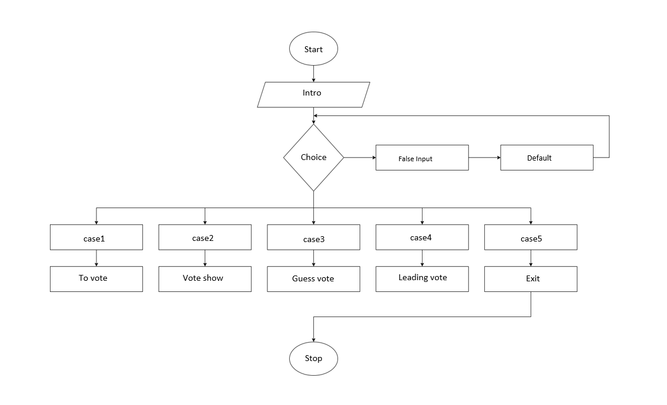

1: Flowchart of Main Menu

# Chapter 3

# Requirement Analysis & Implementation system

### 3.1Hardware Requirement

* PC with Pentium II Processor
* 32 MB of RAM
* Black and White Monitor
* Hard disk with at least 20MB of free space

### 3.2Software Requirement

* OS Windows (Windows XP)

### 3.3System Methodology

System Methodology is a methodology for systematically organizing the best ways to develop systems efficiently. It is a step-by-step process for developing any system. There are many system development methodologies. Some of them are Waterfall Model, Iterative Model, Develope Model, V-Model, Spiral Model, Lean and Agile Model, Prototype Model, etc.

In this project, we are going to use Waterfall Model approach since our project is short and our requirements are fixed. The Waterfall Model is one of the oldest SDLC models but it is best for short projects as this model involves a rigid structure that demands all system requirements be defined at the very start of a project. Only then the design and development stages begin.

**Waterfall Model- Design**

Waterfall approach was the first SDLC Model to be used widely in Software Engineering to ensure success of the project. In “The Waterfall” approach, the whole process of the software development is divided into separate phases. In this Waterfall Model, typically, the outcome of one phase acts as the input for the next phase sequentially.

The following illustration is a representation of the different phases of the Waterfall Model.

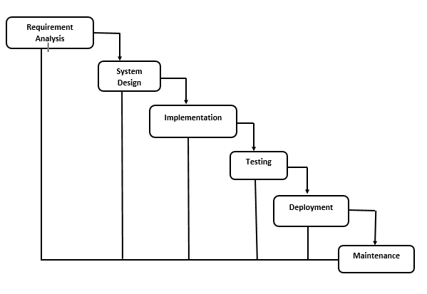

The sequential phases in Waterfall Model are: -

* **Requirement Analysis:** All possible requirements of the system to be developed are captured in this phase and documented in a requirement specification document. The detailed requirements of the client like costs, assumption, risks, dependencies, success matrices, and timelines for completion, etc. are done in this phase.
* **System Design:** The requirement specifications from the first phase are studied in this phase and the system design is prepared. This system design helps in specifying hardware and system requirements and helps in defining the overall system architecture. Here, the software developers design a technical solution to the problems set out by the requirements. Once this is complete, it is transformed into physical design using specific hardware and software technologies. In this project, we have used C programming as System Design Language.
* **Implementation:** With inputs from the system design, the system is first developed in small programs called units, which are integrated in next phase. Each unit is developed and tested for its functionality, which is referred to as Unit testing. Once the design is complete, technical implementation starts. This might be the shortest phase of the Waterfall Model because the detailed research and design have already been done. In this phase, programmers code applications based on project requirements and specifications, with some testing and implementation taking place as well.
* **Integration and Testing:** All the units developed in implementation phase are integrated into a system after testing of each unit. Testing is done to ensure that there are no errors and all the requirements have been completed, ensuring good user experience with the software before releasing the software to the client.
* **Deployment of System:** Once the functional and non-functional testing is done, the product is deployed in client environment or released in the market.
* **Maintenance:** There are some issues which come up in client environment. To fix those issues, patches are released. Also, to enhance the product some better versions are released. Maintenance is done to deliver these changes in the client environment.

All these phases are cascaded to each other in which progress is seen as flowing steadily downwards (like waterfall) through the phases. The next phase is started only after the defined set of goals are achieved for previous phase and it is signed off, so the name “Waterfall Model”. In this model, phase do not overlap.

**Requirement Analysis**

In software and system engineering, a functional requirement defines a function of a system or its component, where a function is described as a specification of behavior between input and outputs.

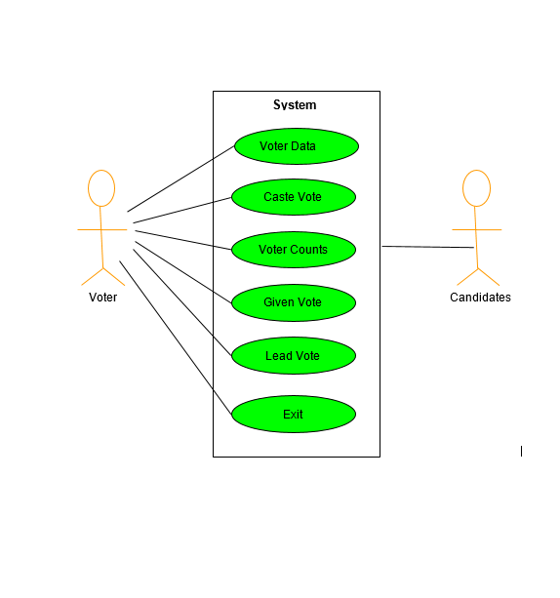

2: Use case Diagram

# Chapter 4

## CONCLUSION

### 4.1Conclusion

Online voting technology has not yet reached a level where the benefits of online voting would be greater than its risks. From the technical point of view, it would be possible to implement an online voting system, but there are deficiencies in how the verifiability and the prevention of pressuring voters could be reconciled. In practice, voters would have to be able to ensure that their vote has been counted as cast, but the system should still not produce a receipt that could be used to pressure voters or sell votes.

### 4.2Future scope

Learning and enhancing skills play vital role in the area of BIT (Bachelor in Information Technology).This also helps us to prepare for getting the highest paying jobs in the field of IT(Information Technology) by widening your arsenal of tools also enhances your values as a professional in your company.

* Nationwide online voting system
* Secured data and security for voters privacy
* Biometric security implementation
* Can be upgraded to advanced voting systems like political voting systems.

## Appendix

### Screenshot

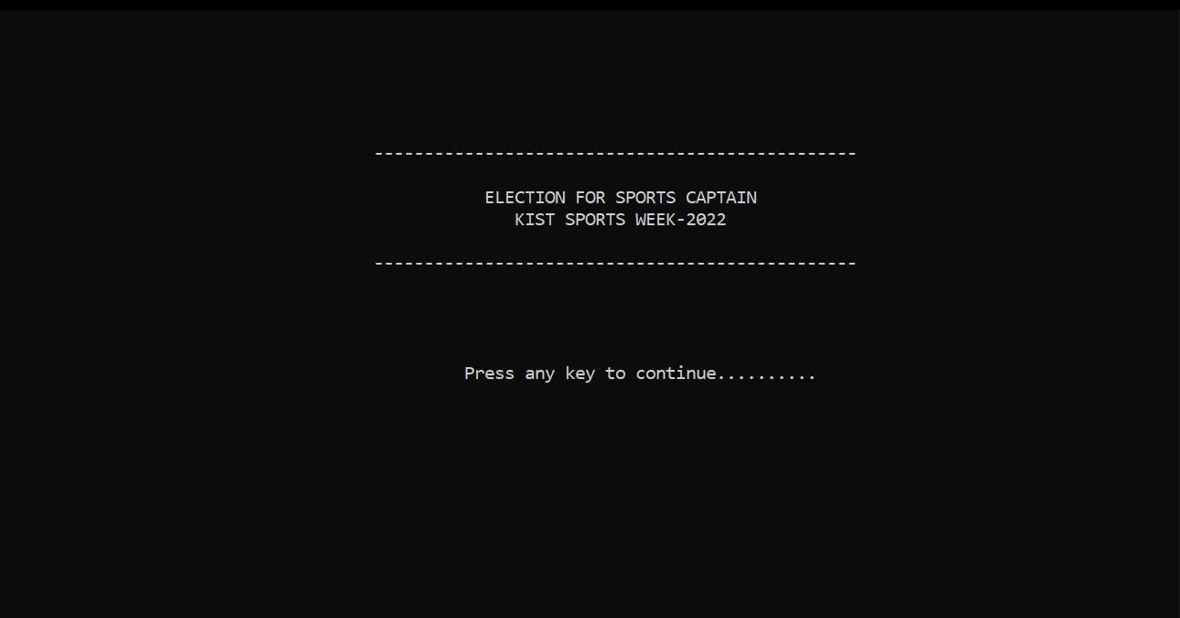**1. Main Menu**

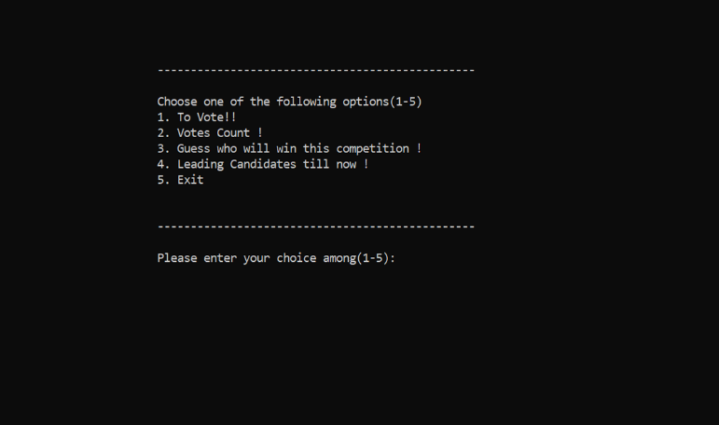

**2. To vote**

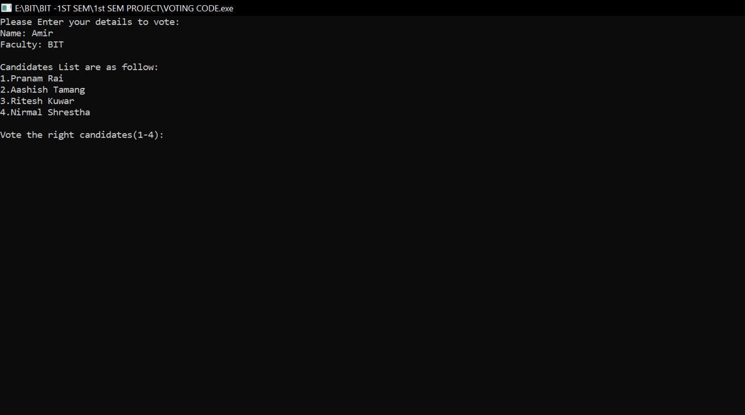

**3.Show total vote counts**

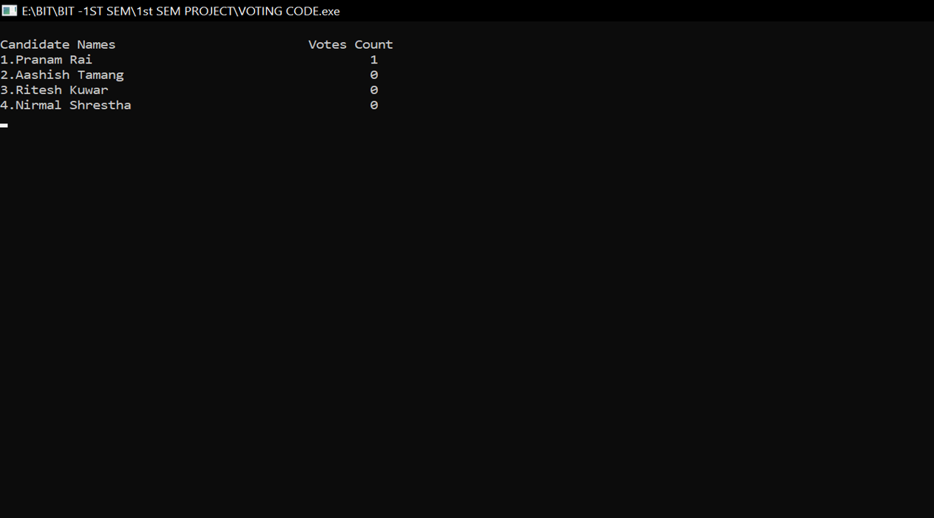

**4.Guess Vote**

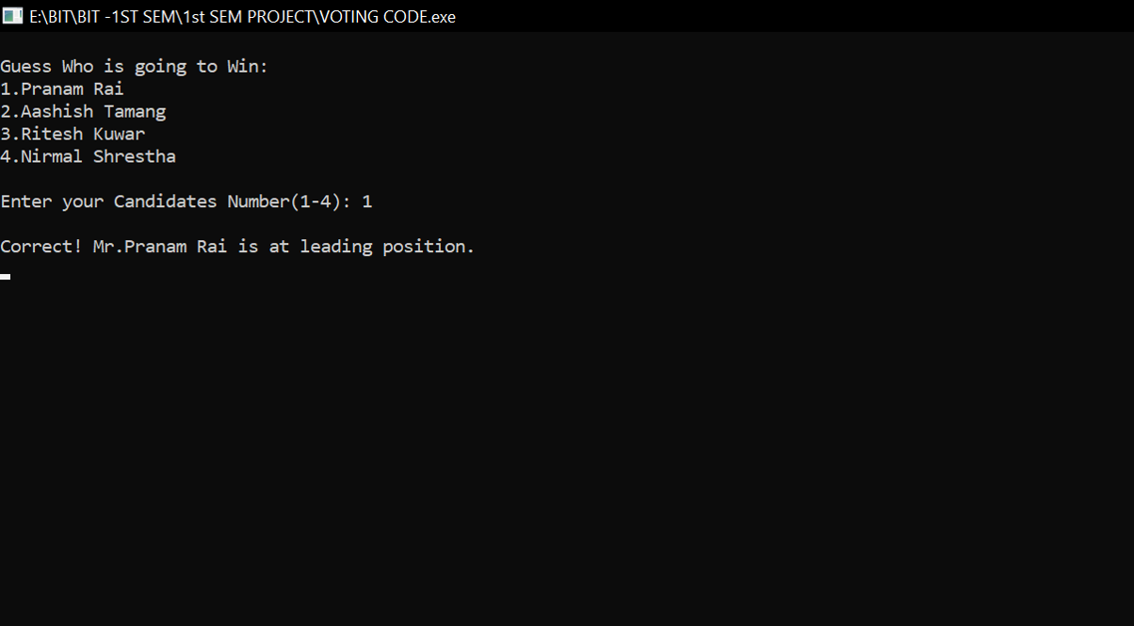

**5.Show leading candidate**

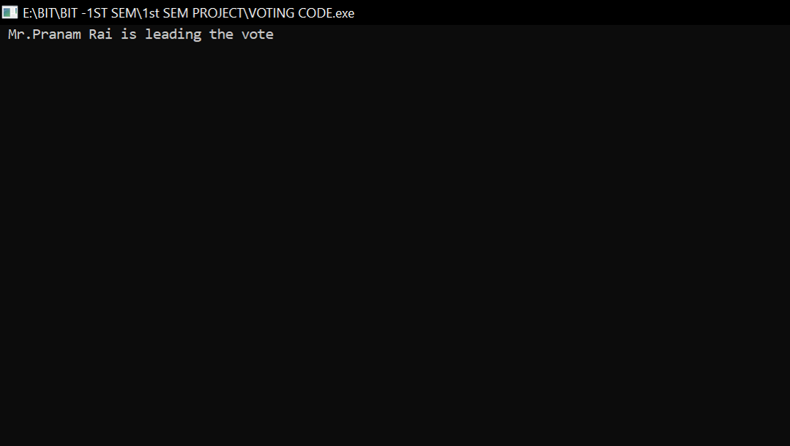

### Source Code

#include<stdio.h>

#include<string.h>

#include<conio.h>

#include<stdlib.h>

#define C1 "Pranam Rai"

#define C2 "Aashish Tamang"

#define C3 "Ritesh Kuwar"

#define C4 "Nirmal Shrestha"

int votec1=0, votec2=0, votec3=0, votec4=0, i=0;

FILE *rvote,*fvote;

struct voters

{

char name[25][25];

int roll,grade,test;

} v;

void intro()

{

printf("\n");

printf("\n\n\n\n\n\t\t\t\t\t------------------------------------------------\n");

printf("\n");

printf("\t\t\t\t\t\t ELECTION FOR SPORTS CAPTAIN \n");

printf("\t\t\t\t\t\t KIST SPORTS WEEK-2022\n");

printf("\n");

printf("\t\t\t\t\t------------------------------------------------\n");

printf("\n");

printf("\n\n\n\t\t\t\t\t\t Press any key to continue..........");

getch();

}

void castevote()

{

system("cls");

printf("Please Enter your details to vote: \n");

printf("Name: ");

scanf("%s",&v.name);

printf("Faculty: ");

scanf("%s",&v.grade);

int candidate_chosen;

printf("\nCandidates List are as follow: \n");

printf("1.%s\n", C1);

printf("2.%s\n", C2);

printf("3.%s\n", C3);

printf("4.%s\n", C4);

printf("\nVote the right candidates(1-4): ");

scanf("%d", &candidate_chosen);

v.test=candidate_chosen;

if(v.test == 1)

{

votec1++;

}

if(v.test == 2)

{

votec2++;

}

if(v.test == 3)

{

votec3++;

}

if(v.test == 4)

{

votec4++;

}

if(v.test>4)

{

printf("Enter the correct choice.");

}

fvote=fopen("Voter.dat","a");

fwrite(&v,sizeof(struct voters),1,fvote);

fclose(fvote);

}

void totalvote()

{

system("cls");

printf("\nCandidate Names\t\t\t\t");

printf("Votes Count\n");

printf("1.%s\t\t\t\t\t%d\n", C1, votec1);

printf("2.%s\t\t\t\t%d\n", C2, votec2);

printf("3.%s\t\t\t\t\t%d\n", C3, votec3);

printf("4.%s\t\t\t\t%d\n", C4, votec4);

getch();

}

void guessvote()

{

system("cls");

int guessNo;

int voteArray[] = {votec1, votec2, votec3, votec4};

int temp;

int i=0,j=0;

for(i = 0; i<sizeof(voteArray)/sizeof(*voteArray); i++)

{

for(j = i + 1; j<sizeof(voteArray)/sizeof(*voteArray); j++)

{

if(voteArray[i]<voteArray[j])

{

temp = voteArray[i];

voteArray[i]=voteArray[j];

voteArray[j] = temp;

}

}

}

printf("\nGuess Who is going to Win: \n");

printf("1.%s\n", C1);

printf("2.%s\n", C2);

printf("3.%s\n", C3);

printf("4.%s\n", C4);

printf("\nEnter your Candidates Number(1-4): ");

scanf("%d", &guessNo);

switch(guessNo)

{

case 1:

if(votec1 == voteArray[0])

{

printf("\nCorrect! Mr.%s is at leading position.\n", C1);

}

else

{

printf("\nSorry! Mr.%s is not the leading candidate.\n", C1);

}

break;

case 2:

if(votec2 == voteArray[0])

{

printf("\nCorrect! Mr.%s is at leading position.\n", C2);

}

else

{

printf("\nSorry! Mr.%s is not the leading candidate.\n", C2);

}

break;

case 3:

if(votec3 == voteArray[0])

{

printf("\nCorrect! Mr.%s is at leading position.\n", C3);

}

else

{

printf("\nSorry! Mr.%s is not the leading candidate.\n", C3);

}

break;

case 4:

if(votec4 == voteArray[0])

{

printf("\nCorrect! Mr.%s is at leading position.\n", C4);

}

else

{

printf("\nSorry! Mr.%s is not the leading candidate.\n", C4);

}

break;

default:

printf("Invalid Choice");

break;

}

getch();

}

void leadcount()

{

system("cls");

if(votec1>votec2 && votec1>votec3 && votec1>votec4)

{

printf(" Mr.%s is leading the vote\n",C1);

}

else if(votec2>votec1 && votec2>votec3 && votec2>votec4)

{

printf(" Mr.%s is leading the vote\n",C2);

}

else if(votec3>votec1 && votec3>votec2 && votec3>votec4)

{

printf(" Mr.%s is leading the vote\n",C3);

}

else if(votec4>votec1 && votec4>votec2 && votec4>votec3)

{

printf(" Mr.%s is leading the vote\n",C4);

}

else

{

printf(" Non win condition\n");

}

getch();

}

int main()

{

int choice;

char password[4], ch;

int p;

rvote = fopen("Voter.dat","r");

while(fread(&v,sizeof(v),1,rvote))

{

if(v.test == 1)

{

votec1++;

}

if(v.test == 2)

{

votec2++;

}

if(v.test == 3)

{

votec3++;

}

if(v.test == 4)

{

votec4++;

}

}

fclose(rvote);

intro();

while(1)

{

system("cls");

printf("\n\n\n\n\t\t\t------------------------------------------------");

printf("\n\n\t\t\tChoose one of the following options(1-5)\n");

printf("\t\t\t1. To Vote!!\n");

printf("\t\t\t2. Votes Count !\n");

printf("\t\t\t3. Guess who will win this competition !\n");

printf("\t\t\t4. Leading Candidates till now !\n");

printf("\t\t\t5. Exit");

printf("\n\n\n\t\t\t------------------------------------------------\n");

printf("\n\t\t\tPlease enter your choice among(1-5): ");

scanf("%d",&choice);

switch(choice)

{

case 1:

castevote();

break;

case 2:

totalvote();

break;

case3:

guessvote();

break ;

case4:

leadcount ();

break ;

case5:

exit (1);

default :

printf ("\nPlease Enter the correct choice!!");

break;

}

getch();

}

return 0;

**REFERENCES**

* www.cprogramming.com
* www.sourcecodesworld.com
* www.sites.google.com/site/completelearning.com
* www.draw.io