Olist E-Commerce – A Case Study  
Portfolio Project | SQL-Based Business Analytics | Brazil E-Commerce (2016–2018)

**Dataset**: Brazilian E-Commerce Public Dataset (source: [Kaggle](https://www.kaggle.com/datasets/olistbr/brazilian-ecommerce/data?select=olist_order_items_dataset.csv))  
**Tool Used**: PostgreSQL (via DBeaver)  
**Prepared by**: Kushagra Sudhir  
**Format**: SQL-only, Business analytics report  
**Objective**: Generate actionable insights across customer behavior, product sales, delivery performance, and operational gaps.

**Table of Contents**

1. Executive Summary
2. Dataset Overview
3. Methodology
4. Section 1: Monthly Order Volume & Cancellation Trends
5. Section 2: Top Product Categories by Revenue and AOV
6. Section 3: Customer Retention & Repeat Behavior
7. Section 4: Payment Method Trends & AOV Analysis
8. Section 5: Delivery Delays by Region
9. Section 6: Review Score Analysis vs Delivery Performance
10. Section 7: Revenue Lost Due to Order Cancellations
11. Section 8: Strategic Recommendations & Appendix
12. Appendix: SQL Queries Used

**Executive Summary**

This case study analyzes transactional and behavioral data from the Brazilian e-commerce platform Olist, using advanced SQL techniques. The goal is to derive data-driven insights around customer retention, payment trends, revenue loss, review performance, and delivery inefficiencies.

The project simulates a real-world analytics engagement, executed using only SQL, without the use of BI tools or scripting languages. Over 100,000 orders spanning 2016–2018 were analyzed through seven structured Questions, with insights that could drive strategic decisions in operations, customer retention, logistics, and seller management.

**Dataset Overview**

This dataset captures over 100,000 real-world e-commerce orders made between 2016 and 2018 across multiple online marketplaces in Brazil. It offers a comprehensive view of each order, spanning key dimensions such as order status, pricing, payment methods, freight logistics, customer geography, product attributes, and customer review behavior.

The data has been fully anonymized to ensure privacy. The dataset was made publicly available by **Olist**, a leading Brazilian e-commerce enabler that empowers small businesses across the country to sell online. Through the Olist Store, merchants can access major marketplaces with a single contract and rely on Olist’s logistics partners for streamlined fulfillment and delivery.

The dataset, includes:

* ~100K unique orders
* ~96K unique customers
* 8 key relational tables including orders, order items, customers, payments, reviews, sellers, and products

**Key Tables Used:**

* ***orders***: Order lifecycle details (timestamps, status)
* **order_*items***: Line-level product and price info per order
* ***customers***: Customer identifiers and geographies
* ***order*_*payments***: Payment methods and value
* ***order*_*reviews***: Customer feedback with review scores
* ***products*** + ***product*_*translation***: Product metadata and translated categories
* ***sellers***: Seller geography and ID

**Visual Schema:**

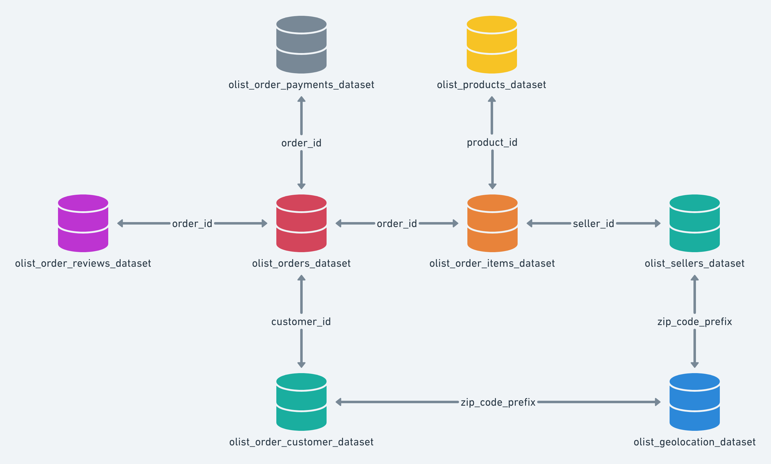

Note: Olist.geolocation_dataset was not used in this project

**Methodology**

Each Question was treated as a standalone SQL case using:

* **CTEs** for stepwise clarity
* **Window functions** (ROW_NUMBER, LAG) for trend and behavior tracking
* **FILTER and CASE** logic for conditional metrics
* **DATE_TRUNC and arithmetic** for time-based aggregation
* **JOINs** across multiple tables for relational insights

Unlike BI dashboarding, this analysis emphasizes **clean code logic, thoughtful metric selection, and sharp business interpretation**, showcasing SQL as an end-to-end analysis tool.

**Section 1: Monthly Order Volume & Cancellation Trends**

**Question**

What does the monthly trend of total orders and cancellations reveal about Olist’s growth and operational efficiency? Are there any key inflection points?

**SQL Methodology**

* Used the orders table
* Cleaned timestamp using DATE_TRUNC('month', order_purchase_timestamp)
* Grouped by month and filtered out outlier months with extremely low volume
* Used FILTER clause to separately count delivered and canceled orders
* Added LAG() function to calculate month-over-month order growth

**Key Metrics Computed (snapshot)**

|  |  |  |  |  |
| --- | --- | --- | --- | --- |
| **Month** | **Total Orders** | **Delivered** | **Canceled** | **Cancellation %** |
| **2016-09** | 4 | 1 | 2 | 50% |
| **2016-10** | 324 | 265 | 24 | 7% |
| **2017-01** | 800 | 750 | 3 | ~0% |
| **2017-06** | 3,245 | 3,135 | 16 | ~0% |
| **2017-11** | 7,544 | 7,289 | 37 | ~0% |
| **2018-08** | 6,512 | 6,351 | 84 | 1.3% |
| **2018-09** | 16 | 0 | 15 | 93.75% |
| **2018-10** | 4 | 0 | 4 | 100% |

**Insights**

1. **Real Growth Started in 2017**

* Early months in 2016 (Sep, Oct, Dec) have low volume (e.g., 4–324 orders), possibly due to soft launch or data inconsistency.
* From Jan 2017, meaningful volume begins (~800+ orders), and steady growth is visible month over month.

1. **Massive Operational Scaling in Nov 2017**

* November 2017 saw a major spike: 7,544 orders, nearly 60%+ jump from previous months.
* Likely due to a campaign or holiday season, such as Black Friday or year-end promotion**.**

1. **Sustained High Volume in 2018**

* Post-Nov 2017, volumes stayed consistently above 6,000 orders/month into mid-2018.
* Indicates that growth wasn’t a one-time spike but rather a scalable improvement in demand or reach.

1. **Extremely Low Cancellation Rates**

* From Jan 2017 to Aug 2018, most months had 0–1% cancellation rates, even with rising volume.
* Shows strong operational fulfillment, with likely good inventory handling, shipping, and seller compliance.

1. **Anomalies in Sep–Oct 2018**

* Sudden crash in volume (16 orders in Sep, 4 in Oct) with 93–100% cancellation rate.
* This is clearly a data cut-off issue — not a business trend. Possibly partial data for those months or ingestion cutoff in dataset.

**Recommendations**

* Use Jan 2017 – Aug 2018 as the valid analysis window. Anything before or after appears unstable or incomplete.
* Investigate what led to the sustained growth post-Nov 2017 — replicate or expand that playbook.
* Maintain current operational rigor — achieving such low cancellation rates at scale is rare and a strong selling point to investors or partners.
* Ignore Sep–Oct 2018 from trend or forecasting logic unless raw data is extended

**Section 2: Top Product Categories by Revenue and Average Order Value**

**Question**

Which product categories contribute the most to total revenue?  
Are these categories with lower volume but high average order value (AOV)?

**SQL Methodology**

* Joined order_items with products and product_translation to translate categories into English
* Aggregated:
  + Total revenue = sum of, no. of items * (price + freight_value)
  + Total item count = count(*)
  + Average revenue per order = total revenue / item count
* Used HAVING clause to filter categories with revenue above 1M for clearer focus

**Key Metrics Computed (Snapshot)**

|  |  |  |  |
| --- | --- | --- | --- |
| **Category** | **Revenue (R$)** | **Orders** | **Avg Revenue per Order (R$)** |
| **health_beauty** | 1,550,391 | 9,670 | 160 |
| **bed_bath_table** | 1,476,978 | 11,115 | 133 |
| **watches_gifts** | 1,368,922 | 5,991 | 228 |
| **computers_accessories** | 1,318,345 | 7,827 | 168 |
| **sports_leisure** | 1,273,379 | 8,641 | 147 |
| **furniture_decor** | 1,161,269 | 8,334 | 139 |

**Insights**

1. **Category Leaders by Revenue**

* health_beauty emerged as a top category, leading in both total revenue and average order value, supported by strong demand and unit pricing.
* bed_bath_table recorded the highest number of orders, indicating wide customer appeal, though its average order value was slightly lower.

1. **Premium Niche Categories**

* watches_gifts and computers_accessories had relatively fewer orders but high average order values, suggesting they attract higher-value purchases.
* These categories may include giftable or premium items, contributing to their pricing strength.

1. **Strategic Observation**

* Some categories managed to maintain both high order volume and solid average value, indicating that Olist has a well-diversified mix of products across different price points and customer segments..

**Recommendations**

* **Double down on Health & Beauty**: push high-frequency products with cross-sell (e.g., skincare + vitamins).
* Launch **gift-oriented campaigns** in watches_gifts, especially around holidays — strong revenue despite fewer orders.
* Use bed_bath_table as a **volume driver**, but experiment with upselling premium variants to improve AOV.
* For furniture_decor, consider **segmenting small decor vs big furniture** in future datasets to isolate true high-value items.

.

**Section 3: Customer Retention & Repeat Behavior Analysis**

**Question**

How many customers return to place another order?  
What is Olist’s repeat purchase rate, and how does it change over time?

**SQL Methodology**

* Used customers and orders tables
* Grouped by customer_unique_id to avoid duplication (since a customer_id can be reused)
* Used COUNT() with HAVING > 1 to flag repeat customers
* Used ROW_NUMBER() over time to analyze **monthly repeat behavior**
* Segmented customers as "new" vs "repeat" per month

**Key Findings (Snapshot)**

|  |  |
| --- | --- |
| **Metric** | **Value** |
| Total Customers | 96,096 |
| Repeat Customers | 2,997 |
| Retention Rate | **3.12%** |

|  |  |  |  |
| --- | --- | --- | --- |
| **Month** | **Total Customers** | **Repeat Customers** | **Repeat Rate (%)** |
| **Jan 2017** | 800 | 36 | 4.50% |
| **Apr 2017** | 2,404 | 52 | 2.16% |
| **Jul 2017** | 4,026 | 132 | 3.28% |
| **Nov 2017** | 7,544 | 240 | 3.18% |
| **Feb 2018** | 6,728 | 277 | **4.12%** |
| **Aug 2018** | 6,512 | 241 | 3.70% |

**Insights**

1. **Overall Retention is Low**

* Of the 96,000+ unique customers, only about 3% placed a second order.
* Indicates that most customers were one-time buyers during the dataset period.

1. **Repeat Rate Improved Over Time**

* Early months (Q1 2017) saw retention rates below 2%, but from mid-2017 onward, repeat rates consistently improved.
* February 2018 had the highest retention at 4.12%, showing some success in customer re-engagement.

1. **Spike in Last Two Months is Misleading**

* September and October 2018 have very high retention % (68–75%) — but extremely low volume (4–16 total customers).
* This is a data limitation, likely caused by a cut-off near the end of the dataset**.**

**Recommendations**

* **Loyalty Program**: Incentivize 2nd and 3rd orders to build habit (discounts, cashback).
* **Customer Lifecycle Targeting**: Send personalized reactivation offers within 30–60 days of 1st purchase.
* **Cohort Tracking**: Set up dashboards that track each monthly cohort’s repeat rate — segment by geography or category.

**Section 4: Payment Method Trends & AOV Analysis**

**Question**

What payment methods do customers prefer?  
How does the choice of payment method affect average order value and revenue contribution?

**SQL Methodology**

* Used order_payments table for payment type and value
* Grouped by payment_type to calculate:
  + Count of payments
  + Sum of payment_value (total transaction value)
  + Average payment size
* Used FILTER, SUM() OVER() to compute **% share of orders and revenue**
* Used DATE_TRUNC on order timestamp to track monthly trends

**Overall Payment Method Breakdown**

|  |  |  |  |  |  |
| --- | --- | --- | --- | --- | --- |
| **Payment Type** | **Total Orders** | **Revenue (R$)** | **% of Orders** | **% of Revenue** | **Avg Order Value (R$)** |
| **Credit Card** | 76,795 | 12,542,106 | 74% | 78% | 163.32 |
| **Boleto** | 19,784 | 2,869,355 | 19% | 18% | 145.03 |
| **Voucher** | 5,775 | 379,437 | 6% | 2% | 65.70 |
| **Debit Card** | 1,529 | 217,990 | 1% | 1% | 142.57 |
| **Not Defined** | 3 | 0.00 | ~0% | ~0% | 0.00 |

**Insights**

1. **Dominance of Credit Cards**

* Credit cards account for the majority of transactions (74%) and an slightly higher share of revenue (78%).
* This payment type also had the highest average order value, making it critical to Olist's revenue engine.

1. **Boleto is a Strong Secondary Method**

* Represents ~19% of transactions and 18% of revenue.
* Average order value (R$145) is not far behind credit cards - possibly due to regional or cash-based consumer segments.
  + Boleto was introduced keeping in mind the large unbanked population in Brazil

1. **Voucher Payments Are Low-Value**

* While making up 6% of transactions, vouchers contribute only 2% of revenue.
* Average order value is much lower (R$65), likely tied to promotional purchases.

1. **Stability Over Time (from Query 2)**

* Monthly breakdown showed little variation in payment method mix.
* Credit card usage remained consistent across both low and high-volume periods.
* Voucher and debit card volumes remained stable and small across months.

**Recommendations**

* **Promote card-based payments** through cashback or EMI incentives — already tied to higher AOV
* Consider **limiting COD or boleto** in categories with high return rates
* For vouchers, bundle with low-cost accessories to raise basket size
* **Experiment with new digital payment options** (as digital banking rises in Brazil, introduction of UPI)

**Section 5: Delivery Delays by Region**

**Question**

Which customer regions experience the highest delivery delays?  
How do average delay days and % of late deliveries vary by state?

**SQL Methodology**

* Used orders and customers tables
* Computed delay_days = delivered_date - estimated_date
* Classified each order as 'delayed' or 'on time' using a CASE expression
* Grouped by customer_state to calculate:
  + Total orders
  + Delayed orders
  + % of delayed orders
  + Average delay in days (only for delayed orders)

**Top 10 States by % of Delayed Orders**

|  |  |  |  |
| --- | --- | --- | --- |
| **State** | **Total Orders** | **% Delayed** | **Avg Delay (days)** |
| **AL (Alagoas)** | 413 | **20.6%** | 1.96 |
| **MA (Maranhao)** | 747 | 16.7% | 1.76 |
| **SE (Sergipe)** | 350 | 14.6% | 2.36 |
| **PI (Piaui)** | 495 | 13.3% | 1.78 |
| **CE (Ceara)** | 1,336 | 13.2% | 2.00 |
| **BA (Bahia)** | 3,380 | 11.7% | 1.41 |
| **RJ (Rio de Janeiro)** | 12,852 | 11.6% | 1.57 |
| **RR (Roraima)** | 46 | 10.9% | **3.96** |
| **ES (Espirito Santo)** | 2,033 | 10.5% | 1.19 |

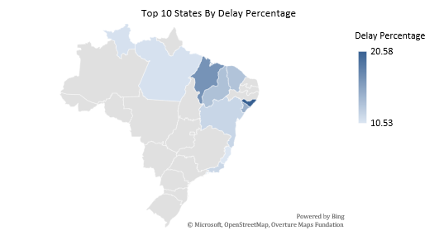

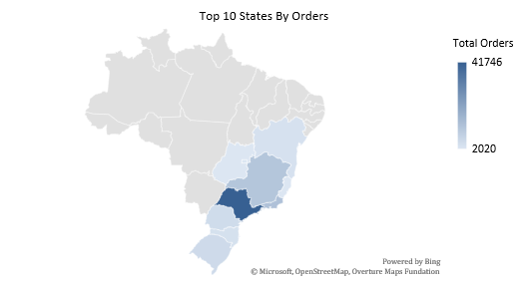

**Insights**

1. **Northern & Northeastern Regions Suffer the Most**
   * **Alagoas (20.6%)**, **Maranhão (16.7%)**, and **Sergipe (14.6%)** show the worst delivery reliability
   * These regions also have **fewer total orders**, which suggests **logistical inefficiencies and/or fewer delivery hubs**
2. **Roraima Stands Out for Delay Duration**
   * With an average delay of nearly **4 days**, it's the worst in terms of customer experience (despite low volume)
3. **Southern and Southeastern States Excel**
   * States like **SP (SaoPaulo)**, **MG (Minas Gerais)**, **PR (Parana)** show **<5% delay rate**
   * These regions benefit from urban infrastructure, warehouse proximity, and stronger delivery networks

**Recommendations**

* **Improve logistics** in North/Northeast through better courier partners or regional micro-hubs
* **Monitor sellers** operating from high-delay regions — cross-check with their fulfillment SLAs (Service Level Agreement)
* Consider **regional delivery incentives** to compensate or reassure customers in red-flag states (logistical disruptions due to external factor)
* **Integrate predictive delivery SLAs** based on location, seasonality, and carrier performance
  + Use past data to **predict how long deliveries will realistically take**, and then set **smarter, customized delivery promises (SLAs)** for each order based on that prediction

**Section 6: Review Score Analysis vs Delivery Performance**

**Question**

How are customer review scores impacted by delivery delays?  
Can periods or categories be identified, where delayed deliveries led to poor customer satisfaction?

**SQL Methodology**

* Joined orders with order_reviews to fetch review_score and delivery timestamps
* Calculated delay_days and labeled each order as 'delayed' or 'on time'
* Grouped results by **month** and **product category** to analyze:
  + % of delayed orders per group
  + Average review score per group

**Trend: Monthly Delays vs Review Score**

|  |  |  |  |  |
| --- | --- | --- | --- | --- |
| **Month** | **Total Orders** | **Delayed Orders** | **Delay %** | **Avg Review Score** |
| Mar 2017 | 2,676 | 113 | 4.2% | 4.1 |
| Apr 2017 | 2,394 | 148 | 6.2% | 4.0 |
| Nov 2017 | 7,534 | 892 | 11.8% | 3.9 |
| Feb 2018 | 6,758 | 922 | 13.6% | 3.8 |
| Mar 2018 | 7,187 | 1,301 | 18.1% | 3.8 |

**Product Categories with Highest Delay % (categories with more than 1000 reviews)**

|  |  |  |  |
| --- | --- | --- | --- |
| **Category** | **Delay %** | **Total Reviews** | **Avg Score** |
| **bed_bath_table** | 6.8% | 11,137 | 3.90 |
| **furniture_decor** | 6.7% | 8,331 | 3.90 |
| **computers_accessories** | 6.2% | 7,849 | 3.93 |
| **housewares** | 4.7% | 6,943 | 4.06 |
| **watches_gifts** | 6.9% | 5,950 | 4.02 |

**Insights**

1. **Strong Correlation Between Delays and Poor Reviews**
   * Across multiple months, **spikes in delay % consistently aligned with drops in review score**
   * Review score dipped to ~3.8 in months with delay spikes above 13%
   * Delay spikes in Nov 2017 to Mar 2018 led to a drop in review scores, even though volumes remained high
   * Post-March 2018, both delays and review sentiment began recovering, implying corrective action may have been taken (e.g., logistics improvement, customer support)
2. **Review Score is Sensitive to Delivery Timeliness**
   * Even a 2–3 day delay impacts perceived service quality
   * Customers punish lateness even if the product quality is good
3. **Furniture, Electronics, and Comfort Items are High-Risk**
   * Higher-value or bulky items tend to have **more complex logistics**
   * Customers in these categories are more likely to leave low reviews if delayed
   * Computers_accessories and watches_gifts also showed meaningful delays and <4.0 scores — suggesting customer dissatisfaction, despite being high-margin categories.
   * Interestingly, housewares and sports_leisure (not shown) had better sentiment even with slightly elevated delays, indicating that perceived product value or category expectations influence review leniency.

**Recommendations**

* **Monitor delay-reviews correlation in real time** — use this as a customer satisfaction early-warning system
* **Pre-empt delay-related frustration** by proactively communicating updated ETAs to customers
* For categories like furniture and electronics:
  + Offer optional **express delivery** (if possible, and by charging them)
  + Build **seller SLAs** tied to on-time performance and review impact
* Run **targeted follow-up surveys** in categories with weak scores to understand post-delivery grievances

**Section 7: Revenue Lost Due to Order Cancellations**

**Question**

How much revenue is lost due to canceled orders?  
Are there specific states or product categories with disproportionately high cancellation losses?

**SQL Methodology**

* Filtered the orders table for order_status = 'canceled'
* Joined with order_items to compute potential revenue = price + freight_value
* Joined with customers and products to analyze:
  + Total revenue lost by state
  + Total revenue lost by category (optional)

**Revenue Lost by State (Top 6)**

|  |  |  |
| --- | --- | --- |
| **State** | **Canceled Orders** | **Revenue Lost** |
| **SP (SaoPaulo)** | 247 | 42,182 |
| **RJ (Rio de Janeiro)** | 64 | 13,701 |
| **MG (Minas Gerais)** | 47 | 12,895 |
| **RS (Rio Grande do Sul)** | 16 | 8,265 |
| **GO (Goias)** | 9 | 7,163 |
| **PR (Parana)** | 16 | 6,739 |

Total loss across all states exceeded **120,000**, with most loss concentrated in the **Southeast and South regions**, which also represent Olist’s highest order volumes.

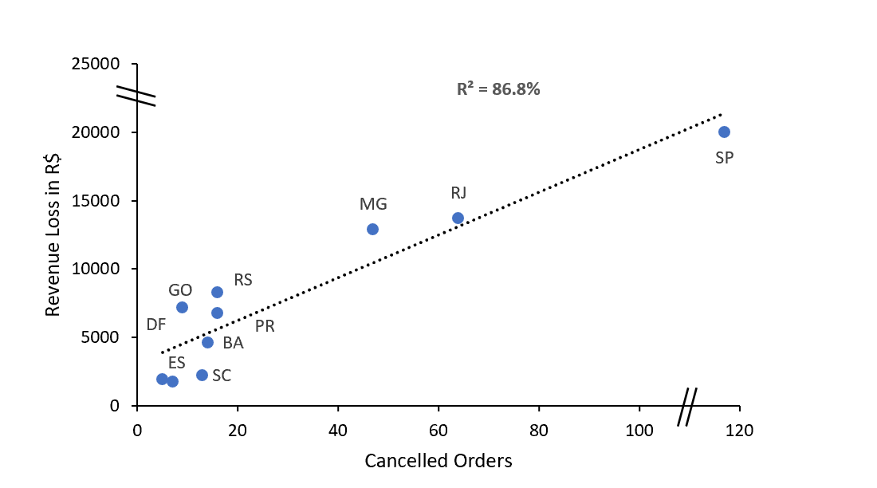

**Insights**

1. **Revenue Loss is Proportional to Volume**
   * States like SaoPaulo and Rio de Janeiro contribute the most to overall revenue loss due to their size and order density.
2. **High Cancellation Rate States Have High-Value Orders**
   * Goias and Rio Grande do Sul have **fewer cancellations**, but high **average loss per order**, indicating potential **bulk or high-value item cancellations**.

**Recommendations**

* **Investigate common causes of cancellations** — product issues, seller behavior, or logistics.
* **Implement seller-level cancellation tracking** and penalties for high cancel % (already flagged in Section 5).
* Use **AI-based pre-confirmation validation** for orders flagged at risk of cancellation.
* **Proactively follow up** with customers on canceled orders — offer alternative products or reactivation coupons.

**Section 8: Recommendations, Final Thoughts & Appendix**

**Strategic Recommendations for Olist**

**1. Seller Governance and SLAs**

* Flag sellers with >10% delay and 200+ orders. Apply tiered penalties or incentives.
* Introduce **delivery performance-based visibility** on product listings.

**2. Proactive Delivery Risk Management**

* Use historical data to forecast delays and adjust **estimated delivery date** dynamically.
* Offer **regional-level delivery time buffer** messaging to customers in delay-prone states.

**3. Targeted Cancellation Reduction**

* Study SKU-level cancellations. Isolate categories with high freight and low fulfillment.
* Implement **soft confirmation step** for users for expensive or high-risk orders.

**4. Review-Based Intervention**

* Monitor rolling delay % and review score to trigger **customer service action**.
* Launch **review recovery outreach** campaigns post delayed deliveries.

**5. Enhancing Repeat Purchases**

* Customers with ≥2 purchases should enter loyalty workflows.
* Recommend new products via email or app notifications to repeat buyers.

**Appendix & Supporting Notes**

* All analysis is based on the **Olist E-Commerce Public Dataset from Kaggle**.
* SQL queries were executed on PostgreSQL using DBeaver.
* Dataset included >100,000 orders, >70,000 unique customers, and 6M+ rows across tables like orders, order_items, payments, reviews, customers, products, etc.

**Appendix: SQL Queries Used**

**Query 1:**

-- Monthly Order Volume & Cancellation Trends  
WITH cleaned_dates AS (  
 SELECT *, DATE_TRUNC('month', order_purchase_timestamp)::date AS order_month  
 FROM orders  
),  
counts AS (  
 SELECT order_month, count(*) AS total_orders,  
 count(*) FILTER (WHERE order_status = 'delivered') AS delivered_orders,  
 count(*) FILTER (WHERE order_status = 'canceled') AS canceled_orders,  
 count(*) FILTER (WHERE order_status = 'canceled')*100/count(*) AS cancellation_percentage  
 FROM cleaned_dates

GROUP BY order_month  
),  
previous_Q AS (  
 SELECT *, lag(total_orders, 11) OVER () AS previous_Q_volume FROM counts  
)  
SELECT *, (total_orders/previous_Q_volume) AS QoQ_growth;

**Query 2:**

SELECT pt.product_category_name_english,

ROUND(SUM(order_item_id * (price + freight_value))) AS product_revenue,

COUNT(*) AS total_orders_by_category,

ROUND(SUM(order_item_id * (price + freight_value)) / COUNT(*)) AS average_revenue_by_order

FROM order_items o

JOIN products p ON o.product_id = p.product_id

JOIN product_translation pt ON p.product_category_name = pt.product_category_name

GROUP BY pt.product_category_name_english

HAVING SUM(order_item_id * (price + freight_value)) > 1000000

ORDER BY product_revenue DESC;

**Query 3:**

-- Count how many customers made more than one purchase

WITH customer_orders AS (

SELECT customer_unique_id, COUNT(*) AS order_count

FROM customers

GROUP BY customer_unique_id

)

SELECT

COUNT(*) AS total_customers,

COUNT(*) FILTER (WHERE order_count > 1) AS repeat_customers,

ROUND(

COUNT(*) FILTER (WHERE order_count > 1)::NUMERIC / COUNT(*) * 100, 2

) AS retention_rate_percent

FROM customer_orders;

WITH base AS (

SELECT

c.customer_unique_id,

DATE_TRUNC('month', o.order_purchase_timestamp)::DATE AS order_month,

ROW_NUMBER() OVER (

PARTITION BY c.customer_unique_id

ORDER BY o.order_purchase_timestamp

) AS purchase_number

FROM orders o

JOIN customers c ON o.customer_id = c.customer_id

),

tagged AS (

SELECT

order_month,

CASE

WHEN purchase_number = 1 THEN 'new'

ELSE 'repeat'

END AS customer_type

FROM base

)

SELECT

order_month,

COUNT(*) FILTER (WHERE customer_type = 'new') AS new_customers,

COUNT(*) FILTER (WHERE customer_type = 'repeat') AS repeat_customers,

COUNT(*) AS total_customers,

ROUND(

COUNT(*) FILTER (WHERE customer_type = 'repeat')::NUMERIC

/ NULLIF(COUNT(*), 0) * 100, 2

) AS repeat_rate_percent

FROM tagged

GROUP BY order_month

ORDER BY order_month;

**Query 4:**

WITH filtered AS (

SELECT

payment_type,

COUNT(*) AS total_count,

SUM(payment_value) AS total_order_value

FROM payments

GROUP BY payment_type

),

total_table AS (

SELECT *,

SUM(total_count) OVER() AS all_count,

SUM(total_order_value) OVER() AS all_value

FROM filtered

)

SELECT

payment_type,

total_count,

total_order_value,

ROUND((total_count::NUMERIC / NULLIF(all_count, 0)) * 100, 2) AS count_share,

ROUND((total_order_value::NUMERIC / NULLIF(all_value, 0))::numeric * 100, 2) AS value_share,

ROUND(total_order_value::NUMERIC / total_count, 2) AS average_order_value

FROM total_table

ORDER BY value_Share;

SELECT

DATE_TRUNC('month', o.order_purchase_timestamp)::DATE AS month,

p.payment_type,

COUNT(*) AS total_orders,

ROUND(SUM(p.payment_value)::numeric, 2) AS total_payment,

ROUND(AVG(p.payment_value) ::numeric, 2) AS avg_payment

FROM payments p

JOIN orders o ON o.order_id = p.order_id

GROUP BY month, p.payment_type

ORDER BY month, total_orders DESC;

**Query 5:**

-- Delivery Delays by Region  
WITH base AS (

SELECT *,

(order_delivered_customer_date::date - order_estimated_delivery_date::date) AS delay_days,

CASE

WHEN (order_delivered_customer_date::date - order_estimated_delivery_date::date) > 0 THEN 'delayed'

ELSE 'on time'

END AS status

FROM orders

)

SELECT

customer_state,

COUNT(*) AS total_orders,

COUNT(*) FILTER (WHERE status = 'delayed') AS total_delays,

ROUND(COUNT(*) FILTER (WHERE status = 'delayed')::numeric * 100 / NULLIF(COUNT(*), 0), 2) AS percentage,

ROUND(AVG(CASE WHEN delay_days > 0 THEN delay_days ELSE 0 END), 2) AS average_delay_days

FROM base b

JOIN customers c ON c.customer_id = b.customer_id

GROUP BY customer_state

ORDER BY percentage DESC;

**Query 6:**

-- Review Score Analysis by Delay  
WITH base AS (  
 SELECT DATE_TRUNC('month', order_purchase_timestamp)::date AS month,  
 CASE WHEN (order_delivered_customer_date::date - order_estimated_delivery_date::date) > 0 THEN 'delayed' ELSE 'on time' END AS status,  
 review_score FROM order_reviews orw  
 JOIN orders o ON orw.order_id = o.order_id  
)  
SELECT month, COUNT(*) AS total_orders,  
 COUNT(*) FILTER (WHERE status = 'delayed') AS delayed_orders,  
 ROUND(COUNT(*) FILTER (WHERE status = 'delayed')::NUMERIC * 100 / NULLIF(COUNT(*),0), 2) AS delay_pc,  
 ROUND(AVG(review_score), 1) AS average_review_score FROM base  
GROUP BY month ORDER BY month;

WITH base AS (

SELECT

pt.product_category_name_english AS category,

CASE

WHEN o.order_delivered_customer_date::date > o.order_estimated_delivery_date::date THEN 1

ELSE 0

END AS is_delayed,

r.review_score

FROM order_reviews r

JOIN orders o ON r.order_id = o.order_id

JOIN order_items oi ON o.order_id = oi.order_id

JOIN products p ON oi.product_id = p.product_id

JOIN product_translation pt ON p.product_category_name = pt.product_category_name

)

SELECT

category,

ROUND(100.0 * SUM(is_delayed)::numeric / NULLIF(COUNT(*), 0), 2) AS delay_pct,

COUNT(*) AS total_reviews,

ROUND(AVG(review_score), 2) AS avg_score

FROM base

GROUP BY category

HAVING COUNT(*) > 20

ORDER BY delay_pct DESC;

**Query 7:**

-- Revenue Lost from Cancellations by State  
SELECT c.customer_state, COUNT(DISTINCT o.order_id) AS canceled_orders,  
 ROUND(SUM(oi.price + oi.freight_value)::NUMERIC, 2) AS revenue_lost  
FROM orders o JOIN order_items oi ON o.order_id = oi.order_id  
JOIN customers c ON o.customer_id = c.customer_id  
WHERE o.order_status = 'canceled'  
GROUP BY c.customer_state ORDER BY revenue_lost DESC;