TrustMind AI
Exploratory Data Analysis of the SWMH Dataset
and Its Relationship to the Research Question

MSc Artificial Intelligence Dissertation
University of the West of England (UWE Bristol)

Abstract
This report presents a comprehensive exploratory data analysis (EDA) of the Reddit SuicideWatch and Mental Health Collection (SWMH) dataset, conducted as the foundational data chapter for the TrustMind AI dissertation. The analysis examines data quality, label distributions, text-length characteristics, qualitative patterns across five mental-health-related subreddit classes, and a documented preprocessing plan for downstream machine learning experiments. The dissertation research question asks: To what extent does Retrieval-Augmented Generation (RAG) improve the trustworthiness, reliability, and explainability of LLM-generated wellbeing assessments compared with standalone LLMs? This report clarifies that EDA does not directly prove an answer to that question; rather, it establishes the dataset conditions, evaluation requirements, and theoretical motivations that justify a controlled comparison between LLM-only and LLM+RAG systems in subsequent experimental chapters.

1. Introduction
TrustMind AI is a text-based wellbeing support platform designed to provide transparent, ethically grounded assessments rather than clinical diagnosis or therapy. A central research objective of this dissertation is to evaluate whether augmenting large language models (LLMs) with retrieval-augmented generation (RAG) improves the trustworthiness, reliability, and explainability of generated wellbeing assessments relative to standalone LLM approaches.
Before any model training or comparative evaluation can proceed, it is essential to understand the benchmark dataset in detail. This report documents the exploratory data analysis of the SWMH dataset—a widely used multi-class benchmark comprising Reddit posts labelled by source subreddit. The EDA was conducted in Jupyter Notebook 01_SWMH_EDA.ipynb and produced four publication-quality visualisations saved to the research/figures directory.

1.1 Research Question
To what extent does Retrieval-Augmented Generation (RAG) improve the trustworthiness, reliability, and explainability of LLM-generated wellbeing assessments compared with standalone LLMs?

1.2 Scope of This Report
This document describes the EDA methodology and findings in dissertation-ready prose. Section 2 introduces the dataset. Sections 3–6 present quantitative and qualitative findings. Section 7 outlines the preprocessing plan. Section 8 explains how EDA supports the research question—both directly (by enabling fair experimental design) and indirectly (by revealing dataset properties that motivate RAG). Section 9 states limitations and next steps.

2. Dataset Description
The Reddit SuicideWatch and Mental Health Collection (SWMH) contains English-language Reddit posts drawn from five subreddits. Each post is labelled according to its source community, providing a multi-class text classification benchmark for mental-health-related natural language processing (NLP).

2.1 Data Schema
Each CSV file contains two columns:
- text — the raw Reddit post body (informal, user-generated language)
- label — the source subreddit name, used as a proxy class label

2.2 Class Labels
Five distinct classes are represented:
- self.depression
- self.SuicideWatch
- self.Anxiety
- self.offmychest
- self.bipolar

2.3 Data Splits
The dataset is pre-partitioned into training, validation, and test splits, supporting reproducible experimental comparison. Table 1 summarises split sizes observed in the local TrustMind AI copy.
Split | Posts | Percentage of Total
Training | 34,823 | 64.0%
Validation | 8,706 | 16.0%
Test | 10,883 | 20.0%
Total | 54,412 | 100%

Table 1: SWMH dataset split sizes.

3. Data Quality Assessment
Prior to modelling, the notebook assessed missing values, duplicate rows, null labels, null text fields, empty strings, and whitespace-only posts. Table 2 summarises the results across all splits.
Split | Rows | Missing Text | Missing Label | Duplicate Rows | Null/Empty Text
Train | 34,823 | 0 | 0 | 22 | 0
Validation | 8,706 | 0 | 0 | 2 | 0
Test | 10,883 | 0 | 0 | 1 | 0

Table 2: Data quality checks by split.
Key findings:
- No missing text or label values were detected in any split.
- No null, empty, or whitespace-only posts were found.
- A total of 25 exact duplicate rows were identified (22 train, 2 validation, 1 test), representing less than 0.05% of the corpus.
- HTML entities (e.g., &amp;nbsp;) were observed in raw text and will require decoding during preprocessing.
Overall, the dataset is exceptionally clean at the structural level. Minor duplicate removal and HTML entity decoding are recommended before tokenisation, but no fundamental data integrity issues were found that would invalidate downstream experiments.

4. Label Distribution and Class Imbalance
Class frequencies were examined in each split to assess imbalance, which affects metric selection (macro-F1 versus weighted-F1) and training strategies (class weighting, stratified sampling). Proportions were preserved consistently across train, validation, and test splits, indicating stratified partitioning.

4.1 Combined Label Distribution
Class | Count | Percentage
depression | 18,746 | 34.5%
SuicideWatch | 10,182 | 18.7%
Anxiety | 9,555 | 17.6%
offmychest | 8,284 | 15.2%
bipolar | 7,645 | 14.1%

Table 3: Combined label distribution across all splits (N = 54,412).
The imbalance ratio (minimum class count divided by maximum class count) is 0.408, indicating moderate class imbalance. Depression is the largest class (~34.5%) and bipolar the smallest (~14.1%). All classes retain sufficient samples for supervised multi-class learning and neural fine-tuning, but macro-averaged F1 and per-class recall should be reported alongside weighted accuracy to reflect performance on minority classes.
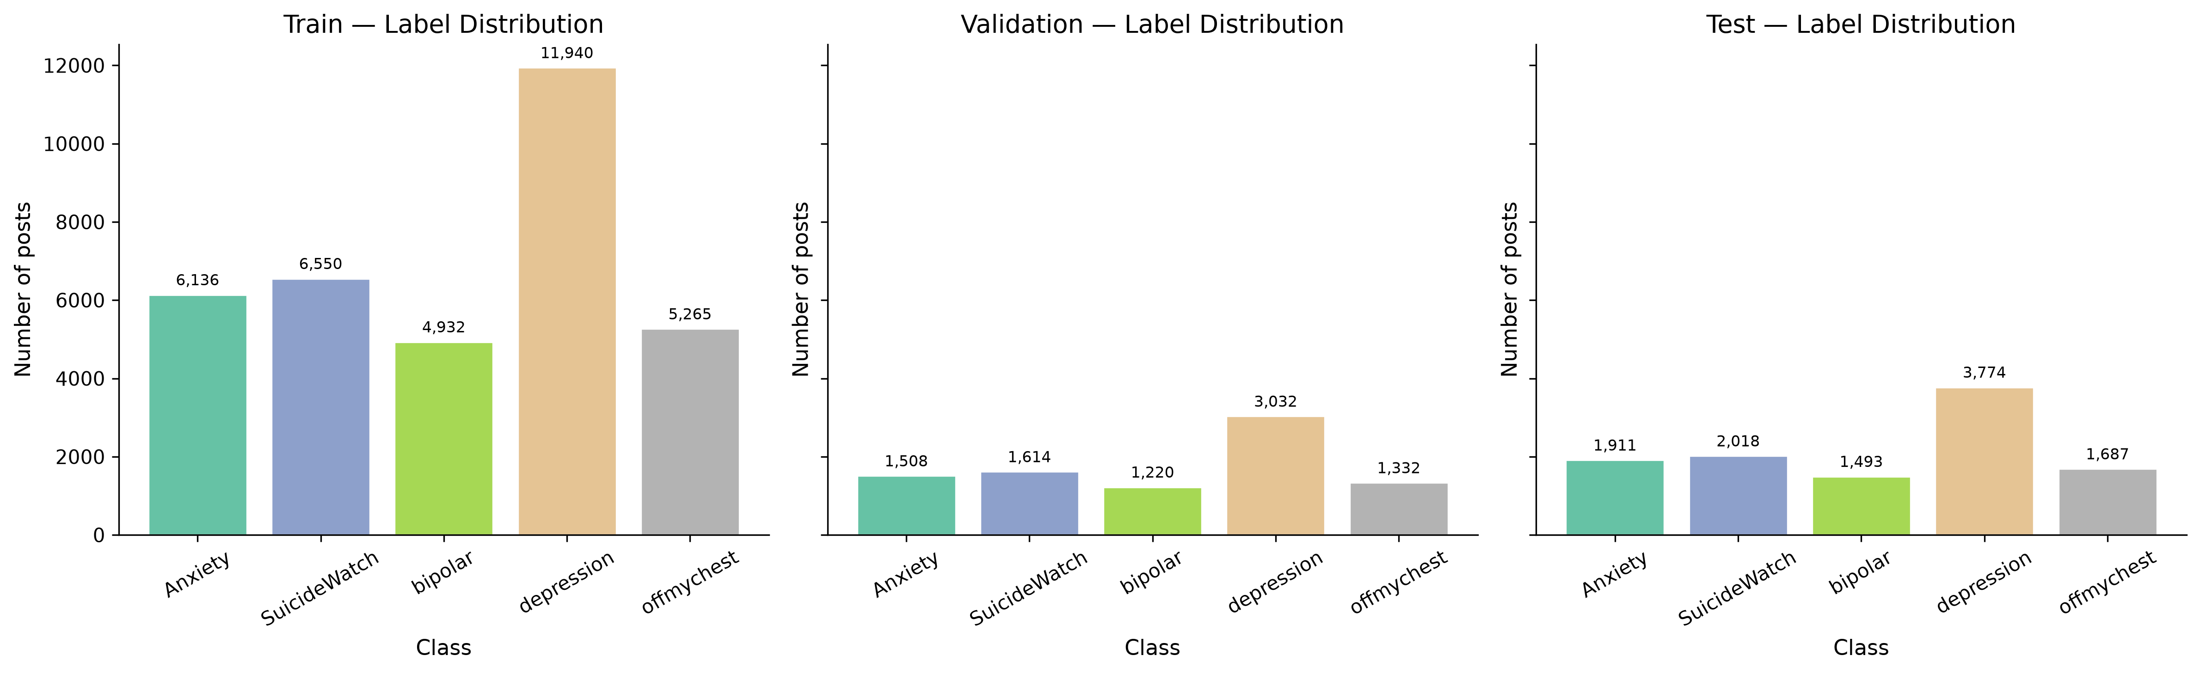
Figure 1: Label distribution across train, validation, and test splits.

4.2 Per-Split Proportions
Class proportions remain stable across splits. For example, depression accounts for approximately 34.3% of training posts, 34.8% of validation posts, and 34.7% of test posts. This consistency supports fair comparison between LLM-only and LLM+RAG conditions on identical held-out data.

5. Text Length Analysis
Post length affects tokenisation limits for transformer models (typically 512 subword tokens for BERT/RoBERTa-family encoders). Character and word counts were computed globally and per class.

5.1 Global Descriptive Statistics
Statistic | Character Count | Word Count
Mean | 932.77 | 178.08
Median | 565.00 | 108.00
Minimum | — | —
Maximum | — | —
Standard Deviation | — | —

Table 4: Global text-length statistics (combined corpus).
Additional length findings:
- 95th percentile word count: 572 words
- 99th percentile word count: 1,121 words
- Posts exceeding 512 words: 3,437 (6.32% of corpus)
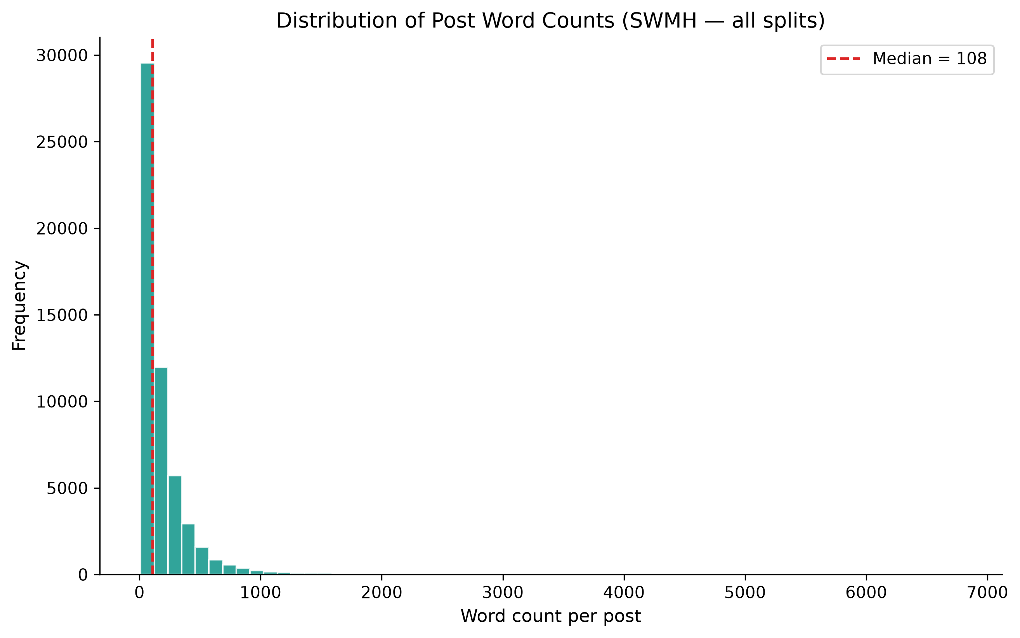
Figure 2: Distribution of word counts across all posts.

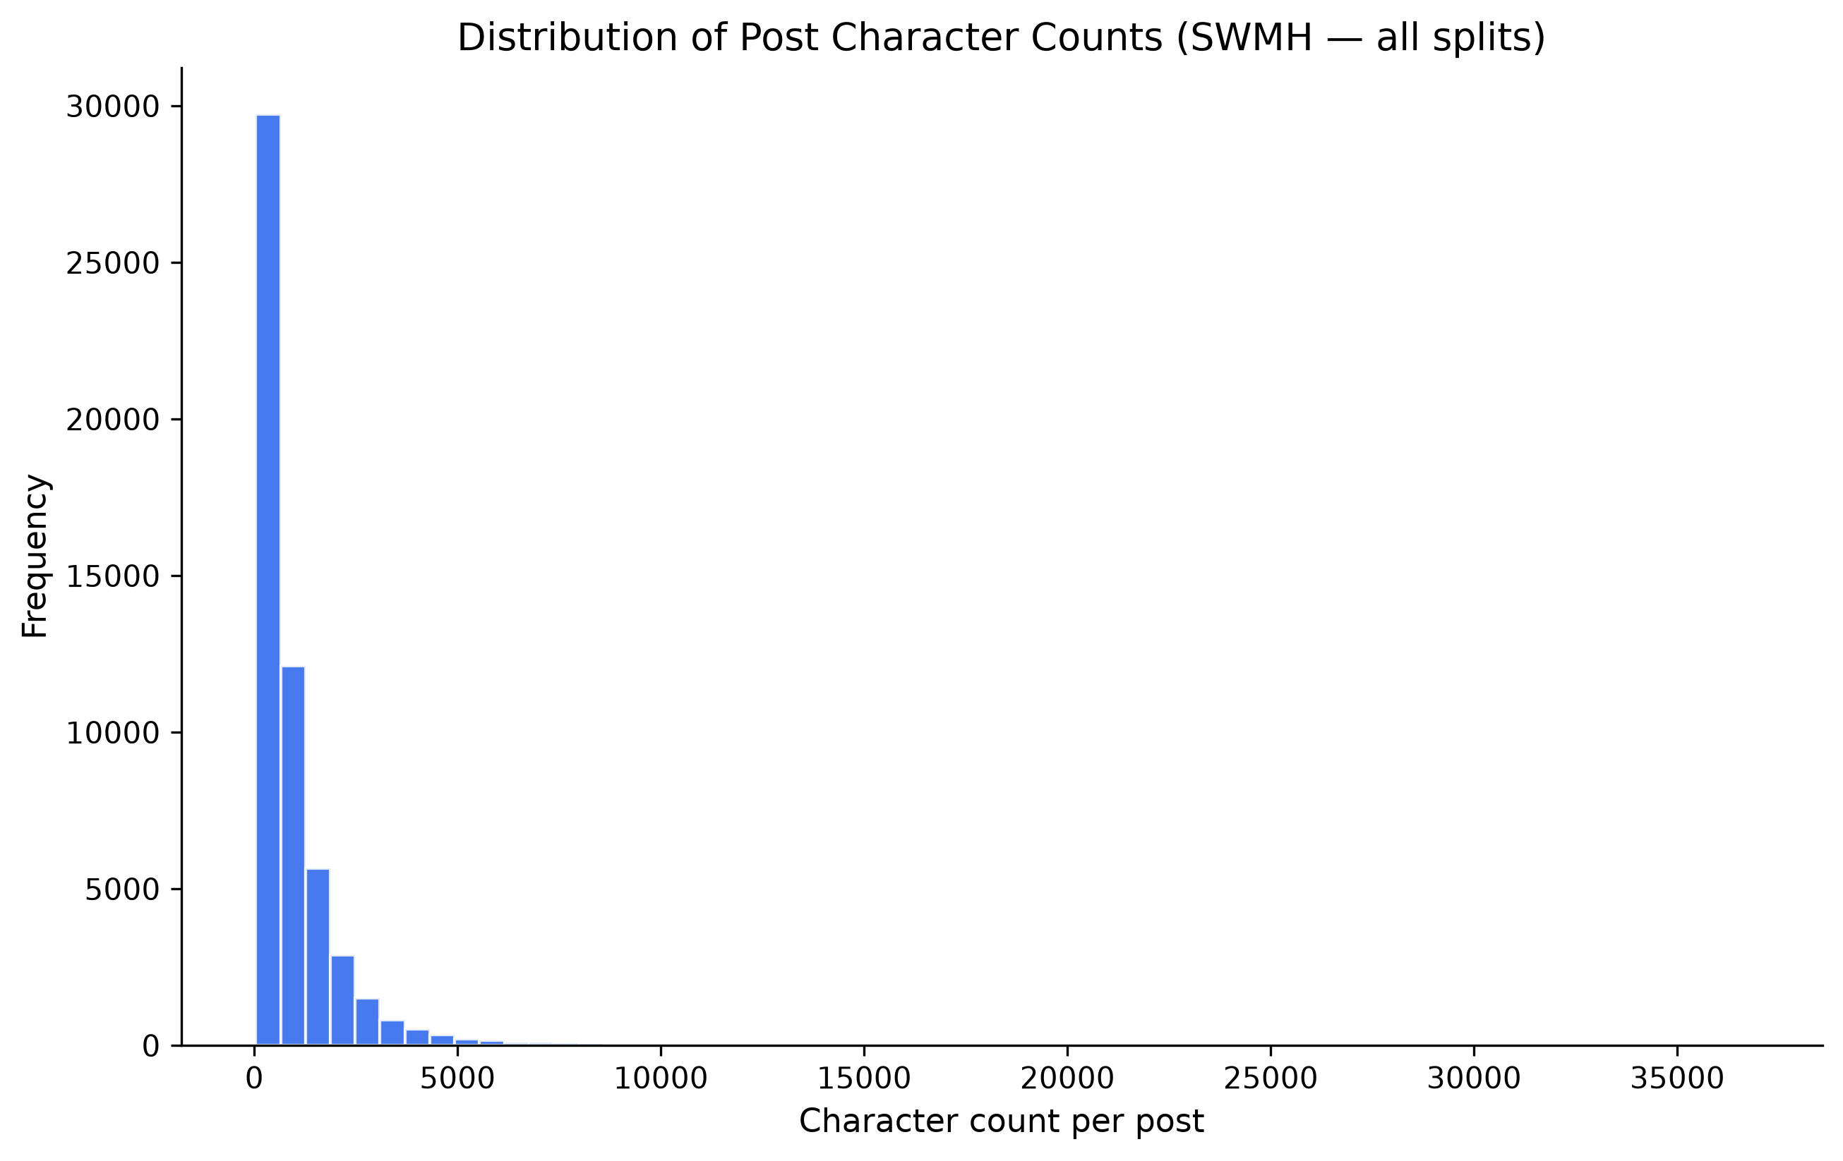
Figure 3: Distribution of character counts across all posts.

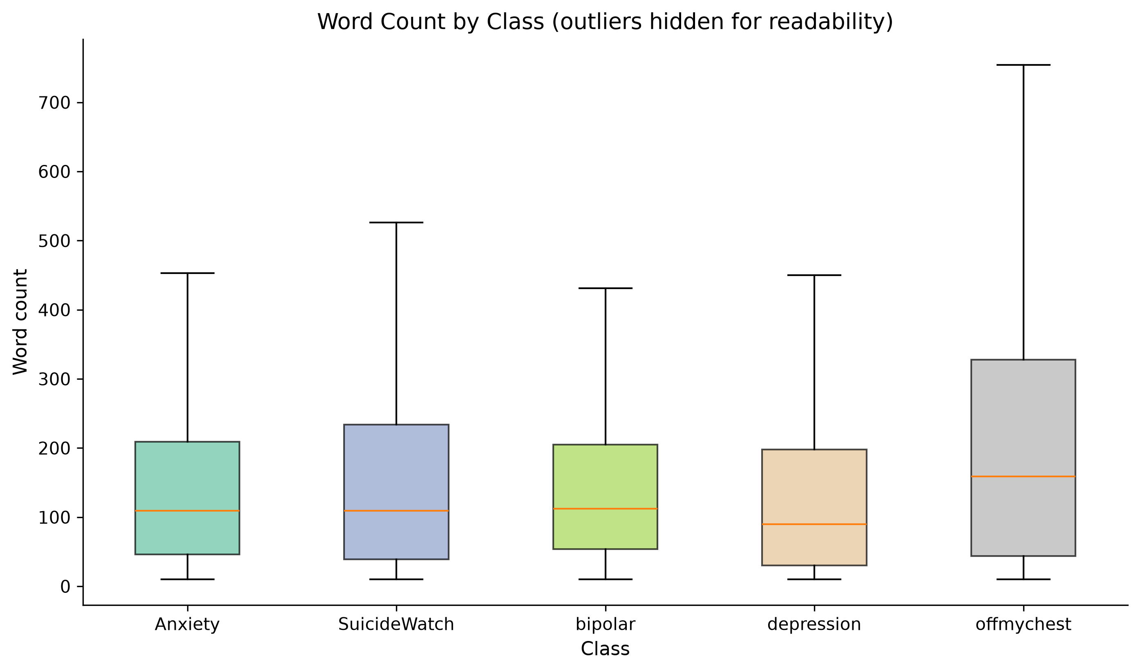
Figure 4: Word count distribution by class (boxplot).

The right-skewed distribution indicates that while most posts are moderate in length (median ~108 words), a non-trivial tail of long narrative disclosures exists. SuicideWatch and offmychest posts tend toward longer personal storytelling; Anxiety posts often describe somatic symptoms and situational triggers in shorter form. Truncation to model token limits will be required for approximately 6.3% of posts, using a head-preserving strategy that retains emotionally salient opening content.

6. Qualitative Observations
Five random posts per class were sampled (random seed = 42) to inspect writing style, thematic content, and label ambiguity. The following patterns emerged.

6.1 Writing Styles
Posts range from brief emotional statements to extended narrative disclosures. Language is informal, first-person, and rich in emotionally charged vocabulary—reflecting real-world digital mental-health discourse rather than clinical intake notes. This ecological validity makes SWMH representative of the text users might submit to TrustMind AI check-ins.

6.2 Overlap Between Categories
Subreddit labels are noisy proxies for mental-health conditions. Symptom vocabulary overlaps substantially across depression, anxiety, and bipolar classes. A single post may express comorbid concerns that do not map cleanly to one subreddit label. For example, posts expressing hopelessness appear in depression, SuicideWatch, and offmychest classes alike.

6.3 Ambiguity of offmychest
The offmychest subreddit is a general venting space, not a clinical mental-health forum. Many posts are situational (relationship conflict, workplace stress) rather than disorder-specific, increasing label noise if treated as a distinct diagnostic category. This class is particularly problematic for standalone LLMs that may exploit superficial lexical cues rather than semantic distress signals.

6.4 Crisis and High-Risk Language
SuicideWatch posts frequently contain explicit crisis language, including suicidal ideation, self-harm references, and requests for support. Sample posts include phrases such as "I feel deader than dead" and "Suicidal, but won't do it. Just need someone to talk to." Any trustworthy wellbeing system must handle such content with abstention policies, safe signposting, and retrieval of authoritative crisis resources rather than open-ended generative advice.

6.5 Implications for LLM-Only Systems
Large language models may exploit subreddit-specific jargon or superficial lexical patterns rather than genuine semantic distress signals. Fine-tuning or prompt-based LLM-only baselines risk overconfident predictions on ambiguous posts—particularly in offmychest and borderline cases. Calibrated uncertainty quantification and abstention when class probability is low are therefore essential evaluation criteria.

6.6 Implications for RAG-Enhanced Systems
Retrieval-augmented generation can ground responses in external wellbeing resources (UWE support pages, NHS Every Mind Matters, Samaritans signposting, ethics policy documents) rather than relying solely on subreddit-derived labels. RAG may improve explainability through cited source snippets and reduce hallucinated clinical advice, particularly for ambiguous offmychest posts and crisis-adjacent content.

7. Preprocessing Plan
The following pipeline is documented for subsequent experiments but was not executed during EDA:
- 1. UTF-8 encoding — ensure consistent character encoding across platforms.
- 2. HTML entity decoding — convert entities such as &amp;nbsp; to plain text.
- 3. URL removal — strip http://, https://, and www. links via regular expressions.
- 4. Username anonymisation — replace Reddit mentions (u/username) with a generic [USER] token.
- 5. Whitespace normalisation — collapse repeated spaces and newlines; strip leading/trailing whitespace.
- 6. Duplicate removal — drop exact duplicate (text, label) pairs where appropriate.
- 7. Truncation to model token limit — truncate to 512 subword tokens using head-preserving strategy; log truncated samples.
- 8. Semantic preservation — avoid aggressive stemming or stop-word removal that could delete emotionally meaningful terms (e.g., "empty", "hopeless", "panic").
This pipeline balances NLP standard practice with mental-health domain sensitivity, supporting fair comparison between LLM-only and LLM+RAG experimental conditions on identically preprocessed data.

8. How EDA Supports the Research Question

8.1 What EDA Can and Cannot Prove
It is important to state clearly: exploratory data analysis alone cannot prove that RAG improves trustworthiness, reliability, or explainability compared with standalone LLMs. Those constructs require controlled experimental evaluation with defined metrics, baselines, and statistical comparison. EDA provides the evidential foundation and experimental justification; the answer to the research question will emerge from the experimental results chapter.

8.2 Direct Support: Enabling Fair Experimental Design
EDA directly supports the research question by establishing the conditions necessary for a rigorous LLM-only versus LLM+RAG comparison:
- A clean, large-scale benchmark (54,412 posts) with pre-defined train/validation/test splits enables identical evaluation data for both conditions.
- Stable class proportions across splits confirm that stratified evaluation on the 10,883-post test set is representative.
- Documented preprocessing steps ensure both systems receive identically prepared inputs, controlling for data-handling confounds.
- Defined evaluation metrics (macro-F1, per-class recall, calibration error, abstention rate, citation faithfulness) are motivated by observed class imbalance and label ambiguity.
Without this EDA foundation, any claim about RAG superiority would rest on an unexamined dataset. The analysis therefore directly supports the research question by making a controlled, reproducible comparison possible.

8.3 Indirect Support: Motivating Why RAG Should Be Tested
EDA indirectly supports the research question by revealing dataset properties that create specific failure modes for standalone LLMs—and corresponding opportunities for RAG to add value:
EDA Finding | Challenge for Standalone LLM | Potential RAG Benefit | Construct Addressed
Noisy subreddit labels; offmychest ambiguity | Overconfident classification from superficial cues | Ground responses in external evidence, not labels alone | Trustworthiness, Reliability
Cross-class symptom overlap | Misclassification of comorbid posts | Retrieve multi-source context for nuanced assessment | Reliability
Crisis language in SuicideWatch | Unsafe or hallucinated advice | Retrieve vetted crisis resources and signposting | Trustworthiness
Long narrative posts (6.32% > 512 words) | Opaque, unverifiable explanations | Cite retrieved snippets as supporting evidence | Explainability
Moderate class imbalance (ratio 0.408) | Biased performance toward majority class | Consistent grounding regardless of class frequency | Reliability

Table 5: Mapping EDA findings to research constructs and RAG hypotheses.

8.4 Evaluation Framework Derived from EDA
Based on EDA findings, the experimental chapter will compare LLM-only and LLM+RAG conditions using metrics aligned to each construct in the research question:
Construct | Metrics | EDA Justification
Trustworthiness | Calibration (ECE), abstention rate on ambiguous/crisis text, human trust ratings | Crisis language and label noise require uncertainty-aware behaviour
Reliability | Macro-F1, per-class recall, test-retest consistency | Class imbalance demands macro-averaged reporting
Explainability | Source attribution rate, citation faithfulness, qualitative expert review | Long narratives and ambiguous labels require traceable evidence

Table 6: Evaluation metrics derived from EDA observations.

8.5 Synthesis Statement
In summary, EDA demonstrates that SWMH is a valid and challenging benchmark whose label noise, class overlap, crisis-related content, and variable post length create conditions where standalone LLMs risk overconfident, weakly grounded assessments. This justifies empirical comparison with a RAG-enhanced system on trustworthiness, reliability, and explainability metrics. EDA establishes why the research question matters and how it will be answered; the experimental chapter will provide the answer itself.

9. Dataset Strengths, Weaknesses, and Suitability

9.1 Strengths
- Scale and diversity — sufficient samples per class for supervised learning and neural fine-tuning.
- Ecological validity — language reflects how individuals naturally describe distress online.
- Established benchmark — widely cited in mental-health NLP literature, enabling comparison with prior work.
- Pre-defined splits — reproducible partitions support fair experimental comparison.

9.2 Weaknesses
- Label noise — subreddit membership is an imperfect proxy for clinical diagnosis.
- Demographic bias — Reddit skews toward younger, English-speaking, tech-literate users.
- Ethical sensitivity — posts may contain self-harm or crisis language requiring careful handling.
- Temporal drift — Reddit discourse evolves; static snapshots may degrade over time.

9.3 Suitability for TrustMind AI
SWMH provides a rigorous testbed because it requires models to distinguish fine-grained emotional contexts, exposes models to ambiguous and overlapping language mirroring real user check-ins, and supports evaluation of safety-critical behaviours such as abstention on crisis-related text. SWMH will serve as the primary benchmark throughout the experimental evaluation chapter.

10. Conclusion and Next Steps
This exploratory data analysis confirms that the SWMH dataset is structurally sound, moderately imbalanced, and rich in the linguistic complexity that makes mental-health NLP both valuable and challenging. The corpus contains no missing data, minimal duplicates, and sufficient per-class samples for multi-class evaluation. Text lengths are predominantly moderate but include a meaningful tail of long narratives requiring truncation. Qualitative inspection reveals label noise, cross-class overlap, and crisis content that collectively motivate retrieval-grounded, abstention-aware, and explainable AI systems.
EDA supports the dissertation research question indirectly by revealing why standalone LLMs may be insufficient for trustworthy wellbeing assessment, and directly by establishing the benchmark, splits, preprocessing plan, and evaluation metrics needed for a fair LLM-only versus LLM+RAG comparison. The following steps will answer the research question empirically:
- Curate a RAG corpus from UWE wellbeing resources, NHS guidance, and ethics policy documents.
- Implement and evaluate an LLM-only baseline on the SWMH test split.
- Implement and evaluate an LLM+RAG system with identical base model and preprocessing.
- Report comparative metrics for trustworthiness, reliability, and explainability.
- Discuss findings with reference to EDA limitations and ethical constraints.

— End of Report —

