1. (a) Write a program in assembly language to print the numbers from 0 to 9.

**Code:**

.MODEL SMALL

.STACK 100h

.DATA

num DB '0'

.CODE

main PROC

mov ax, @data

mov ds, ax

mov cx, 10

print_loop:

mov ah, 0Eh

mov bh, 0

mov bl, 7

mov al, num

int 10h

inc num

loop print_loop

mov ax, 4C00h

int 21h

main ENDP

END main

**OUTPUT:**

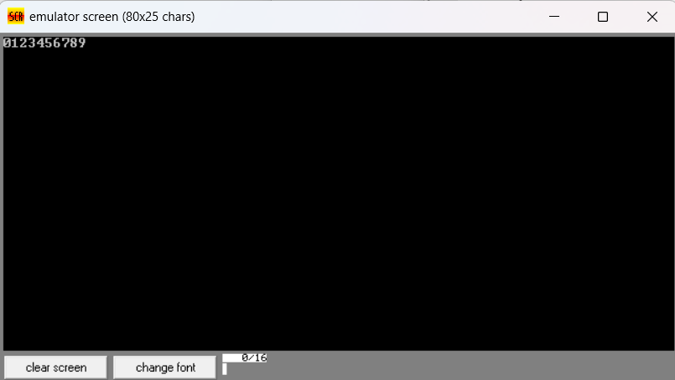

1. **(b)** Write an assembly language program to print the characters from A to Z in reverse order.

**CODE:**

.MODEL SMALL

.STACK 100h

.DATA

char DB 'Z'

.CODE

main PROC

mov ax, @data

mov ds, ax

mov cx, 26

print_loop:

mov ah, 0Eh

mov bh, 0

mov bl, 7

mov al, char

int 10h

dec char

loop print_loop

mov ax, 4C00h

int 21h

main ENDP

END main

**OUTPUT:**

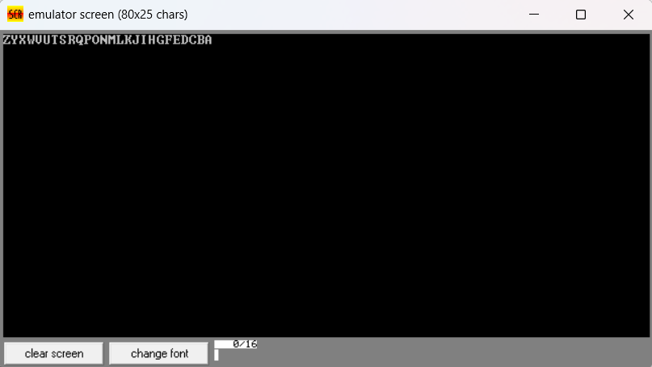

1. (a) Write a program in assembly language to print the numbers from 0 to 9 in reverse order.

**CODE:**

.MODEL SMALL

.STACK 100h

.DATA

num DB '9'

.CODE

main PROC

mov ax, @data

mov ds, ax

mov cx, 10

print_loop:

mov ah, 0Eh

mov bh, 0

mov bl, 7

mov al, num

int 10h

dec num

loop print_loop

mov ax, 4C00h

int 21h

main ENDP

END main

**OUTPUT**:

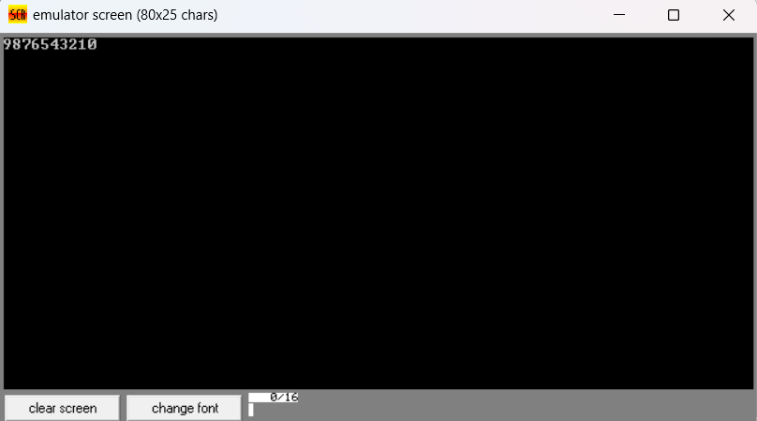

(b) Write an assembly language program to print the characters from A to Z.

**CODE:**

org 100h

mov cx, 26

mov dl, 'A'

print_loop:

mov ah, 02h

int 21h

inc dl

loop print_loop

mov ah, 4Ch

int 21h

**OUTPUT:**

