1. Write an assembly language program to perform addition of 8-bit data.

**Code**:

org 100h

num1 db 30h

num2 db 15h

start:

mov al, [num1]

add al, [num2]

mov bl, al

call print_hex

mov ah, 4Ch

int 21h

print_hex:

mov ah, al

and al, 0F0h

shr al, 4

add al, '0'

cmp al, '9'

jbe print_hex_low

add al, 7

print_hex_low:

mov dl, al

mov ah, 02h

int 21h

mov al, bl

and al, 0Fh

add al, '0'

cmp al, '9'

jbe print_hex_done

add al, 7

print_hex_done:

mov dl, al

mov ah, 02h

int 21h

ret

**Output**:

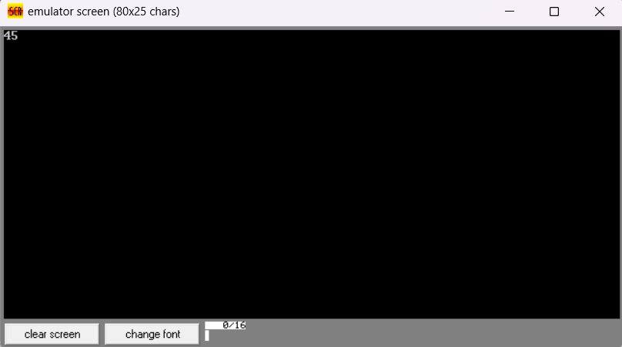

1. Write a program in assembly language to perform addition of 16-bit data.

**Code**:

org 100h

num1 dw 1852h

num2 dw 4572h

start:

mov ax, [num1]

add ax, [num2]

mov bx, ax

mov ah, 0

mov al, ah

call print_hex

mov al, bl

call print_hex

mov ah, 4Ch

int 21h

print_hex:

mov ah, al

and al, 0F0h

shr al, 4

add al, '0'

cmp al, '9'

jbe print_hex_low

add al, 7

print_hex_low:

mov dl, al

mov ah, 02h

int 21h

mov al, ah

and al, 0Fh

add al, '0'

cmp al, '9'

jbe print_hex_done

add al, 7

print_hex_done:

mov dl, al

mov ah, 02h

int 21h

ret

**Output**:

