1. Write a program in assembly language to perform subtraction of 8-bit data.

**Code**:

org 100h

num1 db 40h

num2 db 20h

start:

mov al, num1

sub al, num2

mov ah, al

and ah, 0F0h

shr ah, 4

add ah, 30h

cmp ah, 39h

jle display_upper

add ah, 7

display_upper:

mov dl, ah

mov ah, 02h

int 21h

mov ah, al

and ah, 0Fh

add ah, 30h

cmp ah, 39h

jle display_lower

add ah, 7

display_lower:

mov dl, ah

mov ah, 02h

int 21h

mov ah, 4Ch

int 21h

**Output**:

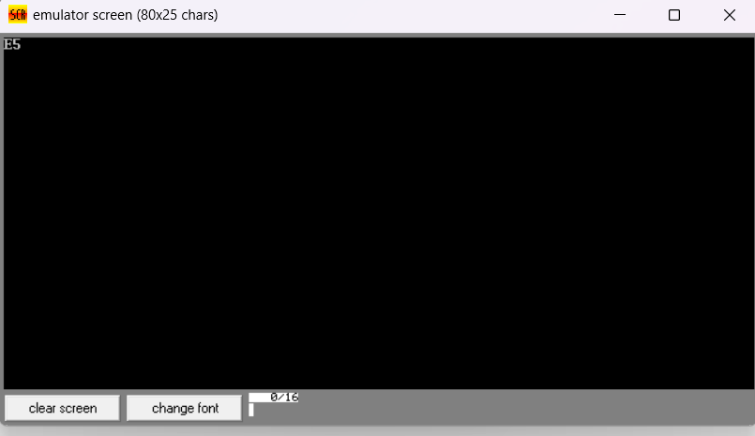

1. Write an assembly language program to perform subtraction of 16-bit data.

**Code**:

org 100h

num1 dw 5697h

num2 dw 1231h

start:

mov ax, num1

sub ax, num2

mov bx, ax

mov ah, bh

shr ah, 4

add ah, 30h

cmp ah, 39h

jle print_first_digit_high

add ah, 7

print_first_digit_high:

mov dl, ah

mov ah, 02h

int 21h

mov ah, bh

and ah, 0fh

add ah, 30h

cmp ah, 39h

jle print_second_digit_high

add ah, 7

print_second_digit_high:

mov dl, ah

mov ah, 02h

int 21h

mov ah, bl

shr ah, 4

add ah, 30h

cmp ah, 39h

jle print_first_digit_low

add ah, 7

print_first_digit_low:

mov dl, ah

mov ah, 02h

int 21h

mov ah, bl

and ah, 0fh

add ah, 30h

cmp ah, 39h

jle print_second_digit_low

add ah, 7

print_second_digit_low:

mov dl, ah

mov ah, 02h

int 21h

mov ah, 4ch

int 21h

**Output**:

