1. Write an assembly language program to perform multiplication of 8-bit data.

Code:

org 100h

mov al, 09h

mov bl, 08h

mul bl

mov bl, al

mov ah, al

and ah, 0F0h

shr ah, 4

add ah, 30h

cmp ah, 39h

jle print_first

add ah, 7

print_first:

mov dl, ah

mov ah, 02h

int 21h

mov ah, bl

and ah, 0Fh

add ah, 30h

cmp ah, 39h

jle print_sec

add ah, 7

print_sec:

mov dl, ah

mov ah, 02h

int 21h

mov ah, 4Ch

int 21h

Output:

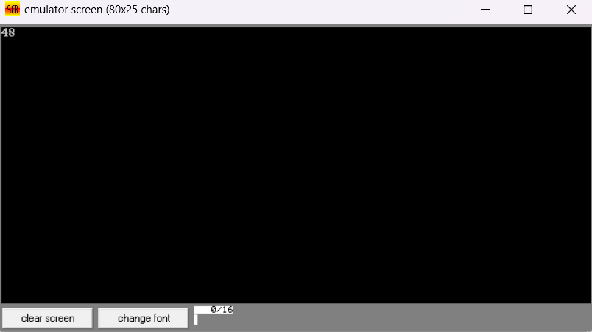

1. Write a program in assembly language to perform multiplication of 16-bit data.

Code:

org 100h

mov ax,1450h

mov bx,1020h

mul bx

mov bx, ax

mov cx, dx

mov ah, ch

and ah,0f0h

shr ah,4

add ah,30h

cmp ah,39h

jle print_high_nibble

add ah,7

print_high_nibble:

mov dl, ah

mov ah,02h

int 21h

mov ah, ch

and ah,0fh

add ah,30h

cmp ah,39h

jle print_low_nibble

add ah,7

print_low_nibble:

mov dl, ah

mov ah,02h

int 21h

mov ah, cl

and ah,0f0h

shr ah,4

add ah,30h

cmp ah,39h

jle print_high_nibble1

add ah,7

print_high_nibble1:

mov dl, ah

mov ah,02h

int 21h

mov ah, cl

and ah,0fh

add ah,30h

cmp ah,39h

jle print_low_nibble1:

add ah,7

print_low_nibble1:

mov dl, ah

mov ah,02h

int 21h

mov ah, bh

shr ah, 4

add ah, 30h

cmp ah, 39h

jle print_high_nibble2

add ah, 7

print_high_nibble2:

mov dl, ah

mov ah, 02h

int 21h

mov ah, bh

and ah, 0fh

add ah, 30h

cmp ah, 39h

jle print_low_nibble2

add ah, 7

print_low_nibble2:

mov dl, ah

mov ah, 02h

int 21h

mov ah, bl

shr ah, 4

add ah, 30h

cmp ah, 39h

jle print_high_nibble3

add ah, 7

print_high_nibble3:

mov dl, ah

mov ah, 02h

int 21h

mov ah, bl

and ah, 0fh

add ah, 30h

cmp ah, 39h

jle print_low_nibble3

add ah, 7

print_low_nibble3:

mov dl, ah

mov ah, 02h

int 21h

mov ah,4ch

int 21h

Output:

