**1. (a)** Write a program in assembly language to print single character on screen.

**Code:**

org 100h

jmp start

msg1: db "Enter the character: ", 0Dh, 0Ah, 24h

msg2: db 0Dh, 0Ah, "The character is: ", 24h

start:

mov dx, msg1

mov ah, 09h

int 21h

mov ah, 01h

int 21h

mov bl, al

mov dx, msg2

mov ah, 09h

int 21h

mov dl, bl

mov ah, 02h

int 21h

mov ah, 0

int 16h

ret

**OUTPUT:**

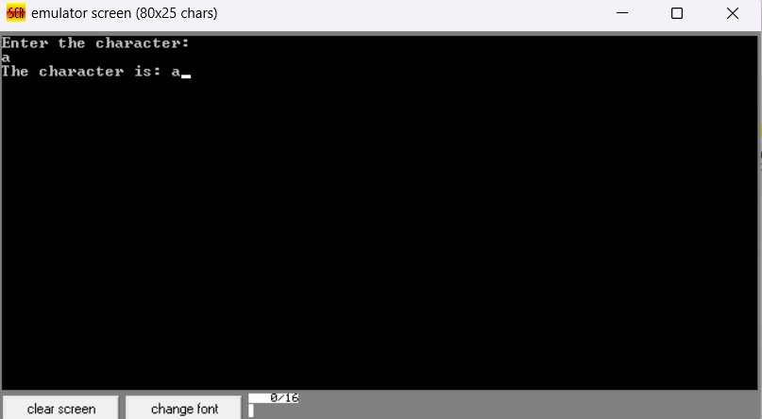

**1.(b)** Write an assembly language program to convert an upper-case letter to the

corresponding lower-case letter.

**Code:**

org 100h

mov dx, offset msg_input

mov ah, 09h

int 21h

mov ah, 01h

int 21h

mov dl, al

mov bl, al

cmp al, 'A'

jl notuppercase

cmp al, 'Z'

jg notuppercase

add bl, 20h

mov dx, offset msg_output

mov ah, 09h

int 21h

mov dl, bl

mov ah, 02h

int 21h

jmp endprogram

notuppercase:

mov dx, offset msg_error

mov ah, 09h

int 21h

endprogram:

mov ah, 4Ch

int 21h

msg_input db 'Enter an uppercase: $'

msg_output db 0dh, 0ah, 'The lowercase letter is: $'

msg_error db 0dh, 0ah, 'Error: The letter is not in uppercase. $'

**Output:**

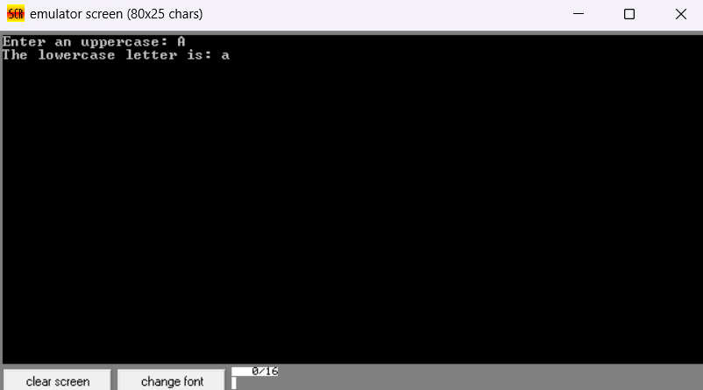

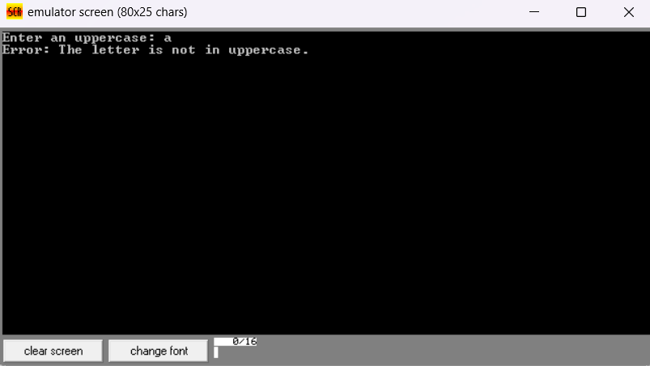

**2.(a)** Write a program in assembly language to print multiple characters on screen.

**Code:**

org 100h

jmp start

msg1: db "Enter the string: ", 0Dh, 0Ah, 24h

msg2: db 0Dh, 0Ah, "The string is: ", 0Dh, 0Ah, 24h

buffer db 20, ?, 20 dup('$') ; Buffer to store the input string (max 20 characters)

start:

; Display "Enter the string: "

mov dx, msg1

mov ah, 09h

int 21h

; Input string from user

mov dx, offset buffer

mov ah, 0Ah ; DOS function to get input string

int 21h

; Display "The string is: "

mov dx, msg2

mov ah, 09h

int 21h

; Display the input string

lea dx, [buffer + 2] ; Offset to skip buffer length and CR

mov ah, 09h

int 21h

; Wait for a key press before exiting

mov ah, 0

int 16h

ret

**Output:**

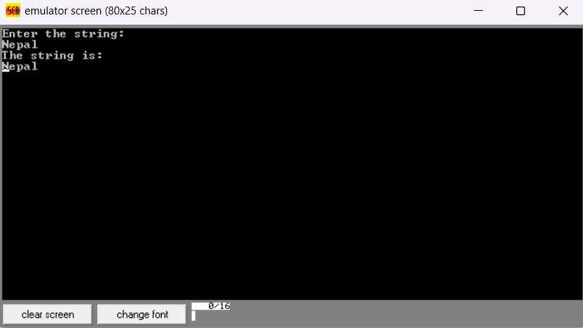

**2.(b**) Write an assembly language program to convert a lower-case letter to the

corresponding upper-case letter.

**Code:**

org 100h

; Display input message

mov dx, offset msg_input

mov ah, 09h

int 21h

; Read character

mov ah, 01h

int 21h

mov dl, al

mov bl, al

; Check if the character is a lowercase letter

cmp al, 'a'

jl notlowercase

cmp al, 'z'

jg notlowercase

; Convert lowercase to uppercase

sub bl, 20h

; Print the output message

mov dx, offset msg_output

mov ah, 09h

int 21h

; Print the converted uppercase letter

mov dl, bl

mov ah, 02h ; 02h to print a single character

int 21h

jmp endprogram

notlowercase:

; Print the error message

mov dx, offset msg_error

mov ah, 09h

int 21h

endprogram:

; End the program

mov ah, 4Ch

int 21h

; Data segment

msg_input db 'Enter a lowercase letter: $'

msg_output db 0dh, 0ah, 'The uppercase letter is: $'

msg_error db 0dh, 0ah, 'Error: The letter is not in lowercase. $'

**Output:**

