1. Write a program in assembly language to take a single-digit integer from the user

and print it on the screen.

**ANS**:

**Code:**

ORG 100h

MOV DX, OFFSET msg_input

MOV AH, 09h

INT 21h

MOV AH, 01h

INT 21h

MOV BL, AL

CMP AL, '0'

JL NotDigit

CMP AL, '9'

JG NotDigit

MOV DX, OFFSET msg_output

MOV AH, 09h

INT 21h

MOV DL, BL

MOV AH, 02h

INT 21h

JMP EndProgram

NotDigit:

MOV DX, OFFSET msg_error

MOV AH, 09h

INT 21h

EndProgram:

MOV AH, 4Ch

INT 21h

msg_input DB 'Enter a single digit: $'

msg_output DB 0Dh, 0Ah, 'The single digit is: $'

msg_error DB 0Dh, 0Ah, 'Error: Not a digit! $'

END

**OUTPUT:**

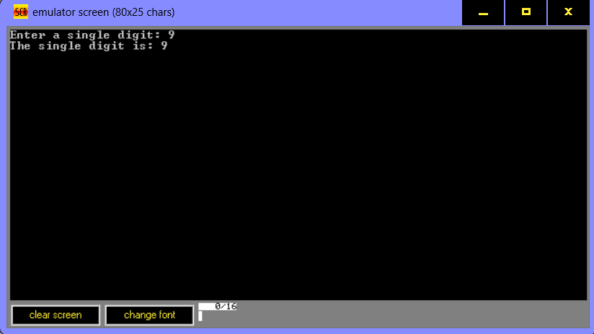

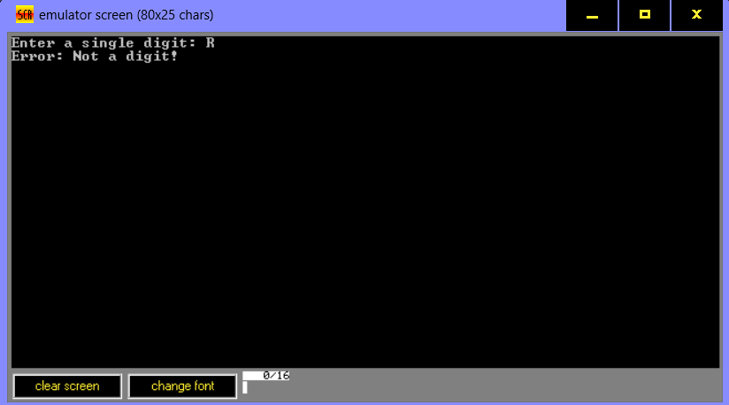

2. Write a program in assembly language to take two single-digit integers from the

user and print the result of subtraction on the screen.

**Ans:**

**CODE:**

ORG 100h

_start:

MOV DX, OFFSET msg_input1

MOV AH, 09h

INT 21h

MOV AH, 01h

INT 21h

CMP AL, '0'

JL InvalidInput

CMP AL, '9'

JG InvalidInput

SUB AL, '0'

MOV BL, AL

MOV DX, OFFSET msg_input2

MOV AH, 09h

INT 21h

MOV AH, 01h

INT 21h

CMP AL, '0'

JL InvalidInput

CMP AL, '9'

JG InvalidInput

SUB AL, '0'

MOV BH, AL

MOV DX, OFFSET msg_result

MOV AH, 09h

INT 21h

SUB BL, BH

JS NegativeResult

ADD BL, '0'

MOV DL, BL

MOV AH, 02h

INT 21h

JMP EndProgram

NegativeResult:

MOV DL, '-'

MOV AH, 02h

INT 21h

NEG BL

ADD BL, '0'

MOV DL, BL

MOV AH, 02h

INT 21h

JMP EndProgram

InvalidInput:

MOV DX, OFFSET msg_error

MOV AH, 09h

INT 21h

JMP EndProgram

EndProgram:

MOV AH, 4Ch

INT 21h

msg_input1 DB 'Enter first digit: $'

msg_input2 DB 0Dh, 0Ah, 'Enter second digit: $'

msg_result DB 0Dh, 0Ah, 'The result is: $'

msg_error DB 0Dh, 0Ah, 'Error: Invalid input! $'

END

**OUTPUT:**

