1. Write a program in assembly language to display a two-digit number on the screen. The

two-digits number is required to be taken in the program itself.

**Ans:**

**CODE:**

.MODEL SMALL

.STACK 100H

.DATA

num1 DB 4

num2 DB 5

msg DB 13, 10, 'The number is: $'

.CODE

START:

MOV AX, @DATA

MOV DS, AX

MOV AH, 09H

LEA DX, msg

INT 21H

MOV AL, num1

ADD AL, 30H

MOV DL, AL

MOV AH, 02H

INT 21H

MOV AL, num2

ADD AL, 30H

MOV DL, AL

MOV AH, 02H

INT 21H

MOV AH, 4CH

INT 21H

END START

**Output:**

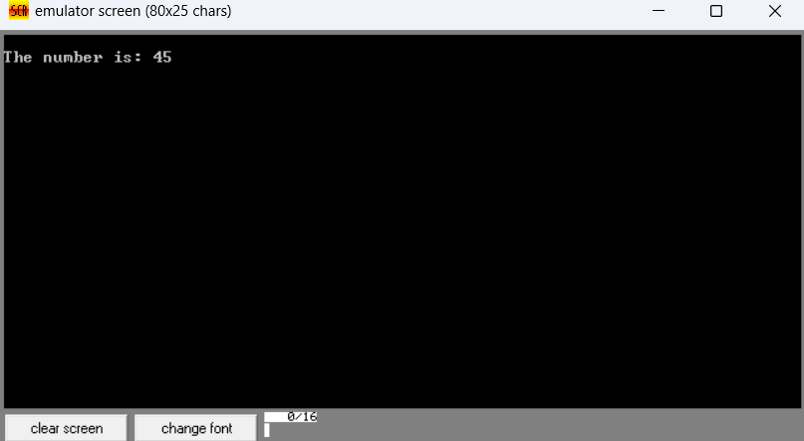

2. Write an assembly language program to take two single-digit integers from the user and

print the result of addition on the screen.

**Ans:**

**CODE:**

ORG 100h

mov ah, 09h

lea dx, msg1

int 21h

mov ah, 02h

mov dl, 0Dh

int 21h

mov dl, 0Ah

int 21h

mov ah, 01h

int 21h

sub al, '0'

mov bl, al

mov ah, 09h

lea dx, msg2

int 21h

mov ah, 02h

mov dl, 0Dh

int 21h

mov dl, 0Ah

int 21h

mov ah, 01h

int 21h

sub al, '0'

add bl, al

cmp bl, 9

jg two_digits

mov ah, 09h

lea dx, msg3

int 21h

mov ah, 02h

mov dl, 0Dh

int 21h

mov dl, 0Ah

int 21h

add bl, '0'

mov dl, bl

mov ah, 02h

int 21h

jmp done

two_digits:

mov ah, 09h

lea dx, msg3

int 21h

mov ah, 02h

mov dl, 0Dh

int 21h

mov dl, 0Ah

int 21h

mov al, bl

mov ah, 0

mov dl, 10

div dl

add al, '0'

mov dl, al

mov bh, ah

mov ah, 02h

int 21h

mov al, bh

add al, '0'

mov dl, al

mov ah, 02h

int 21h

done:

mov ah, 4Ch

int 21h

msg1 db 'Enter first digit: $'

msg2 db 13, 10, 'Enter second digit: $'

msg3 db 13, 10, 'The sum is: $'

**OUTPUT:**

