1. Write a program in assembly language to take two single-digit numbers as input and

display whether they are equal or not.

**Ans:**

**Code:**

.model small

.stack 100h

.data

prompt1 db 'Enter first single-digit number: $'

prompt2 db 0dh, 0ah, 'Enter second single-digit number: $'

equal_msg db 0dh, 0ah, 'The numbers are equal.$'

not_equal_msg db 0dh, 0ah, 'The numbers are not equal.$'

.code

main proc

mov ax, @data

mov ds, ax

lea dx, prompt1

mov ah, 09h

int 21h

mov ah, 01h

int 21h

sub al, '0'

mov bl, al

lea dx, prompt2

mov ah, 09h

int 21h

mov ah, 01h

int 21h

sub al, '0'

cmp bl, al

je equal

lea dx, not_equal_msg

mov ah, 09h

int 21h

jmp exit

equal:

lea dx, equal_msg

mov ah, 09h

int 21h

exit:

mov ah, 4ch

int 21h

main endp

end main

**Output:**

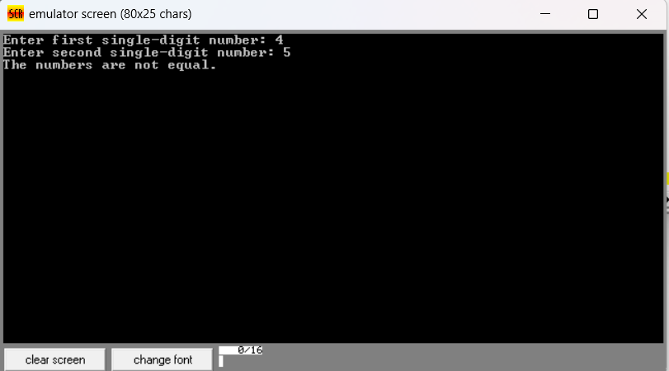

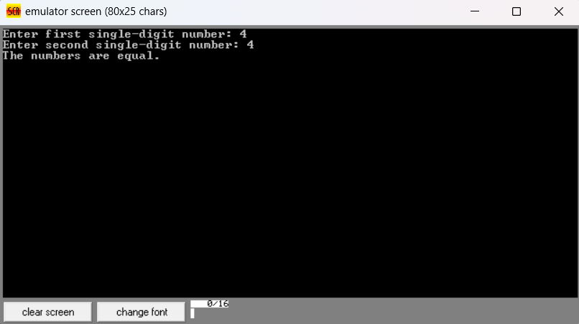

2. Write a program in assembly language to check whether a single-digit number is odd or

even.

**Ans:**

**Code:**

ORG 100h

start:

mov ah, 09h

lea dx, prompt_msg

int 21h

mov ah, 01h

int 21h

sub al, 30h

mov bl, al

mov ah, 00h

mov al, bl

mov cl, 02h

div cl

cmp ah, 00h

je even

odd:

mov ah, 09h

lea dx, odd_msg

int 21h

jmp done

even:

mov ah, 09h

lea dx, even_msg

int 21h

done:

mov ah, 4Ch

int 21h

prompt_msg db 'Enter a single-digit number: $'

even_msg db 0Dh, 0Ah, 'The number is even.$'

odd_msg db 0Dh, 0Ah, 'The number is odd.$'

**Output:**

