**Enabling Java and ActiveX Settings of Internet Explorer:**

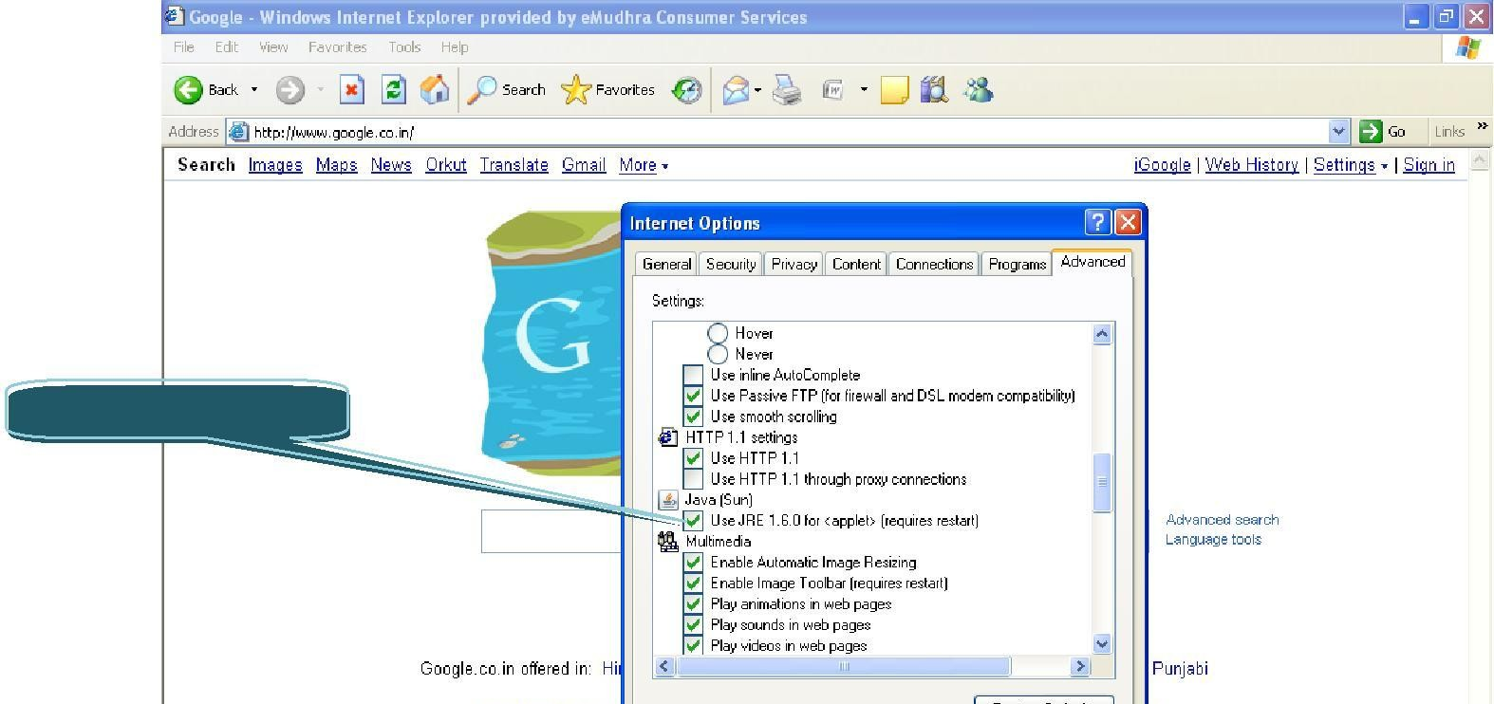

Enable the check Box

Enabling Java and Active X Settings varies for different versions of Internet Explorer. The setting can be done based on the browser you are using:

## IE 6.0 Settings:-

* Click on tools > Internet options > security > trusted site > click on sites button > add the website and click on close button.
* Click on custom level to set the active X control :

|  |  |  |  |
| --- | --- | --- | --- |
| **Active X controls and plug-in** | **Disable** | **Enable** | **Prompt** |
| **Automatic prompting for ActiveX**  **controls.** | ✓ | - | - |
| **Binary and script behaviors.** | - | ✓ | - |
| **Download signed ActiveX**  **controls.** | - | - | ✓ |
| **Download unsigned ActiveX**  **controls.** | - | ✓ | - |
| **Initialize and script ActiveX**  **controls not marked as safe for scripting** | - | ✓ | - |
| **Run ActiveX controls and plug- ins.** | - | ✓ | - |
| **Script ActiveX controls marked**  **safe for scripting.** | - | ✓ | - |

The Java has to be enabled in →two places→. Follow the s→teps and enable th→e java in you→r browser:

* + To Enable the Java open IE Go to Tools Internet options advanced scroll down and

you will be able to see the below pop message:

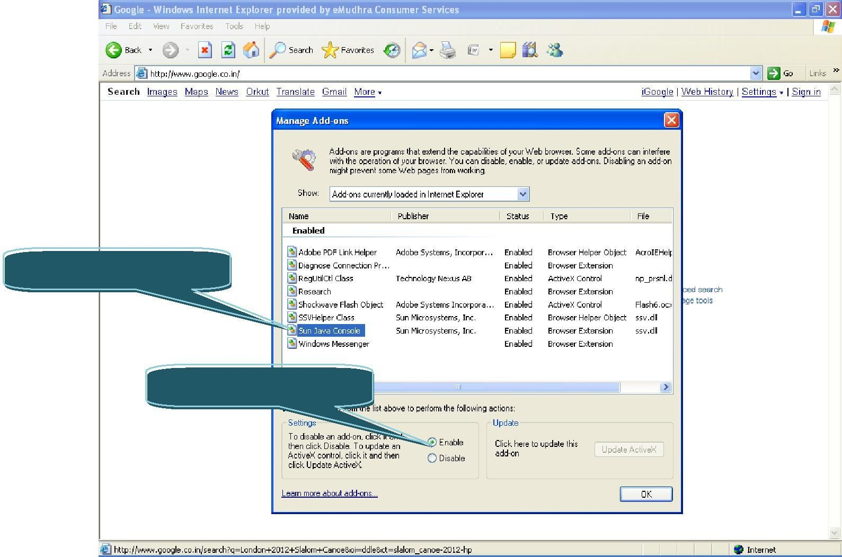

1 Click on Sun Java

2 Click on Enable Button

* To Enable the Java → open IE → Go to Tools → Click on Manage Add-ons → You will be able to see the below pop message:

## IE 7.0 Settings:-

* Click on tools > Internet options > security > trusted site > click on sites button > add the website and click on close button.
* Click on custom level to set the active X control :

|  |  |  |  |  |  |
| --- | --- | --- | --- | --- | --- |
| **Active X controls and plug-in** | **Disable** | | **Enable** | **Prompt** | |
| **Allow previously unused ActiveX**  **controls to run without prompt.** |  | ✓ | - |  | - |
| **Allow Scriptlets.** | ✓ | | - | - | |
| **Automatic prompting for ActiveX**  **controls.** |  | ✓ | - |  | - |
| **Binary and script behaviors.** | - | | ✓ | - | |
| **Display video and animation on a**  **webpage that does not use external media player.** |  | ✓ | - |  | - |
| **Download signed ActiveX**  **controls.** | - | | - | ✓ | |
| **Download unsigned ActiveX**  **controls.** |  | - | ✓ |  | - |
| **Initialize and script ActiveX**  **controls not marked as safe for scripting.** | - | | ✓ | - | |
| **Run ActiveX controls and plug-**  **ins.** | - | | ✓ | - | |
| **Script ActiveX controls marked**  **safe for scripting.** | - | | ✓ | - | |

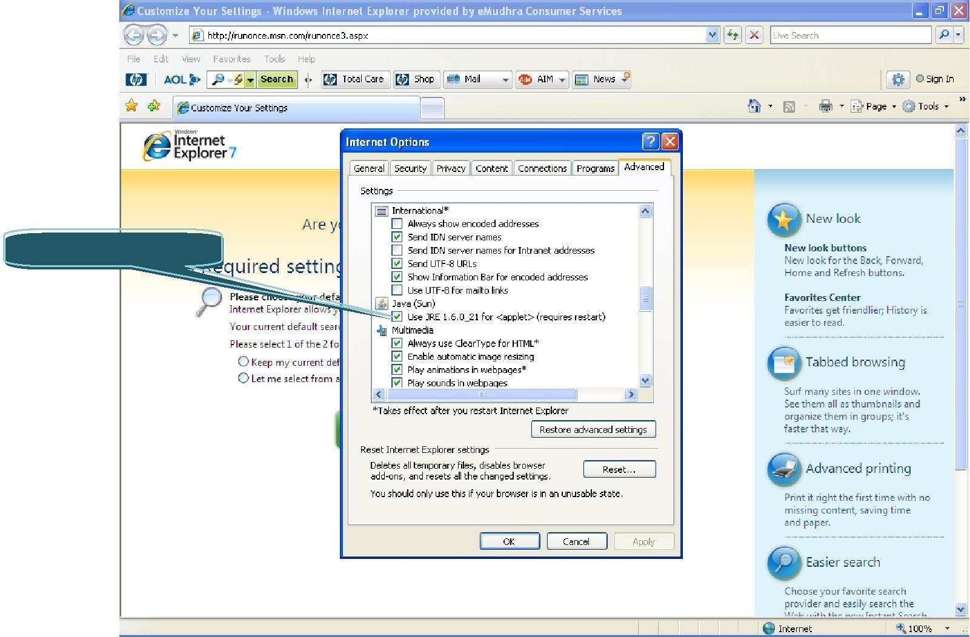

Enable the check Box

The Java has to be enabled in two places. Follow the steps and enable the java in your browser:

* + To Enable the Java → open IE → Go to Tools → Internet options → advanced → scroll down and you will be able to see the below pop message:
    - To Enable the Java → open IE → Go to Tools → Click on Manage Add-ons → Click on Enable or disable add-ons you will be able to see the below pop message:

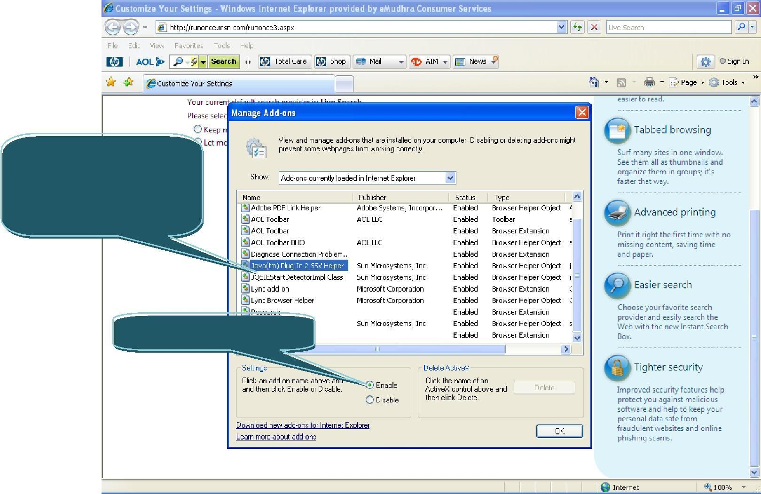

Select

Java(tm) first and enable, Second JQSIE and click on Enable

button.

2 Click on Enable Button



## IE 8.0 Settings:-

|  |  |  |  |  |
| --- | --- | --- | --- | --- |
| **Active X controls and plug-in** | **Disable** | **Enable** | | **Prompt** |
| **Allow previously unused ActiveX**  **controls to run without prompt.** | ✓ | - |  | - |
| **Allow Scriptlets.** | ✓ | - | | - |
| **Automatic prompting for ActiveX**  **controls.** | ✓ | - |  | - |
| **Binary and script behaviors.** | - |  | | - |
| **Display video and animation on a webpage that does not use**  **external media player.** | ✓ | - |  | - |
| **Download signed ActiveX**  **controls.** | - | - | | ✓ |
| **Download unsigned ActiveX**  **controls.** | - | ✓ | | - |
| **Initialize and script ActiveX controls not marked as safe for**  **scripting.** | - | ✓ | | - |
| **Run ActiveX controls and plug-**  **ins.** | - | ✓ | | - |
| **Script ActiveX controls marked**  **safe for scripting.** | - | ✓ | | - |
| **Only allowed approved domains**  **to use ActiveX without prompt.** | - | ✓ |  | - |

The Java has to be enabled in two places. Follow the steps and enable the java in your browser:

* + To Enable the Java → open IE → Go to Tools → Internet options → advanced → scroll down and you will be able to see the below pop message:

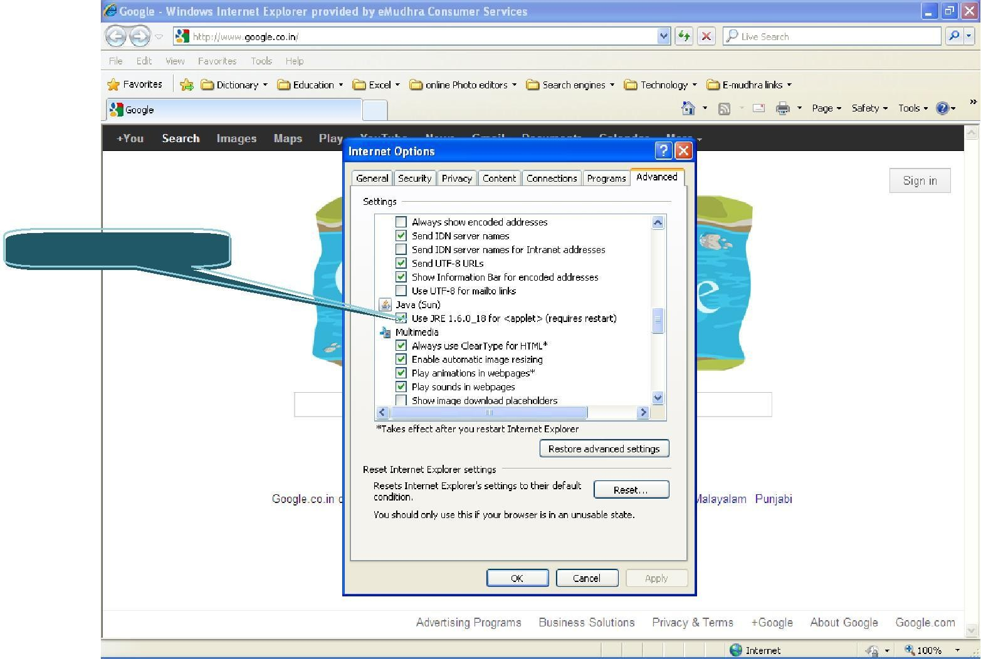

Enable the check Box

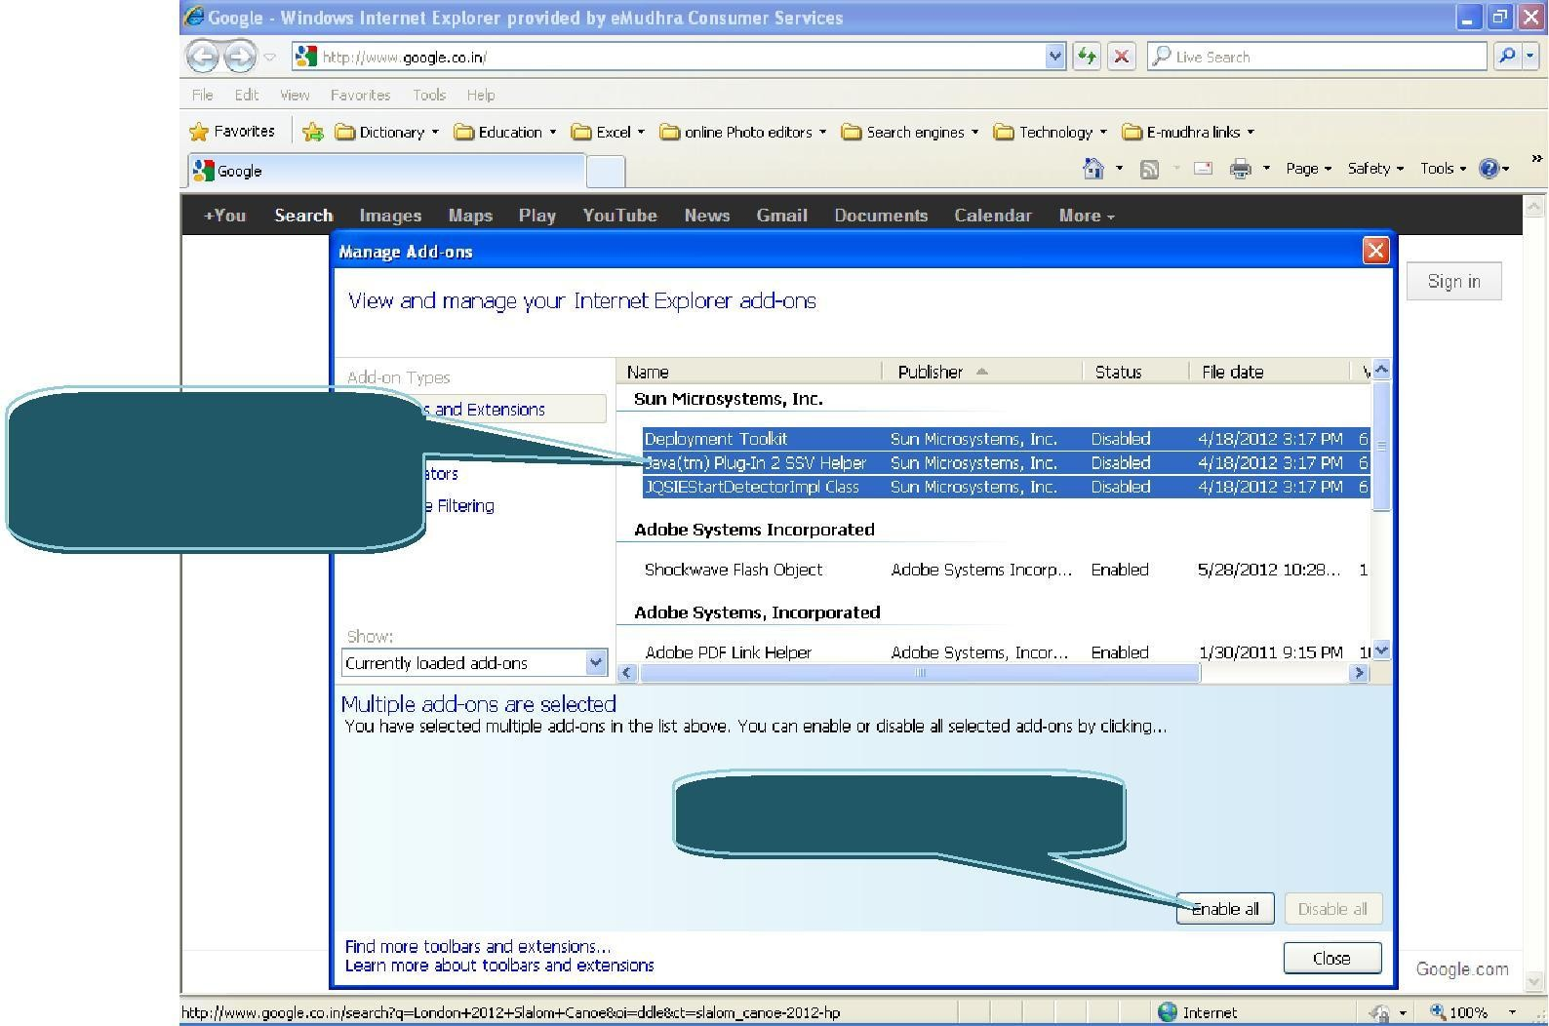

1 Hold the

Control button and select all the 3 options.

2 Click on Enable all Button

* + - To Enable the Java → open IE → Go to Tools → Click on Manage Add-ons → You will be able to see the below pop message:

## IE 9.0 Settings:-

* Click on tools > Internet options > security > trusted site > click on sites button > add the website and click on close button.
* Click on custom level to set the active X control :
* Go To tools and uncheck Active X filtering option.

|  |  |  |  |
| --- | --- | --- | --- |
| **Active X controls and plug-in** | **Disable** | **Enable** | **Prompt** |
| **Allow previously unused ActiveX**  **controls to run without prompt.** | ✓ | - | - |
| **Allow Scriptlets.** | ✓ | - | - |
| **Automatic prompting for ActiveX controls.** | - | ✓ | - |
| **Binary and script behaviors.** | - | ✓ | - |
| **Display video and animation on a**  **webpage that does not use external media player.** | ✓ | - | - |
| **Download signed ActiveX**  **controls.** | - | - | ✓ |
| **Download unsigned ActiveX**  **controls.** | - | ✓ | - |
| **Initialize and script ActiveX**  **controls not marked as safe for scripting.** | - | ✓ | - |
| **Only allowed approved domains**  **to use ActiveX without prompt.** | - | ✓ | - |
| **Run ActiveX controls and plug-**  **ins.** | **-** | ✓ | **-** |
| **Script ActiveX controls marked**  **safe for scripting.** | - | ✓ | - |

## IE 10.0 Settings:-

* Click on tools > Internet options > security > trusted site > click on sites button > add the website and click on close button.
* Go to Tools → Disable Active X filtering.
* Go to tools → Compatibility View settings → add the website (Ex: e-mudhra.com).
* Click on custom level to set the active X control :
* Go To tools and uncheck Active X filtering option.





**Active X controls and plug-in**

**Disable Enable Prompt**

**Allow Active X Filtering**

✓

**Allow previously unused ActiveX controls to run without prompt. Allow Scriptlets.**

✓

-

-

✓

-

-

**Automatic prompting for ActiveX controls.**

**Binary and script behaviors.**

**Display video and animation on a webpage that does not use external media player.**

**Download signed ActiveX controls.**

**Download unsigned ActiveX controls.**

**Initialize and script ActiveX controls not marked as safe for scripting.**

**Only allowed approved domains to use ActiveX without prompt. Run ActiveX controls and plug- ins.**

**Script ActiveX controls marked**

**safe for scripting.**

-

✓

-

-

✓

-

✓

-

-

-

-

✓

-

✓

-

-

✓

-

-

✓

-

**-**

✓

**-**

-

✓

-

* + To Enable the Java → open IE → Go to Tools → Click on Manage Add-ons → You will be able to see the below pop message:

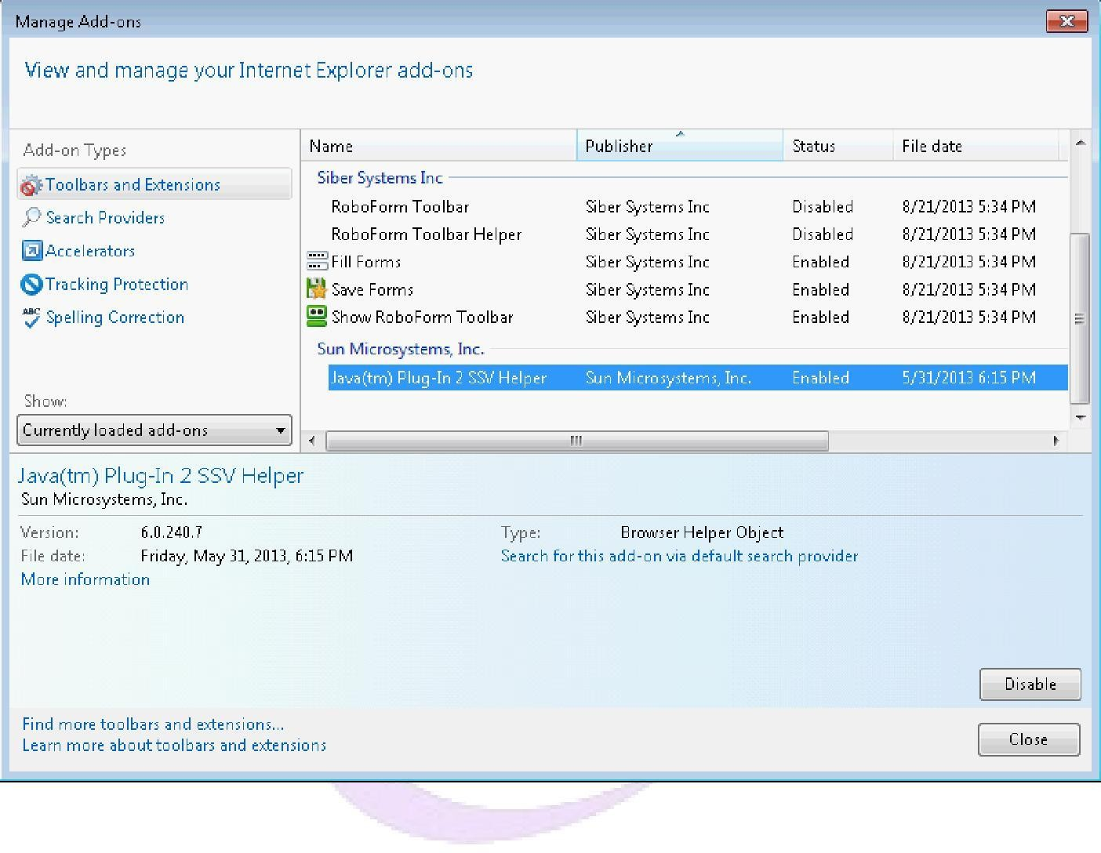

## Mozilla Firefox:

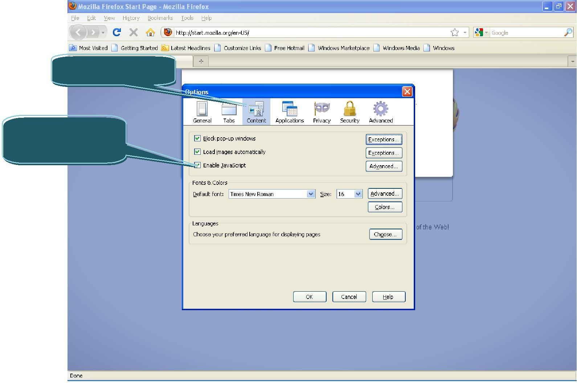

1 Click on Content.

2 Enable the

Check box.

* Go To Tools → Options → Select Content → the below Pop Windows will be displayed:

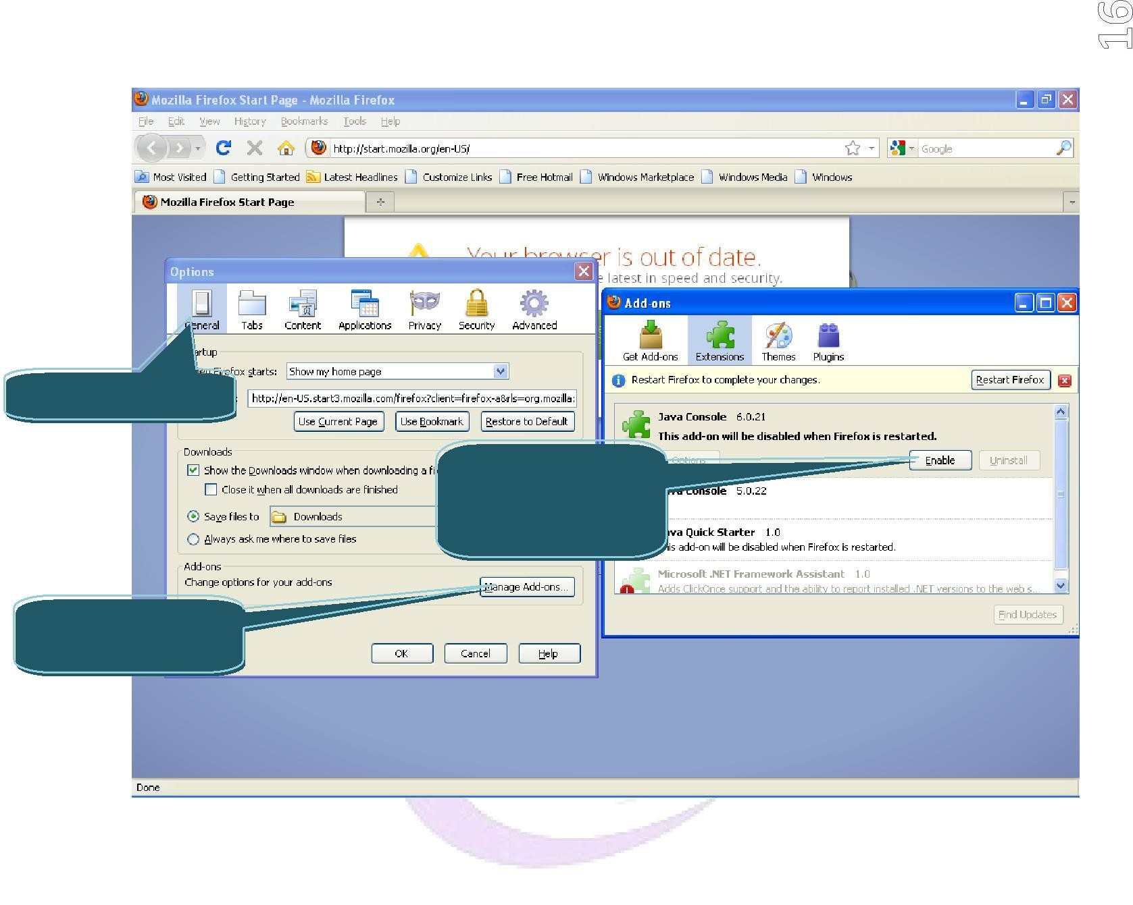

* Click on general → click on Manage Add-ons.

1 Click on general

3 Select Java Console and click on EnableButton.

2 click on Manage Add-ons.

## Mozilla version above 21:

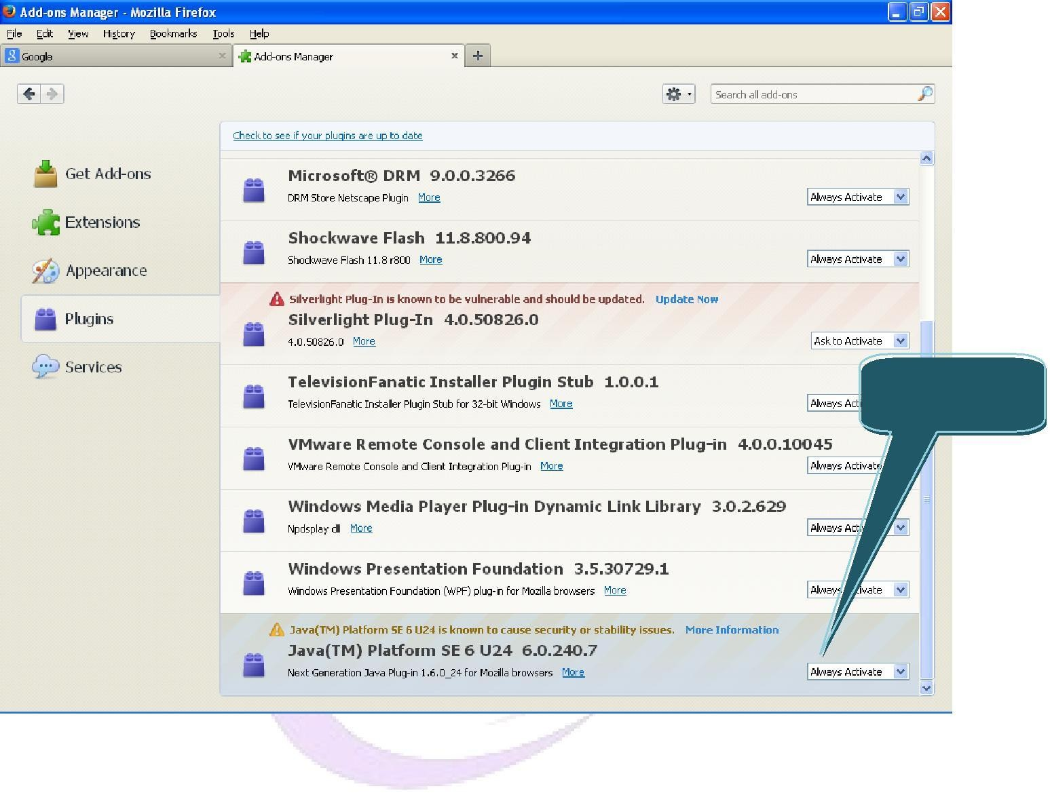

Select Always

Activate

Open Mozilla → go to tools → Click on Addons:

## 6 Google Chrome:

* 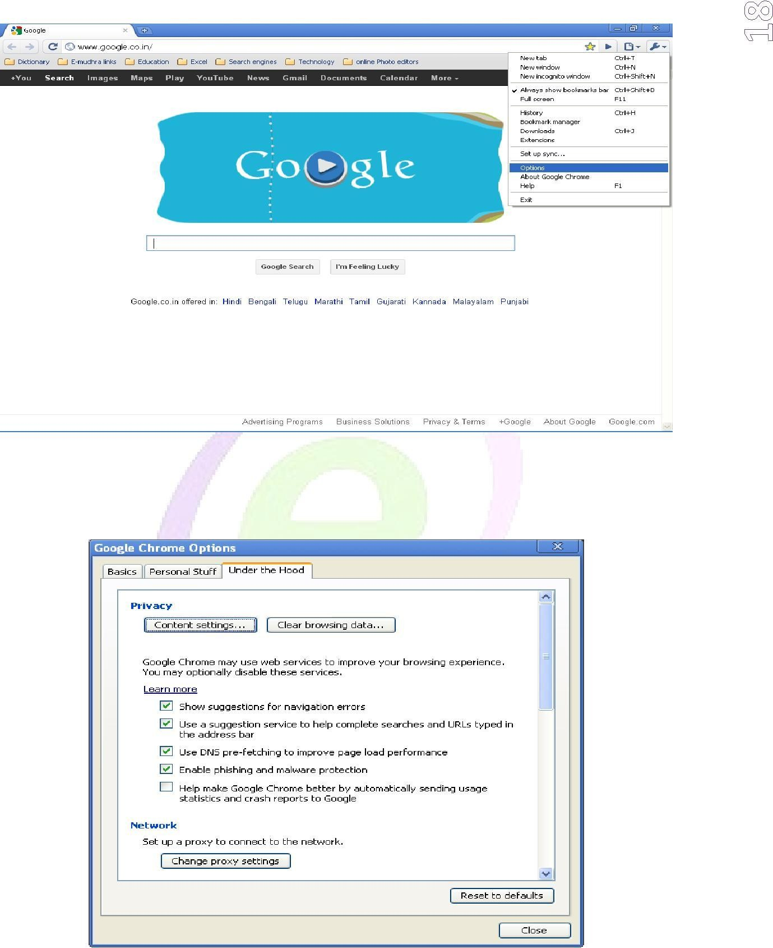Go to Customize and settings → Click on Options.
* Once you click on options the below pop window will be displayed. Click on content settings.
* After clicking on content settings, the below pop window will be displayed → Enable “Allow all sites to run JavaScript”:

After clicking on content settings, the below pop window will be displayed use plug-ins (recommended)”:

## Google Chrome Version 31 and above:

→

Go to Customize and settings Click on Settings.

Once click on settings, scroll down and click on “Advance settings” hyperlink. Enable Java Script Radio button

→

Enable “Allow all sites to

**Enabling NPAPI in Chrome Version 42 and later**

### As of Chrome Version 42, an additional configuration step is required to continue using NPAPI plugins.

1. In your URL bar, enter:

### chrome://flags/#enable-npapi

1. Click the Enable link for the Enable NPAPI configuration option.

### Click the Relaunch button that now appears at the bottom of the configuration page.

**Steps to handle signer applet related issues.**

# JRE 1.6 or higher is required, message on web page.

**Reason :** System does not have java installed or java plugin is not enabled in browser. **Resolution :**

* 1. Go to command prompt and type “ java -version” and check the java version if displayed. If not displayed, java is not installed.
  2. Install the latest java version[JRE] from oracle.com or java.com
  3. Take system restart once java is successfully installed and go to command prompt and type “ java -version” and confirm that java is installed.

# Signature data is not of the format PKCS7. Either set the dataType correctly or check if the signature data is not corrupted.

**Reason :** Signed data is either getting truncated or junk values are getting appended before passing to EMAS web services. This message is coming from EMAS.

#### Resolution :

* 1. Signed data coming out from applet jar and signed data just before passing to EMAS web services should be compared. Both should be same.
  2. Check whether browser is not able to pass complete signed data
  3. If above resolutions did not help, uninstall the java and install a single copy of latest java version.

# Blank applet

#### Reasons and resolution :

* 1. Reason : Token driver is not installed.

Resolution : Install the token driver provided by token vendor.

* 1. Reason : Token driver shows no certificate.

Resolution : Contact the certifying authority and get the certificate downloaded onto token.

* 1. Reason : Certificate is visible in driver but not published in browser

Resolution : Token driver interface will be having an option to publish the certificate, click on that option and publish the certificate.

**Note :** For certificate to be visible in signer applet, it must be visible in certificate store. To view certificate store, open *Internet Explorer -> Internet Options -> Contents -> Certificates*.

# Web page hangs

#### Reasons and resolution :

* 1. Reason : Java plugin is corrupted.

Resolution : Uninstall the java version and install a single copy of latest java version.

* 1. Reason : Conflict of java version if more than one java is installed. Resolution :
* Go to *Control Panel -> Java -> Java -> View*. Here ensure only a single latest java version is selected. This is applicable to both user and system sub tabs.
* Clean the java temporary files [Go to *Control Panel -> Java -> General -> Settings -> Delete Files* -> Select all the check box options and click OK]
* Clean browser cache and restart the browser.
* Now check the application.
* If this is not resolving the issue, uninstall all the older java versions except the latest java version. Restart the system, clean java temporary files and browser cache and test the application.

# Enable Java plugin in Firefox browser

On the page which has signer applet, and if the Java plugin is not enabled, you will see below shown warning message.

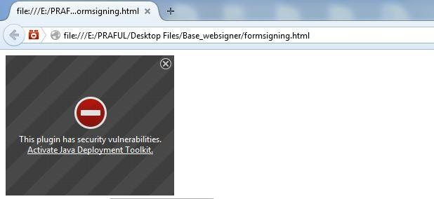

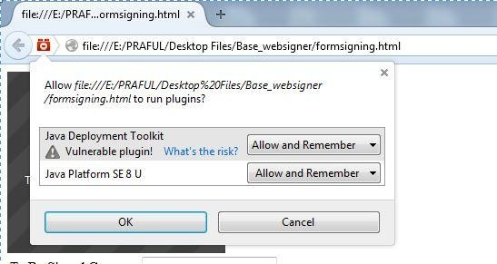Click on Activate Java Deployment Toolkit option. You will see below mentioned confirmation message.

Select **“ Allow and Remember”** options from drop down and click **OK** to enable the plugin.

# Enable Java plugin in Chrome browser

On the page which has signer applet, and if the Java plugin is not enabled, you will see below shown warning message on the right corner of Address bar

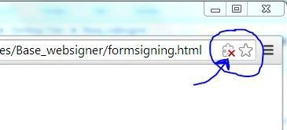

Click on the cross mark and you will see below mentioned confirmation box

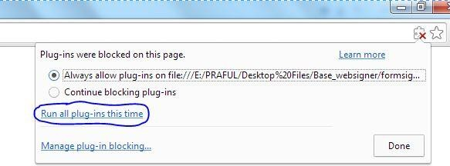

Either select the **Always allow** options or click on **Run all plug-ins this time** and click **Done** to enable the Java plugin.

You might get below shown Security Warning, click **Allow** and continue

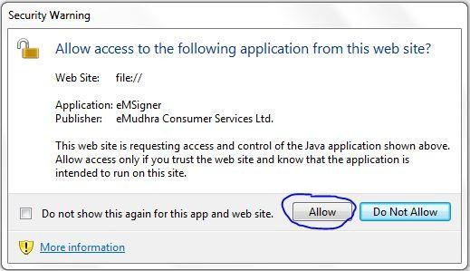

# Enable Java plugin in Internet Explorer

On the page which has signer applet, and if the Java plugin is not enabled, you will see below shown warning message above Task bar



Click on **Allow blocked content** and you might get below shown Security warning. Click **Allow** and continue.

# Java 7 security settings

With Java 7.51 version, oracle added new option to set the security settings. If the signer applet invocation is not happening after the system is updated with Java 7.51 and above, follow below steps to resolve the same.

Go to *Control Panel -> Java -> Security*

Make the security level to Medium

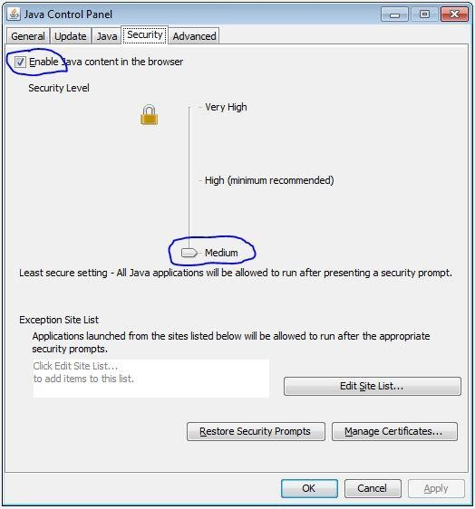

In addition to above step, follow below optional steps. Click on **Edit Site List...** and click on **Add**

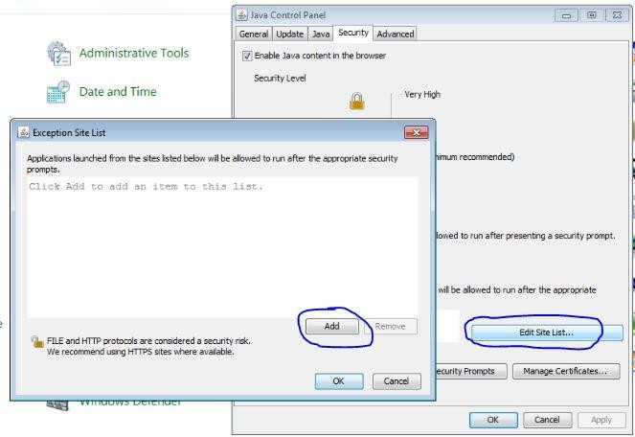

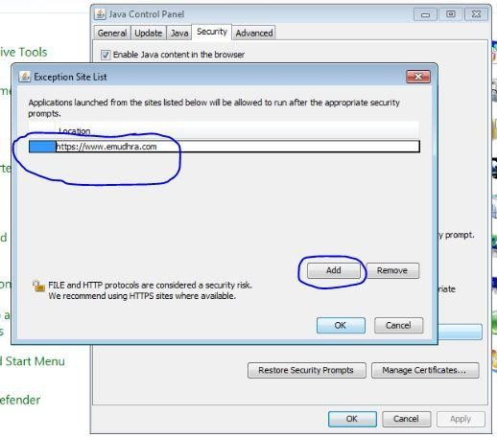Add the site name where the signer applet jar is present in **Exception Site List** as shown in below example

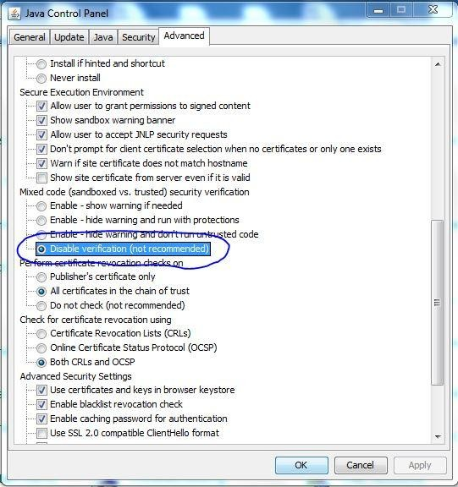Go to *Control Panel -> Java ->Advanced* and disable the **Mixed code security verification** as shown below

# 64 bit java version

Even if the system type is of 64 bit, we recommend to install only 32 bit latest java version.

# General Exception : websigner.applet, class not found exception

* 1. Reason : Java plugin not enabled

Resolution : Enable the java plugin as mentioned in afore mentioned steps.

* 1. Reason : Signer applet jar might be getting blocked by firewall or antivirus software

Resolution : As applet jar resides in temporary location of the system, access should be provided for the same. Firewall or antivirus might block the access. Disable firewall and antivirus and check.

* 1. Reason : Java corrupted

Resolution : Uninstall all the existing java versions and install a single copy of 32 bit latest java version.

* 1. Reason : Conflict of java version if more than one java is installed. Resolution : Refer step 4 . ii for resolution