Agri Predictive Analytics Model
Forecasting district-level crop yield at week 20, and explaining the drivers to business users
Project report - Yuva Intern, Junior Data Scientist Internship in Nagpur
Author: Kalla Kushwanth
Period: 22 Oct 2026 - 26 Nov 2026

Data note. The brief describes about 350,000 records but supplies no file. All results in this report come from a seeded synthetic dataset (src/generate_data.py) built to contain every data problem the brief lists. The results therefore demonstrate the method; they are not real Vidarbha yield statistics.

1. Summary
A fictional Nagpur agritech start-up wants to predict district-level crop yield early enough to act on procurement. I built a forecast issued at the end of week 20 of the agricultural year (about mid-October), using only weeks 1-20 of the current season plus earlier seasons. The model is a tuned gradient-boosting regressor trained on 3,998 block-crop seasons (2006-2019), selected on 857 validation seasons (2020-2022), refit on both and scored once on 854 test seasons (2023-2025).
Headline results. At the district x crop level the final model has a mean absolute error of 1.19 q/ha on the test years, against 1.72 q/ha for the baseline (the 3-year rolling mean). That is 31% better on test and 42% better on validation.
Success criterion from the brief | Result | Evidence
Beat the baseline by at least 15% | Met | 42.0% on validation, 31.0% on test
Test within 5% of validation | Not met | Test MAE is 40% above validation; the baseline itself got 17% worse
Top five drivers make business sense | Met, with a caveat | Rainfall and price signals dominate; price features are signals, not causes (section 9)

What I would tell the business. The forecast is reliable in normal seasons (about 10% average block-level error) and noticeably weaker in unusually wet seasons (about 16%), which doubled in frequency in the test years. Shortfall calls for kharif crops were reliable in the 2025 hindsight check; rabi crop shortfall calls in a very wet year were not.

2. Problem and data
The data is one row per block x crop x week of the agricultural year (week 1 = 1 June): 349,959 rows and 23 columns covering 6 districts (Nagpur, Wardha, Amravati, Yavatmal, Chandrapur, Bhandara), 48 blocks, 6 crops (soybean, cotton, tur, rice, wheat, gram) and agricultural years 2003-2025. Columns cover weekly rainfall and maximum temperature, block-level soil tests, weekly mandi price, season yield, and a few post-harvest columns.
Because no file was provided, the data was generated with a documented data-generating process: yield responds to monsoon rainfall in a curved way (too little and too much both hurt), dry spells in the flowering window, heat, soil quality, an irrigation share, a slow technology trend and previous-year prices, plus district-level shocks (pink bollworm in Yavatmal cotton, floods in Amravati). Then the problems the brief lists were injected. The generator is seeded so the dataset can be rebuilt exactly.
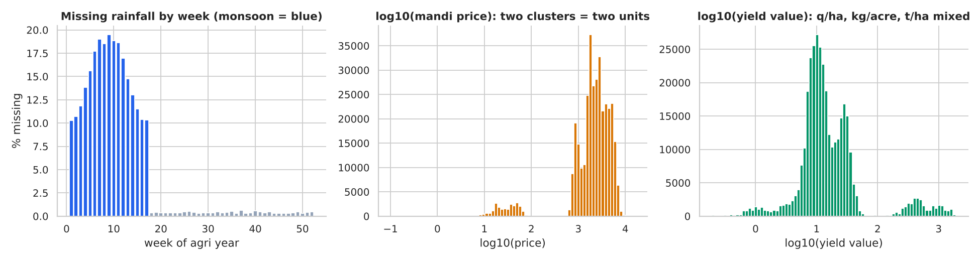
Figure 1. Raw data audit: missing rainfall by week, mixed price units, mixed yield units.

3. Cleaning
Each fix is detected from the data rather than hard-coded, and the affected rows are counted.
Problem | Rows affected | How it was found and fixed
Exact duplicate rows | 5,511 | Dropped exact copies including the record ID
Inconsistent labels (Soya bean, Paddy, NAGPUR) | 10,327 crop, 10,231 district | Trimmed, lower-cased and mapped to one name
Prices per kg mixed with per quintal | 22,372 | Ratio to the same crop's median price in the same week was about 0.01; multiplied by 100
Yield in kg/acre or t/ha | 37,336 | Converted using the declared unit to q/ha
Yield mislabelled as q/ha | 2,964 | Values more than 5 times the crop median were kg/acre; divided by 40.47
Missing rainfall and -999 sentinels | 18,311 | Filled from the same gauge under another crop, then from other blocks in the district that week

Missing rainfall deserves a note. Heavy-rain weeks are more likely to go missing, so the imputed monsoon cells averaged 78.8 mm per week against 58.4 mm for the observed cells. A global or seasonal average would have understated monsoon totals, which is why neighbouring blocks in the same week were used instead.
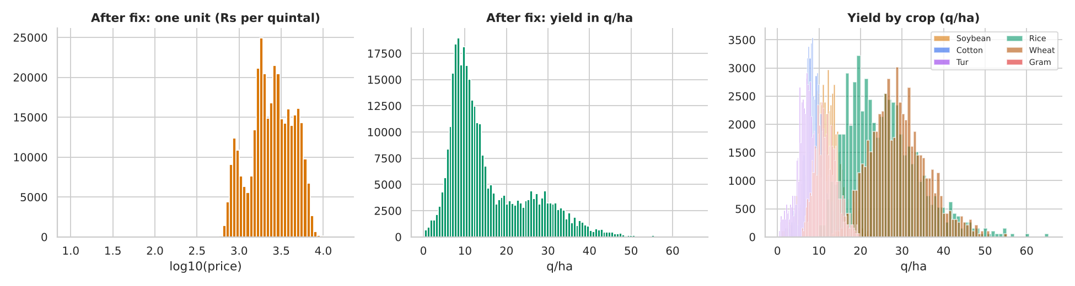
Figure 2. After cleaning: one price unit and one yield unit.

4. Exploratory analysis and leakage check
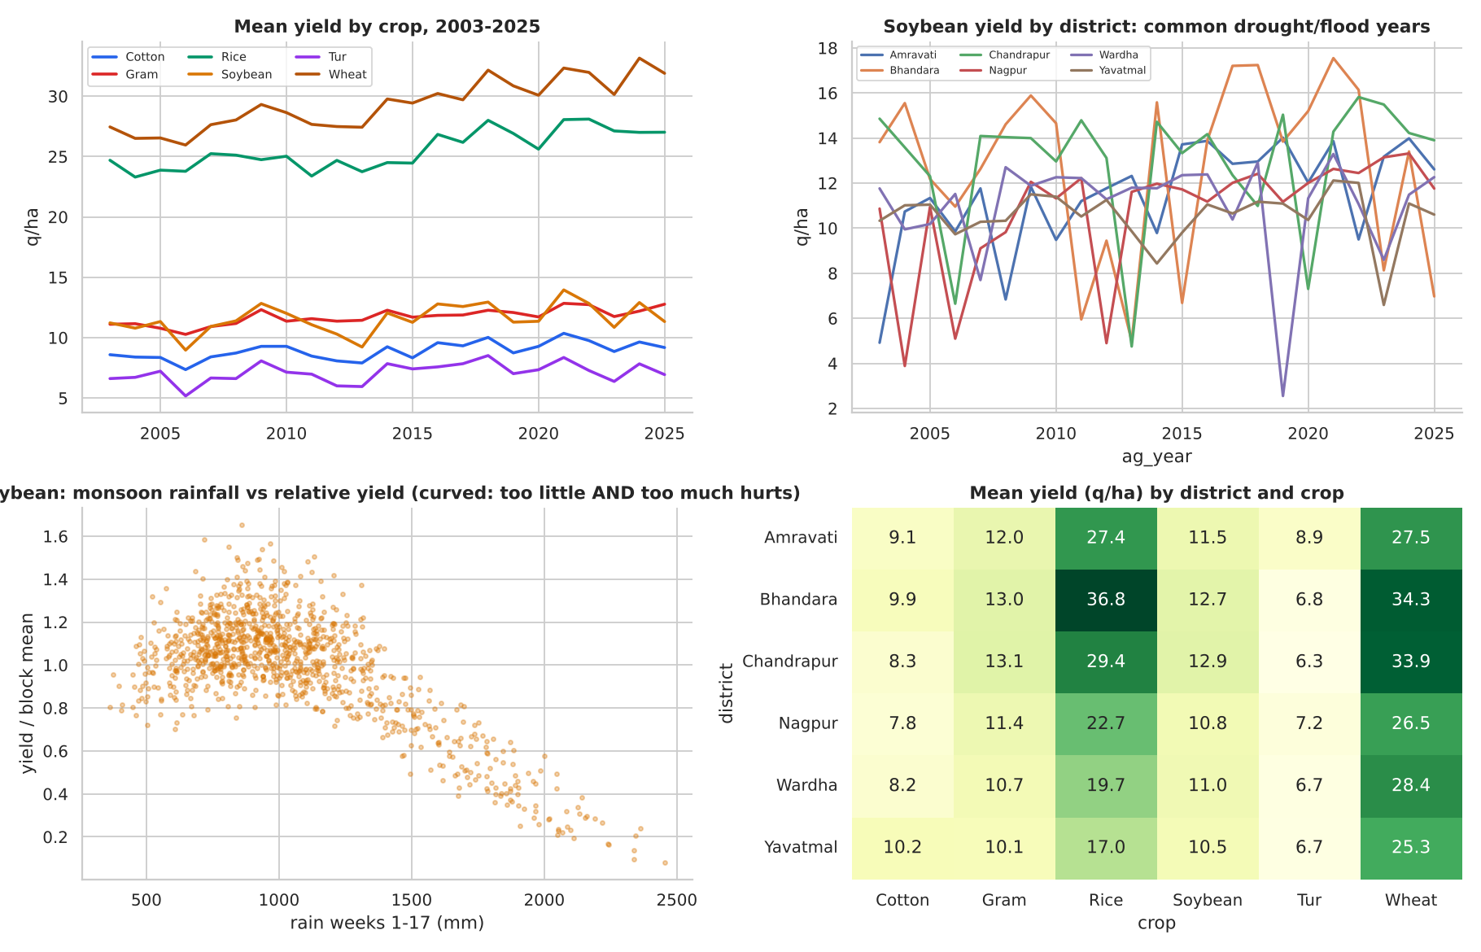
Figure 3. Trends, district differences and the curved rainfall response.
Three observations shaped the modelling. Yields rise slowly with technology. Bad years (2009, 2014-15, 2018) are shared across districts, so weather is the main driver. The rainfall response is an inverted U, so a straight-line term will under-use it.

Leakage
Before building features I tested which columns would not exist on the forecast date.
Column | Why suspicious | Correlation with yield
cce | post-harvest column | 0.998
prod_per_ha | post-harvest column | 1.000
proc_per_ha | post-harvest column | 0.934
rain_season_total_rel | uses weeks after cutoff / after harvest | −0.502
price_post_harvest_rel | uses weeks after cutoff / after harvest | −0.057

All five were excluded. To show why this matters, I compared three setups with the same random forest.
Setup | MAE (log-ratio)
Honest: time split, no leaky columns | 0.1097
Random shuffled CV (same features) | 0.0999
Time split but keeping leaky columns | 0.0276

A randomly shuffled cross-validation looks 9% better than the honest setup because it lets the model see other blocks from the same year, which share weather. Keeping the leaky columns looks 75% better. Neither is achievable on the forecast date.

5. Feature engineering and splits
The final model uses 50 features, of which 15 are lag, rolling or ratio features. They come from five families, all computed from weeks 1-20 or earlier seasons:
- Rainfall: window sums, ratio to the block's own history (expanding, past only), 3-year rolling mean, longest dry spell in weeks 5-14, and the share of readings that were missing.
- Temperature: mean temperature and the number of hot weeks in the flowering window.
- Soil: the last available test (forward-filled, so never from the future), a missing flag and the N:P ratio.
- Price: early-season level, volatility, momentum, and ratios to the previous year's early price and previous harvest price.
- History: last year's yield, two years ago, 3-year rolling mean and standard deviation, ratios to the rolling mean, and a district-level lag.
High-cardinality categories. There are 48 blocks, 48 mandis and 240 seed varieties. Mandi is a one-to-one duplicate of block, so it was dropped. Block and variety use a smoothed target encoding that only looks at earlier years, so the encoding never sees the row's own year or the future. Crop and district (6 levels each) are one-hot encoded.
Missing values. Rainfall was imputed from neighbours as described in section 3. Soil tests were forward-filled from the block's previous test. Lag features are empty in the first seasons, so modelling starts in 2006. Tree models handle any remaining gaps natively.
Time-aware split. Train 2006-2019, validation 2020-2022, test 2023-2025. Cross-validation uses expanding windows (train up to 2013, 2015 and 2017; validate on the next two years). The target is log(yield / 3-year block-crop rolling mean), converted back to q/ha.

6. Models and tuning
The baseline is the 3-year block-crop rolling mean, what an analyst would do without a model. I compared a ridge regression, a random forest and gradient boosting using the expanding-window cross-validation, then tuned gradient boosting with a 24-draw randomised search over the same folds.
Model | CV MAE (log-ratio)
Gradient boosting (tuned) | 0.1193
Gradient boosting (default) | 0.1194
Random forest | 0.1291
Ridge (linear) | 0.1493
Baseline (3-yr rolling mean) | 0.1836

Tuning improved cross-validation error only slightly (0.1194 to 0.1193) but did reduce validation district error from 0.896 to 0.849 q/ha. I treat that gain as modest rather than decisive. The selected parameters are in the model card.
Model on validation years | MAE district (q/ha) | WAPE % | vs baseline
Gradient boosting (tuned) | 0.849 | 5.03 | 42.0%
Gradient boosting (default) | 0.896 | 5.31 | 38.9%
Random forest | 0.938 | 5.55 | 36.0%
Baseline (3-yr rolling mean) | 1.465 | 8.68 | 0.0%
Ridge (linear) | 1.583 | 9.37 | −8.0%

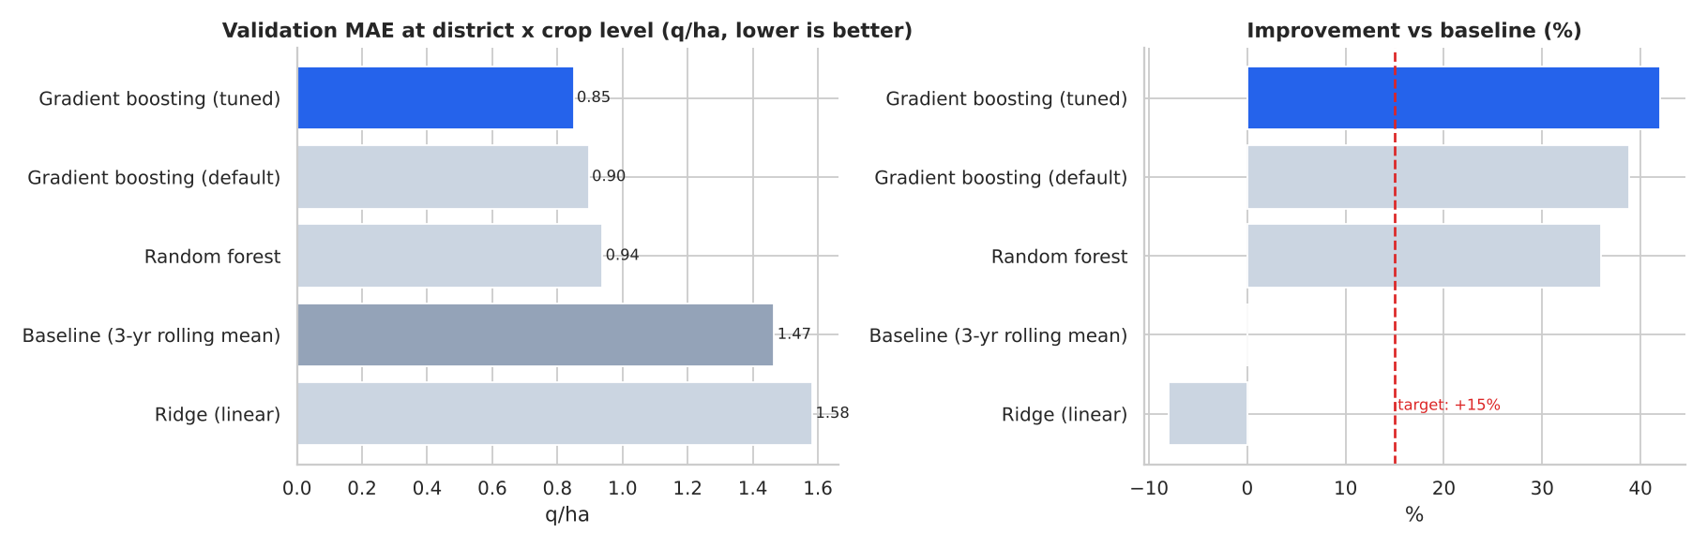
Figure 4. Model comparison on the validation years.
The linear model is worse than the baseline because yield reacts to rainfall in a curve and differently by crop; gradient boosting captures this without hand-built interactions.

7. Metrics that match the cost of errors
Over-forecasting yield makes the start-up under-book supply; under-forecasting leaves it over-committed on storage and cash. Both costs scale with the size of the miss in quintals, so the primary metric is mean absolute error in q/ha at the district x crop x year level, the level the product is used at. I also report WAPE, and the recall of shortfall events at a fixed precision, because a missed shortfall is the costly error (a shortfall is a yield below 92% of the district-crop 3-year normal).
Metric | Validation | Test
MAE, district x crop (q/ha) | 0.849 | 1.187
MAE, block (q/ha) | 1.623 | 1.775
WAPE, district (%) | 5.03 | 7.20
Baseline MAE, district (q/ha) | 1.465 | 1.721
Improvement vs baseline (%) | 42.0 | 31.0
Shortfall recall at precision (threshold fixed on validation) | 61% at 73% | 82% at 61%

The precision target of 70% was met on validation but not on test (61%): on the test years the same threshold flags more false alarms while catching more real shortfalls.
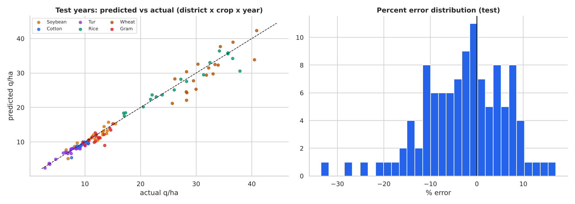
Figure 5. Test years: predicted vs actual and the error distribution.

Why test error is higher than validation
Test error is 40% above validation, so the stability criterion is not met. The baseline also got worse (17%), so the test years are harder, but the model degraded more than that. I looked for the cause rather than tuning against the test set.
The natural suspect is rainfall relative to the block's own history, because wet seasons are rare in training. Seasons more than 1.4 times the block's norm doubled from 9% of validation rows to 16% of test rows. In normal seasons the model is stable (average block-level error 10.0% on validation and 9.6% on test). In unusually wet seasons it reaches 15.9%, with a bias of −8.6%, meaning it forecasts a bigger collapse than actually happened. The effect is strongest in irrigated Bhandara (22% error, −24% bias) and for rabi crops (−17% bias), which are far less rain-sensitive than kharif crops. With few wet-season examples in training, the model transfers the kharif collapse pattern too widely.
A follow-up experiment. I tested a hybrid model (a linear stage with crop x rainfall interactions, then boosting on the residuals). It was worse on validation (0.881 vs 0.849 q/ha), so I kept plain gradient boosting. On the test years it looked better (1.019 vs 1.187). I had already looked at test results by then, so I did not use that to select the model; it is a lead for a version 2 that needs a fresh hold-out.

8. Explainability
Explanations use Shapley values. The shap package could not be installed in my offline environment, so the notebook uses a permutation-sampling Shapley estimator (permutation-sampling Shapley estimator (24 permutations x 150 background rows)); the same code uses shap.TreeExplainer automatically when the package is available.
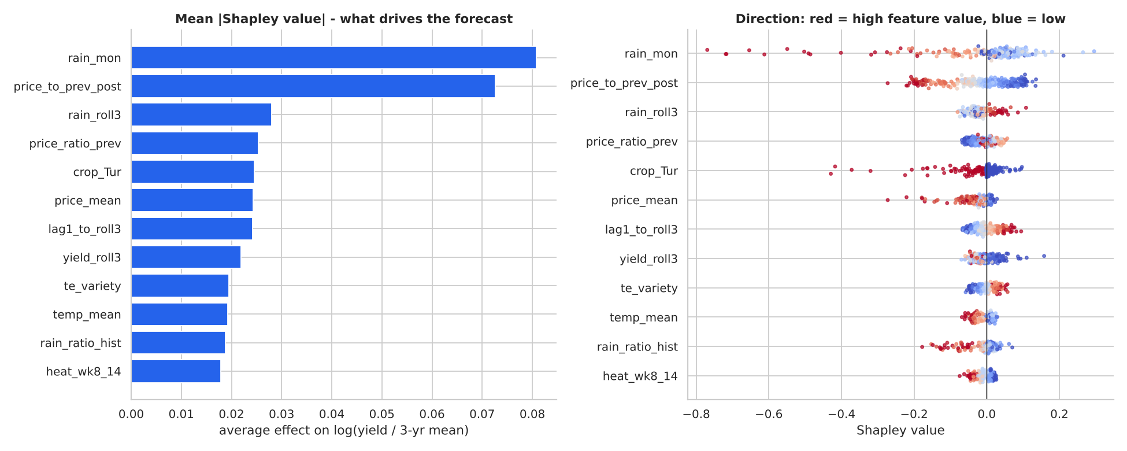
Figure 6. Mean absolute Shapley value and direction of effect for the top features.
Feature family | Share of attribution (%)
Rainfall | 27.8
Price signals | 25.6
Yield history / block & variety effect | 19.5
Crop / district identity | 10.0
Soil | 7.4
Temperature | 6.5
Other (area, trend) | 3.2

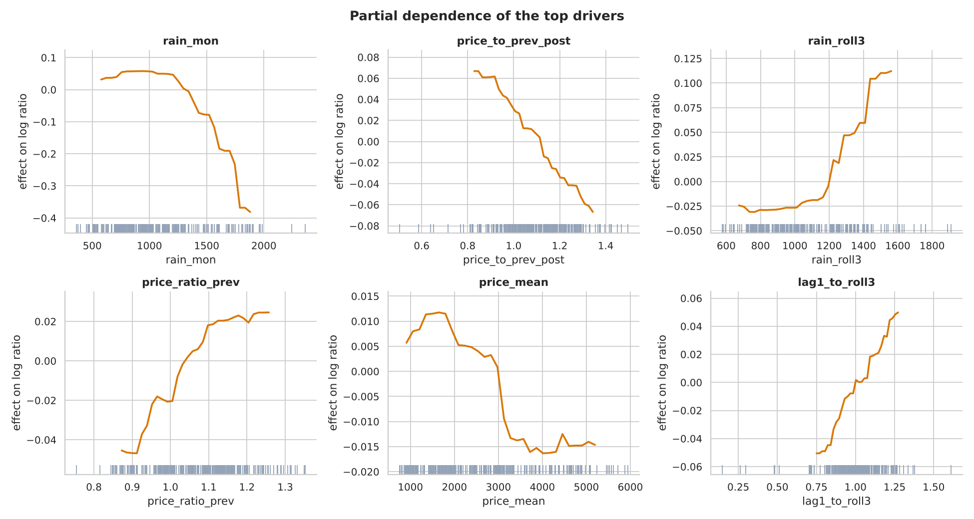
Figure 7. Partial dependence of the top numeric drivers.

9. Do the drivers make business sense?
- Rainfall dominates. Monsoon rainfall in weeks 1-17 is the largest single driver, and its 3-year average (soil-moisture memory) is third. The partial-dependence curves are not straight lines: yields fall when the monsoon is far from what the block normally gets. An agronomist would expect this.
- Price signals are the second family. The ratio of the early price to last harvest's price carries information about local supply, and good prices push farmers to invest more in inputs. The caveat is that these are market signals, not agronomic causes, and they are only available if mandi prices arrive on time for weeks 1-20. Part of their power comes from traders pricing in crop condition.
- Yield history (last year relative to the 3-year norm, block effect, seed variety) adds a smaller, real share.
- Dry-spell length, soil and heat rank lower than I expected from the exploratory analysis. They help, but rainfall totals and history carry most of the predictable signal.
- Tur appears in the top five because it is the crop most hurt by wet monsoons in this data; that is crop identity acting through rainfall, not an independent cause.

10. From forecast to action
To show how the forecast would be used, I trained on seasons up to 2024 and forecast the 2025 season at week 20. For each district x crop I compared predicted supply with the 3-year normal, and added early-season price momentum into a priority score (shortfall plus half of price momentum; a heuristic, not an optimiser). Rules: book early when predicted supply is 4% or more below normal, wait and buy spot when 4% or more above, otherwise follow the routine plan.
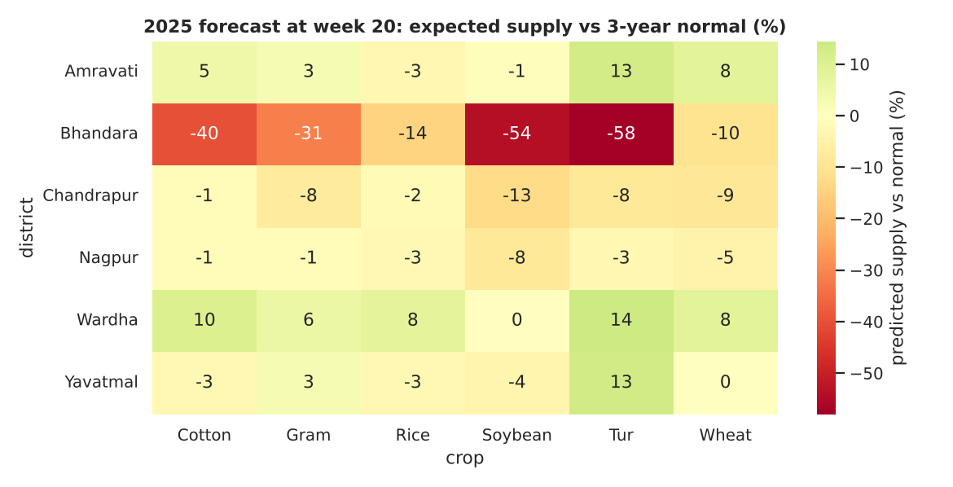
Figure 8. Expected 2025 supply versus the 3-year normal (%), forecast at week 20.
District | Crop | Predicted supply vs normal (%) | Actual (%) | Action
Bhandara | Tur | −58.0 | −55.6 | BOOK EARLY
Bhandara | Soybean | −53.9 | −44.2 | BOOK EARLY
Bhandara | Cotton | −39.9 | −20.6 | BOOK EARLY
Bhandara | Gram | −31.2 | 9.6 | BOOK EARLY
Bhandara | Wheat | −10.4 | −2.0 | BOOK EARLY
Chandrapur | Wheat | −8.8 | −12.5 | BOOK EARLY
Bhandara | Rice | −14.4 | 3.3 | BOOK EARLY
Chandrapur | Gram | −7.5 | −4.6 | BOOK EARLY

Counts across all 36 district-crop pairs: routine 15, book early 12, wait 9. A hindsight check against the 2025 actuals gives a rank correlation of 0.75 and the right direction (shortfall vs surplus) in 75% of pairs.
The hindsight check is informative about where to trust the forecast. Bhandara's kharif shortfalls were real (tur forecast −58%, actual −56%; soybean forecast −54%, actual −44%). Its rabi flags were wrong (gram forecast −31%, actual +10%; rice forecast −14%, actual +3%), which is the wet-season weakness from section 7. In practice I would treat rabi shortfall flags in unusually wet years as low confidence.

11. Stretch: fairness and stability
I checked error and signed bias (negative means the model forecast less than actual) on the test years by district, by crop, and by farm size (terciles of sown area, as a proxy for customer groups).
District | MAE (q/ha) | MAPE (%) | Bias (%)
Amravati | 1.66 | 8.8 | −4.2
Bhandara | 2.46 | 14.8 | −7.9
Chandrapur | 1.78 | 8.7 | 0.6
Nagpur | 1.61 | 9.7 | −5.0
Wardha | 1.68 | 10.5 | −3.3
Yavatmal | 1.47 | 10.8 | 1.3

Farm size group | MAE (q/ha) | MAPE (%) | Bias (%)
small | 1.81 | 10.7 | −3.3
medium | 1.80 | 10.9 | −3.4
large | 1.71 | 10.1 | −2.5

Error is similar across small, medium and large farms. The weak spot is region and weather regime: Bhandara has the highest error and the largest under-forecast bias. Among crops, wheat has the largest absolute error in q/ha because its yields are largest, and gram has the largest under-forecast bias.
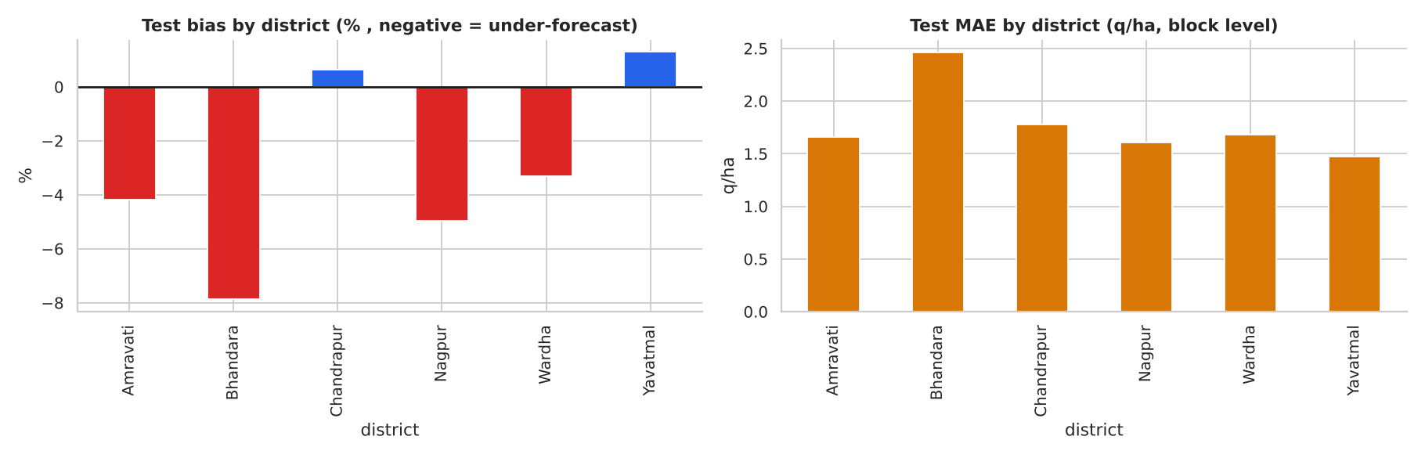
Figure 9. Test bias and MAE by district.
Distribution shift. The population stability index between training and test is above 0.25 (a major shift) for the price ratio to last year (0.69) and for monsoon rainfall (0.33), and moderate for soil organic carbon (0.15). These are the features to monitor in production.
Recalibration. I tested an online correction that adds half of the previous season's district-crop residual. It made forecasts worse on 2024-25 (district MAE 1.10 to 1.29 q/ha; Chandrapur 0.90 to 1.30), because one season's residual is mostly weather noise shared across blocks. Annual retraining already absorbs the Chandrapur drift built into the data (Chandrapur test bias is small). I would not ship this recalibration; a multi-season, significance-tested correction or a wider uncertainty band in unusually wet years are better options.

12. One wrong prediction, explained
The largest percentage error on the test years is WRD-Block-8 (Wardha), soybean, 2023: the model forecast 15.2 q/ha and the actual yield was 9.9 q/ha, an over-forecast of 53%.
- What the model saw. The 3-year baseline was 15.6 q/ha, and the model forecast 0.97 times the baseline. The two largest contributions were both upward and both from price features (last harvest's price relative to now, and early price momentum). The rainfall features contributed almost nothing (each under 0.01 in log units, apart from the 3-year rain average at -0.03).
- What actually happened. The monsoon (weeks 1-17) was 1332 mm, 1.44 times the block's own history and wetter than 88% of its earlier seasons. In 2006-2022, 63 soybean seasons with similar relative wetness realised on average 0.69 times their baseline. This one realised 0.63 times. The data already contained the pattern; the model did not apply it.
- A second contributor. The baseline itself was inflated: the block's last three yields were 13.6, 18.6, 14.8 q/ha, and the very good 2021 season lifted the average to 15.6.
- Ruled out. Late-season weather: rainfall in weeks 21-40 (61 mm vs a past mean of 64 mm) and hot weeks in the grain-filling window (1) were normal, so this was not an unobservable late shock.
- Lesson. This is a model miss, not noise. Price features outweighed rainfall in an unusually wet season. Fixes to test next: crop-specific wet-season features, monotonic constraints on rainfall, or the hybrid model from section 7, each judged on a fresh hold-out.
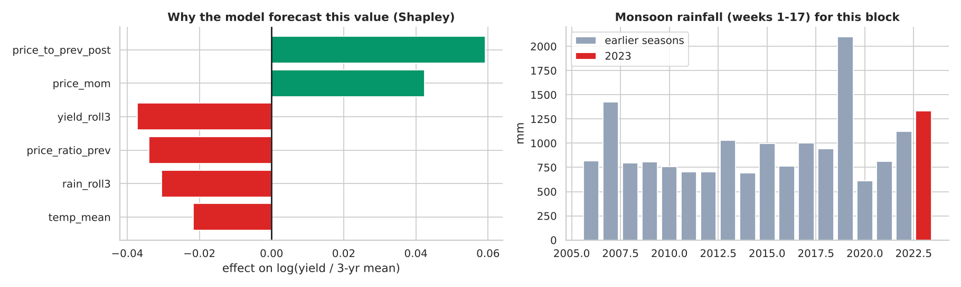
Figure 10. Shapley contributions for this forecast and the block's monsoon rainfall history.

13. Limitations and next steps
- Simulated data. All numbers describe a synthetic dataset. The workflow transfers to real data, the figures do not.
- Stability criterion not met. Test error was higher than validation, largely in unusually wet seasons; see section 7.
- Test set looked at once during development. After the first full run I inspected test errors to diagnose the gap. I did not change the selected model because of it; the hybrid experiment is labelled as a diagnostic.
- Shapley estimator. Used instead of the shap package for offline reproducibility; estimates are Monte-Carlo and slightly noisy.
- Price features depend on timely mandi data and partly encode traders' expectations.
- Next steps. Add wet-season handling and test the hybrid on a fresh hold-out; quantile forecasts so the business sees a range; monitor the shifted features; validate on real district data.

Appendix: reproducibility
Repository layout: src/generate_data.py (synthetic data), notebooks/analysis.py and notebooks/agri_yield_analysis.ipynb (full analysis with outputs), src/build_notebook.py (executes the notebook), models/yield_model.joblib, reports/model_card.md, reports/metrics.json, reports/test_predictions.csv and reports/figures. To rebuild: run python src/generate_data.py, then python src/build_notebook.py. All random seeds are fixed (2026 for the data, 42 for modelling).

