WEEK 3 – EXPLORATORY DATA ANALYSIS (EDA)
REPORT DESIGN
Agribusiness Data Analysis: Wheat and Soybean in India
Junior Data Scientist Internship – Week 3
Prepared by: Kalla Kushwanth
Date: 05 November 2026
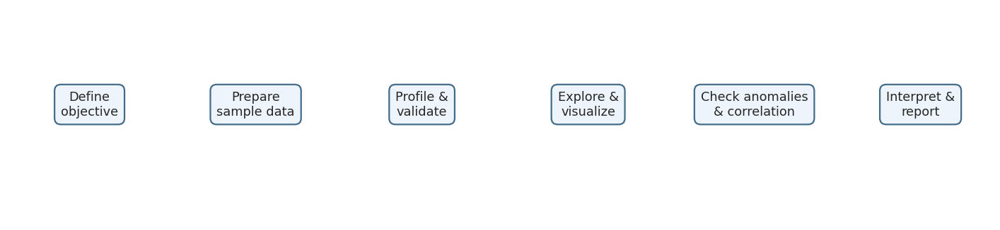
Figure 1. Planned EDA workflow

Executive Summary
This report outlines an Exploratory Data Analysis (EDA) plan for an agribusiness study of wheat and soybean in India. It covers dataset profiling, descriptive statistics, crop and regional comparisons, monthly price trends, market-arrival relationships, correlation analysis and anomaly detection. Five core visualizations were created in Google Colab using a 10-row fictional sample dataset. Additional fictional datasets were added to demonstrate state-wise production comparison and a 12-month price-trend analysis. The practical results are examples of the EDA workflow only and are not official agricultural statistics. The report also explains the data required for a future real-world analysis, expected outcomes, limitations and recommendations.

Purpose of this document
This report presents a structured plan for conducting Exploratory Data Analysis (EDA) on agribusiness information related to wheat and soybean in India. It describes the variables, statistical methods, visualizations, anomaly checks, correlation analysis and expected outcomes. A small fictional dataset was analysed in Google Colab to demonstrate the planned techniques.
Data note: All numerical records in the practical demonstration are fictional sample values created for learning. They are not official production, mandi price or market-arrival observations.

1. Objectives
- Understand the structure, quality and distribution of agricultural data.
- Compare wheat and soybean production, prices and market arrivals in the sample dataset.
- Plan regional and seasonal analyses that can be performed when suitable real data is available.
- Use visualizations to communicate patterns and possible relationships.
- Identify potential anomalies and examine correlations without assuming causation.
- Convert analytical observations into clear findings and recommendations.

2. Scope and dataset overview
The proposed EDA focuses on wheat and soybean. A complete real-world analysis may combine crop production statistics with market price and arrival records. These sources may have different time periods, geographic levels, units and reporting practices, so they must be checked before combining.
Variable | Description | Suggested unit / format
Month | Month of observation | Jan–Dec or YYYY-MM
Crop | Crop name | Wheat / Soybean
Production | Quantity produced | Tonnes
Price | Market price | ₹ per quintal
Arrivals | Quantity arriving at market | Tonnes
Region / State (planned) | Geographic location | State, district or market
Date / Season (planned) | Reporting date or agricultural season | Date / season label

The current Colab demonstration contains 10 rows, five for each crop, and five columns: Month, Crop, Production, Price and Arrivals. It does not contain a Region or State column; regional comparisons are therefore planned, not completed.

3. Data preparation and initial profiling
The notebook uses Pandas to create and inspect the sample DataFrame. Initial checks include row and column counts, data types, descriptive statistics and missing-value counts.
Check | Observed result
Number of records | 10
Number of columns | 5
Numeric columns | Production, Price, Arrivals
Text columns | Month, Crop
Missing values | 0 in all five columns
Data types | 3 integer columns and 2 object columns

For larger real datasets, preparation should also include duplicate checks, consistent crop and market names, date parsing, unit verification, missing-value treatment and validation of geographic identifiers. Sources should only be combined after matching time period, crop, location and unit.

4. Descriptive statistical analysis
Descriptive statistics summarise the centre, spread and range of numeric variables. The sample dataset produces the following values:
Metric | Production (tonnes) | Price (₹/quintal) | Arrivals (tonnes)
Count | 10 | 10 | 10
Mean | 1,240.0 | 3,490.0 | 116.5
Median | 1,200.0 | 3,475.0 | 115.0
Standard deviation | 250.33 | 837.26 | 23.93
Minimum | 900 | 2,600 | 85
Maximum | 1,600 | 4,400 | 150

In this fictional sample, average production is 1,240 tonnes, average price is ₹3,490 per quintal and average arrivals are 116.5 tonnes. These values describe only the demonstration records.

5. Planned analyses and visualizations

5.1 Bar chart – crop production comparison
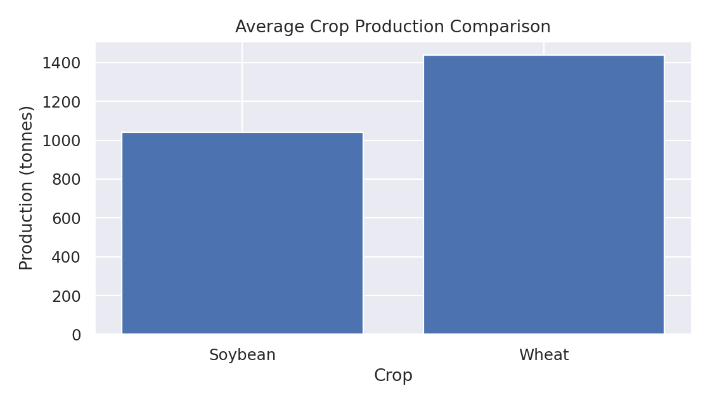
Figure 2. Average production by crop in the sample dataset
The bar chart compares average production for the two crop groups. Wheat has a sample average of 1,440 tonnes and soybean has a sample average of 1,040 tonnes. This chart is suitable for comparing categories. In a full study, it can also compare production by state or district when geographic data is available.

5.2 Histogram – market price distribution
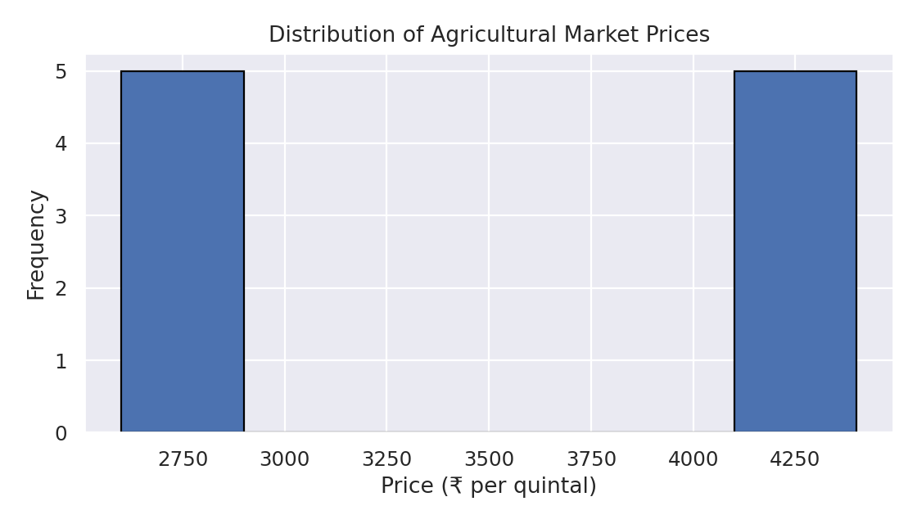
Figure 3. Distribution of sample market prices
The histogram groups price observations into ranges and shows their frequency. The sample prices form two visible groups: wheat values around ₹2,600–₹2,800 and soybean values around ₹4,150–₹4,400. Separate crop-wise histograms may be useful in a larger dataset.

5.3 Line chart – monthly price trends
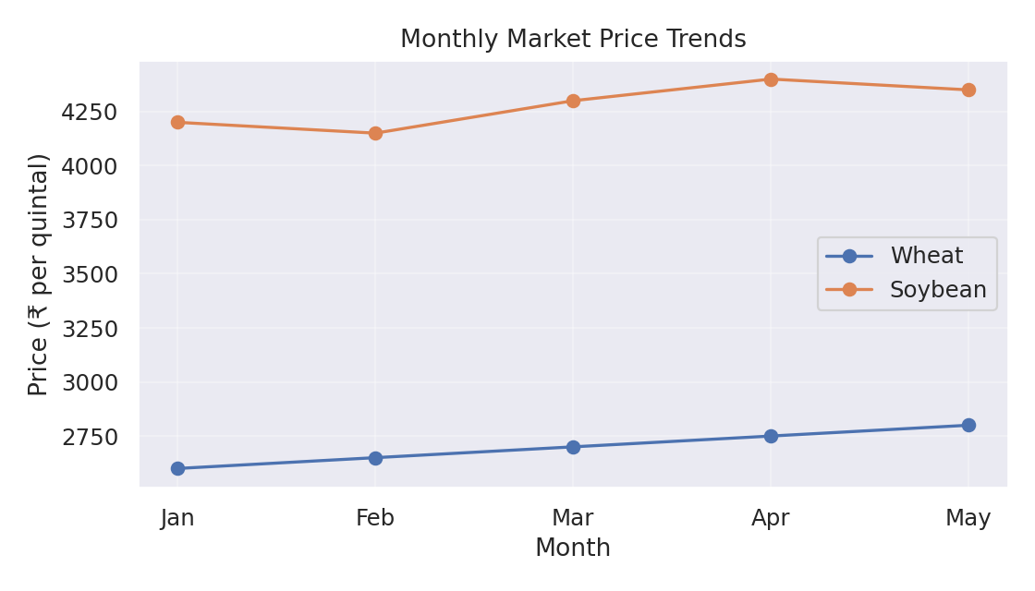
Figure 4. Monthly sample price trends
The line chart shows wheat prices rising from ₹2,600 in January to ₹2,800 in May. Soybean prices fall from ₹4,200 to ₹4,150 in February, rise to ₹4,400 in April and then ease to ₹4,350 in May. A real seasonal analysis should use a longer, consistently dated time series, preferably covering multiple years.

5.4 Scatter plot – arrivals versus price
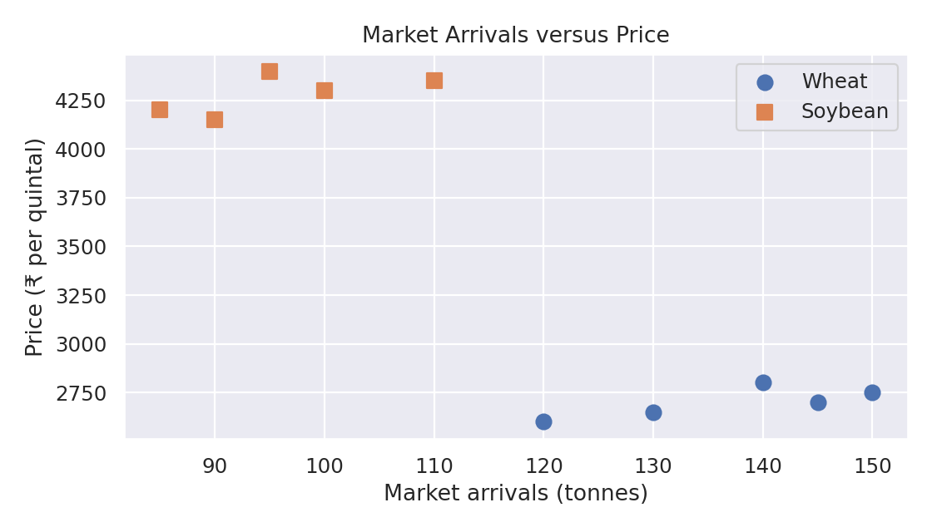
Figure 5. Sample market arrivals versus price
Each point represents one crop-month observation. The colour/marker distinguishes wheat and soybean. The plot helps inspect whether prices and arrivals move together within each crop. This small sample does not prove that arrivals cause price changes.

5.5 Heatmap – correlation analysis
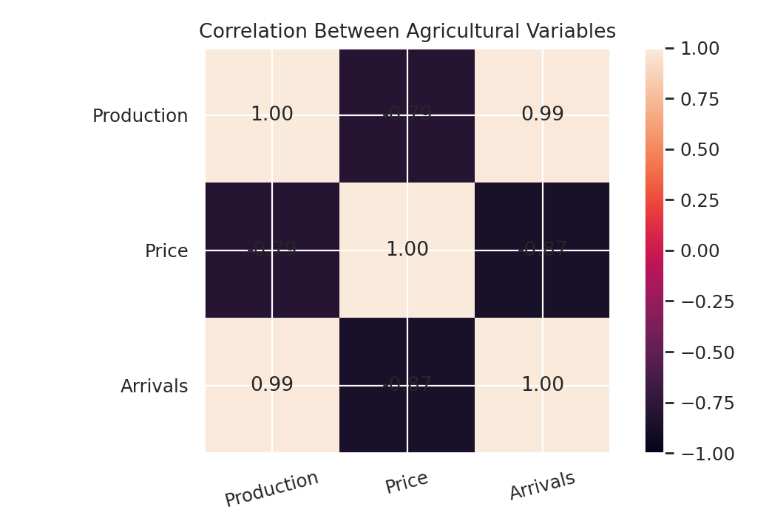
Figure 6. Correlation matrix for numeric sample variables
The Pearson correlation matrix shows Production–Price = -0.79, Production–Arrivals = +0.99 and Price–Arrivals = -0.87. Positive values indicate variables tend to move in the same direction; negative values indicate opposite movement. Correlation does not establish causation.
Important limitation: correlations are calculated across both crop groups together. Since wheat and soybean have different price and production ranges, combined correlations may mainly reflect differences between crops. A stronger analysis should calculate correlations separately by crop and use more observations.

6. Statistical anomaly detection
The notebook applies the Interquartile Range (IQR) method to the Price column. Q1 is the 25th percentile, Q3 is the 75th percentile, and IQR = Q3 − Q1. Potential outliers are values below Q1 − 1.5 × IQR or above Q3 + 1.5 × IQR.
IQR measure | Calculated value
Q1 | ₹2,712.50
Q3 | ₹4,275.00
IQR | ₹1,562.50
Lower limit | ₹368.75
Upper limit | ₹6,618.75
Potential outliers detected | 0

No sample price falls outside the calculated limits. This does not prove every record is correct. In real agricultural data, unusual values should be checked against the original source, units, date, market and crop before deciding whether to correct, retain or exclude them.

7. Correlation and feature relationship strategy
Variable pair | Sample correlation | Interpretation within this sample
Production and Price | -0.79 | Negative linear association
Production and Arrivals | +0.99 | Very strong positive linear association
Price and Arrivals | -0.87 | Negative linear association

For a full EDA, correlations should be calculated within comparable groups, such as the same crop, market and time period. Correlation analysis should be supported by scatter plots and domain checks. Season, transport, quality, demand, weather and policy may also influence prices.

8. Regional and seasonal analysis plan
The original 10-row demonstration dataset does not contain a State, district or market-location field. To demonstrate regional analysis, a separate fictional dataset was created with wheat and soybean production values for Maharashtra, Madhya Pradesh, Rajasthan and Uttar Pradesh. A grouped bar chart compares the sample values by state and crop. This is a method demonstration only; it is not evidence of actual state production.
The original demonstration dataset covers January to May. A separate fictional 12-month price dataset was therefore added to demonstrate a full-year line-chart format. It illustrates how month-wise comparisons can be organised, but it does not establish real seasonal behaviour. A reliable seasonal study should use verified monthly observations across several years.

9. Expected outcomes and recommendations
- Identify differences in crop production across regions when geographic records are available.
- Understand how market prices vary by crop, market and time period.
- Observe whether market arrivals and prices move together within comparable crop-market groups.
- Detect unusual records for verification rather than removing them automatically.
- Provide clear charts and summary statistics to support further agricultural analysis.
- Use validated, multi-year data before making operational or policy recommendations.

10. Limitations
- The practical dataset contains only 10 fictional records and is intended for demonstration.
- The sample covers January to May only and cannot establish annual or long-term seasonal patterns.
- No State, district or market identifier is included, so regional comparisons are not yet possible.
- Combined correlations across wheat and soybean may be affected by differences between crop groups.
- The sample results must not be presented as official agricultural statistics or market findings.

11. Conclusion
This EDA exercise demonstrates how agricultural data can be inspected, summarised and visualised using Python, Pandas, Matplotlib and Seaborn in Google Colab. Five visualizations were created, the correlation matrix was calculated, and the IQR method was used to check for potential price outliers. The results provide a practical demonstration of the EDA process. A full agribusiness study will require verified real-world data with consistent dates, units and geographic details.

12. Tools and files
Item | Purpose
Google Colab | Notebook environment for practical analysis
Python | Programming language
Pandas and NumPy | Data handling and numerical operations
Matplotlib and Seaborn | Charts and statistical visualizations
Week_3_Exploratory_Data_Analysis_Updated.ipynb | Practical notebook with core EDA, regional and seasonal demonstration cells
week3_agriculture_sample.csv | Original fictional 10-row dataset used for the five core visualizations
week3_regional_sample.csv | Fictional state-wise production data for regional comparison
week3_seasonal_sample.csv | Fictional 12-month price data for seasonal trend demonstration

13. Supplementary regional and seasonal demonstration
To demonstrate the requested regional production and seasonal trend techniques, two supplementary fictional datasets and two additional charts were prepared. These demonstrations complement the original 10-row dataset; they do not replace the need for verified regional and multi-year market data in a real agribusiness study.

Regional production analysis
The regional sample includes fictional wheat and soybean production values for Maharashtra, Madhya Pradesh, Rajasthan and Uttar Pradesh. The grouped bar chart demonstrates how state-wise production could be compared. The values are illustrative and must not be quoted as actual state production.
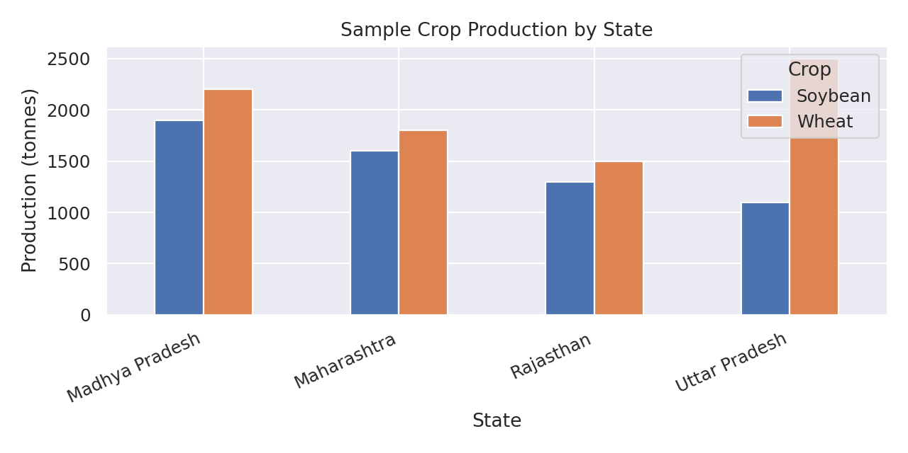
Figure 7. Fictional state-wise crop production comparison

Seasonal trend analysis
A separate fictional 12-month sample price dataset demonstrates how monthly prices could be plotted for both crops. The chart demonstrates the technique only; it does not establish actual seasonal price behaviour. A real analysis should use several years of verified observations.
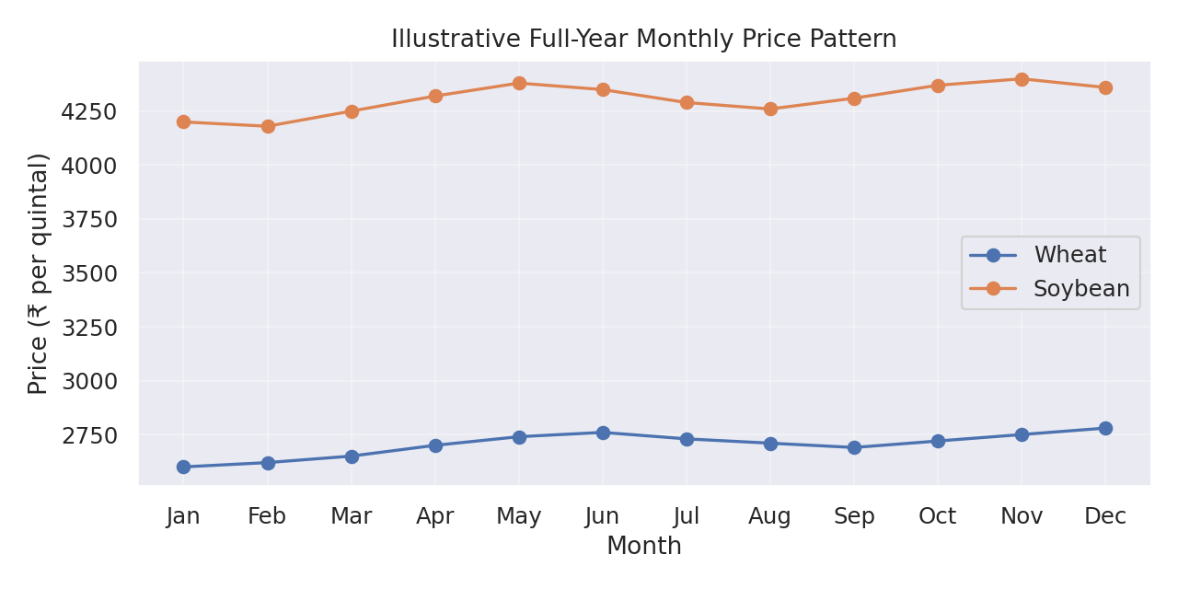
Figure 8. Fictional 12-month crop price trend

References / learning resources
- Pandas documentation: https://pandas.pydata.org/docs/
- Matplotlib documentation: https://matplotlib.org/stable/
- Seaborn documentation: https://seaborn.pydata.org/
- Google Colab: https://colab.research.google.com/

